\*\*Marked with orange, are the results we extracted from 2 CPUs

Latency vs Number of Users:

The round-trip time between sending a request and receiving the response with 1 or 2 CPUs are very similar. There are only small differences appearing in the graph that show that the latency, when using 2 CPUs, is bigger. We can observe, that in both cases, the latency is increasing according to the number of users.

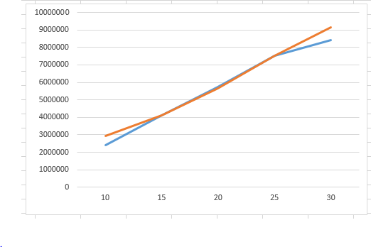

Throughput vs Number of Users:

As we can observe in the Latency graph, the throughput is similarly close in the 2 solutions. Also while the latency is high (in the graph with 2 CPUs) the throughput is low. The only time the throughput with one CPU is lower than with two CPUs is when the difference in the latency is low.

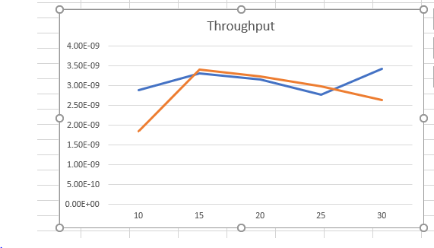

Throughput vs Average Memory Utilization:

This graph presents the percentage of memory in use, compared with the throughput in both cases ( with 1 CPU and 2 CPUs).

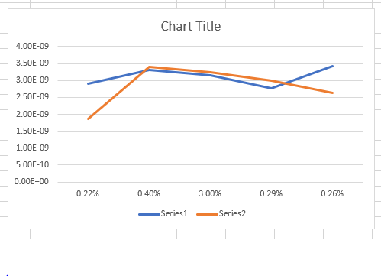

Throughput vs Average CPU Load:

