APPLIED DATA SCIENCE-1

ASSIGNMENT-2: Statistics and Trends- Report

STUDENT NAME: SRI CHARAN KARRI

STUDENT ID: 21083133

ABSTRACT:

In this report, 8 countries are selected from the

dataset to the analysis of the different aspects of climate change in the world. These countries are related to the changes in the climates and the different decisions that are taken by the country over climate change. In the below analysis, we have covered the different results over the countries and the cause of the research result. The graph that extract is the reducing of effect of climate change help Vietnam. According to the graph the data shows that the Cameroon and Vietnam has nearly same forest area but in the Cameroon the area of the forest is getting loss in the total but Vietnam continuously grows forest area. On the other side India and Vietnam is also growing in the reaching the highest of the electricity coverage in the future. By the analysis European Area countries and the India are continuously working on the production of renewable energy. When the renewable energy production is increases the chances of the reducing global warming and climate changes is getting less.

LINK OF THE REPOSITORY :

Analyzing data based on climatic Changes

In this report, I took 8 countries from the dataset to the analysis of the different aspects of climate change in the world. These countries are related to the changes in the climates and the different decisions that are taken by the country over climate change.

In the below analysis, we have covered the different results over the countries and the cause of the research result.

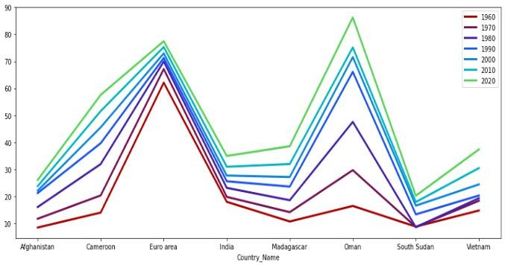

In the above line graph, we have taken the 8

countries data and the data that is taken to the analysis is between 1960 – 2020 with the 10 years of the difference. In the above graph shows the Urban Population of these taken countries. By the analysis of the graph the highest number of Urban Population Oman that is continuously increasing over the year and the second highest Urban Population has the European Area’s Countries.

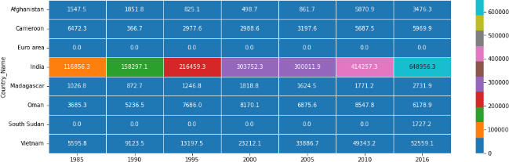

The above graph is heatmap graph that for the analysis of the CO2 emission from the liquid fuel consumption. The graph’s shows the data of the

range of 1985 – 2016, that countries that is taken the sample of the stating. The analysis show that the carbon emission is the highest of the India in between these countries. The second highest carbon emission that is Vietnam. The contribution of the India in climate change on the reason of the carbon emission is high.

The above graph represents the forest area measures of the taken sample countries. The data that is taken in the range of 1985 – 2016. According to the graph the data shows that the Cameroon and Vietnam has nearly same forest area but in the Cameroon the area of the forest is getting loss in the total but Vietnam continuously growing forest area. The conclusion of the graph that extract is the reducing of effect of climate change help Vietnam.

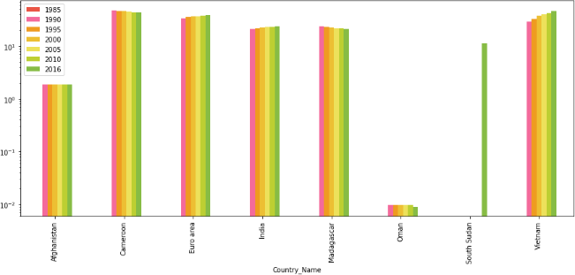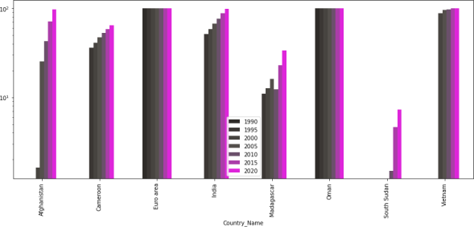

European area country and Oman has the access of the highest % population of electricity. In the other side South Sudan, the access of the population has minimum % population of electricity that has reached. The data of the graph is nearly taken by 1990 – 2020. On the other side India and Vietnam is also growing in the reaching the highest of the electricity coverage in the future.

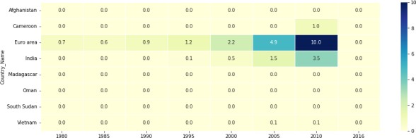

In the above graph this is shows the production of the renewable energy of the sample taken countries. The data of the analysis is taken in the range of 1980 - 2016. By the analysis European Area countries and the India are continuously working on the production of the renewable energy. But in the other side other countries does not trying to work on the production of the renewable energy. When the renewable energy production is increases the chances of the reducing of the global warming and climate changes is getting less.

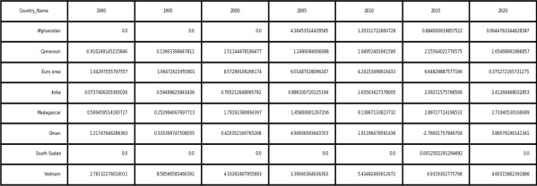

The above table graph shows the data of the Foreign Direct Investment flow in the % of the total GDP of the country. The data of the country sample taken of the 1990 – 2020. With the increasing FDI, expenses in the working of changing the climate environment should be high because of the when the country expense goes in the investment of the climate change.