

SIMATS ENGINEERING
Saveetha Institute of Medical and Technical Sciences
Chennai – 602105

SMART WATER CONSUMPTION MONITORING AND
LEAK DETECTION MANAGEMENT SYSTEM

A CAPSTONE PROJECT REPORT

A Capstone Project Report submitted in partial fulfilment of the requirements
for the course and award of the degree of

BACHELOR OF TECHNOLOGY
IN
COMPUTER SCIENCE AND ENGINEERING

Submitted by
K. Krishna Charan – 192311316

Under the Supervision of
Madhan

SIMATS ENGINEERING
Saveetha Institute of Medical and Technical Sciences
Chennai – 602105

SEPTEMBER 2026

BONAFIDE CERTIFICATE

This is to certify that the Capstone Project entitled “Smart Water Consumption Monitoring and Leak Detection Management System” has been carried out by M. Poojith Ganesh (192311290) and K. Krishna Charan (192311316) under the supervision of Madhan and is submitted in partial fulfilment of the requirements for the current semester of the B.Tech. Computer Science and Engineering programme at SIMATS Engineering, Saveetha Institute of Medical and Technical Sciences, Chennai.
The project applies Object-Oriented Analysis and Design principles to model water-consumption monitoring, abnormal-flow analysis, leakage detection, alert management, reporting and data storage. The report presents the analysis and proposed design using UML-based artefacts and a layered software architecture.

Role | Name / Designation | Signature
Project Supervisor | Madhan
Course / Faculty | CSA1101 – Object Oriented Analysis and Design
Student | M. Poojith Ganesh – 192311290
Student | K. Krishna Charan – 192311316

Place:
Date:

DECLARATION
We, M. Poojith Ganesh (192311290) and K. Krishna Charan (192311316), students of the Computer Science and Engineering programme at SIMATS Engineering, hereby declare that the Capstone Project Work entitled “Smart Water Consumption Monitoring and Leak Detection Management System” is the result of our academic work.
The report has been prepared using the supplied project presentation as the primary project source and by developing the corresponding OOAD documentation in a capstone-report structure. The UML diagrams, system architecture, requirements tables and database model included in this report represent the proposed design of the system based on the project scope described in the source presentation.
All books, standards and other sources used for the report have been acknowledged in the References section. No claim of measured field performance is made where implementation or experimental evidence is not available in the supplied material.

Place:
Date:
Signature of Students with Names

INDIVIDUAL CONTRIBUTION STATEMENT
Student | Analysis & Design | Implementation / Modelling | Testing & Documentation | Contribution
M. Poojith Ganesh | Requirement analysis, use-case modelling | Water-consumption monitoring design, UML modelling | Review of system behaviour and records | 50%
K. Krishna Charan | Problem analysis, architecture and class identification | Leak detection, alert-management and database design | Integration, testing plan and final documentation | 50%
TOTAL |  |  |  | 100%

The responsibilities are divided around the two principal functional areas identified in the project presentation: water-consumption monitoring and leak detection/alert management. Both students contribute to the OOAD analysis, UML design, validation and final report preparation.

Academic Deliverables
- Requirements and problem definition.
- Object-oriented analysis and identification of actors, use cases, classes and interactions.
- System architecture and layered design.
- Use Case, Class, Sequence, Activity, Component and Deployment diagrams.
- Logical database model for users, consumption records, leakage information, alerts and logs.
- Testing strategy, limitations, future scope and final technical documentation.

ABSTRACT
The Smart Water Consumption Monitoring and Leak Detection Management System is an object-oriented software design intended to monitor water consumption, identify abnormal water-flow behaviour and support timely leakage alerts. The project addresses the limitations of conventional water management, where periodic meter readings and manual inspection can delay the identification of excessive usage or leakage.
The system is analysed using Object-Oriented Analysis and Design (OOAD) principles. UML artefacts—including Use Case, Class, Sequence, Activity, Component and Deployment diagrams—are used to represent functional requirements, static structure, interactions, process flow and deployment structure. The proposed architecture is organized into a User Interface Layer, Business Logic Layer and Database Layer. Water-flow sensor data is processed by the business logic, consumption records are maintained in the database, and abnormal patterns are passed to a leak-detection engine that can create alerts and notifications.
The design is divided into two principal functional areas: Water Consumption Monitoring and Leak Detection and Alert Management. The first area tracks usage and maintains consumption records; the second analyses flow behaviour, identifies possible leak conditions, manages notifications and maintains leakage history. The system also provides a foundation for report generation, user management and configurable system settings.
The proposed design emphasizes modularity, maintainability, scalability and timely decision-making. Future extensions can include IoT-enabled sensors, mobile applications, smart meters, machine-learning-based prediction and advanced analytics. The report therefore provides a structured OOAD foundation for developing a smart water-management application that can help reduce water wastage and improve resource management.
Keywords: Object-Oriented Analysis and Design, Smart Water Management, Water Consumption, Leak Detection, UML, IoT, Database, Alert Management.

TABLE OF CONTENTS
Sl. No. | Title | Page No.
1 | CHAPTER 1: INTRODUCTION AND ENGINEERING PROBLEM | 9
1.1 | Background | 9
1.2 | Need for the Project | 10
1.3 | Problem Statement | 10
1.4 | Aim and Objectives | 10
1.5 | Scope | 10
1.6 | Expected Engineering Outcome | 11
2 | CHAPTER 2: LITERATURE REVIEW AND EXISTING SOLUTIONS | 12
2.1 | Review Method | 12
2.2 | Review of Existing Work | 12
2.3 | Comparative Analysis | 13
2.4 | Research / Engineering Gap | 13
2.5 | Proposed Contribution | 13
3 | CHAPTER 3: SYSTEM ANALYSIS AND OOAD DESIGN | 14
3.1 | Requirements Analysis | 14
3.2 | Functional and Non-Functional Requirements | 14
3.3 | Constraints and Design Principles | 15
3.4 | Design Specifications | 15
3.5 | System Architecture | 16
3.6 | Use Case Model | 17
3.7 | Class Model | 18
3.8 | Interaction Model – Sequence | 19
3.9 | Activity Model | 20
3.10 | Component and Deployment Models | 21
3.11 | Database Design | 22
3.12 | Design Alternatives and Trade-Offs | 23
3.13 | Sustainability, Ethics, Safety, Risk & Security | 23
4 | CHAPTER 4: IMPLEMENTATION, TESTING & RESULTS | 24
4.1 | Development Approach and Resources | 24
4.2 | Implementation Flow | 25
4.3 | Testing and Verification | 26
4.4 | Results and Discussion | 27
4.5 | Challenges and Limitations | 28
4.6 | Project Management | 28
5 | CHAPTER 5: CONCLUSION, FUTURE WORK AND REFLECTION | 29
5.1 | Conclusion | 29
5.2 | Future Scope | 29
5.3 | Professional Learning & Reflection | 30
 | REFERENCES | 31
 | APPENDICES | 32

LIST OF FIGURES
Figure No. | Figure Name | Page No.
Figure 1.1 | Expected system workflow | 11
Figure 3.1 | System Architecture | 16
Figure 3.2 | Use Case Diagram | 17
Figure 3.3 | Class Diagram | 18
Figure 3.4 | Sequence Diagram | 19
Figure 3.5 | Activity Diagram | 20
Figure 3.6 | Component Diagram | 21
Figure 3.7 | Deployment Diagram | 21
Figure 3.8 | Logical Database Model | 22

LIST OF TABLES
Table No. | Table Name | Page No.
Table 2.1 | Literature Review / Background | 12
Table 2.2 | Comparative Analysis of Existing Approaches | 13
Table 3.1 | Stakeholder and User Requirements | 14
Table 3.2 | Functional and Non-Functional Requirements | 14
Table 3.3 | Constraints and Design Principles | 15
Table 3.4 | Design Specifications | 15
Table 3.5 | Design Alternatives Evaluation | 23
Table 3.6 | Sustainability, Ethics, Safety and Security | 23
Table 3.7 | Project Risk Register | 23
Table 4.1 | Development Resources Used | 24
Table 4.2 | Test Plan and Verification | 26
Table 4.3 | System Testing Scenarios | 27

LIST OF ABBREVIATIONS / SYMBOLS

Abbreviation | Description
OOAD | Object-Oriented Analysis and Design
UML | Unified Modeling Language
UI | User Interface
DBMS | Database Management System
IoT | Internet of Things
API | Application Programming Interface
SQL | Structured Query Language
CRUD | Create, Read, Update, Delete
SMS | Short Message Service
HTTPS | Hypertext Transfer Protocol Secure
PK | Primary Key
FK | Foreign Key

CHAPTER 1
INTRODUCTION AND ENGINEERING PROBLEM

1.1 BACKGROUND
Water is a critical resource for domestic, institutional and industrial activities. Effective management requires not only accurate measurement of consumption but also timely identification of abnormal flow conditions. Conventional water meters provide useful readings, yet periodic manual observation may not provide continuous visibility into consumption behaviour or leakage.
The supplied project presentation proposes a Smart Water Consumption Monitoring and Leak Detection Management System using OOAD principles. The system is intended to collect water-flow information, monitor consumption, analyse abnormal usage patterns, detect possible leakage and provide alerts. The design is organized around a user interface, business logic and database layer, enabling separation of concerns and easier maintenance.
From an OOAD perspective, the problem is modelled through actors, use cases, domain classes, object interactions, activities, components and deployment nodes. This allows the proposed software to be examined before implementation and provides a common representation for developers, evaluators and stakeholders.

1.1.1 Project Context
- Real-time or near-real-time flow information can provide better visibility than periodic manual readings.
- Abnormal or continuous flow can be treated as an indication requiring further inspection.
- A centralized record of consumption and leakage events supports analysis and reporting.
- Alert management provides a mechanism for communicating possible leakage conditions to users or administrators.
- A modular OOAD design supports later integration with smart meters, IoT devices and analytics.

1.2 NEED FOR THE PROJECT
- Water usage may be monitored periodically rather than continuously.
- Leakages can remain undetected when inspection depends on manual observation.
- Excessive consumption is difficult to analyse without organized historical records.
- Timely alerts can reduce the delay between abnormal flow and corrective action.
- Centralized management can improve visibility of users, consumption, leakage and alert history.

1.3 PROBLEM STATEMENT
Traditional water distribution and consumption systems often lack continuous monitoring and integrated leakage-management mechanisms. Water leakage and excessive consumption may remain undetected, resulting in avoidable water wastage. The engineering problem is therefore to design an object-oriented system that collects water-flow information, maintains consumption records, identifies abnormal flow patterns, generates leakage alerts and provides a maintainable mechanism for managing the resulting information.

1.4 AIM AND OBJECTIVES
Aim: To design an OOAD-based Smart Water Consumption Monitoring and Leak Detection Management System that monitors water usage, identifies possible leakages and supports timely alert and record management.
- Analyse system requirements and identify actors and major use cases.
- Design a layered, modular architecture for monitoring and management.
- Model water-consumption data and abnormal-flow analysis using object-oriented classes.
- Represent system interactions through sequence and activity models.
- Provide leakage-alert and notification management.
- Design a logical database structure for consumption, leakage, alerts and logs.
- Evaluate design alternatives, risks, limitations and future extensions.

1.5 SCOPE
Included: water-flow data monitoring, consumption records, abnormal-flow analysis, leak detection, alert management, reporting, user management, settings and database storage. Excluded from the core design are guaranteed physical leak localization, full commercial deployment, and advanced AI/ML prediction unless added as future enhancements.

1.6 EXPECTED ENGINEERING OUTCOME
The expected outcome is a structured object-oriented software design in which water-flow data moves through monitoring and analysis services, abnormal conditions are evaluated by a leak-detection engine, and relevant events are stored and communicated through the alert-management subsystem.
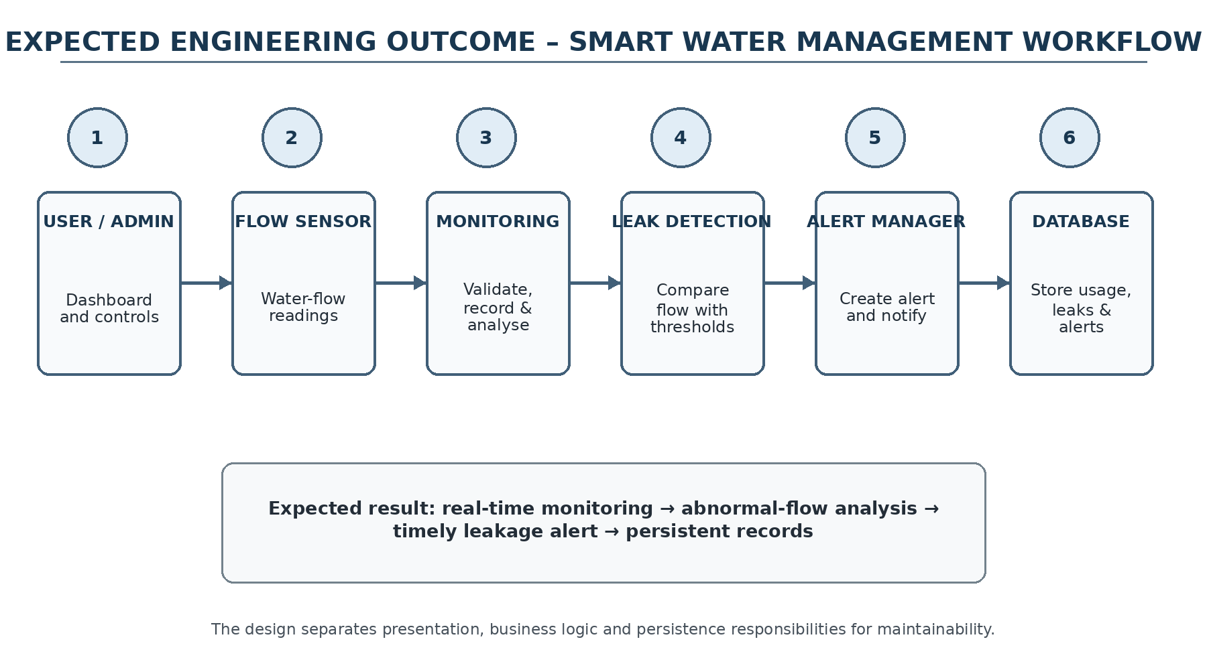
Figure 1.1 – Expected System Workflow / High-Level Architecture
The workflow is consistent with the source presentation: users interact through a dashboard and related interfaces; sensor readings enter the business-logic layer; consumption analysis and leak detection operate on the readings; alerts are managed and records are maintained in the database. The architecture also leaves a clear path for mobile notifications, email/SMS and cloud backup as extensions.

CHAPTER 2
LITERATURE REVIEW AND EXISTING SOLUTIONS

2.1 REVIEW METHOD
The literature review is based primarily on the material supplied in the OOAD project presentation. The presentation identifies traditional water-management practices, IoT-based smart monitoring, sensor-based leakage detection and real-time consumption monitoring as relevant background areas.

2.2 REVIEW OF EXISTING WORK
S.No | Study / Approach | Methodology Used | Drawbacks
1 | Smart Water Management: A Review of IoT-Based Technologies | IoT sensors and smart monitoring techniques for collecting and managing water data. | Limited focus on integrated leakage management.
2 | IoT-Based Smart Water Monitoring System | Flow sensors, microcontrollers and IoT communication for real-time monitoring. | Depends on connectivity and sensor accuracy.
3 | Water Leakage Detection Using Smart Sensors | Flow-pattern analysis and sensor readings to identify possible leakage. | Irregular normal usage may cause false detection.
4 | Real-Time Water Consumption Monitoring Using IoT | Smart meters and IoT platforms for continuous monitoring. | Requires calibration, maintenance and reliable communication.

2.3 COMPARATIVE ANALYSIS
Existing Approach | Advantages | Limitations | Relevance
Traditional meter + manual monitoring | Simple and familiar | Periodic readings; delayed leakage awareness | Baseline approach to improve
IoT-based smart monitoring | Real-time visibility and remote access | Connectivity and integration complexity | Future-compatible architecture
Sensor-based leakage detection | Can analyse flow behaviour | False alerts for irregular usage | Core detection concept
Proposed OOAD system | Modular, maintainable, traceable design | Implementation quality depends on sensor/data reliability | Selected capstone approach

2.4 RESEARCH / ENGINEERING GAP
The project presentation identifies a need for a system that combines real-time consumption monitoring, abnormal-flow analysis, leakage alerts and centralized records. The OOAD contribution is to express this integrated functionality through explicit requirements, domain classes, interactions and layered architecture so that the design can be implemented and extended systematically.
- Monitoring and leakage management should be treated as coordinated functions.
- Consumption and alert history should be retained for analysis.
- Abnormal usage should be handled as a detection problem with configurable decision logic.
- The architecture should support future IoT and analytics integration without redesigning the entire system.

2.5 PROPOSED CONTRIBUTION
The proposed contribution is a structured OOAD model for smart water management, including UML diagrams, logical data structures, design alternatives, testing scenarios and an implementation-oriented architecture.

CHAPTER 3
SYSTEM ANALYSIS AND OOAD DESIGN

3.1 REQUIREMENTS ANALYSIS
Requirements are derived from the project presentation and organized into stakeholder needs, functional requirements and non-functional requirements. The design emphasizes traceability from user need to system behaviour and from system behaviour to object-oriented structure.
Stakeholder | Requirement
User | View current and historical water-consumption information.
User | Receive or view alerts for possible leakage conditions.
Administrator | Manage users and system settings.
Administrator | Review consumption and leakage records and generate reports.
System / Sensor | Provide water-flow readings to the monitoring subsystem.
Maintenance / Operator | Access organized records and system logs for inspection.

3.2 FUNCTIONAL AND NON-FUNCTIONAL REQUIREMENTS
Type | Requirement | Acceptance / Design Target
Functional | Collect flow data | Sensor readings are accepted by the monitoring service.
Functional | Record consumption | Readings are stored with time/context information.
Functional | Analyse usage | Usage patterns are processed for abnormal conditions.
Functional | Detect leakage | Possible abnormal flow creates a leakage event.
Functional | Manage alerts | Alert state, message and delivery channel are maintained.
Non-functional | Maintainability | Services and classes are modular and testable.
Non-functional | Reliability | Invalid or missing readings are handled without corrupting records.
Non-functional | Security | User access and stored records are protected through authentication and controlled access.

3.3 CONSTRAINTS AND DESIGN PRINCIPLES
Constraint / Principle | Application in the Project
OOAD modularity | Separate responsibilities into domain classes and services.
Separation of concerns | Keep presentation, business logic and database responsibilities distinct.
Data integrity | Validate sensor readings and database operations before storing or displaying data.
Scalability | Allow additional sensors, users, notification channels and analytics to be integrated.
Availability | Design the monitoring workflow so temporary communication problems do not silently corrupt records.
Usability | Provide understandable dashboards, status information and alerts.
Security | Use authentication, authorization, input validation and controlled database access.

3.4 DESIGN SPECIFICATIONS
Parameter | Target / Requirement | Priority
Flow sensing | Accept water-flow readings from the sensor interface | High
Consumption monitoring | Maintain current and historical usage information | High
Leak detection | Analyse abnormal/continuous flow behaviour | High
Alert management | Create, store and communicate leakage alerts | High
User management | Support user/admin access and settings | Medium
Reporting | Generate organized consumption/leakage summaries | Medium
Database | Store users, readings, leakage events, alerts and logs | High
Extensibility | Support future IoT, mobile and analytics integration | Medium

3.5 SYSTEM ARCHITECTURE
The proposed architecture follows the three-layer structure stated in the project presentation. The User Interface Layer provides dashboards, records, alerts, user management and settings. The Business Logic Layer processes flow data, analyses consumption, performs leak detection, manages alerts and generates reports. The Database Layer stores users, consumption records, leakage information, alert history and system logs.
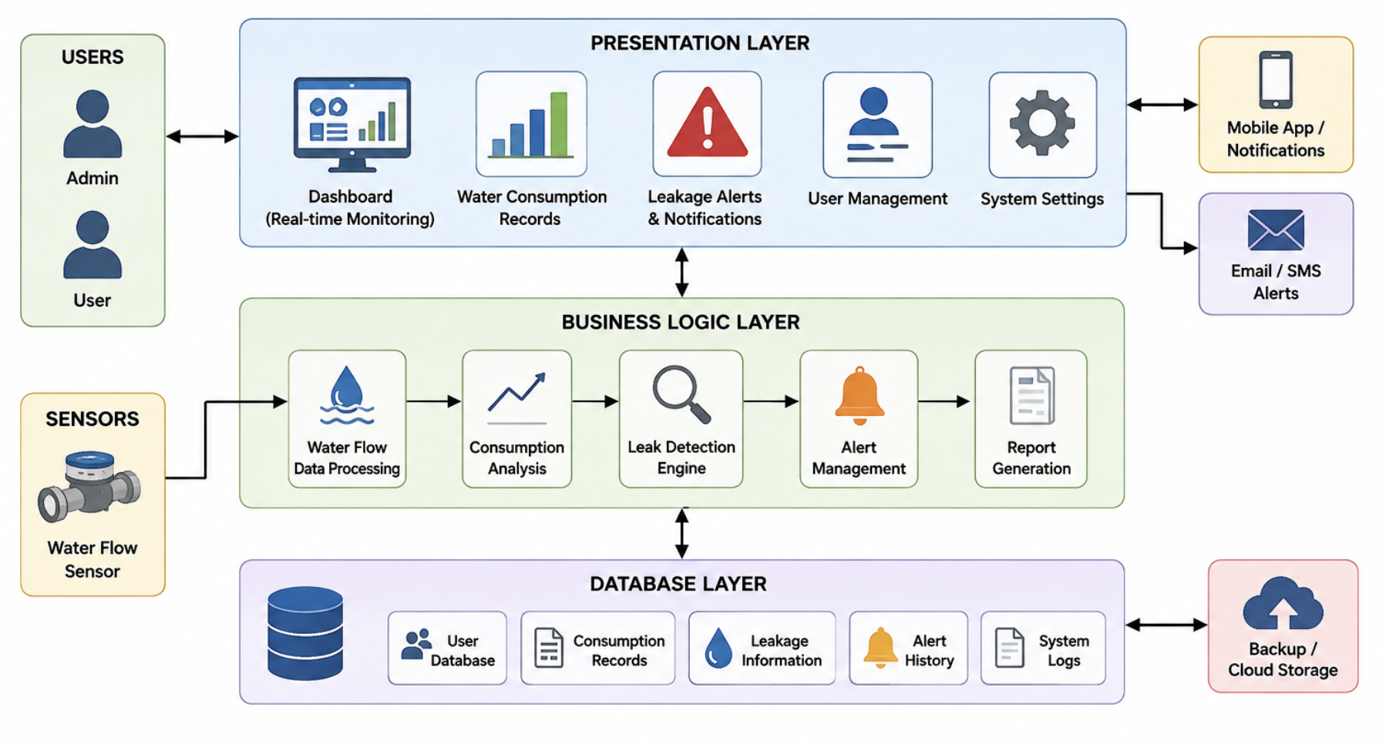
Figure 3.1 – System Architecture of the Smart Water Management System

3.6 USE CASE MODEL
The Use Case model identifies Admin, User and Water Flow Sensor as the principal external actors. Users and administrators authenticate and interact with dashboards and records. The sensor supplies flow data. Administrative use cases additionally include user management, settings and report generation.
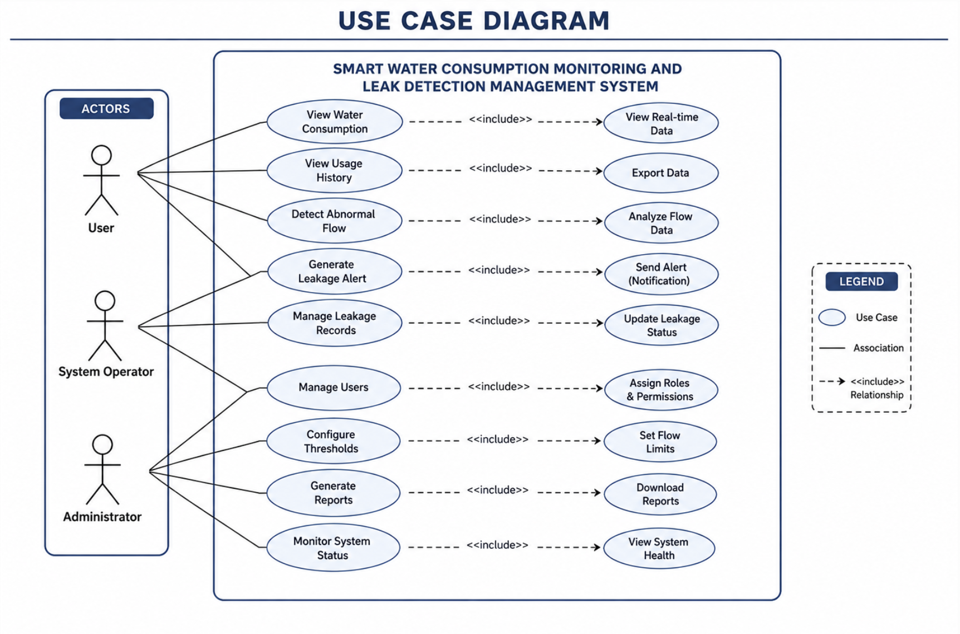
Figure 3.2 – Use Case Diagram
Key use cases include Login/Authenticate, View Dashboard, Monitor Water Consumption, View Consumption Records, Detect Abnormal Flow/Leakage, Receive/Manage Alerts, Generate Reports, Configure Thresholds & Settings, Manage Users and Send Flow Data.

3.7 CLASS MODEL
The class model represents the major objects responsible for data and behaviour. User is generalized by Admin for privileged operations. WaterFlowSensor produces readings that are represented by ConsumptionRecord. LeakDetectionEngine analyses records and can create Alert objects. NotificationService communicates alerts, while Report generates summaries from stored records. Database represents persistence responsibilities.
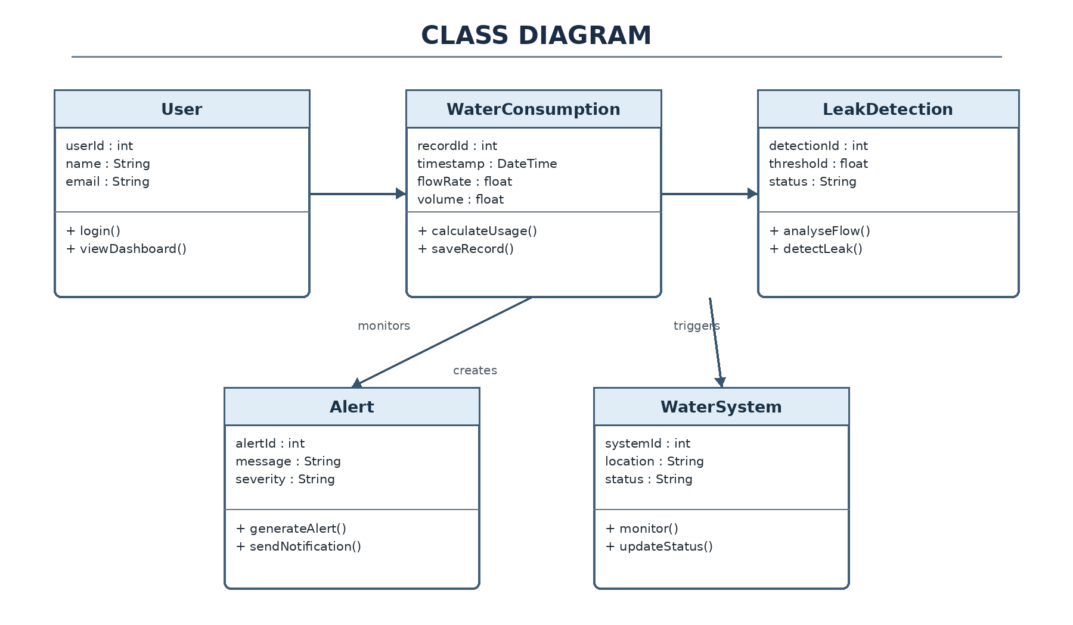
Figure 3.3 – Class Diagram
The proposed classes follow single-responsibility-oriented decomposition. This reduces coupling and makes it possible to test monitoring, detection, alerting and reporting services independently.

3.8 INTERACTION MODEL – SEQUENCE
A typical monitoring-and-alert interaction begins when the Water Flow Sensor supplies a reading. The Monitoring Service validates and stores the reading, then forwards it to the Leak Detection Engine. If the engine identifies an abnormal condition, an Alert is created, persisted and passed to the Notification Service. The user can simultaneously request dashboard information and retrieve historical records.
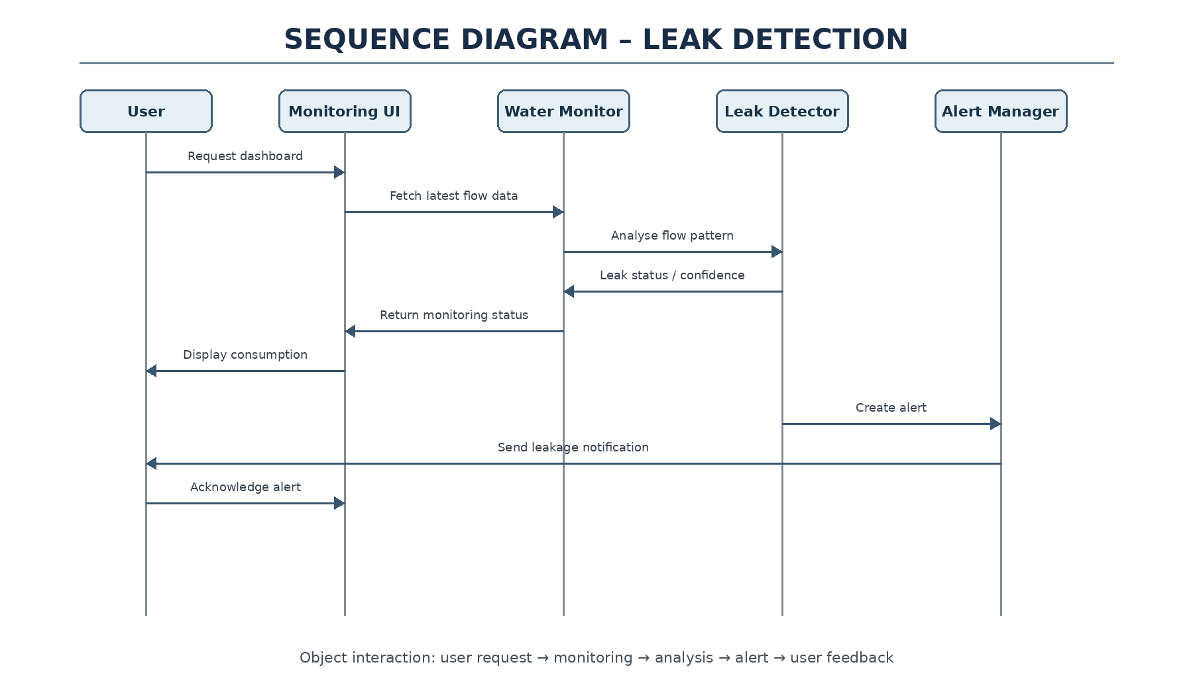
Figure 3.4 – Sequence Diagram for Monitoring and Leak Alert Generation
The sequence emphasizes that data persistence and alert creation are part of the business workflow rather than isolated user-interface functions.

3.9 ACTIVITY MODEL
The activity model describes the continuous monitoring process. Sensor data is read, stored and analysed. A decision point determines whether the flow behaviour is abnormal. If it is abnormal, an alert is generated and communicated; otherwise, the dashboard and records are updated. The process then returns to monitoring.
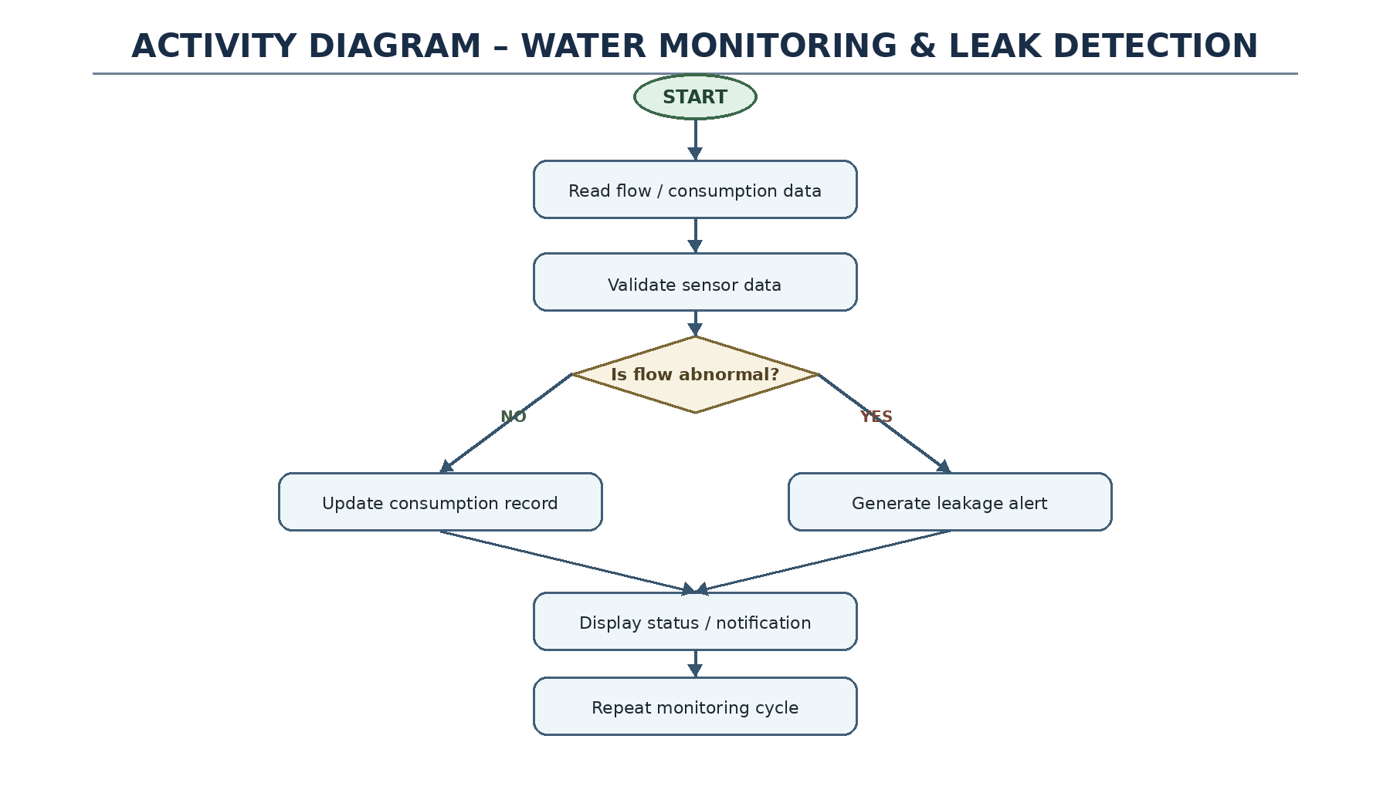
Figure 3.5 – Activity Diagram for Water Monitoring and Leak Detection
This model supports structured testing because each activity can be associated with an observable input, processing step and expected outcome.

3.10 COMPONENT AND DEPLOYMENT MODELS

3.10.1 Component Model
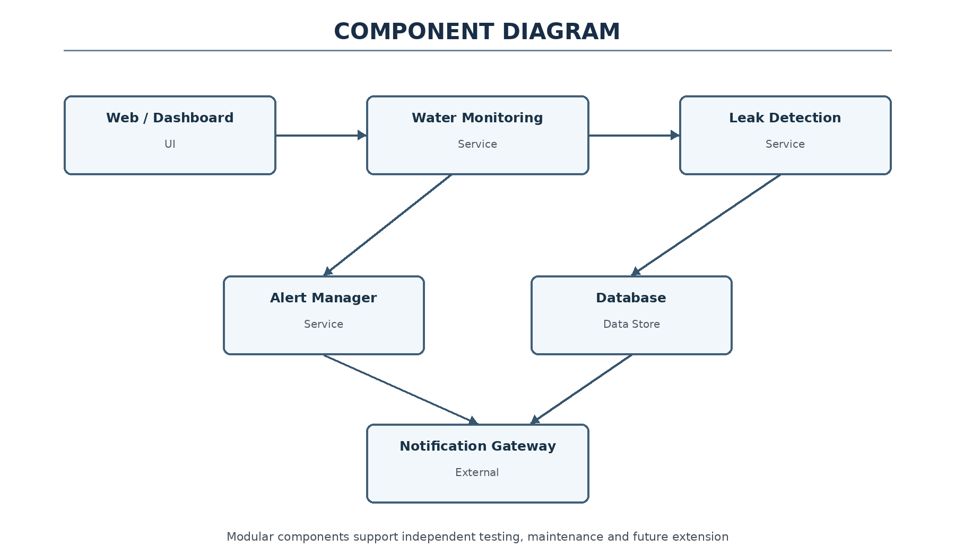
Figure 3.6 – Component Diagram

3.10.2 Deployment Model
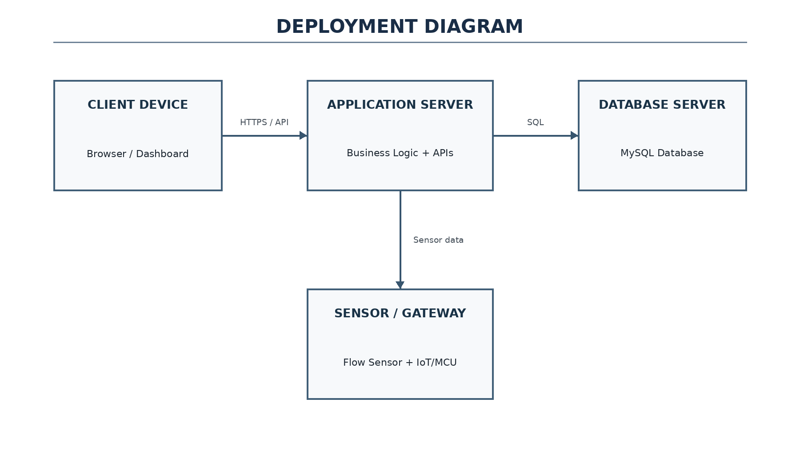
Figure 3.7 – Deployment Diagram
The component model separates monitoring, leak detection, alert management, reporting and persistence. The deployment model places the client interface, sensor gateway, application server, database and external notification services on appropriate logical nodes. The exact technology choices can be finalized during implementation.

3.11 DATABASE DESIGN
The project presentation specifies database storage for user information, water-consumption records, leakage details and alert data. The following logical model extends that description into an implementation-ready relational structure while keeping the scope of the proposed design.
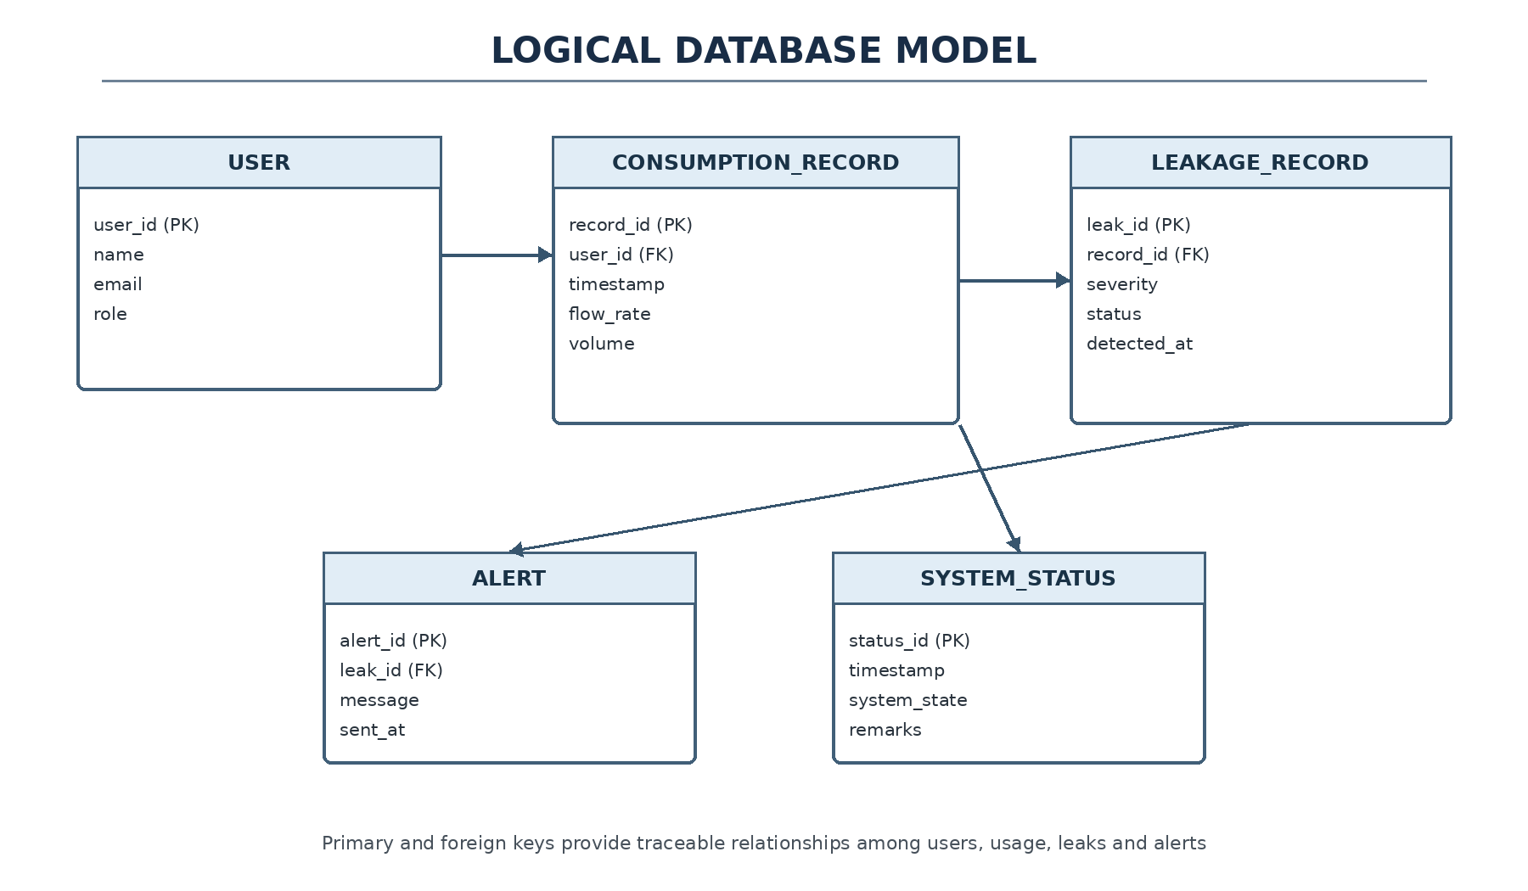
Figure 3.8 – Proposed Logical Database Model
Entity | Important Attributes | Purpose
User | user_id, name, email, role | Authentication and user management.
ConsumptionRecord | record_id, user_id, timestamp, flow_value, period_total | Stores water usage observations.
Leakage | leakage_id, record_id, severity, detected_at, status | Stores suspected/confirmed leakage events.
Alert | alert_id, leakage_id, channel, sent_at, status | Tracks alert delivery and state.
SystemLog | log_id, user_id, timestamp, action | Supports audit and troubleshooting.

3.12 DESIGN ALTERNATIVES AND TRADE-OFFS
Decision | Alternative | Benefit of Selected Design | Trade-Off
Architecture | Monolithic design | Layered design improves maintainability and separation of concerns. | More components to coordinate.
Monitoring | Manual/periodic entry | Automated flow readings improve timeliness. | Requires sensor integration.
Leak detection | Fixed manual inspection | Automated analysis can flag abnormal patterns earlier. | May produce false alerts.
Notifications | Dashboard only | Multiple channels improve responsiveness. | External services add dependency.
Storage | Single flat record | Relational entities improve traceability. | Database design is more involved.

3.13 SUSTAINABILITY, ETHICS, SAFETY, RISK & SECURITY
Domain | Consideration | Design Response
Sustainability | Reduce water wastage through earlier awareness. | Monitoring and alerts support conservation.
Ethics | Avoid misleading leakage claims. | Present suspected leakage as an alert requiring validation.
Safety | Incorrect sensor values may trigger unnecessary actions. | Validate readings and use controlled thresholds.
Security | User and consumption records are sensitive operational data. | Authentication, authorization and secure storage are required.
Reliability | Irregular flow may resemble leakage. | Use configurable logic and maintain alert history.

Project Risk Register
Risk | Probability | Impact | Mitigation
False leakage detection | Medium | Medium | Use thresholds/pattern rules and validation.
Missing/incorrect sensor data | Medium | High | Validate readings and record sensor status.
Database inconsistency | Low–Medium | High | Use transactions, constraints and backups.
Notification failure | Medium | Medium | Retain alert in the system and retry delivery.
Integration delay | Medium | Medium | Develop and test subsystems independently.

CHAPTER 4
IMPLEMENTATION, TESTING & RESULTS

4.1 DEVELOPMENT APPROACH AND RESOURCES
The implementation approach follows an incremental, modular sequence: requirement analysis, OOAD modelling, architecture design, database design, module development, integration, testing and documentation. The project presentation identifies StarUML/Umbrello, UML, HTML, CSS, JavaScript, MySQL and Git/GitHub as the proposed technology stack, with Java/Python/web technologies listed as possible implementation technologies.
Resource / Tool | Purpose | Stage
StarUML / Umbrello | UML modelling and visualization | Analysis & design
HTML, CSS, JavaScript | User interface implementation | Presentation layer
Java / Python / Web technologies | Application logic implementation options | Business logic
MySQL | Persistent storage of system records | Database
Git / GitHub | Version control and collaboration | Development
Flow sensor interface | Water-flow data source | Input

4.1.1 Module Decomposition
- Water Consumption Monitoring: collects readings, analyses usage and maintains consumption records.
- Leak Detection and Alert Management: identifies abnormal flow, creates alerts, manages notification state and maintains leakage history.
- Supporting services: authentication, user management, reporting, persistence and system logging.

4.2 IMPLEMENTATION FLOW
The implementation flow translates the OOAD design into a sequence of software operations:
1. Authenticate the user and load the appropriate dashboard permissions.
2. Receive a water-flow reading from the sensor interface.
3. Validate and normalize the incoming reading.
4. Create and store a consumption record.
5. Pass the relevant reading/history to the consumption-analysis and leak-detection services.
6. If abnormal flow is detected, create a leakage event and alert.
7. Persist alert state and send the configured notification.
8. Update dashboard, records and reports.
9. Record significant operations in the system log.
10. Repeat monitoring while the system is active.

4.2.1 Processing Logic
The core processing separates data acquisition from decision logic. This enables the sensor interface to be replaced or expanded without changing the leak-detection algorithm. Similarly, the alert service can support dashboard alerts, mobile notifications, email or SMS without changing the consumption-recording class.

4.3 TESTING AND VERIFICATION
Testing is derived from the project presentation and is organized around functional behaviour, use cases, object interactions, data flow and system-level performance. Since the supplied presentation contains design information rather than measured execution logs, the test plan below is an implementation verification plan rather than a claim of completed experimental results.
Test ID | Test Action | Expected Result | Verification Type
T01 | Submit a valid flow reading | Reading is accepted and stored | Functional / black-box
T02 | Submit repeated readings | Consumption record sequence is maintained | Functional
T03 | Trigger abnormal/continuous flow condition | Leak detection identifies a possible leak | Use-case
T04 | Generate a leakage event | Alert is created and logged | Functional
T05 | Open dashboard | Current status and records are displayed | UI / use-case
T06 | Retrieve historical records | Correct records are returned | Database / functional
T07 | Use invalid or missing sensor data | Input is rejected/handled without corrupting data | Error handling
T08 | Generate a report | Consumption/leakage summary is produced | Functional
T09 | Verify class interaction | Services exchange expected objects/data | White-box
T10 | Run repeated monitoring cycles | System remains stable during test interval | Performance / reliability

Acceptance Principles
- Each functional requirement should have at least one corresponding test.
- Sensor and user inputs should be validated before persistence or decision-making.
- Alert generation should be traceable to the underlying consumption record.
- The system should preserve records even when notification delivery fails.
- Results should be recorded using actual implementation evidence before final deployment claims are made.

4.4 RESULTS AND DISCUSSION
The project presentation states that the proposed system enables real-time monitoring of water consumption, helps identify abnormal usage and possible leakages, provides a modular architecture and supports centralized records and reports. These statements define the intended system outcomes. In this capstone report, they are treated as design objectives unless reproduced by an implemented prototype.

Area | Expected / Intended Result | Engineering Interpretation
Consumption monitoring | Water-flow readings are captured and represented as records. | Provides a continuous data basis for usage analysis.
Leak detection | Abnormal flow is identified as a possible leakage condition. | Transforms raw readings into actionable events.
Alert management | Leakage alerts are created, stored and communicated. | Reduces delay in responding to suspected leaks.
OOAD architecture | Responsibilities are separated into classes/layers. | Improves maintainability and extensibility.
Database | Users, consumption, leakage and alert data are retained. | Supports history, reporting and auditing.
Reporting | Organized summaries can be generated. | Supports decision-making and conservation analysis.

Engineering Discussion
A central design issue is false detection: normal irregular consumption may appear similar to leakage. Therefore, the leak-detection engine should not be treated as an infallible classifier. Thresholds, time windows, user context and historical behaviour can be used to reduce false alerts in a future implementation.
Another important issue is data quality. Missing or noisy sensor readings can directly affect both consumption totals and leakage decisions. Validation, logging and calibration therefore form part of the functional reliability of the software, not merely an implementation detail.

4.5 CHALLENGES AND LIMITATIONS
- Accurate monitoring depends on the reliability and calibration of water-flow data.
- Irregular normal usage can produce false leakage alerts.
- The system depends on timely sensor data and suitable communication between components.
- Database records must remain consistent as readings and alerts are created continuously.
- External notification services can fail or become unavailable.
- Advanced analytics and IoT integration increase software and deployment complexity.
- The supplied project presentation does not provide measured field-performance data; therefore numerical performance claims are intentionally avoided.

4.6 PROJECT MANAGEMENT
Phase | Major Activities | Deliverable
1. Requirement Analysis | Problem definition, objectives, scope | Requirement specification
2. Literature Review | Background and engineering gap | Review summary
3. OOAD Analysis | Actors, use cases, classes and interactions | Analysis models
4. System Design | Architecture, database and UML diagrams | Design package
5. Module Development | Monitoring and leak-management services | Software modules
6. Integration | Connect UI, business logic and database | Integrated system
7. Testing | Functional, use-case and reliability tests | Test records
8. Documentation | Results, limitations, conclusion and references | Final capstone report

Version / Change Management
Git/GitHub can be used to maintain design files, source code and documentation revisions. Each module can be developed in a separate branch or logical work package and integrated after review and testing.

CHAPTER 5
CONCLUSION, FUTURE WORK AND REFLECTION

5.1 CONCLUSION
The Smart Water Consumption Monitoring and Leak Detection Management System presents a structured OOAD solution for improving visibility of water usage and supporting timely leakage detection. The system is designed around the collection of water-flow information, consumption analysis, abnormal-flow detection, alert management, reporting and database storage.
The use of object-oriented analysis provides a clear mapping from stakeholder requirements to actors, use cases, classes and interactions. The layered architecture separates presentation, business logic and persistence responsibilities, which improves maintainability and provides a practical foundation for future implementation.
The project addresses a meaningful engineering problem: water wastage can be reduced when abnormal usage is detected earlier and presented to users in an understandable form. The design should be interpreted as a capstone software architecture and OOAD model; actual field performance must be established through implementation and measured testing.

5.2 FUTURE SCOPE
- Integrate IoT-enabled smart water-flow sensors for continuous data acquisition.
- Develop a mobile application for remote monitoring and instant leakage alerts.
- Add machine-learning models for consumption forecasting and improved leak-pattern detection.
- Integrate smart water meters for automated and higher-resolution data collection.
- Add advanced analytics and dashboards for daily, weekly and monthly usage trends.
- Support multiple buildings, zones and sensor groups through scalable deployment.
- Add automated notification escalation when an alert remains unresolved.
- Introduce stronger authentication, audit trails and secure API communication for production deployment.

5.3 PROFESSIONAL LEARNING & REFLECTION

Knowledge Acquired
- Application of Object-Oriented Analysis and Design to a practical monitoring problem.
- Use of UML to represent system behaviour, structure, interaction and deployment.
- Understanding of layered architecture and separation of responsibilities.
- Design of domain classes and relationships around real-world entities.
- Logical database modelling for operational and historical data.
- Importance of validation, error handling and traceability in monitoring systems.

Engineering & Professional Skills Developed
- Requirement analysis and problem decomposition.
- System architecture and UML modelling.
- Database and component-level design.
- Testing strategy and acceptance criteria definition.
- Risk identification and trade-off analysis.
- Technical documentation and presentation.

Individual Reflection – M. Poojith Ganesh
The main learning outcome was understanding how a real-world water-management problem can be decomposed into actors, use cases and domain objects. Developing the monitoring-oriented part of the design highlighted the importance of clean data models, traceability and user-focused presentation of consumption information.

Individual Reflection – K. Krishna Charan
The main learning outcome was understanding how abnormal-flow analysis can be connected to alert management without tightly coupling the system components. Designing the leak-detection, database and integration aspects emphasized modularity, error handling, security and the need to distinguish suspected leakage from confirmed physical leakage.

REFERENCES
[1] I. Sommerville, Software Engineering, Pearson Education.
[2] G. Booch, J. Rumbaugh, and I. Jacobson, The Unified Modeling Language User Guide, Addison-Wesley.
[3] C. Larman, Applying UML and Patterns: An Introduction to Object-Oriented Analysis and Design, Pearson Education.
[4] Object Management Group (OMG), Unified Modeling Language (UML) Specification.
[5] A. K. Sharma and R. K. Gupta, “Smart Water Management and Leakage Detection Using IoT,” International Journal of Engineering Research and Technology.
[6] Espressif Systems, ESP32 Documentation, for IoT-based monitoring and sensor integration.
[7] OOAD Project Presentation, “Smart Water Consumption Monitoring and Leak Detection Management System,” CSA1101 – Object Oriented Analysis and Design, supplied project material, 2026.
Note: The literature-review entries and project-specific system description are reproduced/structured from the supplied OOAD project presentation. The presentation itself lists the six principal UML diagram types and the proposed technology stack used as the basis for this report.

APPENDICES

Appendix A – UML Deliverables Summary
Artefact | Purpose | Primary Elements
Use Case Diagram | Capture user/system functionality | Admin, User, Sensor, monitoring, detection, alerts, reports
Class Diagram | Represent static object structure | User, Admin, Sensor, Record, Detection Engine, Alert, Notification, Report, Database
Sequence Diagram | Show object interactions over time | Sensor → Monitoring → Database → Detection → Alert → User
Activity Diagram | Represent process workflow | Read → Store → Analyse → Decision → Alert/Update → Repeat
Component Diagram | Show software modules | UI, monitoring, leak detection, alert, reporting, database
Deployment Diagram | Show runtime nodes | Client, sensor gateway, application server, database, notification service

Appendix B – Proposed Logical Data Fields
Entity | Field | Type / Meaning
User | user_id | Primary identifier
User | role | User / Admin authorization role
ConsumptionRecord | timestamp | Time of observation
ConsumptionRecord | flow_value | Measured flow value from sensor
ConsumptionRecord | period_total | Aggregated usage for a period
Leakage | severity | Classification of suspected event
Leakage | status | Open / resolved state
Alert | channel | Dashboard / push / email / SMS
Alert | status | Delivery / acknowledgement state
SystemLog | action | Recorded system operation

Appendix C – End-to-End Processing Logic
START → Authenticate User / Initialize Monitoring → Receive Flow Reading → Validate Reading → Store Consumption Record → Analyse Usage Pattern → Abnormal Flow? → YES: Create Leakage Event → Create Alert → Send Notification → Log Event → Update Dashboard → Continue Monitoring → NO: Update Dashboard / Records → Continue Monitoring.

Appendix D – Implementation Evidence to Add Before Final Submission

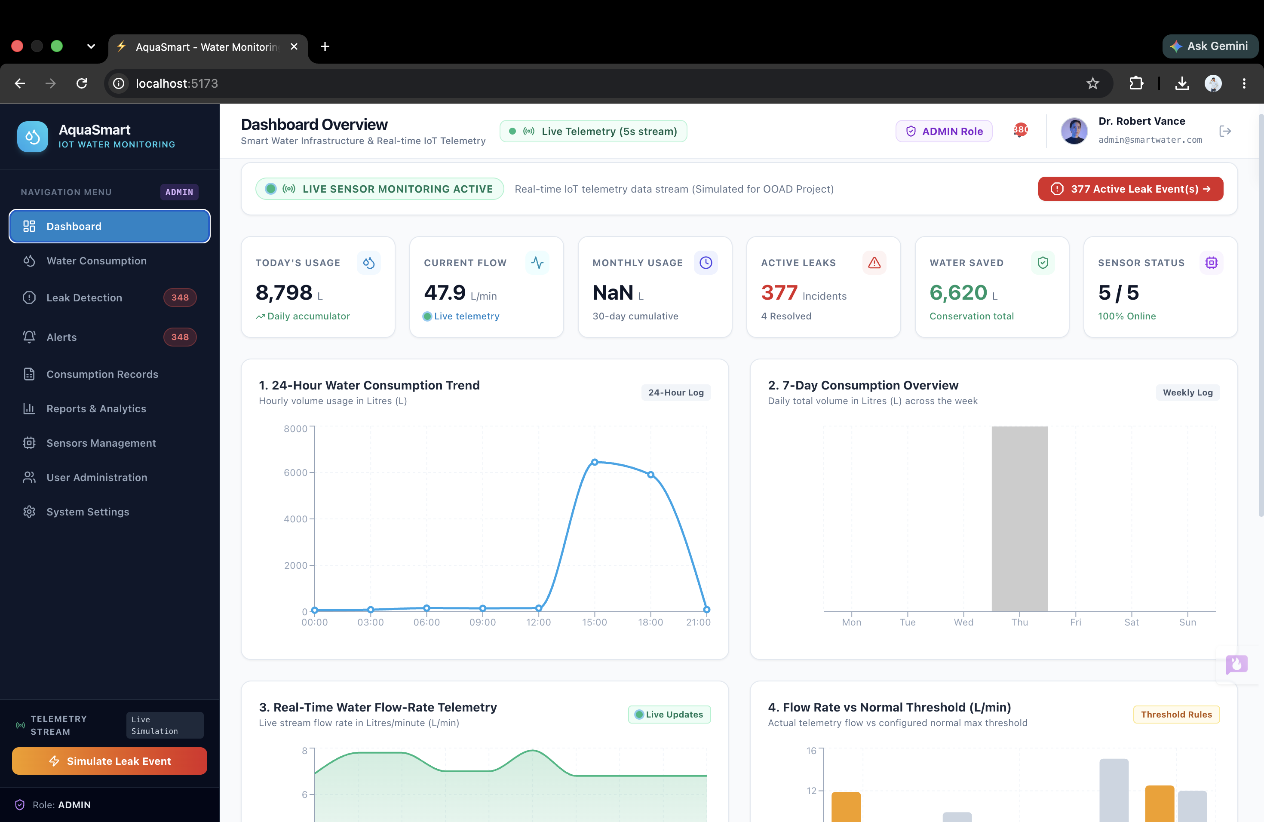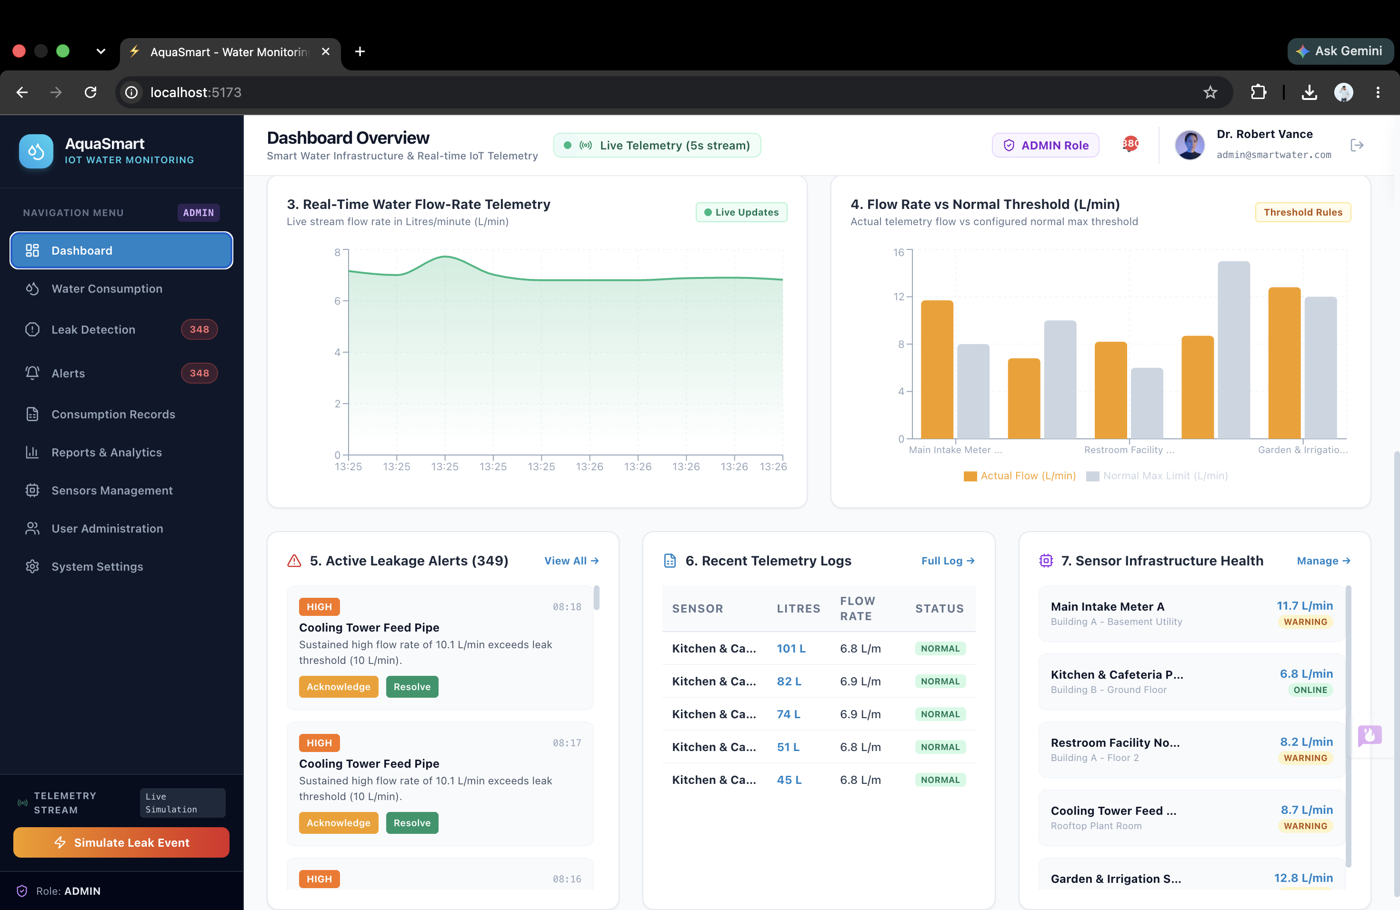
Dashboard

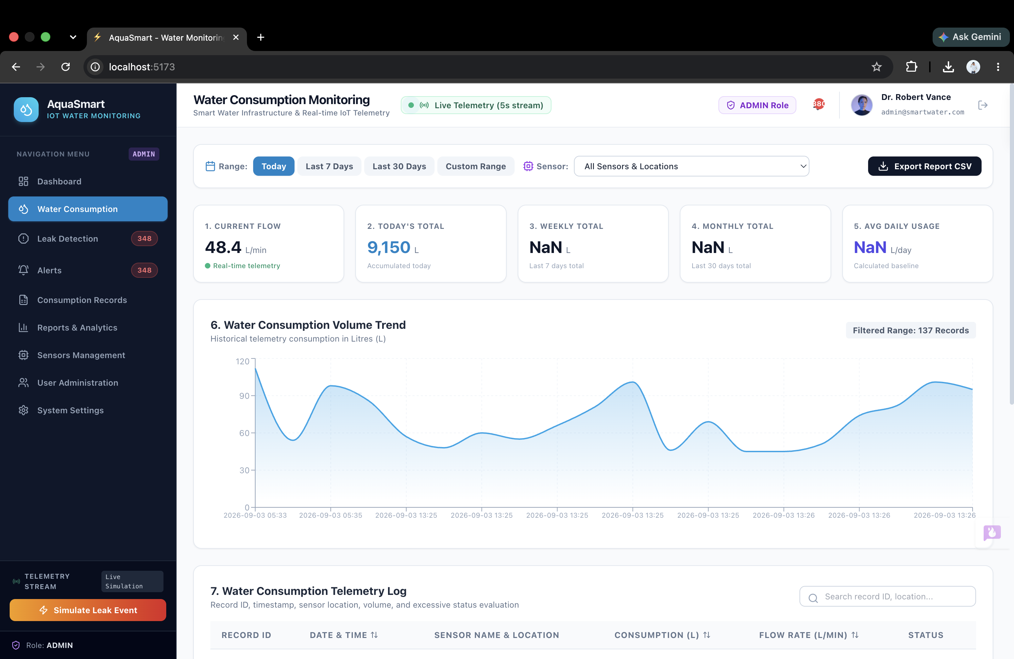
Water Consumption

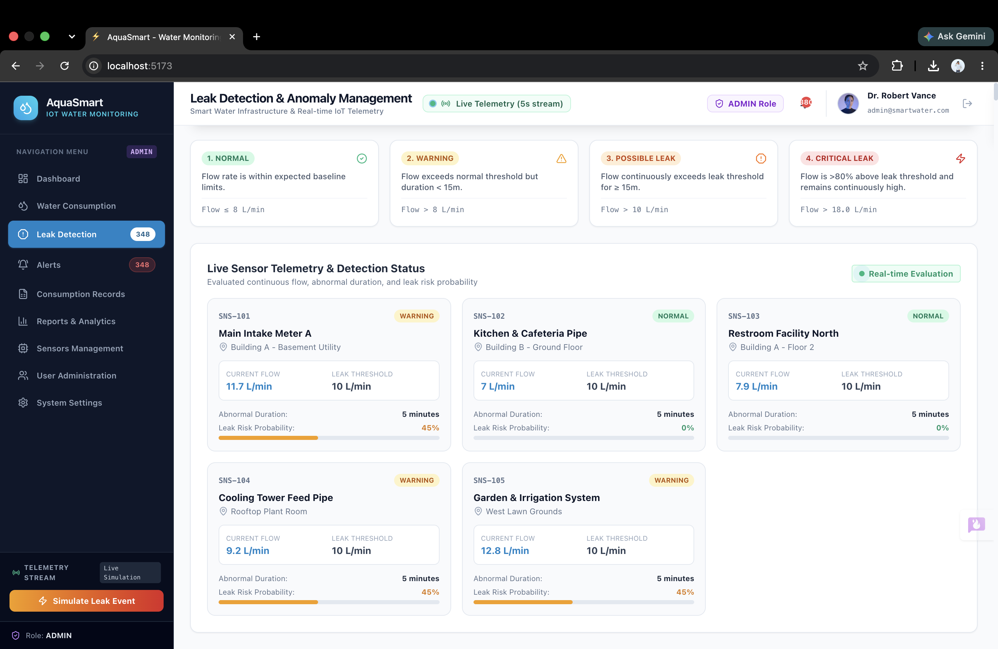
Leak Detection

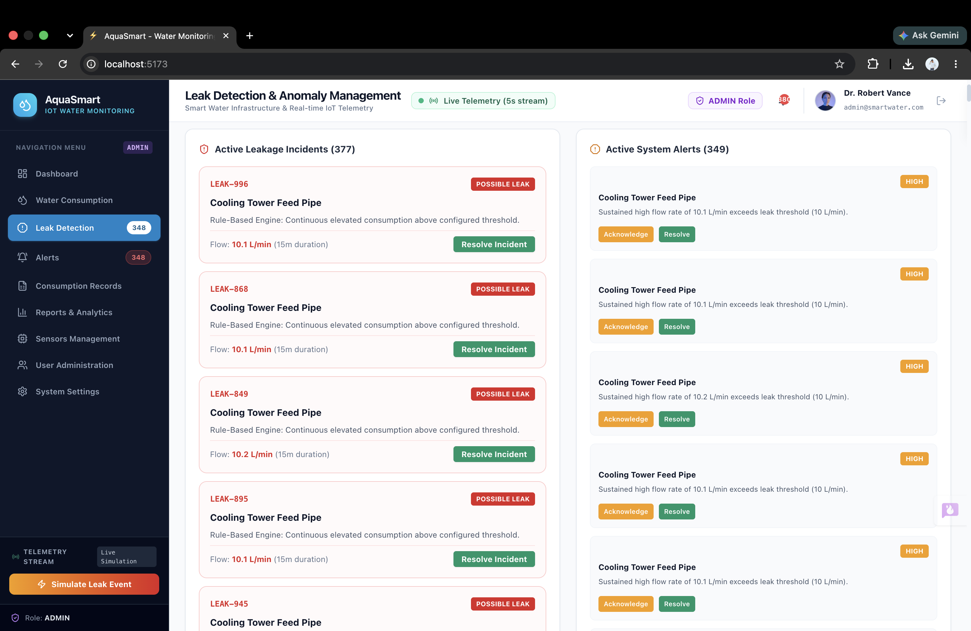
Active Leakage and System Alerts

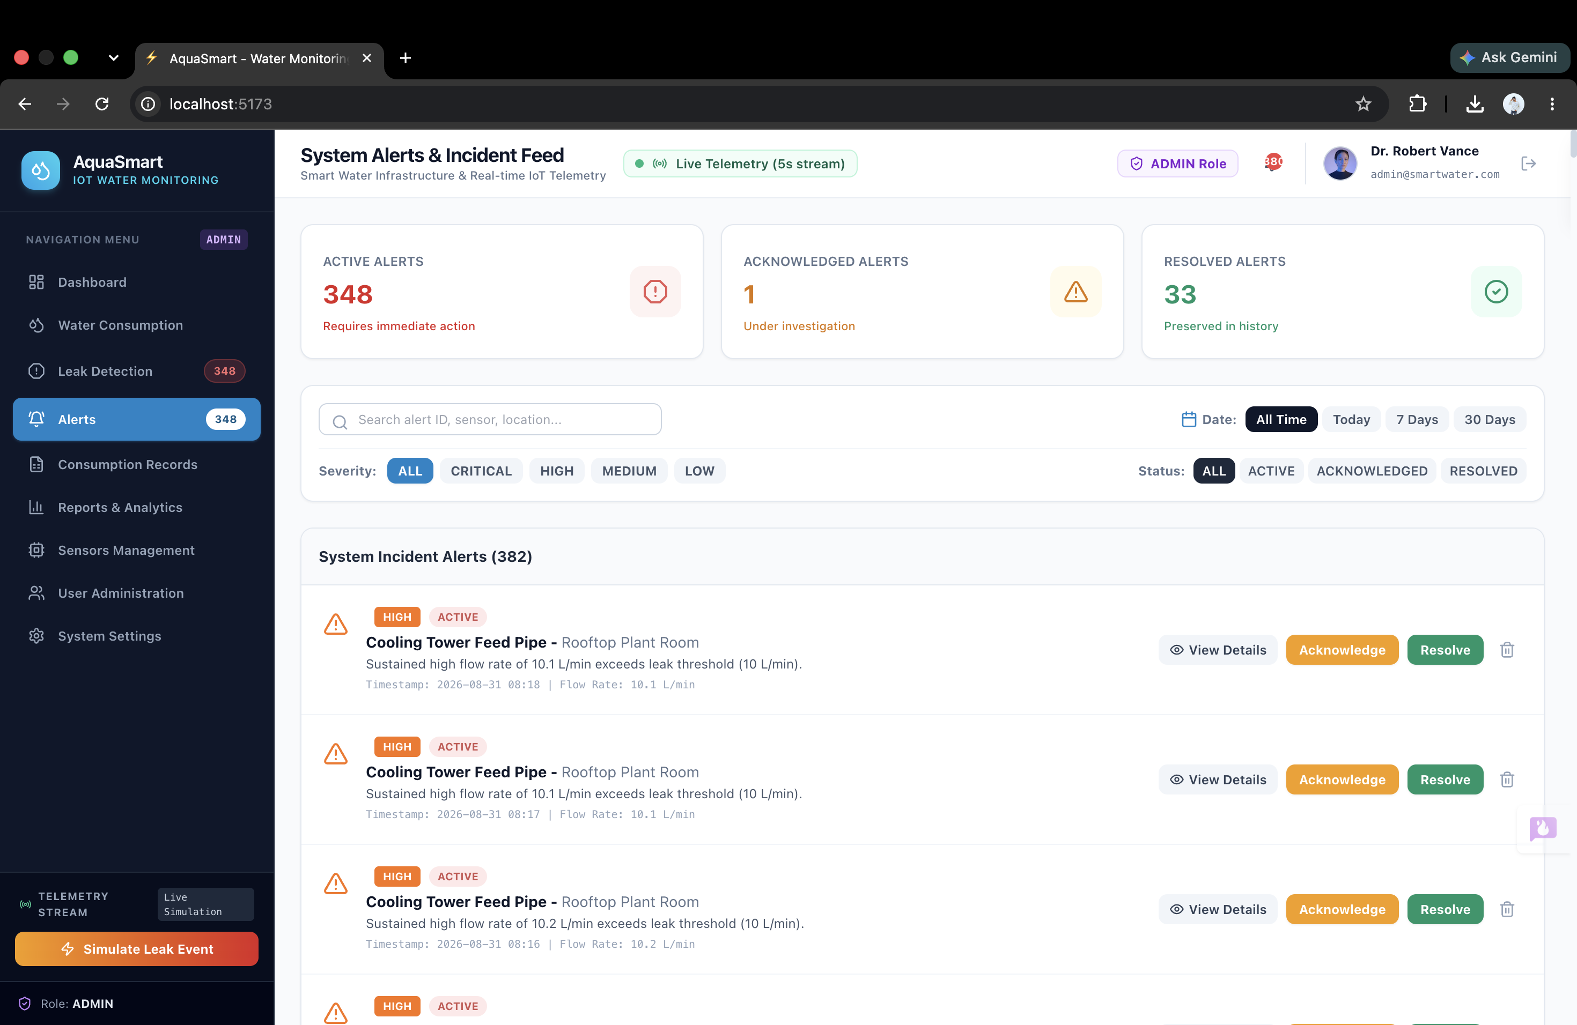

System Incident Alerts

