**1.CODE**

<!DOCTYPE html>

<html>

<head>

<title>Student Grade Calculator</title>

<style>

body {

font-family: Arial, sans-serif;

padding: 20px;

}

input {

margin: 5px 0;

}

#result {

margin-top: 15px;

font-weight: bold;

}

</style>

</head>

<body>

<h2>Enter Marks for 3 Subjects</h2>

<form id="marksForm">

Subject 1: <input type="number" id="subject1" min="0" max="100" required><br>

Subject 2: <input type="number" id="subject2" min="0" max="100" required><br>

Subject 3: <input type="number" id="subject3" min="0" max="100" required><br><br>

<button type="button" onclick="calculateResult()">Calculate</button>

</form>

<div id="result"></div>

<script>

function calculateResult() {

const s1 = parseFloat(document.getElementById("subject1").value);

const s2 = parseFloat(document.getElementById("subject2").value);

const s3 = parseFloat(document.getElementById("subject3").value);

if (isNaN(s1) || isNaN(s2) || isNaN(s3)) {

document.getElementById("result").innerText = "Please enter all marks.";

return;

}

const average = (s1 + s2 + s3) / 3

const grade = average >= 90 ? 'A' :

average >= 75 ? 'B' :

average >= 50 ? 'C' : 'F';

const failedAny = (s1 < 50 || s2 < 50 || s3 < 50);

document.getElementById("result").innerHTML = `

Average: ${average.toFixed(2)}<br>

Grade: ${grade}<br>

${failedAny ? "❌ Failed in one or more subjects." : "✅ Passed all subjects."}

`;

}

</script>

</body>

</html>

**OUTPUT:**

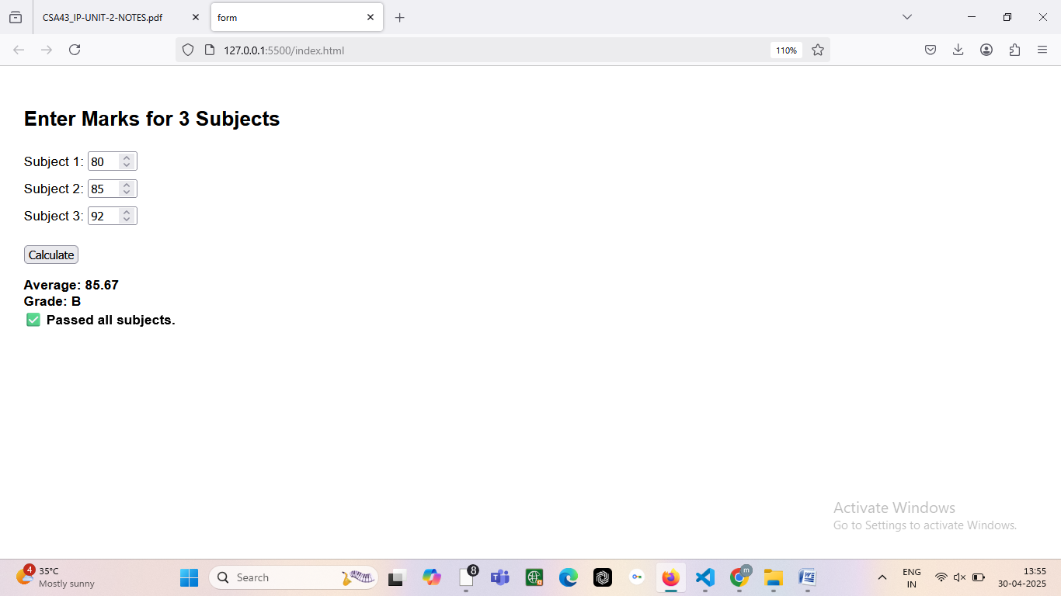

**2.CODE**

<!DOCTYPE html>

<html>

<head>

<title>Simple Calculator</title>

<style>

body {

font-family: Arial, sans-serif;

padding: 20px;

}

input {

margin: 5px;

width: 100px;

}

button {

margin: 5px;

padding: 5px 10px;

}

#result {

margin-top: 15px;

font-weight: bold;

}

</style>

</head>

<body>

<h2>Calculator</h2>

<input type="number" id="num1" placeholder="Number 1">

<input type="number" id="num2" placeholder="Number 2"><br>

<button onclick="calculate('+')">+</button>

<button onclick="calculate('-')">-</button>

<button onclick="calculate('*')">*</button>

<button onclick="calculate('/')">/</button>

<button onclick="calculate('%')">%</button>

<button onclick="calculate('**')">**</button>

<div id="result"></div>

<script>

function calculate(operator) {

const n1 = parseFloat(document.getElementById('num1').value);

const n2 = parseFloat(document.getElementById('num2').value);

let result;

if (isNaN(n1) || isNaN(n2)) {

document.getElementById('result').innerText = "Please enter valid numbers.";

return;

}

switch(operator) {

case '+':

result = n1 + n2;

break;

case '-':

result = n1 - n2;

break;

case '*':

result = n1 * n2;

break;

case '/':

result = n2 !== 0 ? n1 / n2 : "Cannot divide by zero";

break;

case '%':

result = n1 % n2;

break;

case '**':

result = n1 ** n2;

break;

default:

result = "Invalid operation";

}

document.getElementById('result').innerText = `Result: ${result}`;

}

</script>

</body>

</html>

**OUTPUT:**

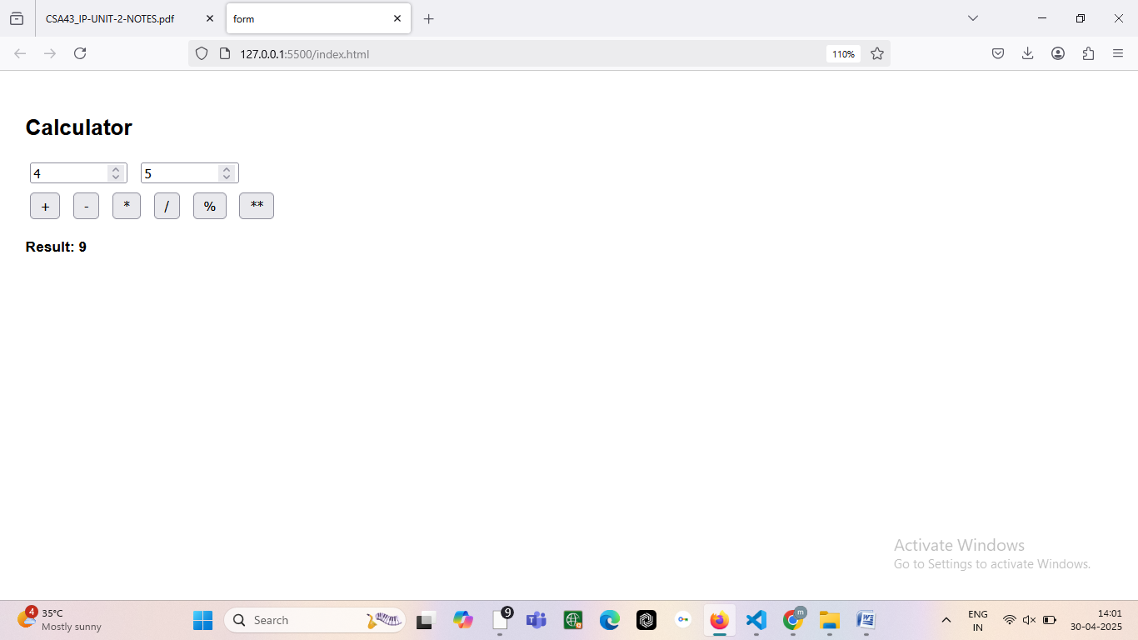

**3. CODE**

<!DOCTYPE html>

<html>

<head>

<title>Form to JSON</title>

<style>

body {

font-family: Arial, sans-serif;

padding: 20px;

}

input {

margin: 5px 0;

width: 250px;

padding: 5px;

}

button {

margin-top: 10px;

padding: 6px 12px;

}

#jsonOutput {

margin-top: 20px;

font-family: monospace;

white-space: pre-wrap;

background: #f4f4f4;

padding: 10px;

border-left: 4px solid #333;

}

</style>

</head>

<body>

<h2>User Info Form</h2>

<form id="userForm">

Name: <br>

<input type="text" id="name" required><br>

Email: <br>

<input type="email" id="email" required><br>

<button type="submit">Submit</button>

</form>

<div id="jsonOutput"></div>

<script>

document.getElementById('userForm').addEventListener('submit', function(event) {

event.preventDefault(); // Prevent page refresh

const name = document.getElementById('name').value.trim();

const email = document.getElementById('email').value.trim();

// Convert to JSON

const userData = {

name: name,

email: email

};

const jsonString = JSON.stringify(userData, null, 2); // pretty-print

// Display the result

document.getElementById('jsonOutput').innerText = jsonString;

});

</script>

</body>

</html>

**OUTPUT:**

