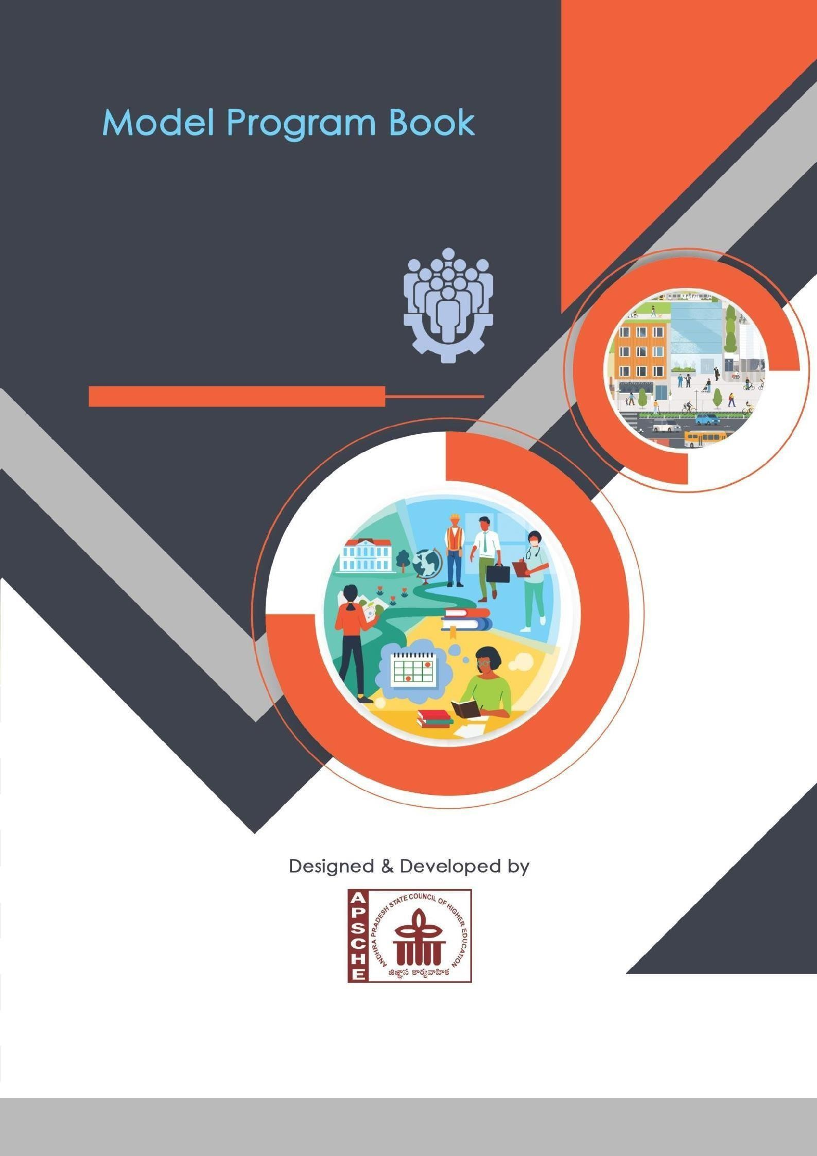

S.R.K.R ENGINEERING COLLEGE (AUTONOMOUS)
(Approved by AICTE, New Delhi, Affiliated to JNTUK, Kakinada) Accredited by NAAC with ‘A+’ Grade
Recognized as Scientific and Industrial Research Organization
SRKR MARG, CHINA AMIRAM, BHIMAVARAM-534204, W.G.Dt., A.P., INDIA

COMMUNITY SERVICE INTERNSHIP
B.TECH (R23-Regulation)

ANDHRAPRADESH
STATE COUNCIL OF HIGHER EDUCATION
(A STATUTORY BODY OF GOVERNMENT OF ANDHRAPRADESH)

PROGRAM BOOK FOR
COMMUNITY SERVICE INTERNSHIP

NAME OF THE STUDENTS : B. SRILAKSHMI , B. VENKATESH , B. LIKHITHA ,
B. SANDEEP, B. CHARAN SAI , B. JASMINE ,
B. KAVYANJALI , B. KARTHEEK , B. CHANDU ,
B. ESWAR SAI , B. MOHANA PREETHI

NAME OF THE COLLEGE : S.R.K.R.ENGINEERING COLLEGE (A)
BHIMAVARAM

REGISTRATION NO. : 23B91A6111, 23B91A6112, 23B91A6113,
23B91A6114, 23B91A6115, 23B91A6116,
23B91A6117, 23B91A6118, 23B91A6119,
23B91A6120, 23B91A6121

PERIOD OF CSP : FROM : 28-05-2025 TO : 29-07-2025

NAME & ADDRESS OF THE COMMUNITY/HABITATION: VEMPADU, BHIMAVARAM

JAWAHARLAL NEHRU TECHNOLOGICAL UNIVERSITY, KAKINADA
YEAR: 2025-2026
Community Service Internship Report
Submitted in accordance with the requirement for the degree of Bachelor of Technology (B.Tech) in Artificial Intelligence and Machine Learning

Name of the College : S.R.K.R ENGINEERING COLLEGE
Department : Computer Science and Engineering
Name of the Faculty Guide : Dr.B.N.V.Narasimha Raju
Duration of the CSP : FROM: 28 - 05 – 2025 TO: 29 -07-2025
Name of the Student : B. Sri Lakshmi, B. Venkatesh, B. Likhitha,
B. Sandeep, B. Charan Sai, B. Jasmine,
B. Kavyanjali, B. Kartheek, B. Chandu,
B. Eswar, B. Mohana Preethi
Programme of Study : B.Tech- Artificial Intelligence and Machine Learning Year of Study : 3rd Year 1st Sem
Register Number : 23B91A6111, 23B91A6112, 23B91A6113,
23B91A6114, 23B91A6115, 23B91A6116,
23B91A6117, 23B91A6118, 23B91A6119,
23B91A6120, 23B91A6121
Date of Submission :
STUDENT’S DECLARATION

We, B. Sri Lakshmi (23B91A6111), B. Venkatesh (23B91A6112), B. Likhitha (23B91A6113), B. Sandeep (23B91A6114), B. Charan Sai (23B91A6115), B. Jasmine (23B91A6116), B. Kavyanjali (23B91A6117), B. Kartheek (23B91A6118), B. Chandu (23B91A6119), B. Eswar Sai (23B91A6120) and B. Mohana Preethi (23B91A6121), students of B.Tech – Artificial Intelligence and Machine Learning (AIML), of the Department of Computer Science and Engineering, SRKR Engineering College, Bhimavaram, do hereby declare that we have successfully completed the mandatory Community Service Project (CSP) from 28-05-2025 to 29-07- 2025 in Chinna Amariam community under the faculty guidance of Dr. B.N.V. Narasimha Raju, Department of Computer Science and Engineering, SRKR Engineering College, Bhimavaram.

B. Sri Lakshmi | 23B91A6111
B. Venkatesh | 23B91A6112
B. Likhitha | 23B91A6113
B. Sandeep  B. Charan Sai  B. Jasmine  B. Kavyanjali  B. Kartheek  B. Chandu  B. Eswar  B. Mohana Preethi | 23B91A6114  23B91A6115  23B91A6116  23B91A6117  23B91A6118  23B91A6119  23B91A6120  23B91A6121

Endorsements

Faculty Guide Head of the Department
Dr. B. N. V. Narasimha Raju Dr. Bh V S R Krishnam Raju
Assistant Professor Professor

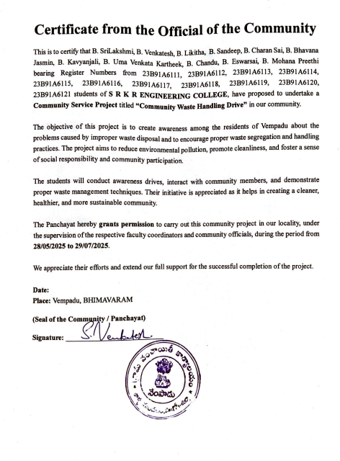

ACKNOWLEDGEMENT

We would like to express my heartfelt gratitude to everyone who supported and guided me during the successful completion of my Community Service Project titled “Community Waste Handling Drive in Vempadu”.

We are deeply thankful to the management and faculty of SAGI RAMAKRISHNAM RAJU ENGINEERING COLLEGE for providing us with the opportunity to undertake this socially impactful initiative as part of the Community Service Project. We are especially grateful to our faculty mentor, Dr. B. N. V. NARASIMHA RAJU, for his continuous encouragement, valuable suggestions, and timely guidance throughout the project.

Our sincere thanks to the local community, especially the Vempadu Panchayat officials, Sarpanch, and all the residents, for their warm cooperation, valuable insights, and active participation during our waste management and plastic awareness campaign. Their support played a vital role in helping us understand the waste disposal practices and environmental challenges faced by the community and in organizing effective awareness sessions on proper segregation and reduction of plastic waste.

Lastly, we extend our appreciation to all our teammates, including Vempadu, for their dedication, collaboration, and strong team spirit, which were crucial to the successful implementation of this project.

This experience has been truly enriching and has instilled in us a strong sense of social responsibility, empathy, and civic awareness, motivating us to contribute more actively toward community development in the future.

B. Sri Lakshmi | 23B91A6111
B. Venkatesh | 23B91A6112
B. Likhitha | 23B91A6113
B. Sandeep  B. Charan Sai  B. Jasmine  B. Kavyanjali  B. Kartheek  B. Chandu  B. Eswar  B. Preethi | 23B91A6114  23B91A6115  23B91A6116  23B91A6117  23B91A6118  23B91A6119  23B91A6120  23B91A6121

Contents

S.No | Chapter | Page.No
1. | Executive Summary | 1
2. | Overview of the Community | 2
3. | Community Service Activities | 3
4. | Weekly Activity Logs | 4 - 19
5. | Weekly Reports | 4 - 19
6. | Outcomes Description | 20 - 34
7. | Recommendations & Conclusions | 35 - 36
8. | Student Self Evaluation | 38 - 47
9. | Evaluation by Community Official | 48 - 58
10. | Photos & Links | 59 - 61

CHAPTER 1: EXECUTIVE SUMMARY

This Community Service Project took place in Vempadu, Bhimavaram, a semi-urban area with a lively community surrounded by developing surroundings. Through our visits and interactions, we gained a good understanding of how residents manage waste, their awareness of environmental issues, and their sanitation practices. As part of the project, we conducted a survey to find out how the community views waste management and plastic use. The survey revealed that improper waste segregation and high plastic use are significant issues that need urgent attention.

Based on these findings, we organized three awareness sessions focusing on waste segregation, reducing plastic use, recycling, and maintaining a clean environment. The program encouraged residents to avoid single-use plastic, separate biodegradable and non-biodegradable waste, and use eco-friendly options in their daily lives. Throughout the project, the involvement of the local community helped us create a positive and lasting impact on waste management and environmental awareness.

This experience gave us valuable insights into environmental and community needs and improved our communication, teamwork, and organizational skills. We learned how even small efforts to raise awareness can significantly promote sustainability. Our main learning objectives included understanding community waste practices, recognizing environmental issues, enhancing public engagement skills, developing leadership and responsibility, and working together for cleaner surroundings. Overall, the project deepened our sense of environmental awareness, social responsibility, and empathy towards community welfare. It enriched our understanding and contributed to our personal and social growth.

CHAPTER 2: OVERVIEW OF THE COMMUNITY

The Community Service Project took place in Vempadu, a developing semi-urban area in Bhimavaram, West Godavari District, Andhra Pradesh. This area has gradually changed from a traditional village into a modern residential zone because of educational institutions, business growth, and nearby urban centers. Vempadu shows a mix of traditional village values and modern influences, where people celebrate festivals like Sankranti, Ugadi, and Deepavali with unity and enthusiasm. The community is known for its cooperative spirit, respect for elders, and active involvement in development programs. Residents prioritize cleanliness, environmental awareness, and social responsibility, which fits well with our waste management and plastic awareness initiative supported by local groups and leaders.

From a socio-economic viewpoint, Vempadu consists of families working in education, small businesses, agriculture, private sector jobs, and self-employment. With access to schools, colleges, hospitals, and transportation, the standard of living is slowly improving. However, like many developing communities, issues such as waste disposal, plastic management, and sanitation awareness still exist. Most households have basic waste collection systems, but there is limited understanding of segregation and recycling practices. The youth are eager to engage in environmental activities and community welfare, providing a strong foundation for sustainable initiatives. Overall, Vempadu represents a motivated and evolving community with a positive outlook on environmental improvement and responsible waste management.

CHAPTER 3 : COMMUNITY SERVICE ACTIVITES

During the Community Service Project in Vempadu, Bhimavaram, we carried out several activities aimed at understanding the community’s waste management practices and promoting environmental awareness. The project started with field visits. We interacted with local residents to learn about their waste disposal habits, sanitation conditions, and awareness of plastic usage. We conducted a door-to-door survey to gather information on the community’s waste segregation, recycling, and cleanliness practices. The survey highlighted improper waste management, plastic pollution, and a lack of awareness about segregation as key areas needing attention and improvement.

Based on the survey results, we organized three awareness sessions focused on waste segregation, plastic reduction, and community cleanliness. The sessions discussed important topics like proper disposal of household waste, reducing single-use plastics, recycling methods, and the importance of maintaining a clean environment. We also encouraged residents to separate biodegradable and non-biodegradable waste, use eco-friendly alternatives, and actively participate in keeping their surroundings clean. These sessions effectively raised awareness and motivated the community to adopt sustainable waste management practices.

Throughout the project, we improved our communication, teamwork, planning, and problem-solving skills by engaging directly with the community on waste management and environmental awareness. Interacting with residents helped us develop confidence, patience, and empathy. We learned to listen to their challenges, respect diverse viewpoints, and share information effectively. This experience strengthened our sense of social and environmental responsibility, leadership, and community participation. Overall, the project created a positive impact among the residents and fostered our growth and values of cooperation, respect, accountability, and service toward a cleaner and greener society.

CHAPTER 4 : WEEKLY ACTIVITY LOGS AND REPORTS

ACTIVITY LOG FOR THE FIRST WEEK

Day & Date |  | Brief description of the daily activity |  | Learning Outcome |  | Person In-  Charge Signature
Day-1 |  |  | Conducted door-to-door survey on health and sanitation issues |  | Covered 60 households
Day-2 |  | Identified mosquito breeding points and open waste areas |  | Noted 5 critical zones
Day | 3 |  | Collected resident feedback on  waste collection and drainage |  | Noted recurring drainage problems
Day | 4 |  | Documented findings and photographed problem areas |  | Created initial  Field data report
Day | 5 |  | Compiled survey responses  and prepared data  summary |  | Structured data  for analysis
Day-6 |  | Met local volunteers for awareness planning |  | Community showed interest in participation

WEEKLY REPORT
WEEK1 (From 28-05-2025 to 03-06-2025)

Objective of the Activity Done: To identify major community health and
infrastructure problems such as mosquitoes, waste management, and poor drainage.
Detailed Report:
During the first week, students conducted a door-to-door socio-

economic and health survey covering around 60 households in the selected area.
Residents reported several issues including stagnant water, open garbage disposal, and
frequent mosquito infestation leading to health concerns such as fever and skin allergies.
The survey also revealed that drainage systems were either blocked or broken, causing
overflow during rain. Poor sanitation and lack of awareness about waste segregation were
common across households.
Students documented the findings with photographs, location mapping, and survey forms.
The team also interacted with local officials to understand existing waste management systems
and gaps in implementation.
It was observed that the absence of proper garbage bins and irregular waste collection
schedules aggravated the hygiene problems. The community also highlighted the presence
of stray dogs near garbage sites, adding to safety and cleanliness concerns.
The collected data was organized into preliminary reports for further analysis. This week
served as a foundation for identifying key problem zones, prioritizing action
areas, and preparing awareness materials and future action plans to be executed in the
subsequent weeks.

ACTIVITY LOG FOR THE SECOND WEEK

Day & Date |  | Brief description of the daily activity | Learning Outcome | Person In-  Charge Signature
Day | 1 | Analyzed collected survey data and identified key issues | Organized issues into main categories
Day - 2 |  | Prepared summary charts and maps of problem areas | Visual representation created Noted 5 critical zones
Day | 3 | Conducted interactive  sessions with residents | Good participation from families
Day | 4 | Distributed awareness pamphlets on sanitation | Encouraged waste  segregation
Day | 5 |  | Displayed simple  home- based  methods
  Demonstrated mosquito
  Prevention techniques
Day - 6 |  | Organized poster and slogan competition for youth | Active involvement from students

WEEKLY REPORT
WEEK2 (From 04-06-2025 to 10-06-2025)

Objective of the Activity Done: To conduct a cleanliness drive and educate residents
about preventing mosquito breeding.
Detailed Report:
In the second week, the team focused on data analysis and community
interaction. The collected responses were categorized under major
issues—mosquito breeding, stray dogs, damaged roads, and poor drainage. Students
prepared charts and summary sheets to visualize the frequency and intensity of problems.
They conducted interactive sessions with community members,
explaining the impact of poor waste disposal and stagnant water on health.
An initial awareness campaign was organized at the community center to promote
cleanliness and preventive health measures. the team prepared presentation materials
to brief local officials about the findings. A few volunteers demonstrated simple home-
based mosquito prevention measures, such as using covered water containers and
natural repellents.
Children and youth were encouraged to participate in maintaining clean surroundings
through “Clean Street Challenges” and slogan-writing competitions. The feedback from
residents was positive, and many expressed their willingness to contribute
actively.

ACTIVITY LOG FOR THE THIRD WEEK

Day & Date |  | Brief description of the daily  activity | Learning Outcome | Person In- Charge Signature
Day | 1 | Met local government officials to present survey findings | Shared charts and evidence reports.
Day-2 |  | Discussed sanitation and  drainage problems with  municipal officers | Officials agreed  For field inspection
Day | 3 | Participated in joint site visits  with sanitation department | Inspected 2  major drainage  zones
Day | 4 |  | Awaiting official  response
  Submitted written requests for
  waste collection improvements
Day | 5 | Held review session to  document official feedback | Recorded comments for next actions
Day-6 |  | Prepared meeting summary  and shared with community | Residents appreciated initiative

WEEKLY REPORT
WEEK3 (From 11-06-2025 to 17-06-2025)

Objective of the Activity Done: To identify and report unsafe road conditions and
create awareness about road safety.
Detailed Report:
In the third week, the team focused on discussing the identified
problems with government officials and local authorities. The students presented

detailed survey findings, including charts, maps, and photographic evidence, to help
officials understand the community’s pressing issues.
Meetings were conducted with representatives from the municipality, health
department, and sanitation board to seek support for drainage cleaning and mosquito
control. The officials appreciated the students’ initiative and agreed to conduct joint
inspections in the affected zones.
The team highlighted the need for timely waste collection and regular fogging in stagnant
water areas. Officials assured that temporary measures would be taken while long-term
plans were being prepared.
Students also documented official feedback and prepared follow-up reports for the next
phase. This week strengthened the link between the community and government,
promoting collaborative problem-solving.
The week concluded with officials visiting two high-risk streets, inspecting blocked
drains, and promising quick action. Students also learned how administrative
coordination works in practical field conditions.

ACTIVITY LOG FOR THE FORTH WEEK

Day & Date |  | Brief description of the  daily activity | Learning Outcome | Person In- Charge Signature
Day | 1 | Conducted follow-up visits  with municipal staff | ObservedCleaning activities
Day - 2 |  | Monitored garbage removal  And drainage work | Visible progress in 2 streets
Day | 3 | Submitted formal  representation for road  maintenance | Requested permanent repairs
Day | 4 | Documented progress and took photos of cleaned areas | Evidence added to  report
Day | 5 | Met with ward officer for status update | Received assurance on long-term action
Day-6 |  | Updated progress tracking  sheet | Data verified and stored

WEEKLY REPORT
WEEK4 (From 18-06-2025 to 24-06-2025)

Objective of the Activity Done: To create awareness on stray dog management and
humane animal control.
Detailed Report:
In the fourth week, the focus remained on follow-up meetings with
local authorities and further coordination for implementing basic improvements. The
team worked closely with the municipal staff to monitor cleaning and waste removal
activities.
Government officers conducted inspections in several streets based on the students survey
data, identifying key drainage blocks and garbage accumulation points.
The team also submitted written representations requesting better road maintenance and
drainage systems.
Through these interactions, students gained practical exposure to administrative processes
and policy communication.
By the end of the week, some areas witnessed visible improvements such as cleaned
drains and removed garbage piles, showing the impact of active community- government
collaboration.
Additionally, students noted that consistent communication with officials led to faster
response times. They also initiated a progress tracking sheet to record improvements over
the coming weeks.

ACTIVITY LOG FOR THE FIFTH WEEK

Day & Date |  | Brief description of the  daily activity | Learning Outcome | Person In- Charge Signature
Day | 1 | Conducted health  awareness campaign in the  village | Covered 40 households
Day-2 |  | Organized street plays on  cleanliness and hygiene | Students performed at local center
Day | 3 | Invited health officials for  interactive session | Discussed prevent common diseases
Day | 4 | Conducted free medical check-up and awareness rally | 70+participants attended
Day | 5 | Distributed pamphlets on waste disposal , hygiene | Residents appreciated initiative
Day-6 |  | Collected feedback from participants | Majority found  It helpful

WEEKLY REPORT
WEEK5 (From 25-06-2025 to 01-07-2025)

Objective of the Activity Done: To evaluate improvements and follow up on
previously identified issues through surveys and observations.
Detailed Report:
In the fifth week, students conducted an awareness program on
community health and hygiene. The main goal was to educate residents about
preventive health practices related to mosquito-borne diseases, water contamination,
and waste handling.
The team organized street plays, poster presentations, and group discussions with
local families. They emphasized the importance of boiling water before use, using
mosquito nets, and keeping surroundings clean.
Health department officials were invited to explain the significance of vaccination
and cleanliness in preventing diseases like dengue and malaria.
Free medical check-ups and basic health screenings were also arranged for residents.
Overall, this week enhanced public knowledge on health safety and encouraged a more
hygienic lifestyle among the villagers.
Participants shared positive feedback, and many families pledged to keep their
surroundings clean. The success of the campaign motivated the team to plan a similar
drive for school students next week.

ACTIVITY LOG FOR THE SIXTH WEEK

Day & Date |  | Brief description of the daily activity | Learning Outcome | Person In- Charge Signature
Day | 1 | Conducted awareness session on public infrastructure maintenance | Explained  importance of  clean roads
Day-2 |  | Observation of mosquito  fogging and larvicide  treatment | Noted effective  mosquito control  zones
Day | 3 | Visited areas with poor  Drainage and lighting | Displayed in public  gathering points
Day | 4 |  | Students actively  participated
  Held workshop for school
  students on civic responsibility
Day | 5 | Encouraged residents to  report infrastructure issues | Shared official  Complaint  methods
Day-6 |  | Documented improvements  in repaired zones | Captured photos  and updates

WEEKLY REPORT
WEEK 6 (From 02-07-2025 to 02-09-2025)

Objective of the Activity Done: To collaborate with local health officials and gather
insights on long-term mosquito control and sanitation programs.
Detailed Report:
In the sixth week, the focus shifted toward public infrastructure
awareness. Students conducted field visits and interactive discussions highlighting the
importance of well-maintained roads, proper drainage, and street lighting for public
well-being.
Visual demonstrations and models were used to show how good infrastructure
directly impacts community health and safety.
The team encouraged residents to report damaged infrastructure to the concerned
authorities through official grievance channels.
Workshops were held in schools to teach children the importance of conserving public
resources and maintaining civic spaces responsibly.
This week helped people realize that infrastructure and health are interconnected,
and community involvement plays a crucial role in sustainable development.
The team also documented before-and-after photos of certain repaired areas and
submitted them as progress evidence. The initiative encouraged residents to take
collective responsibility for maintaining public spaces.

ACTIVITY LOG FOR THE SEVENTH WEEK

Day & Date |  | Brief description of the daily activity | Learning Outcome | Person In- Charge Signature
Day | 1 | Introduced “GreenNova”  App to community  members | Demonstrated app  usage
Day-2 |  | Helped residents install the  app and register complaints | Assisted 25 users  successfully
Day | 3 | Distributed pamphlets explaining app features | Good public response
Day | 4 | Conducted live demo with  local officials present | Positive feedback  from authorities
Day | 5 | Guided senior citizens on how to use the app | Provided one-on  one help
Day-6 |  | Collected data on number of  reports submitted via app | 18 new civic issues  reported

WEEKLY REPORT
WEEK7 (From 10-07-2025 to 16-07-2025)

Objective of the Activity Done: To conclude all activities, collect feedback from
residents, and propose future recommendations for improving community health and
infrastructure.
Detailed Report:
In the seventh week, students introduced the “GreenNova” mobile
application to the community, which allows citizens to report civic issues directly to
municipal authorities. Demonstrations were given on how to register complaints related
to garbage collection, potholes, and streetlight repairs.
Posters and handouts explaining the app’s usage were distributed to residents.
The team helped older citizens and those unfamiliar with smartphones to create accounts
and understand the interface.
Local officials also joined the awareness session to explain how complaints are processed
and resolved through the app.
By the end of the week, many residents had successfully reported minor civic issues,
marking a positive step toward digital participation in local governance.
The initiative helped bridge the communication gap between residents and municipal
staff. The week concluded with a short review session, where students reflected on
how technology can empower citizens to bring change efficiently.

ACTIVITY LOG FOR THE EIGHTH WEEK

Day & Date |  | Brief description of the daily activity | Learning Outcome | Person In- Charge Signature
Day | 1 | Consolidated all survey and  awareness data | Final draft ready
Day-2 |  | Prepared final presentation | Reviewed by guide
Day | 3 | Met with local authorities | Presented findings
Day | 4 | Discussed improvement plans | Good community  response
Day | 5 | Created posters and banners | Displayed in  community hall
Day-6 |  | Final report submission | Appreciated by  mentor

WEEKLY REPORT
WEEK8 (From 17-07-2025 to 23-07-2025)

Objective of the Activity Done: To summarize all activities, prepare a final report, and
present recommendations for sustainable public health and infrastructure
improvement.
Detailed Report:
In the final week, we compiled all our findings, photos, and reports from
the previous weeks. We discussed solutions such as installing covered garbage bins,
regular fogging to prevent mosquito breeding, and maintenance of drainage and
roads. Our final presentation highlighted community involvement as the key to sustainable
change. Through this project, I learned the value of civic sense, teamwork and social
responsibility. The experience strengthened my understanding of how small local initiatives
can lead to a healthier and cleaner environment for everyone.

CHAPTER 6: OUTCOMES DESCRIPTION

6.1 Details of the Socio-Economic Survey of the Village/Habitation Attach the questionnaire prepared for the survey.

The socio-economic survey in the adopted area aimed to evaluate waste management practices, plastic use, and sanitation awareness among residents. Through door-to-door interactions, our team gathered useful data on how households handle waste, their disposal habits, recycling awareness, and their understanding of the environmental effects of plastic waste.

The survey showed that many people faced issues like irregular waste collection, improper sorting of garbage, and open dumping of plastic waste. These problems contributed to dirty surroundings and environmental pollution. Many residents were also worried about the burning of plastic waste and the lack of proper disposal bins in some areas. Furthermore, clogged drains from plastic buildup led to health problems and issues during the rainy season. This highlighted the need for better waste management and increased community awareness.

The findings highlighted the importance of community participation and support from local authorities to ensure effective waste management and reduce plastic use. Our awareness programs urged residents to separate dry and wet waste, avoid single-use plastics, and properly dispose of household waste. As a result, several families improved their waste segregation practices, and local authorities showed interest in organizing regular cleanup drives, providing waste bins, and promoting recycling efforts to keep the environment cleaner and healthier.

This project not only improved our understanding of local waste management challenges but also strengthened our commitment to environmental responsibility and teamwork. The experience showed that small, consistent actions, like awareness campaigns, waste sorting efforts, and community involvement, can bring about significant improvements in cleanliness, sustainability, and overall community well-being.

GENERAL COMMUNITY SURVEY
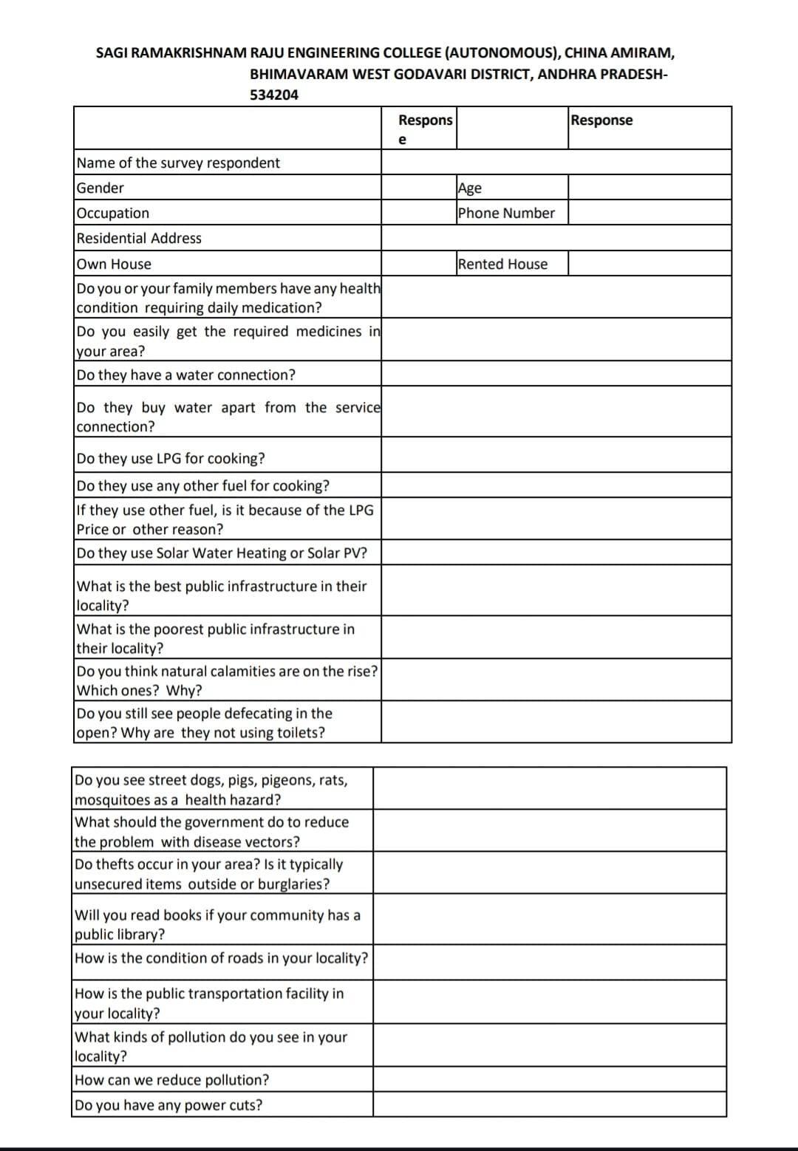
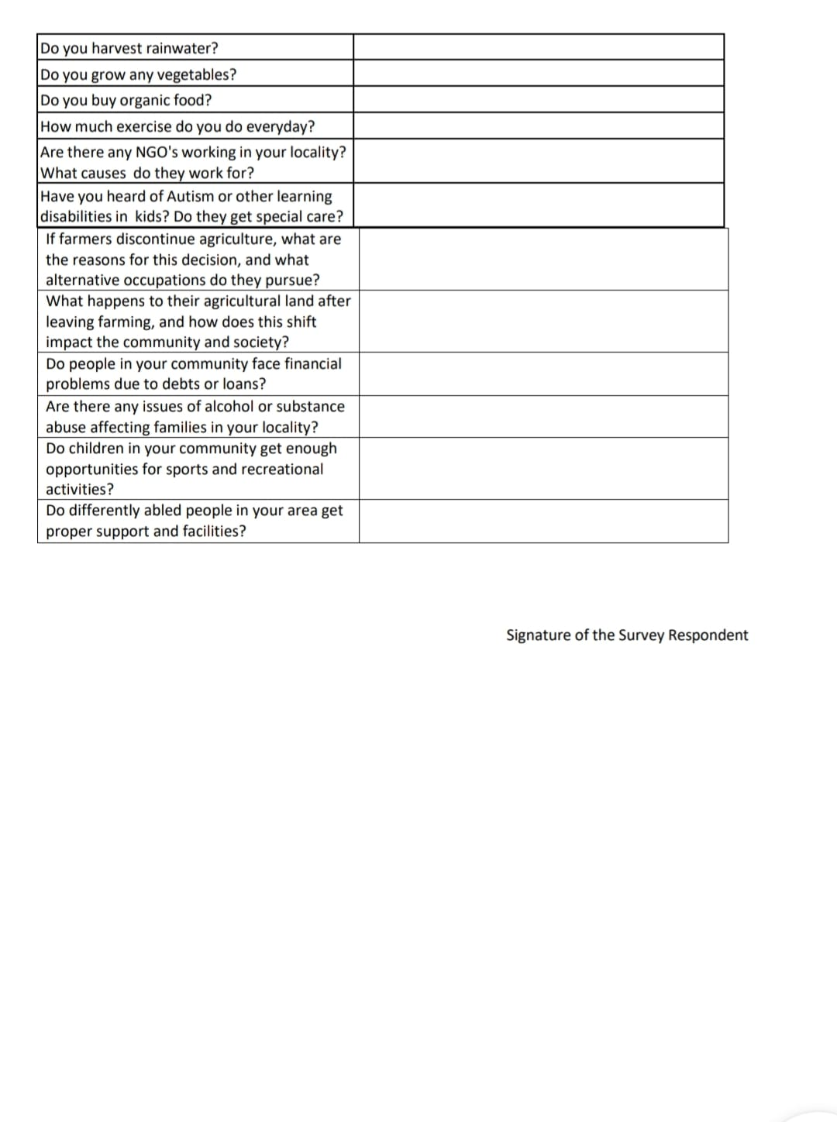

SURVEY ON HEALTH AND PUBLIC INFRASTRUCTURE

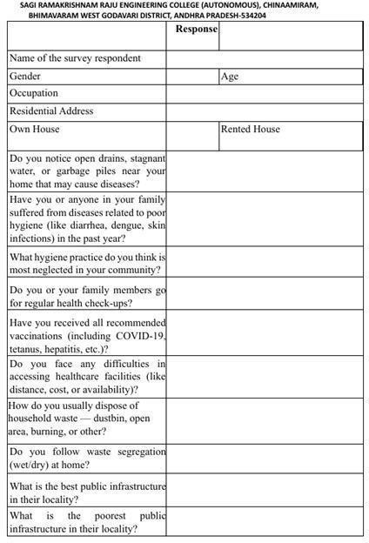

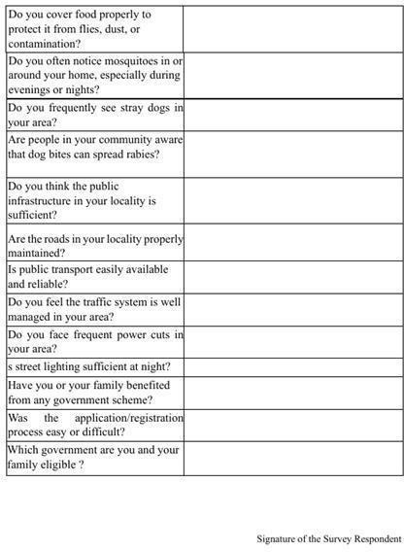

6.2 Describe the problems you have identified in the community
During the community engagement and socio-economic survey, several key issues related to waste management and environmental awareness were identified. The problems observed were both environmental and social in nature, affecting the overall cleanliness and health of the residents..
- Improper Waste Segregation and Disposal:
Many households were found to mix biodegradable and non-biodegradable waste, leading to improper disposal. Waste was often dumped in open areas or near drainage lines, causing foul odors, pollution, and an unpleasant environment. The lack of separate bins and minimal awareness about segregation contributed to the issue.
- Irregular Waste Collection:
A significant number of residents continued to use single-use plastics such as carry bags and bottles, which were often discarded irresponsibly. This led to blocked drains, soil pollution, and damage to the local ecosystem. Awareness about eco-friendly alternatives was limited.
- Irregular Waste Collection:
Garbage collection by local authorities was inconsistent in certain parts of the community. Due to irregular collection schedules, waste often accumulated on streets, attracting stray animals and creating unsanitary conditions.
- Drainage Blockages and Poor Maintenance:
Clogging of drains due to plastic and other non-biodegradable waste was a recurring problem. During rains, this led to water stagnation, unpleasant smells, and hygiene issues for nearby households.
- Lack of Awareness on Environmental Responsibility:
While residents recognized the importance of cleanliness, many were unaware of sustainable waste management practices such as recycling, composting, or reducing plastic usage. This reflected a need for continuous awareness programs and environmental education.
- Limited Community Participation:
Most residents relied solely on municipal workers for waste disposal and cleanliness. There was limited collective participation in community-driven initiatives like waste segregation drives or cleanliness campaigns. Encouraging civic responsibility and teamwork among residents remains essential for sustainable change.

6.3 Short-term and long-term action plan for possible solutions for the problems identified and that could be recommended to the concerned authorities for implementation.
6.3.1. Improper Waste Management and Plastic Usage
Short-Term Actions:
Conduct door-to-door awareness campaigns on waste segregation of plastic.
Organize community cleanliness drives and place separate bins for biodegradable and non-
biodegradable waste in public areas.
Coordinate with municipal staff for timely waste collection.
Long-Term Actions:
Establish a sustainable waste segregation and composting system within the community.
Promote plastic-free zones and encourage the use of eco-friendly alternatives such as cloth or jute
bags.
6.3.2. Drainage Blockages and Poor Maintenance
Short-Term Actions:
Remove accumulated plastic and waste materials from drainage lines.
Educate residents about not disposing of household waste or plastic into drains.
Long-Term Actions:
Upgrade drainage infrastructure to improve flow and reduce clogging.
Encourage residents to participate in maintaining cleanliness near drainage areas and report
any blockages immediately.

6.3.3. Improper Plastic Disposal and Littering
Short-Term Actions:
Conduct awareness sessions to educate residents about the harmful effects of plastic on the
environment and health.
Encourage community members to properly dispose of plastic waste and avoid littering in
open spaces.
Long-Term Actions:
Establish partnerships with NGOs for plastic recycling programs.
Establish collection centers for plastic waste and sent for recycling.

6.3.4. Drainage Blockages and Waste Accumulation
Short-Term Actions:
Identify and clean drains clogged with plastic and household waste to prevent overflow and
water stagnation..
Report areas with frequent waste accumulation or drainage problems to local authorities for
immediate action.
Long-Term Actions:
Recommend the development of a well-structured drainage and waste management system
that minimizes blockages.
Encourage the use of waste filters or nets at drainage entry points to prevent plastic and solid
waste from entering.

6.3.5. Lack of Public Awareness and Civic Participation in Waste Management
Short-Term Actions:
Organize awareness programs on waste segregation, recycling, and the harmful effects of
plastic pollution.
Encourage school and college students to participate in cleanliness and waste reduction
drives to spread awareness effectively.
Long-Term Actions:
Introduce monthly community meetings to discuss progress, challenges, and new waste
management ideas.
Form youth and women-led environmental groups to ensure continuous community
engagement in cleanliness and sustainability initiatives.

6.4 Description of the Community awareness programme/s conducted w.r.t the problems and their
outcomes.

As part of the Community Service Project on Waste Management and Plastic Awareness, a community awareness programme was conducted focusing on educating residents about proper waste segregation, plastic reduction, and sustainable waste disposal methods. The programme aimed to help the community understand the importance of responsible waste management and how collective action can lead to a cleaner and healthier environment.
Objective of the Programme
The main objective of the programme was to educate residents on effective waste segregation practices, reduction of plastic usage, and recycling methods. The initiative aimed to build awareness about the environmental impacts of improper waste disposal and to encourage residents to take active participation in maintaining cleanliness and sustainability in their locality.
Activities Conducted
- An awareness session was organized at the local community center in Vempadu on 10-07-2025, where the team explained the importance of waste segregation and the harmful effects of single-use plastics through visual demonstrations and posters.
- Residents were guided on how to separate biodegradable and non-biodegradable waste and how to properly dispose of household garbage.
- The team demonstrated simple composting techniques using kitchen waste to promote organic fertilizer use.
- Pamphlets highlighting the 3Rs—Reduce, Reuse, and Recycle—were distributed to every household.
- The importance of timely reporting and government response tracking was emphasized. Community Participation
The programme received active participation from students, homemakers, and elderly residents. Many participants shared their current disposal habits and showed interest in adopting segregation and plastic reduction practices. Several residents also pledged to switch from plastic to cloth or jute bags and to educate their neighbors about the importance of proper waste disposal.
Outcomes and Impact
- Increased awareness: Over 50 residents gained practical knowledge about waste segregation, composting, and the effects of plastic on the environment.
- Improved communication: The programme created a direct link between the community and local authorities through the app.
- Sustainability Initiatives: The Panchayat members expressed interest in organizing monthly cleanliness drives and introducing color-coded waste bins for better segregation.
- Behavioral change: Residents began separating wet and dry waste and reduced plastic usage in daily.

6.5 Report of the mini-project work done in the related subject w.r.t the habitation /village.

6.5.1 Introduction
Waste management and environmental awareness play a crucial role in promoting public health and sustainable living within any community. During the community service internship, a mini-project titled “Waste Management and Plastic Awareness” was undertaken to study the waste disposal practices, sanitation conditions, and environmental challenges faced by the residents of the selected village.

The main objective of this project was to identify and analyze issues such as improper waste segregation, excessive plastic usage, irregular waste collection, and drainage blockages caused by plastic waste. These problems were carefully observed to understand how they affect the cleanliness, hygiene, and overall quality of life of the community members.

A socio-economic and environmental survey was conducted through household visits and interactions with residents to collect first-hand information on waste management habits and awareness levels. The findings revealed that open dumping of garbage, lack of waste segregation, and plastic littering were major contributors to unhygienic surroundings and pollution. Additionally, limited awareness and insufficient waste collection facilities added to the challenges faced by the community.

To address these concerns, a community awareness programme on proper waste segregation and plastic reduction was conducted, educating residents on eco-friendly practices such as composting, recycling, and minimizing single-use plastics. The initiative encouraged residents to adopt sustainable waste habits and actively participate in maintaining a clean, green, and pollution-free environment. This effort helped strengthen community involvement and demonstrated how collective action and environmental awareness can significantly improve living conditions in the village.
6.5.2 Objectives of the Study

  - To assess the waste management and sanitation practices followed by the residents in the habitation.
  - To identify key environmental issues such as improper waste segregation, and drainage blockages.

  - To understand the socio-economic factors influencing awareness and participation.
  - To identify the challenges faced by the community in accessing proper waste collection systems.

  - To conduct a digital awareness campaign on the GreenNova App for civic problem reporting.
  - To suggest both short-term and long-term action plans to the concerned authorities.

6.5.3 Methodology

The study was conducted through a combination of structured surveys, field visits, interactive sessions, and awareness programs to understand the waste management practices and environmental challenges faced by the residents of the village. The approach was participatory and community-centered, involving direct interaction with households to gather insights on waste segregation habits, plastic usage, and sanitation awareness.

6.5.3.1 Survey:
A detailed socio-economic and environmental survey was conducted among 50 households across different parts of the village to assess waste management and sanitation practices. A structured questionnaire was designed to collect data on household waste disposal methods, segregation awareness, plastic usage, frequency of waste collection, and participation in cleanliness activities.

6.5.3.2 Observation:
Multiple field visits were carried out to observe the waste disposal sites, drainage systems, and overall cleanliness of the village surroundings. Photographic evidence and detailed field notes were taken to document the condition of public areas, accumulation of plastic waste, open dumping spots, and drainage blockages.

6.5.3.3 Interaction:
Face-to-face interviews and informal discussions were held with residents, local leaders, and municipal staff. These interactions helped identify not only visible issues like improper waste disposal and plastic littering but also underlying problems such as lack of awareness about segregation practices, irregular waste collection, and limited coordination between residents and authorities.

6.5.3.4 Awareness Programme:
A community awareness session was organized to educate residents about proper waste segregation, composting, and reduction of plastic usage. Participants were guided on how to separate wet and dry waste, use eco-friendly alternatives, and maintain clean surroundings. The session received active participation from youth, homemakers, and elders, who showed interest in adopting sustainable practices.

6.5.3.5 Problems Identified:
Based on the fieldwork and responses, the following problems were identified in the community:
- Improper waste segregation and open dumping of garbage.
- Excessive use of single-use plastics.
- Irregular waste collection and clogged drainage systems.
- Low awareness of recycling and sustainable waste practices.
- Limited community participation in cleanliness initiatives.

Short-Term and Long-Term Action Plan
To address the above problems, action plans were prepared and suggested to the local authorities:

Short-Term Actions:
  - Conduct cleanliness drives and remove accumulated plastic and waste from drains and open areas.
  - Organize awareness campaigns on waste segregation, and sustainable disposal practices.
  - Temporary road repair and pothole filling.
  - Encourage residents to use eco-friendly alternatives and avoid single-use plastics.

Long-Term Actions:
  - Establish a proper waste segregation and composting system within the community.
  - Implement a structured waste collection schedule and develop a local recycling unit.
  - Strengthen the drainage infrastructure to prevent blockages and water stagnation.
  - Form a community-led environmental committee for regular monitoring and awareness.
  - Collaborate with NGOs and local authorities to promote plastic-free initiatives and long-term
sustainability programs.

Community Awareness Programme

As part of the mini-project on Waste Management and Plastic Awareness, a community awareness programme was conducted to educate residents about proper waste segregation, plastic reduction, and eco-friendly disposal methods. The main objective of this programme was to encourage citizens to actively participate in maintaining cleanliness, reducing plastic use, and promoting sustainable waste management practices within the community.
During the session, residents were given live demonstrations on how to separate biodegradable and non-biodegradable waste, simple composting methods for kitchen waste, and the use of reusable alternatives to plastic. Posters, pamphlets, and visual aids were distributed to illustrate the importance of segregation, recycling, and responsible waste disposal.
The programme was organized in collaboration with local volunteers and community members, ensuring participation from students, homemakers, youth, and elderly residents. The interactive approach allowed participants to share their experiences, ask questions, and pledge to adopt plastic-free habits. Over 50 residents actively took part in the event, with many showing interest in continuing segregation and composting at home.
The awareness drive not only strengthened community cooperation but also encouraged long-term behavioral change toward cleanliness and environmental responsibility. It empowered residents to take initiative in keeping their surroundings clean and to reduce plastic waste generation at the source.

Outcomes:
- Increased community participation in waste segregation and cleanliness drives.
- Improved coordination and cooperation between residents and local authorities.
- Enhanced awareness about reducing single-use plastics and promoting recycling.
- Strengthened sense of ownership and civic responsibility among villagers.
- Encouraged sustainable habits among youth and elderly members alike.

  - Findings and Observations

- The level of public awareness on hygiene and civic responsibility was low but showed improvement after the awareness programme.
- Residents were willing to cooperate once proper guidance was given.
- The pension issue was primarily due to document mismatches and lack of information about eligibility.
- Women and senior citizens actively participated in the awareness event and shared valuable feedback.
- The GreenNova app proved to be a useful tool for bridging the gap between citizens and municipal authorities.

CHAPTER 7: RECOMMENDATIONS AND CONCLUSIONS OF THE MINI PROJECT/COMMUNITY SERVICE INTERNSHIP

Based on the observations, survey results, and outcomes of the Community Service Project on Waste Management and Plastic Awareness, the following recommendations are proposed for the sustainable improvement of cleanliness and environmental health in the locality:

Improved Waste Segregation and Disposal System:

Local authorities should establish a structured waste collection system with separate bins for biodegradable and non-biodegradable waste. Community bins should be placed at suitable locations to avoid open dumping and encourage proper disposal.

Reduction of Plastic Usage:

Awareness campaigns should be conducted regularly to educate residents about the harmful effects of single-use plastics. Authorities can collaborate with local vendors to promote eco-friendly alternatives such as cloth or jute bags and implement a plastic-free zone policy in the area.

Regular Cleaning and Drainage Maintenance:

Drainage systems should be cleaned and inspected periodically to prevent clogging caused by plastic waste. Covered drains and proper waste filtering systems should be installed to ensure smooth flow and reduce stagnation.

Recycling and Composting Initiatives:

Establish community-level composting pits for biodegradable waste and introduce recycling collection centers for plastic and other non-biodegradable materials. Residents can be trained in simple composting techniques to convert kitchen waste into organic fertilizer.

Infrastructure Improvement:

Ensure timely repair of drainage and waste collection routes to prevent littering and overflow. Public sanitation facilities should be upgraded and maintained regularly to promote hygiene and reduce environmental pollution.

Community Participation:

Encourage residents to form Community Cleanliness and Green Committees for continuous monitoring and awareness. Schools and colleges should conduct student-led drives and eco-clubs to sustain participation and promote environmental responsibility among youth.

Use of Digital Tools for Waste Management:

A simple mobile or web-based complaint system can be introduced for residents to report issues like waste accumulation, blocked drains, or improper segregation directly to the local authorities. This will ensure faster response and better accountability.

CONCLUSION

The Community Service Project on "Waste Management and Plastic Awareness" significantly improved the understanding of how community efforts can promote environmental cleanliness and sustainable living. Through surveys, interactions, and awareness programs, the project highlighted the effects of proper waste segregation, reducing plastic use, and sanitation practices on the health and well-being of residents. Students used their academic knowledge to tackle real-life issues by identifying problems like improper waste disposal, excessive plastic use, and drainage blockages, and by developing practical solutions that encouraged local participation and municipal support.

The awareness programs on waste segregation, recycling, and reducing plastic use led to visible changes in community behavior. Residents became more aware of the importance of separating biodegradable and non-biodegradable waste, avoiding single-use plastics, and keeping their surroundings clean. Community-led activities, such as cleanliness drives and plastic-free campaigns, strengthened the bond between students and residents, creating a shared sense of responsibility for a clean environment. These initiatives also highlighted the importance of working together to achieve long-term environmental sustainability.

The involvement of municipal authorities was vital for the project's success. Local officials helped coordinate waste collection, drain cleaning, and awareness activities. Their support helped create a connection between student volunteers and public administration. Regular communication with sanitation departments improved response times to cleanliness issues and encouraged residents to take a more active role in government-led waste management programs. This collaboration between students, the community, and municipal authorities showed how working together can lead to lasting improvements in environmental health.

Overall, this project provided a valuable learning experience that built social responsibility, leadership, and problem-solving skills among students. It reinforced the idea that sustainable change can happen through awareness, cooperation, and consistent effort. The project not only improved waste management practices in the area but also inspired students to continue their commitment to environmental protection with dedication, empathy, and innovation.

CHAPTER 8

Student Self-Evaluation for the Community Service Project
Student Name : B. Sri Lakshmi
Registration No : 23B91A6111
Branch: AIML
Year/Sem: 3/1
Period of CSP : From: 28 -05-2025 To: 29-07-2025
Date of Evaluation:
Please rate your performance in the following areas:
Rating Scale: Letter grade of CGPA calculation to be provided

1 Oral communication | 1 | 2 | 3 | 4 | 5
2 Written communication | 1 | 2 | 3 | 4 | 5
3 Proactiveness | 1 | 2 | 3 | 4 | 5
4 Interaction ability with community | 1 | 2 | 3 | 4 | 5
5 Positive Attitude | 1 | 2 | 3 | 4 | 5
6 Self-confidence | 1 | 2 | 3 | 4 | 5
7 Ability to learn | 1 | 2 | 3 | 4 | 5
8 Work Plan and organization | 1 | 2 | 3 | 4 | 5
9 Professionalism | 1 | 2 | 3 | 4 | 5
10 Creativity | 1 | 2 | 3 | 4 | 5
11 Quality of work done | 1 | 2 | 3 | 4 | 5
12 Time Management | 1 | 2 | 3 | 4 | 5
13 Understanding the Community | 1 | 2 | 3 | 4 | 5
14 Achievement of Desired Outcomes | 1 | 2 | 3 | 4 | 5
15 OVERALLPERFORMANCE | 1 | 2 | 3 | 4 | 5

Date: Signature of the Student

Student Self-Evaluation for the Community Service Project
Student Name : B. Venkatesh
Registration No : 23B91A6112
Branch:AIML
Year/Sem: 3/1
Period of CSP : From: 28-05-2025 To: 29-07-2025
Date of Evaluation:
Please rate your performance in the following areas:
Rating Scale: Letter grade of CGPA calculation to be provided

1 Oral communication | 1 | 2 | 3 | 4 | 5
2 Written communication | 1 | 2 | 3 | 4 | 5
3 Proactiveness | 1 | 2 | 3 | 4 | 5
4 Interaction ability with community | 1 | 2 | 3 | 4 | 5
5 Positive Attitude | 1 | 2 | 3 | 4 | 5
6 Self-confidence | 1 | 2 | 3 | 4 | 5
7 Ability to learn | 1 | 2 | 3 | 4 | 5
8 Work Plan and organization | 1 | 2 | 3 | 4 | 5
9 Professionalism | 1 | 2 | 3 | 4 | 5
10 Creativity | 1 | 2 | 3 | 4 | 5
11 Quality of work done | 1 | 2 | 3 | 4 | 5
12 Time Management | 1 | 2 | 3 | 4 | 5
13 Understanding the Community | 1 | 2 | 3 | 4 | 5
14 Achievement of Desired Outcomes | 1 | 2 | 3 | 4 | 5
15 OVERALLPERFORMANCE | 1 | 2 | 3 | 4 | 5

Date: Signature of the Student

Student Self-Evaluation for the Community Service Project
Student Name : B. Likhitha
Registration No : 23B91A6113
Branch:AIML
Year/Sem: 3/1
Period of CSP : From: 28-05-2025 To: 29-07-2025
Date of Evaluation:
Please rate your performance in the following areas:
Rating Scale: Letter grade of CGPA calculation to be provided

1 Oral communication | 1 | 2 | 3 | 4 | 5
2 Written communication | 1 | 2 | 3 | 4 | 5
3 Proactiveness | 1 | 2 | 3 | 4 | 5
4 Interaction ability with community | 1 | 2 | 3 | 4 | 5
5 Positive Attitude | 1 | 2 | 3 | 4 | 5
6 Self-confidence | 1 | 2 | 3 | 4 | 5
7 Ability to learn | 1 | 2 | 3 | 4 | 5
8 Work Plan and organization | 1 | 2 | 3 | 4 | 5
9 Professionalism | 1 | 2 | 3 | 4 | 5
10 Creativity | 1 | 2 | 3 | 4 | 5
11 Quality of work done | 1 | 2 | 3 | 4 | 5
12 Time Management | 1 | 2 | 3 | 4 | 5
13 Understanding the Community | 1 | 2 | 3 | 4 | 5
14 Achievement of Desired Outcomes | 1 | 2 | 3 | 4 | 5
15 OVERALLPERFORMANCE | 1 | 2 | 3 | 4 | 5

Date: Signature of the Student

Student Self-Evaluation for the Community Service Project
Student Name : B.Sandeep
Registration No : 23B91A6114
Branch:AIML
Year/Sem: 3/1
Period of CSP : From: 28-05-2025 To: 29-07-2025
Date of Evaluation:
Please rate your performance in the following areas:
Rating Scale: Letter grade of CGPA calculation to be provided

1 Oral communication | 1 | 2 | 3 | 4 | 5
2 Written communication | 1 | 2 | 3 | 4 | 5
3 Proactiveness | 1 | 2 | 3 | 4 | 5
4 Interaction ability with community | 1 | 2 | 3 | 4 | 5
5 Positive Attitude | 1 | 2 | 3 | 4 | 5
6 Self-confidence | 1 | 2 | 3 | 4 | 5
7 Ability to learn | 1 | 2 | 3 | 4 | 5
8 Work Plan and organization | 1 | 2 | 3 | 4 | 5
9 Professionalism | 1 | 2 | 3 | 4 | 5
10 Creativity | 1 | 2 | 3 | 4 | 5
11 Quality of work done | 1 | 2 | 3 | 4 | 5
12 Time Management | 1 | 2 | 3 | 4 | 5
13 Understanding the Community | 1 | 2 | 3 | 4 | 5
14 Achievement of Desired Outcomes | 1 | 2 | 3 | 4 | 5
15 OVERALLPERFORMANCE | 1 | 2 | 3 | 4 | 5

Date: Signature of the Student

Student Self-Evaluation for the Community Service Project
Student Name : B. Charan Sai
Registration No : 23B91A6115
Branch:AIML
Year/Sem: 3/1
Period of CSP : From: 28-05-2025 To: 29-07-2025
Date of Evaluation:
Please rate your performance in the following areas:
Rating Scale: Letter grade of CGPA calculation to be provided

1 Oral communication | 1 | 2 | 3 | 4 | 5
2 Written communication | 1 | 2 | 3 | 4 | 5
3 Proactiveness | 1 | 2 | 3 | 4 | 5
4 Interaction ability with community | 1 | 2 | 3 | 4 | 5
5 Positive Attitude | 1 | 2 | 3 | 4 | 5
6 Self-confidence | 1 | 2 | 3 | 4 | 5
7 Ability to learn | 1 | 2 | 3 | 4 | 5
8 Work Plan and organization | 1 | 2 | 3 | 4 | 5
9 Professionalism | 1 | 2 | 3 | 4 | 5
10 Creativity | 1 | 2 | 3 | 4 | 5
11 Quality of work done | 1 | 2 | 3 | 4 | 5
12 Time Management | 1 | 2 | 3 | 4 | 5
13 Understanding the Community | 1 | 2 | 3 | 4 | 5
14 Achievement of Desired Outcomes | 1 | 2 | 3 | 4 | 5
15 OVERALLPERFORMANCE | 1 | 2 | 3 | 4 | 5

Date: Signature of the Student

Student Self-Evaluation for the Community Service Project
Student Name : B. Jasmine
Registration No : 23B91A6116
Branch:AIML
Year/Sem: 3/1
Period of CSP : From: 28-05-2025 To: 29-07-2025
Date of Evaluation:
Please rate your performance in the following areas:
Rating Scale: Letter grade of CGPA calculation to be provided

1 Oral communication | 1 | 2 | 3 | 4 | 5
2 Written communication | 1 | 2 | 3 | 4 | 5
3 Proactiveness | 1 | 2 | 3 | 4 | 5
4 Interaction ability with community | 1 | 2 | 3 | 4 | 5
5 Positive Attitude | 1 | 2 | 3 | 4 | 5
6 Self-confidence | 1 | 2 | 3 | 4 | 5
7 Ability to learn | 1 | 2 | 3 | 4 | 5
8 Work Plan and organization | 1 | 2 | 3 | 4 | 5
9 Professionalism | 1 | 2 | 3 | 4 | 5
10 Creativity | 1 | 2 | 3 | 4 | 5
11 Quality of work done | 1 | 2 | 3 | 4 | 5
12 Time Management | 1 | 2 | 3 | 4 | 5
13 Understanding the Community | 1 | 2 | 3 | 4 | 5
14 Achievement of Desired Outcomes | 1 | 2 | 3 | 4 | 5
15 OVERALLPERFORMANCE | 1 | 2 | 3 | 4 | 5

Date: Signature of the Student

Student Self-Evaluation for the Community Service Project
Student Name : B. Kavyanjali
Registration No : 23B91A6117
Branch:AIML
Year/Sem: 3/1
Period of CSP : From: 28-05-2025 To: 29-07-2025
Date of Evaluation:
Please rate your performance in the following areas:
Rating Scale: Letter grade of CGPA calculation to be provided

1 Oral communication | 1 | 2 | 3 | 4 | 5
2 Written communication | 1 | 2 | 3 | 4 | 5
3 Proactiveness | 1 | 2 | 3 | 4 | 5
4 Interaction ability with community | 1 | 2 | 3 | 4 | 5
5 Positive Attitude | 1 | 2 | 3 | 4 | 5
6 Self-confidence | 1 | 2 | 3 | 4 | 5
7 Ability to learn | 1 | 2 | 3 | 4 | 5
8 Work Plan and organization | 1 | 2 | 3 | 4 | 5
9 Professionalism | 1 | 2 | 3 | 4 | 5
10 Creativity | 1 | 2 | 3 | 4 | 5
11 Quality of work done | 1 | 2 | 3 | 4 | 5
12 Time Management | 1 | 2 | 3 | 4 | 5
13 Understanding the Community | 1 | 2 | 3 | 4 | 5
14 Achievement of Desired Outcomes | 1 | 2 | 3 | 4 | 5
15 OVERALLPERFORMANCE | 1 | 2 | 3 | 4 | 5

Date: Signature of the Student

Student Self-Evaluation for the Community Service Project
Student Name : B. Kartheek
Registration No : 23B91A6118
Branch:AIML
Year/Sem: 3/1
Period of CSP : From: 28-05-2025 To: 29-07-2025
Date of Evaluation:
Please rate your performance in the following areas:
Rating Scale: Letter grade of CGPA calculation to be provided

1 Oral communication | 1 | 2 | 3 | 4 | 5
2 Written communication | 1 | 2 | 3 | 4 | 5
3 Proactiveness | 1 | 2 | 3 | 4 | 5
4 Interaction ability with community | 1 | 2 | 3 | 4 | 5
5 Positive Attitude | 1 | 2 | 3 | 4 | 5
6 Self-confidence | 1 | 2 | 3 | 4 | 5
7 Ability to learn | 1 | 2 | 3 | 4 | 5
8 Work Plan and organization | 1 | 2 | 3 | 4 | 5
9 Professionalism | 1 | 2 | 3 | 4 | 5
10 Creativity | 1 | 2 | 3 | 4 | 5
11 Quality of work done | 1 | 2 | 3 | 4 | 5
12 Time Management | 1 | 2 | 3 | 4 | 5
13 Understanding the Community | 1 | 2 | 3 | 4 | 5
14 Achievement of Desired Outcomes | 1 | 2 | 3 | 4 | 5
15 OVERALLPERFORMANCE | 1 | 2 | 3 | 4 | 5

Date: Signature of the Student

Student Self-Evaluation for the Community Service Project
Student Name : B. Chandu
Registration No : 23B91A6119
Branch:AIML
Year/Sem: 3/1
Period of CSP : From: 28-05-2025 To: 29-07-2025
Date of Evaluation:
Please rate your performance in the following areas:
Rating Scale: Letter grade of CGPA calculation to be provided

1 Oral communication | 1 | 2 | 3 | 4 | 5
2 Written communication | 1 | 2 | 3 | 4 | 5
3 Proactiveness | 1 | 2 | 3 | 4 | 5
4 Interaction ability with community | 1 | 2 | 3 | 4 | 5
5 Positive Attitude | 1 | 2 | 3 | 4 | 5
6 Self-confidence | 1 | 2 | 3 | 4 | 5
7 Ability to learn | 1 | 2 | 3 | 4 | 5
8 Work Plan and organization | 1 | 2 | 3 | 4 | 5
9 Professionalism | 1 | 2 | 3 | 4 | 5
10 Creativity | 1 | 2 | 3 | 4 | 5
11 Quality of work done | 1 | 2 | 3 | 4 | 5
12 Time Management | 1 | 2 | 3 | 4 | 5
13 Understanding the Community | 1 | 2 | 3 | 4 | 5
14 Achievement of Desired Outcomes | 1 | 2 | 3 | 4 | 5
15 OVERALLPERFORMANCE | 1 | 2 | 3 | 4 | 5

Date: Signature of the Student

Student Self-Evaluation for the Community Service Project
Student Name : B. Mohana Preethi
Registration No : 23B91A6121
Branch:AIML
Year/Sem: 3/1
Period of CSP : From: 28-05-2025 To: 29-07-2025
Date of Evaluation:
Please rate your performance in the following areas:
Rating Scale: Letter grade of CGPA calculation to be provided

1 Oral communication | 1 | 2 | 3 | 4 | 5
2 Written communication | 1 | 2 | 3 | 4 | 5
3 Proactiveness | 1 | 2 | 3 | 4 | 5
4 Interaction ability with community | 1 | 2 | 3 | 4 | 5
5 Positive Attitude | 1 | 2 | 3 | 4 | 5
6 Self-confidence | 1 | 2 | 3 | 4 | 5
7 Ability to learn | 1 | 2 | 3 | 4 | 5
8 Work Plan and organization | 1 | 2 | 3 | 4 | 5
9 Professionalism | 1 | 2 | 3 | 4 | 5
10 Creativity | 1 | 2 | 3 | 4 | 5
11 Quality of work done | 1 | 2 | 3 | 4 | 5
12 Time Management | 1 | 2 | 3 | 4 | 5
13 Understanding the Community | 1 | 2 | 3 | 4 | 5
14 Achievement of Desired Outcomes | 1 | 2 | 3 | 4 | 5
15 OVERALLPERFORMANCE | 1 | 2 | 3 | 4 | 5

Date: Signature of the Student

CHAPTER 9

Evaluation by the Person in-charge in the Community Official
Student Name: B. Sri Lakshmi
Registration No: 23B91A6111
Period of CSP: From: 28-05-2025 To: 29-07-2025
Date of Evaluation:
Name of the Person in-charge: Dr.B.N.V Narasimha Raju
Address with mobile number:9494491083
Please rate the performance in the following areas:

Please note that your evaluation shall be done independent of the self- evaluation

Rating Scale: 1 is lowest and 5 is highest rank

1 Oral communication | 1 | 2 | 3 | 4 | 5
2 Written communication | 1 | 2 | 3 | 4 | 5
3 Proactiveness | 1 | 2 | 3 | 4 | 5
4 Interaction ability with community | 1 | 2 | 3 | 4 | 5
5 Positive Attitude | 1 | 2 | 3 | 4 | 5
6 Self-confidence | 1 | 2 | 3 | 4 | 5
7 Ability to learn | 1 | 2 | 3 | 4 | 5
8 Work Plan and organization | 1 | 2 | 3 | 4 | 5
9 Professionalism | 1 | 2 | 3 | 4 | 5
10 Creativity | 1 | 2 | 3 | 4 | 5
11 Quality of work done | 1 | 2 | 3 | 4 | 5
12 Time Management | 1 | 2 | 3 | 4 | 5
13 Understanding the Community | 1 | 2 | 3 | 4 | 5
14 Achievement of Desired Outcomes | 1 | 2 | 3 | 4 | 5
15 OVERALLPERFORMANCE | 1 | 2 | 3 | 4 | 5

Date: Signature of the Supervisor

Evaluation by the Person in-charge in the Community Official
Student Name: B. Venkatesh
Registration No: 23B91A6112
Period of CSP: From: 28-05-2025 To: 29-07-2025
Date of Evaluation:
Name of the Person in-charge: Dr.B.N.V Narasimha Raju
Address with mobile number:9494491083
Please rate the performance in the following areas:

Please note that your evaluation shall be done independent of the self- evaluation

Rating Scale: 1 is lowest and 5 is highest rank

1 Oral communication | 1 | 2 | 3 | 4 | 5
2 Written communication | 1 | 2 | 3 | 4 | 5
3 Proactiveness | 1 | 2 | 3 | 4 | 5
4 Interaction ability with community | 1 | 2 | 3 | 4 | 5
5 Positive Attitude | 1 | 2 | 3 | 4 | 5
6 Self-confidence | 1 | 2 | 3 | 4 | 5
7 Ability to learn | 1 | 2 | 3 | 4 | 5
8 Work Plan and organization | 1 | 2 | 3 | 4 | 5
9 Professionalism | 1 | 2 | 3 | 4 | 5
10 Creativity | 1 | 2 | 3 | 4 | 5
11 Quality of work done | 1 | 2 | 3 | 4 | 5
12 Time Management | 1 | 2 | 3 | 4 | 5
13 Understanding the Community | 1 | 2 | 3 | 4 | 5
14 Achievement of Desired Outcomes | 1 | 2 | 3 | 4 | 5
15 OVERALLPERFORMANCE | 1 | 2 | 3 | 4 | 5

Date: Signature of the Supervisor

Evaluation by the Person in-charge in the Community Official
Student Name: B. Likhitha
Registration No: 23B91A6113
Period of CSP: From: 28-05-2025 To: 29-07-2025
Date of Evaluation:
Name of the Person in-charge: Dr.B.N.V Narasimha Raju
Address with mobile number:9494491083
Please rate the performance in the following areas:

Please note that your evaluation shall be done independent of the self- evaluation

Rating Scale: 1 is lowest and 5 is highest rank

1 Oral communication | 1 | 2 | 3 | 4 | 5
2 Written communication | 1 | 2 | 3 | 4 | 5
3 Proactiveness | 1 | 2 | 3 | 4 | 5
4 Interaction ability with community | 1 | 2 | 3 | 4 | 5
5 Positive Attitude | 1 | 2 | 3 | 4 | 5
6 Self-confidence | 1 | 2 | 3 | 4 | 5
7 Ability to learn | 1 | 2 | 3 | 4 | 5
8 Work Plan and organization | 1 | 2 | 3 | 4 | 5
9 Professionalism | 1 | 2 | 3 | 4 | 5
10 Creativity | 1 | 2 | 3 | 4 | 5
11 Quality of work done | 1 | 2 | 3 | 4 | 5
12 Time Management | 1 | 2 | 3 | 4 | 5
13 Understanding the Community | 1 | 2 | 3 | 4 | 5
14 Achievement of Desired Outcomes | 1 | 2 | 3 | 4 | 5
15 OVERALLPERFORMANCE | 1 | 2 | 3 | 4 | 5

Date: Signature of the Supervisor

Evaluation by the Person in-charge in the Community Official
Student Name: B. Sandeep
Registration No: 23B91A6114
Period of CSP: From: 28-05-2025 To: 29-07-2025
Date of Evaluation:
Name of the Person in-charge: Dr.B.N.V Narasimha Raju
Address with mobile number:9494491083
Please rate the performance in the following areas:

Please note that your evaluation shall be done independent of the self- evaluation

Rating Scale: 1 is lowest and 5 is highest rank

1 Oral communication | 1 | 2 | 3 | 4 | 5
2 Written communication | 1 | 2 | 3 | 4 | 5
3 Proactiveness | 1 | 2 | 3 | 4 | 5
4 Interaction ability with community | 1 | 2 | 3 | 4 | 5
5 Positive Attitude | 1 | 2 | 3 | 4 | 5
6 Self-confidence | 1 | 2 | 3 | 4 | 5
7 Ability to learn | 1 | 2 | 3 | 4 | 5
8 Work Plan and organization | 1 | 2 | 3 | 4 | 5
9 Professionalism | 1 | 2 | 3 | 4 | 5
10 Creativity | 1 | 2 | 3 | 4 | 5
11 Quality of work done | 1 | 2 | 3 | 4 | 5
12 Time Management | 1 | 2 | 3 | 4 | 5
13 Understanding the Community | 1 | 2 | 3 | 4 | 5
14 Achievement of Desired Outcomes | 1 | 2 | 3 | 4 | 5
15 OVERALLPERFORMANCE | 1 | 2 | 3 | 4 | 5

Date: Signature of the Supervisor

Evaluation by the Person in-charge in the Community Official
Student Name: B. Charan Sai
Registration No: 23B91A6115
Period of CSP: From: 28-05-2025 To: 29-07-2025
Date of Evaluation:
Name of the Person in-charge: Dr.B.N.V Narasimha Raju
Address with mobile number:9494491083
Please rate the performance in the following areas:

Please note that your evaluation shall be done independent of the self- evaluation

Rating Scale: 1 is lowest and 5 is highest rank

1 Oral communication | 1 | 2 | 3 | 4 | 5
2 Written communication | 1 | 2 | 3 | 4 | 5
3 Proactiveness | 1 | 2 | 3 | 4 | 5
4 Interaction ability with community | 1 | 2 | 3 | 4 | 5
5 Positive Attitude | 1 | 2 | 3 | 4 | 5
6 Self-confidence | 1 | 2 | 3 | 4 | 5
7 Ability to learn | 1 | 2 | 3 | 4 | 5
8 Work Plan and organization | 1 | 2 | 3 | 4 | 5
9 Professionalism | 1 | 2 | 3 | 4 | 5
10 Creativity | 1 | 2 | 3 | 4 | 5
11 Quality of work done | 1 | 2 | 3 | 4 | 5
12 Time Management | 1 | 2 | 3 | 4 | 5
13 Understanding the Community | 1 | 2 | 3 | 4 | 5
14 Achievement of Desired Outcomes | 1 | 2 | 3 | 4 | 5
15 OVERALLPERFORMANCE | 1 | 2 | 3 | 4 | 5

Date: Signature of the Supervisor

Evaluation by the Person in-charge in the Community Official
Student Name: B. Jasmine
Registration No: 23B91A6116
Period of CSP: From: 28-05-2025 To: 29-07-2025
Date of Evaluation:
Name of the Person in-charge: Dr.B.N.V Narasimha Raju
Address with mobile number:9494491083
Please rate the performance in the following areas:

Please note that your evaluation shall be done independent of the self- evaluation

Rating Scale: 1 is lowest and 5 is highest rank

1 Oral communication | 1 | 2 | 3 | 4 | 5
2 Written communication | 1 | 2 | 3 | 4 | 5
3 Proactiveness | 1 | 2 | 3 | 4 | 5
4 Interaction ability with community | 1 | 2 | 3 | 4 | 5
5 Positive Attitude | 1 | 2 | 3 | 4 | 5
6 Self-confidence | 1 | 2 | 3 | 4 | 5
7 Ability to learn | 1 | 2 | 3 | 4 | 5
8 Work Plan and organization | 1 | 2 | 3 | 4 | 5
9 Professionalism | 1 | 2 | 3 | 4 | 5
10 Creativity | 1 | 2 | 3 | 4 | 5
11 Quality of work done | 1 | 2 | 3 | 4 | 5
12 Time Management | 1 | 2 | 3 | 4 | 5
13 Understanding the Community | 1 | 2 | 3 | 4 | 5
14 Achievement of Desired Outcomes | 1 | 2 | 3 | 4 | 5
15 OVERALLPERFORMANCE | 1 | 2 | 3 | 4 | 5

Date: Signature of the Supervisor

Evaluation by the Person in-charge in the Community Official
Student Name: B. Kavyanjali
Registration No: 23B91A6117
Period of CSP: From: 28-05-2025 To: 29-07-2025
Date of Evaluation:
Name of the Person in-charge: Dr.B.N.V Narasimha Raju
Address with mobile number:9494491083
Please rate the performance in the following areas:

Please note that your evaluation shall be done independent of the self- evaluation

Rating Scale: 1 is lowest and 5 is highest rank

1 Oral communication | 1 | 2 | 3 | 4 | 5
2 Written communication | 1 | 2 | 3 | 4 | 5
3 Proactiveness | 1 | 2 | 3 | 4 | 5
4 Interaction ability with community | 1 | 2 | 3 | 4 | 5
5 Positive Attitude | 1 | 2 | 3 | 4 | 5
6 Self-confidence | 1 | 2 | 3 | 4 | 5
7 Ability to learn | 1 | 2 | 3 | 4 | 5
8 Work Plan and organization | 1 | 2 | 3 | 4 | 5
9 Professionalism | 1 | 2 | 3 | 4 | 5
10 Creativity | 1 | 2 | 3 | 4 | 5
11 Quality of work done | 1 | 2 | 3 | 4 | 5
12 Time Management | 1 | 2 | 3 | 4 | 5
13 Understanding the Community | 1 | 2 | 3 | 4 | 5
14 Achievement of Desired Outcomes | 1 | 2 | 3 | 4 | 5
15 OVERALLPERFORMANCE | 1 | 2 | 3 | 4 | 5

Date: Signature of the Supervisor

Evaluation by the Person in-charge in the Community Official
Student Name: B. Kartheek
Registration No: 23B91A6118
Period of CSP: From: 28-05-2025 To: 29-07-2025
Date of Evaluation:
Name of the Person in-charge: Dr.B.N.V Narasimha Raju
Address with mobile number:9494491083
Please rate the performance in the following areas:

Please note that your evaluation shall be done independent of the self- evaluation

Rating Scale: 1 is lowest and 5 is highest rank

1 Oral communication | 1 | 2 | 3 | 4 | 5
2 Written communication | 1 | 2 | 3 | 4 | 5
3 Proactiveness | 1 | 2 | 3 | 4 | 5
4 Interaction ability with community | 1 | 2 | 3 | 4 | 5
5 Positive Attitude | 1 | 2 | 3 | 4 | 5
6 Self-confidence | 1 | 2 | 3 | 4 | 5
7 Ability to learn | 1 | 2 | 3 | 4 | 5
8 Work Plan and organization | 1 | 2 | 3 | 4 | 5
9 Professionalism | 1 | 2 | 3 | 4 | 5
10 Creativity | 1 | 2 | 3 | 4 | 5
11 Quality of work done | 1 | 2 | 3 | 4 | 5
12 Time Management | 1 | 2 | 3 | 4 | 5
13 Understanding the Community | 1 | 2 | 3 | 4 | 5
14 Achievement of Desired Outcomes | 1 | 2 | 3 | 4 | 5
15 OVERALLPERFORMANCE | 1 | 2 | 3 | 4 | 5

Date: Signature of the Supervisor

Evaluation by the Person in-charge in the Community Official
Student Name: B. Chandu
Registration No: 23B91A6119
Period of CSP: From: 28-05-2025 To: 29-07-2025
Date of Evaluation:
Name of the Person in-charge: Dr.B.N.V Narasimha Raju
Address with mobile number:9494491083
Please rate the performance in the following areas:

Please note that your evaluation shall be done independent of the self- evaluation

Rating Scale: 1 is lowest and 5 is highest rank

1 Oral communication | 1 | 2 | 3 | 4 | 5
2 Written communication | 1 | 2 | 3 | 4 | 5
3 Proactiveness | 1 | 2 | 3 | 4 | 5
4 Interaction ability with community | 1 | 2 | 3 | 4 | 5
5 Positive Attitude | 1 | 2 | 3 | 4 | 5
6 Self-confidence | 1 | 2 | 3 | 4 | 5
7 Ability to learn | 1 | 2 | 3 | 4 | 5
8 Work Plan and organization | 1 | 2 | 3 | 4 | 5
9 Professionalism | 1 | 2 | 3 | 4 | 5
10 Creativity | 1 | 2 | 3 | 4 | 5
11 Quality of work done | 1 | 2 | 3 | 4 | 5
12 Time Management | 1 | 2 | 3 | 4 | 5
13 Understanding the Community | 1 | 2 | 3 | 4 | 5
14 Achievement of Desired Outcomes | 1 | 2 | 3 | 4 | 5
15 OVERALLPERFORMANCE | 1 | 2 | 3 | 4 | 5

Date: Signature of the Supervisor

Evaluation by the Person in-charge in the Community Official
Student Name: B. Eswar Sai
Registration No: 23B91A6120
Period of CSP: From: 28-05-2025 To: 29-07-2025
Date of Evaluation:
Name of the Person in-charge: Dr.B.N.V Narasimha Raju
Address with mobile number:9494491083
Please rate the performance in the following areas:

Please note that your evaluation shall be done independent of the self- evaluation

Rating Scale: 1 is lowest and 5 is highest rank

1 Oral communication | 1 | 2 | 3 | 4 | 5
2 Written communication | 1 | 2 | 3 | 4 | 5
3 Proactiveness | 1 | 2 | 3 | 4 | 5
4 Interaction ability with community | 1 | 2 | 3 | 4 | 5
5 Positive Attitude | 1 | 2 | 3 | 4 | 5
6 Self-confidence | 1 | 2 | 3 | 4 | 5
7 Ability to learn | 1 | 2 | 3 | 4 | 5
8 Work Plan and organization | 1 | 2 | 3 | 4 | 5
9 Professionalism | 1 | 2 | 3 | 4 | 5
10 Creativity | 1 | 2 | 3 | 4 | 5
11 Quality of work done | 1 | 2 | 3 | 4 | 5
12 Time Management | 1 | 2 | 3 | 4 | 5
13 Understanding the Community | 1 | 2 | 3 | 4 | 5
14 Achievement of Desired Outcomes | 1 | 2 | 3 | 4 | 5
15 OVERALLPERFORMANCE | 1 | 2 | 3 | 4 | 5

Date: Signature of the Supervisor

Evaluation by the Person in-charge in the Community Official
Student Name: B. Mohana Preethi
Registration No: 23B91A6121
Period of CSP: From: 28-05-2025 To: 29-07-2025
Date of Evaluation:
Name of the Person in-charge: Dr.B.N.V Narasimha Raju
Address with mobile number:9494491083
Please rate the performance in the following areas:

Please note that your evaluation shall be done independent of the self- evaluation

Rating Scale: 1 is lowest and 5 is highest rank

1 Oral communication | 1 | 2 | 3 | 4 | 5
2 Written communication | 1 | 2 | 3 | 4 | 5
3 Proactiveness | 1 | 2 | 3 | 4 | 5
4 Interaction ability with community | 1 | 2 | 3 | 4 | 5
5 Positive Attitude | 1 | 2 | 3 | 4 | 5
6 Self-confidence | 1 | 2 | 3 | 4 | 5
7 Ability to learn | 1 | 2 | 3 | 4 | 5
8 Work Plan and organization | 1 | 2 | 3 | 4 | 5
9 Professionalism | 1 | 2 | 3 | 4 | 5
10 Creativity | 1 | 2 | 3 | 4 | 5
11 Quality of work done | 1 | 2 | 3 | 4 | 5
12 Time Management | 1 | 2 | 3 | 4 | 5
13 Understanding the Community | 1 | 2 | 3 | 4 | 5
14 Achievement of Desired Outcomes | 1 | 2 | 3 | 4 | 5
15 OVERALLPERFORMANCE | 1 | 2 | 3 | 4 | 5

Date: Signature of the Supervisor

CHAPTER 10
PHOTOS

