AIMS-Campus: AI-Powered Intelligent Maintenance & Smart Complaint Management System
A Project Based Learning Report Submitted in partial fulfilment of the requirements for the award of the degree

of

Bachelor of Technology
in The Department of Computer Science and Engineering
Database Management Systems – 25CS1302E

Submitted by
2510030005: Arabati Charan
2510030268: Gaurav Sri Harsha
2510030148: Dandyala Indrakaran Reddy
2510030394: Yagneshwar Reddy
2510030326 – Hemanth Goud

Under the guidance of
Dr. Rafeeq Mohammed



Department of Computer Science and Engineering
Koneru Lakshmaiah Education Foundation, Aziz Nagar
Aziz Nagar – 500075
OCT - 2026.
Abstract
Managing maintenance complaints on a large university campus is still handled through paper registers, phone calls and informal messages in many institutions. Such processes make complaints easy to lose, hard to prioritise and almost impossible to audit. This project presents AIMS-Campus (AI-Powered Intelligent Maintenance & Smart Complaint Management System), a full-stack database-driven application designed for NexGen University that digitises the entire life of a campus complaint, from the moment a student reports a problem to the moment the student verifies that it has been fixed.
The system is built on the MERN-style stack: a React 19 front end (Vite, Tailwind CSS v4, Zustand, Recharts), a Node.js and Express.js REST API, and a MongoDB Atlas database accessed through Mongoose. Incoming complaints are analysed by the Groq large language model (llama3-8b-8192), which suggests the category, priority level, responsible department and an immediate action, with a rule-based fallback when the AI service is unavailable. Role-Based Access Control separates the views and permissions of students, maintenance staff, managers and administrators. Every complaint receives a unique number, moves through a controlled lifecycle (PENDING, ASSIGNED, ACCEPTED, IN_PROGRESS, RESOLVED, VERIFIED) and is tracked against priority-based Service Level Agreement (SLA) deadlines that are shown as OK, Near or Breached.
From a database-management point of view, the project demonstrates schema design with references between collections, indexed querying, status-driven workflow control, and analytics computed inside the database using MongoDB aggregation pipelines for KPIs, monthly trends, category breakdowns and staff workload. Security is addressed through JWT access and refresh tokens, bcrypt password hashing, Helmet, CORS, rate limiting and NoSQL-injection sanitisation, while Cloudinary is used for secure image hosting. The report describes the problem, requirements, design, implementation, test scenarios and outcomes of the system, supported by screenshots of the running application, and outlines directions for future work.
Keywords: DBMS, MongoDB, Complaint Management, Role-Based Access Control, SLA Tracking, Aggregation Pipeline, Groq LLM, React, Express.js

List of Figures
Figure 1: Use-case diagram showing the four actors and the main functions of AIMS-Campus. 9
Figure 2: Overall architecture of AIMS-Campus: four layers with the numbered request path. 10
Figure 3: Level-1 data flow diagram of the system. 11
Figure 4: Entity-relationship view of the main collections and their references. 12
Figure 5: Complaint lifecycle: PENDING to VERIFIED, with the role responsible for each step. 13
Figure 6: AI analysis flow with Groq LLM and the rule-based fallback. 14
Figure 7: Login page of AIMS-Campus with demo quick-login buttons. 17
Figure 8: Student dashboard with summary cards and recent complaints. 18
Figure 9: Complaint submission form with AI analysis preview and image upload. 19
Figure 10: Manager's complaint list with priority, status, assignment and SLA indicators. 20
Figure 11: Monthly complaint trend for 2026 (total, resolved and critical). 20

List of Tables
Table 1: Functional requirements 7
Table 2: Technology stack of AIMS-Campus 9
Table 3: Main collections and their purpose 12
Table 4: User roles and their capabilities 13
Table 5: Threats and countermeasures 15
Table 6: Sample complaint records used during testing 16
Table 7: Functional test scenarios and expected outcomes 16
Table 8: Manual complaint handling versus AIMS-Campus 21

Table of Contents
1. Introduction 6
a. Problem Statement 6
b. Objectives 7
c. Scope of the Project 7
d. Motivation and Significance 7
2. Methodology 7
a. Requirement Analysis 7
b. System Overview and Use Cases 8
c. Technology Stack 9
d. System Architecture 9
e. Data Flow 10
f. Database Design 11
g. Complaint Identification, Location and Categories 12
h. Role-Based Access Control 13
i. Complaint Lifecycle and SLA Tracking 13
j. Smart Assignment 14
k. AI-Powered Complaint Analysis 14
l. Notifications 14
m. Analytics with Aggregation Pipelines 14
n. Media Handling 15
o. Security Design 15
p. Frontend Design 15
3. Experiments 16
a. Experimental Setup 16
b. Test Data 16
c. Functional Test Scenarios 16
d. Walkthrough Scenario 17
4. Results 17
a. Login Page and Demo Access 17
b. Student Dashboard 17
c. Complaint Submission 18
d. Manager View: All Complaints 19
e. Analytics: Monthly Complaint Trend 20
f. Observed System Behaviour 20
g. Comparison with the Manual Process 20
h. Advantages 21
i. Limitations 21
j. Discussion 21
5. CONCLUSION and FUTURE WORK 21
References 22
Appendix A: Glossary of Terms 22

AIMS-Campus: AI-Powered Intelligent Maintenance & Smart Complaint Management System

Introduction
A university campus is a small city. A single institution such as NexGen University operates classrooms, laboratories, hostels, libraries, canteens and sports facilities, all of which depend on working electrical systems, plumbing, air-conditioning, furniture and network infrastructure. Faults in any of these are inevitable, and the speed with which they are reported, understood and repaired directly affects the learning environment and the daily life of thousands of students and staff members.
In many campuses the complaint process is still manual. A student describes a problem to a warden or office clerk, the complaint is written in a register or passed along through a phone call or a chat message, and someone eventually forwards it to the relevant maintenance team. This approach has well-known weaknesses: complaints are lost or duplicated, urgent problems such as a short circuit are treated like routine ones, nobody can see who is working on what, the student never learns the status of the request, and management has no reliable data about recurring faults, response times or staff workload.
These weaknesses are fundamentally data-management problems. A complaint is a record with attributes (location, description, photograph, category, priority), relationships (the student who raised it, the department responsible, the technician assigned) and a lifecycle (a sequence of states over time). The questions management needs answered, such as how many High-priority complaints are open, which category grows fastest each month, or which technician is overloaded, are queries over that data. A Database Management System (DBMS) provides the structured storage, integrity, concurrent access and query facilities required to handle all of this reliably [1], [2].
AIMS-Campus (AI-Powered Intelligent Maintenance & Smart Complaint Management System) is the solution developed in this project. It replaces manual reporting with a smart, automated system in which the complaint is stored in a MongoDB database, analysed by an AI model that classifies the issue and determines its priority, and then routed to the correct maintenance department instantly. Role-Based Access Control gives students, staff, managers and administrators exactly the screens and permissions they need, and priority-based SLA deadlines make delays visible and accountable.
MongoDB Atlas was chosen as the database because a complaint is naturally a self-contained document that can carry nested information such as the AI analysis, uploaded image links, work records and feedback, while still being referenced to users and departments through object identifiers [3]. In addition, the MongoDB aggregation framework allows the heavy analytical work (KPI counts, monthly trends, category breakdowns and staff workload) to be performed inside the database engine instead of loading large arrays into the application server.
The remainder of this report is organised as follows. Section 2 explains the methodology, including the requirements, architecture, database design, access control, workflow, AI integration, analytics and security. Section 3 describes the experimental setup, test data and test scenarios. Section 4 presents the results with screenshots of the running system and a comparison with the manual process. Section 5 concludes the work and lists possible future enhancements.

Problem Statement
To design and implement a centralised, secure and intelligent campus maintenance platform that (i) accepts complaints with supporting images from students, (ii) automatically classifies each complaint and determines its priority, (iii) routes and tracks the complaint through a well-defined workflow until the student verifies the repair, and (iv) gives management real-time analytics, all on top of a properly designed database.

Objectives
- To design a document-oriented database schema that models users, departments, complaints, work records, notifications and audit logs with clear relationships.
- To automate complaint classification (category, priority, department and suggested action) using the Groq LLM, with a rule-based fallback for reliability.
- To implement Role-Based Access Control for Students, Staff (Technicians), Managers and Admins.
- To implement a complete complaint lifecycle and SLA tracking that flags breached deadlines.
- To provide dashboards and analytics computed with MongoDB aggregation pipelines.
- To apply security best practices: hashed passwords, JWT-based authentication, rate limiting, header hardening and NoSQL-injection protection.

Scope of the Project
The project covers a web-based system for a single campus (NexGen University) with four user roles. It includes complaint submission with image upload, AI-assisted analysis, assignment, work logging, verification with 5-star feedback, in-app notifications, SLA monitoring, and campus-wide and department-level analytics. Native mobile applications, IoT sensor integration and integration with external ERP systems are outside the present scope and are listed under future work.

Motivation and Significance
For students, the benefit is transparency: a complaint that disappears into a register gives no feedback, whereas a numbered digital complaint with a visible status builds trust in the system. For maintenance staff, the benefit is clarity: each technician sees exactly the tasks assigned to them, in priority order, and the work record they log becomes evidence of what was done. For managers and administrators, the benefit is control: SLA indicators, workload figures and trend charts replace guesswork with data.
From an academic point of view, the project is a practical exercise in database management. It requires entity identification, relationship design, integrity constraints, indexing, transaction-like workflow control, query optimisation through aggregation, and the security of stored data, all of which are core topics of a DBMS course.

Methodology

Requirement Analysis
The requirements were gathered by studying how complaints are handled in a campus today and by identifying what each stakeholder needs from a digital replacement. They are grouped into functional requirements (what the system must do) and non-functional requirements (how well it must do it). Table 1 lists the functional requirements.
Table 1: Functional requirements
ID | Requirement | Description
FR1 | User registration and login | Users register with an email and password and sign in; a session is maintained with JWT access and refresh tokens.
FR2 | Role-based access | Students, Staff, Managers and Admins see only the pages and actions permitted to their role.
FR3 | Complaint submission | A student submits a title, detailed description, optional category, location (building, floor, room, area), optional contact phone and up to five images.
FR4 | AI classification | The system analyses the complaint text and suggests category, priority, department and an immediate action; a live AI preview is shown while the student types.
FR5 | Unique complaint number | Every complaint receives a readable identifier such as CMP-2026-000016.
FR6 | Assignment | Managers and Admins assign complaints to staff based on department and workload; the system can suggest the least-loaded staff member.
FR7 | Task handling | Staff accept tasks, update progress, log parts used and time taken, and mark the task resolved.
FR8 | Verification and feedback | The student confirms the repair, marks the complaint VERIFIED and gives a 5-star rating.
FR9 | SLA monitoring | The system computes a deadline from the priority and shows each complaint as OK, Near or Breached.
FR10 | Notifications | Users receive in-app notifications whenever the status of their complaint changes.
FR11 | Analytics | Admins and Managers view KPIs, monthly trends, category breakdowns and staff workload.
FR12 | Search and filter | Managers search complaints by title or description and filter them by status, priority and category.

The non-functional requirements describe the quality attributes expected from the system:
- Security: passwords must be hashed, all private routes authenticated, and requests rate-limited and sanitised.
- Availability: the core complaint flow must continue to work even if the AI service is temporarily unavailable.
- Performance: dashboard figures must be computed inside the database so that response time stays low as the number of complaints grows.
- Usability: a clean, responsive interface with light and dark themes, clear status colours and minimal steps to submit a complaint.
- Maintainability: a layered code structure (routes, controllers, services) and a modular front end.
- Integrity: every complaint must reference a valid user and department, and its status may change only through allowed transitions.

System Overview and Use Cases
Four kinds of users interact with the system. Figure 1 shows the main use cases of each actor. Students create and follow complaints; Staff carry out the work; Managers supervise a department, review AI decisions and assign tasks; and Admins have complete oversight, including user management, analytics and audit logs.
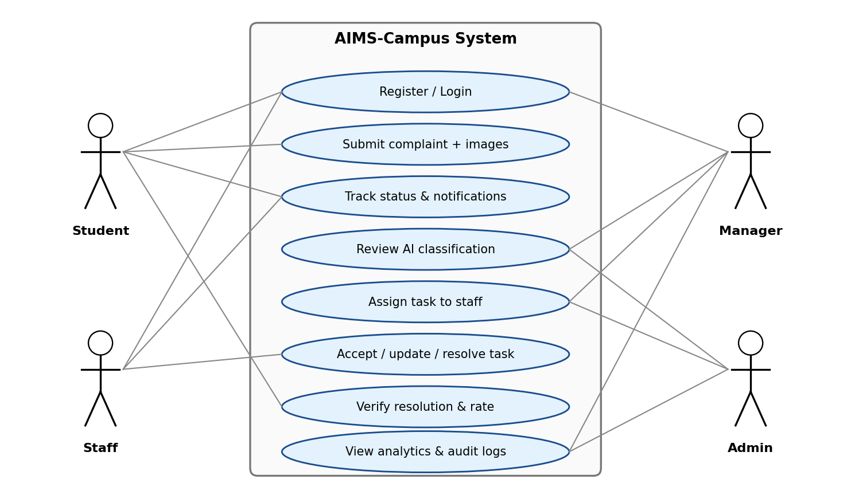
Figure 1: Use-case diagram showing the four actors and the main functions of AIMS-Campus.

Technology Stack
The system follows a three-tier architecture with a React single-page application as the presentation tier, an Express.js REST API as the application tier and MongoDB Atlas as the data tier. Two external services, Groq and Cloudinary, supply AI inference and media hosting [7]–[10]. Table 2 summarises the technologies used in each layer.
Table 2: Technology stack of AIMS-Campus
Layer | Technology | Purpose
Frontend | React 19 (Vite) | Component-based single-page user interface
Frontend | Tailwind CSS v4 | Utility-first responsive styling with light and dark themes
Frontend | Zustand (persisted) | Lightweight global state management
Frontend | React Router DOM v7 | Client-side routing and role-based route guards
Frontend | React Hook Form + Zod | Form handling and schema validation
Frontend | Recharts | Charts for dashboards and analytics
Frontend | Axios | API calls with JWT interceptors for automatic token refresh
Backend | Node.js + Express.js | RESTful API with routes, controllers and services
Database | MongoDB Atlas + Mongoose | Document storage, schema modelling and aggregation
Security | JWT, bcryptjs, Helmet, Express Rate Limit, Mongo Sanitize, CORS | Authentication, hashing, header hardening, abuse and injection protection
External | Groq SDK (llama3-8b-8192) | AI analysis of complaint text
External | Cloudinary | Image upload, storage and delivery

System Architecture
Figure 2 shows the overall architecture as four layers: the browser (presentation tier), the Express API (application tier), the database (data tier) and the external services. The numbered markers show the path of a typical request:
- (1) The user acts in the React application; Axios sends an HTTPS request in JSON format and attaches the JWT access token. If the token has expired, an interceptor silently obtains a new one with the refresh token and repeats the request.
- (2) On the server, security middleware (Helmet, CORS, rate limiting and Mongo Sanitize) inspects the request, and the authentication and RBAC layer verifies the token and the user's role.
- (3) The route passes the request to a controller, which validates the input and decides which service should handle it.
- (4) The service layer contains the business logic: AI analysis, assignment, SLA calculation and analytics.
- (5) The service uses Mongoose to read or write documents, applying schema validation.
- (6) MongoDB Atlas stores the data, and aggregation pipelines compute the summaries used by dashboards.
- (7) When needed, the service calls Groq for classification (or the rule-based fallback if Groq is unavailable) and Cloudinary for image upload.
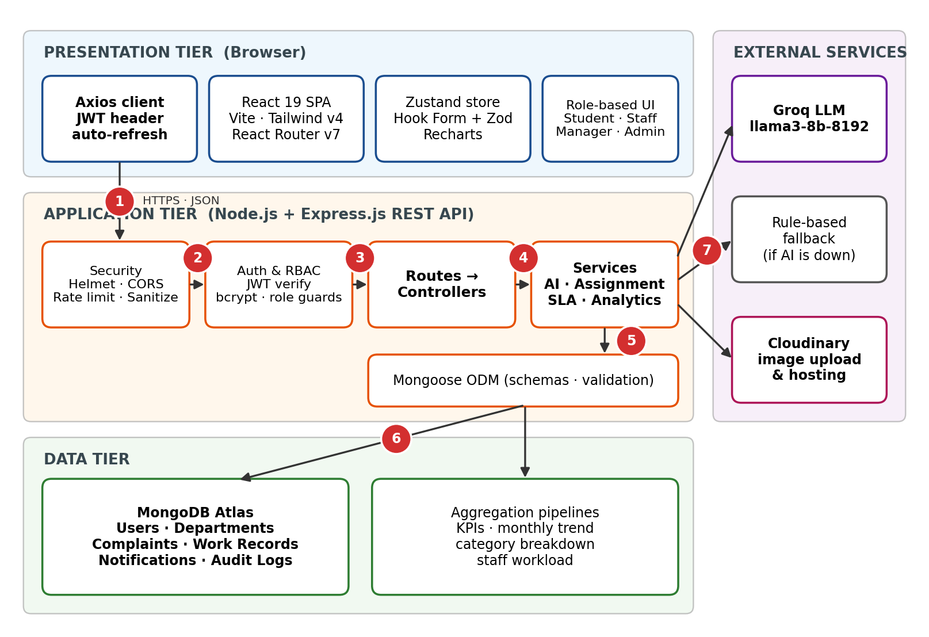
Figure 2: Overall architecture of AIMS-Campus: four layers with the numbered request path.
This clean separation of routes, controllers and services keeps the code maintainable and testable, and it means that a component, for example the AI provider, can be replaced without changing the rest of the system.

Data Flow
Figure 3 presents a level-1 data flow diagram. Four main processes exchange data with four data stores. Process 1.0 authenticates users and reads the Users store. Process 2.0 accepts a new complaint, sends its text to the Groq LLM, sends images to Cloudinary and stores the resulting complaint record. Process 3.0 handles assignment and the technician's work, reading and updating complaints and writing work records. Process 4.0 covers verification and analytics and writes notifications and audit entries.
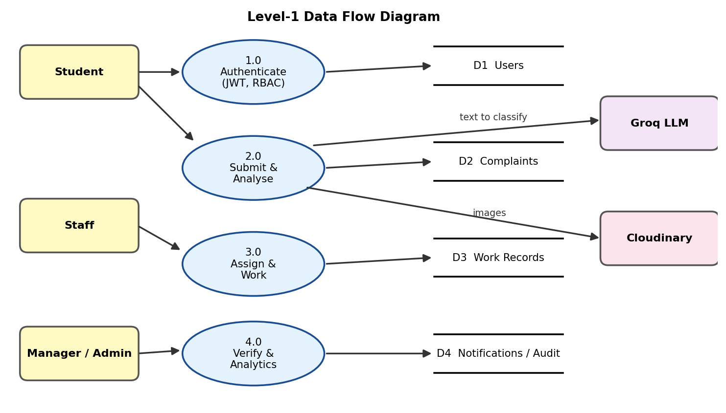
Figure 3: Level-1 data flow diagram of the system.

Database Design
The data layer is implemented in MongoDB through Mongoose schemas. Although MongoDB is a document database, the design follows the same discipline as relational modelling: each real-world entity has its own collection, every document has a unique identifier (_id), and relationships are expressed through references that play the role of foreign keys. Data that is always read together with a complaint and has no independent life (AI analysis result, image URLs, location and the student's feedback) is embedded in the complaint document, while entities shared by many complaints (users and departments) are referenced. This mix avoids duplication and redundancy, which is the goal of normalisation [1], [2], while still allowing a complaint to be fetched in one read.
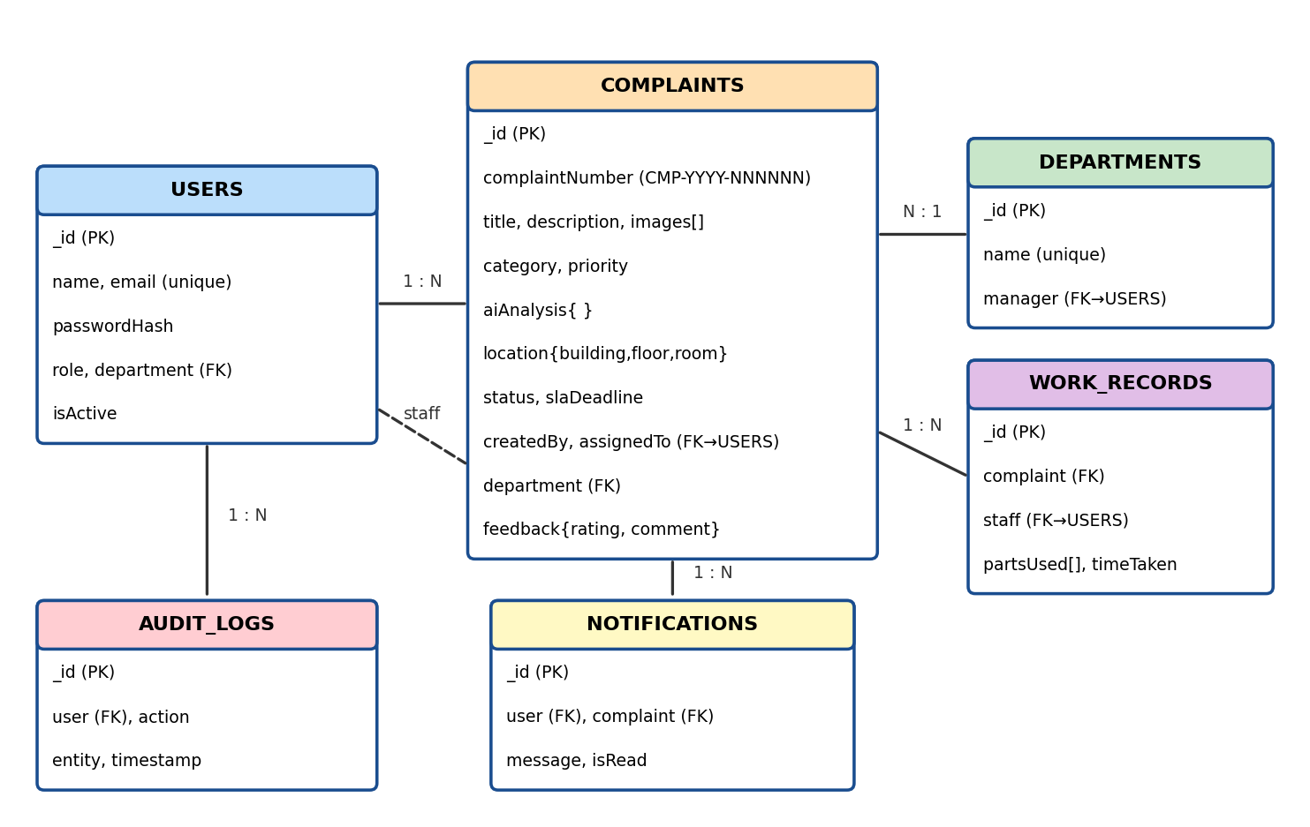
Figure 4: Entity-relationship view of the main collections and their references.
Table 3 lists the principal collections and their roles. The complaint collection is the centre of the model: it references the student who created it, the staff member it is assigned to and the department that owns it, and it carries the status and the SLA deadline that drive the workflow.
Table 3: Main collections and their purpose
Collection | Purpose and key fields
Users | Registered people of the system: name, unique email, bcrypt password hash, role (Student, Staff, Manager, Admin) and department reference.
Departments | Maintenance departments such as Electrical, Plumbing and HVAC, each with a managing user.
Complaints | The core record: complaint number, title, description, image URLs, category, priority, embedded AI analysis, location (building, floor, room, area), status, SLA deadline, created-by and assigned-to references, department reference and the student's rating and feedback.
Work Records | Log entered by a technician for a complaint: parts or materials used and time taken.
Notifications | Messages sent to users when the state of their complaint changes (for example, when it is resolved).
Audit Logs | Who did what and when, giving administrators a trail of important actions.

Integrity is maintained at three levels: Mongoose schemas enforce data types, required fields and allowed values (for example, the status and priority enumerations); Zod validates input on the client before it is sent; and the server sanitises every request body before it reaches the database. Queries that filter or join frequently, such as complaints by status, department, assigned staff or creation date, benefit from indexes on those fields.

Complaint Identification, Location and Categories
Each complaint is given a human-readable identifier of the form CMP-YYYY-NNNNNN (for example, CMP-2026-000016), made of the year and a zero-padded running sequence number. Compared with a raw database identifier, this number is easy to quote on the phone, to print on a work order or to search in a list. The complaint also stores a structured location: building, floor, room and a free-text area description such as a computer lab or corridor. Structured locations make it possible to group complaints by building and to spot buildings with repeated faults.
The complaint category (for example IT/Network, Plumbing, Cleaning, Electrical, HVAC or Furniture) decides the department that handles it. The student may choose the category, or leave it as "AI will suggest", in which case the AI result is used.

Role-Based Access Control
Access to data and operations is governed by the role stored in the user's document and checked by middleware on every protected route. Table 4 summarises the four roles. A student can see only their own complaints, a technician only the tasks assigned to them, a manager the complaints of the department being managed, and an administrator the entire system. The navigation menu is also role-specific: a student sees Dashboard, My Complaints, New Complaint, Notifications and Profile, whereas a manager sees Dashboard, Complaints, Staff, Analytics, Notifications and Profile.
Table 4: User roles and their capabilities
Role | Key capabilities
Student / User | Submit complaints with images, track real-time status, verify resolutions and give 5-star feedback.
Staff (Technician) | View assigned tasks, accept and update task status, log work records (parts used, time taken) and mark the complaint as resolved.
Manager | Oversee a department, review AI classifications and override them if needed, assign tasks to staff and view department analytics.
Admin | Full system oversight, management of all users and departments, campus-wide analytics and audit logs.

Complaint Lifecycle and SLA Tracking
Every complaint is a small state machine. As shown in Figure 5, it starts as PENDING when the student submits it, becomes ASSIGNED when a manager or administrator allocates it to a technician (based on department and current workload), ACCEPTED when the technician takes the job, IN_PROGRESS while work is carried out, RESOLVED when the technician finishes and logs the work, and finally VERIFIED when the student confirms the problem is fixed and leaves a rating. Restricting each transition to the right role keeps the data consistent and prevents, for example, a student from marking their own complaint as resolved.
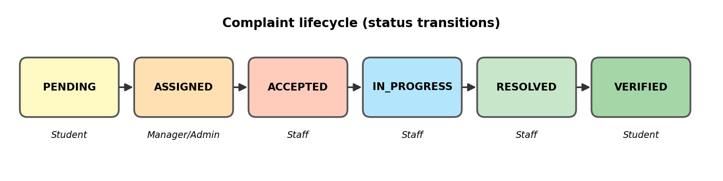
Figure 5: Complaint lifecycle: PENDING to VERIFIED, with the role responsible for each step.
Service Level Agreement tracking is layered on top of the lifecycle. When a priority is determined (Low, Medium, High or Critical), a resolution deadline is calculated for it, with shorter deadlines for higher priorities. The system continuously compares the deadline with the current time and the complaint status. A complaint is shown with one of three SLA indicators: OK when the deadline is comfortably away, Near when it is approaching, and Breached when it has passed, so that managers can act and accountability is maintained.

Smart Assignment
Assigning every complaint by hand does not scale. The system therefore supports smart assignment: when a complaint is routed to a department, the service looks at the staff members of that department and their number of active tasks (ASSIGNED, ACCEPTED or IN_PROGRESS), and proposes the least-loaded technician. Managers and Admins can accept the proposal or choose another person. Because the workload is computed with an aggregation pipeline, the figure is always based on the current data.

AI-Powered Complaint Analysis
When a complaint is submitted, the Express service sends its text to the Groq LLM (llama3-8b-8192) with a prompt that asks for a structured answer. The model returns the category, the priority level, the suggested department and a recommended immediate action, which are stored with the complaint as an embedded analysis object. Managers can review the result and override it if the AI has misjudged the situation. For example, "broken AC" is classified as HVAC with High priority and routed to the HVAC department. On the submission page an "AI Analysis Preview" panel updates as the student types, and a tips panel advises the student to be specific about the location, describe the problem clearly, mention how many people are affected and use emergency words such as flood, fire or hazard for critical issues.
Because an external AI service can be slow or temporarily unavailable, a rule-based fallback is built into the service layer. If the AI call fails, keyword rules classify the complaint so that the submission is never blocked. Figure 6 illustrates this flow.
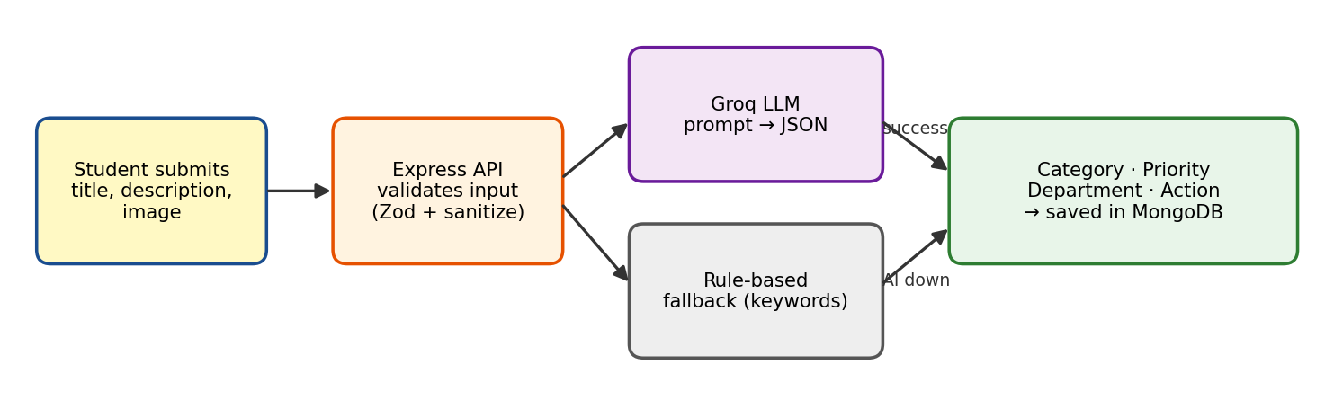
Figure 6: AI analysis flow with Groq LLM and the rule-based fallback.

Notifications
A notification document is created whenever something relevant happens: a complaint is assigned, a task is accepted or resolved, or a student verifies the repair. The notification bell in the top bar of the application shows new messages, and a dedicated Notifications page lists them. This closes the communication gap of the manual process, in which students had to ask for updates.

Analytics with Aggregation Pipelines
Dashboards require summarised data: counts by status, monthly trends, category breakdowns and the workload of each technician. Instead of fetching thousands of documents and looping over them in Node.js, AIMS-Campus pushes this work to the database using MongoDB aggregation pipelines [3]. A pipeline passes documents through stages such as $match (filter), $group (summarise), $lookup (join with another collection), $sort and $project. The following illustrative pipeline computes the number of active tasks per technician:
db.complaints.aggregate([
{ $match: { status: { $in: ['ASSIGNED','ACCEPTED','IN_PROGRESS'] } } },
{ $group: { _id: '$assignedTo', activeTasks: { $sum: 1 } } },
{ $lookup: { from: 'users', localField: '_id',
foreignField: '_id', as: 'staff' } },
{ $sort: { activeTasks: -1 } }
])

A second illustrative pipeline produces the monthly trend: it groups the complaints of the selected year by month and counts the total, the resolved and the critical ones, which is exactly the data plotted in the Monthly Complaint Trend chart.
db.complaints.aggregate([
{ $match: { createdAt: { $gte: start2026, $lt: start2027 } } },
{ $group: { _id: { $month: '$createdAt' },
total: { $sum: 1 },
resolved: { $sum: { $cond: [{ $in: ['$status',['RESOLVED','VERIFIED']] },1,0] } },
critical: { $sum: { $cond: [{ $eq: ['$priority','CRITICAL'] },1,0] } } } },
{ $sort: { _id: 1 } }
])

Doing the calculation where the data lives reduces network transfer, memory use in the application server and response time.

Media Handling
Students can attach up to five photographs (JPEG, PNG or WebP, maximum 10 MB each) to a complaint. Images are uploaded to Cloudinary, and only the secure URL returned by the service is stored in the complaint document. This keeps the database small and fast, while Cloudinary handles storage, optimisation and delivery.

Security Design
Security is treated as a core requirement. Passwords are never stored in plain text; they are hashed with bcrypt [4]. Authentication uses short-lived JWT access tokens and longer-lived refresh tokens [5]. Helmet sets protective HTTP headers, CORS restricts which origins may call the API, and Express Rate Limit throttles repeated requests to defend against brute-force attacks. The express-mongo-sanitize middleware removes operator characters such as $ and . from incoming data, mitigating NoSQL-injection attacks, which are among the risks highlighted by OWASP [6]. Table 5 summarises the main threats and the countermeasures.
Table 5: Threats and countermeasures
Threat | Countermeasure | Component
Password theft from the database | One-way salted hashing | bcryptjs
Stolen or expired session token | Short-lived access token, refresh token, automatic renewal | JWT + Axios interceptor
Unauthorised access to other users' data | Role checks on every protected route | RBAC middleware
Brute-force login attempts | Request throttling per client | Express Rate Limit
NoSQL injection through operators | Removal of $ and . keys from input | express-mongo-sanitize
Malicious web origins and header attacks | Origin whitelist and secure headers | CORS + Helmet
Invalid or malformed input | Client and server validation | Zod + Mongoose schemas

Frontend Design
The React application is organised by feature: authentication pages, dashboards, complaint pages, staff and analytics pages, notifications and profile. Reusable components (cards, badges, tables, form fields and charts) keep the interface consistent. Status and priority are shown with colour-coded badges (for example PENDING in amber, RESOLVED and VERIFIED in green, High priority in orange), which lets users understand the state of a complaint at a glance. A collapsible sidebar, a light and dark theme switch, and a notification bell are available on every page, and a demo quick-login panel on the sign-in page allows the four roles to be tried instantly during evaluation.

Experiments

Experimental Setup
The system was exercised in a development environment consisting of the Vite development server for the React client, a Node.js runtime running the Express API, a MongoDB Atlas cluster accessed through Mongoose, and the Groq and Cloudinary services reached through their SDKs. Test accounts were created for each of the four roles (Admin, Manager, Staff and Student), and complaints were created, assigned and resolved through the user interface, so that each feature of the project could be checked against its expected behaviour.

Test Data
The database was populated with sample data representing a working campus: sixteen complaints (numbered CMP-2026-000001 to CMP-2026-000016) spread over several categories such as IT/Network, Plumbing, Cleaning and Furniture, several locations in Blocks A, B and C, and complaints in every stage of the lifecycle. Table 6 lists some of the records visible in the complaint list of the Manager account.
Table 6: Sample complaint records used during testing
Complaint no. | Title | Category | Location | Priority | Status
CMP-2026-000016 | Projector not working | IT/Network | Block A, A-201 | Medium | Pending
CMP-2026-000004 | Projector not displaying input | IT/Network | Block A, A-301 | Medium | Pending
CMP-2026-000008 | Washroom tap leaking | Plumbing | Block B, B-GF-01 | Medium | Resolved
CMP-2026-000012 | Cafeteria floor slippery | Cleaning | Block C, C-201 | High | Verified
CMP-2026-000005 | Broken desk in classroom | Furniture | Block B, B-201 | Low | Resolved

Functional Test Scenarios
Table 7 lists the principal scenarios used to verify the system, covering the AI module, workflow, access control, SLA tracking, analytics and security. The expected outcome is the behaviour required by the project design.
Table 7: Functional test scenarios and expected outcomes
ID | Scenario | Expected outcome
T1 | Student submits a complaint with a photograph | Complaint is saved with a unique number and status PENDING; the image is stored on Cloudinary and its URL saved in the complaint.
T2 | Complaint text: "broken AC" | AI classifies it as HVAC, priority High, department HVAC, and suggests an immediate action.
T3 | Groq service unavailable | Rule-based fallback classifies the complaint; submission still succeeds.
T4 | Student opens a manager-only or admin-only page or API route | Request is rejected by RBAC middleware.
T5 | Manager assigns a complaint to a technician | Status changes to ASSIGNED and the technician sees the task on the dashboard.
T6 | Technician accepts, works on and resolves the task | Status moves ACCEPTED, IN_PROGRESS, RESOLVED; work record (parts used, time taken) is saved.
T7 | Student verifies the resolution and rates it | Status becomes VERIFIED and a 5-star rating is stored for the technician.
T8 | Complaint stays unresolved beyond its SLA deadline | Complaint is flagged as Breached; one close to the deadline is flagged Near.
T9 | Access token expires during use | Axios interceptor uses the refresh token and retries the request without logging the user out.
T10 | Request body contains MongoDB operators such as $ne | Operators are removed by the sanitiser; no unauthorised data is returned.
T11 | Many rapid login attempts from one client | Rate limiter blocks further requests for the configured window.
T12 | Admin or Manager opens the analytics page | KPIs, monthly trends, category breakdown and staff workload are returned by aggregation pipelines.
T13 | Student leaves a required field (title, description or building) empty | Form validation shows an error and the complaint is not submitted.
T14 | Manager searches by title or description | Only matching complaints are listed.

Walkthrough Scenario
A representative end-to-end scenario was used to check the whole workflow. A student photographs a broken air-conditioner and submits the complaint. The AI module classifies it as HVAC with High priority. An administrator or HVAC manager reviews it and assigns it to an available HVAC technician, who accepts the job, repairs the unit, logs the materials used and marks the status RESOLVED. The student receives a notification, confirms that the AC works, marks the complaint VERIFIED and rates the technician.

Results

Login Page and Demo Access
Figure 7 shows the sign-in page of AIMS-Campus. The left side presents the purpose of the portal ("AI-Powered Campus Maintenance System") and four key promises: AI auto-classification by category and priority, smart auto-assignment to the least-loaded staff, real-time analytics with SLA tracking, and instant notifications for all status updates. The right side contains the sign-in form with email and password fields, a password visibility toggle, a forgot-password link and a registration link. The demo quick-login buttons for Admin, Manager, Staff and Student allow an evaluator to enter the system under each role with one click.
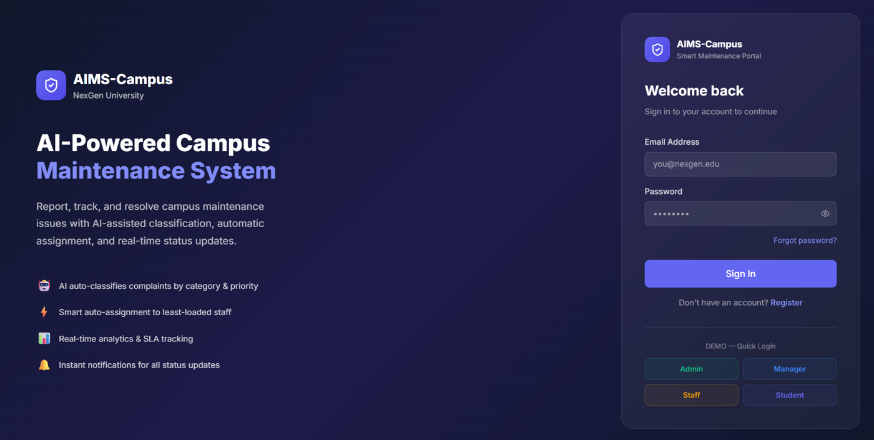
Figure 7: Login page of AIMS-Campus with demo quick-login buttons.

Student Dashboard
Figure 8 shows the dashboard of a student. Four summary cards display the number of complaints that are Total, Pending, In Progress and Resolved, and a Recent Complaints table lists the complaint number, title, category, location, priority, status and date. In the example, the student has one complaint, CMP-2026-000016 "Projector Not working", in the IT/Network category at Block A, A-201, with Medium priority and PENDING status, submitted on 03 Oct 2026. The sidebar shows the student-specific menu, and the top bar has the notification bell and the profile avatar. A prominent New Complaint button starts the submission flow.
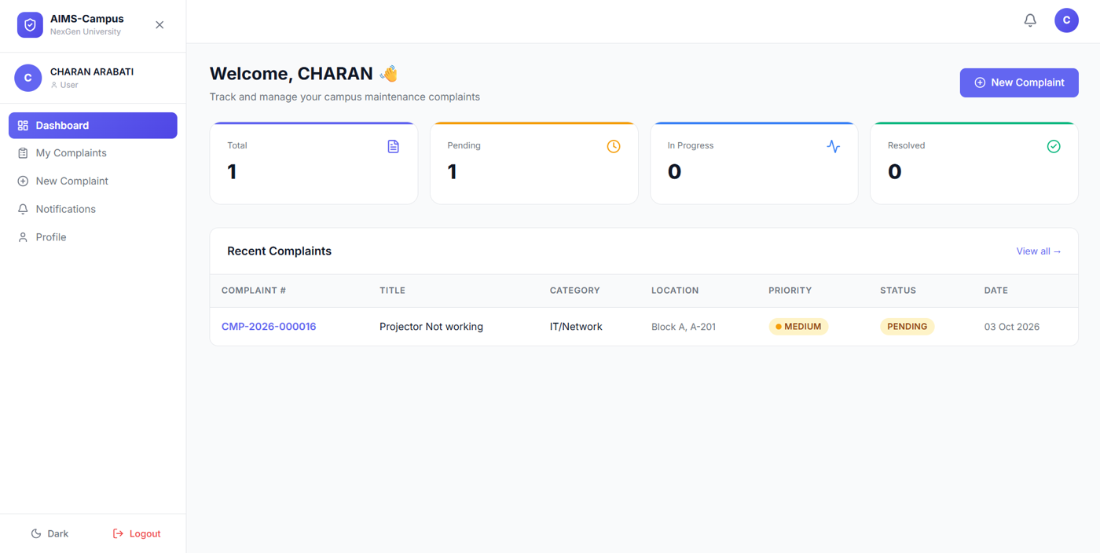
Figure 8: Student dashboard with summary cards and recent complaints.

Complaint Submission
Figure 9 shows the Submit Complaint page. The Complaint Details card collects a title and a detailed description (both required), an optional category (default "AI will suggest") and an optional 10-digit contact phone number. The Location card collects the building (required), floor, room and area description. The Upload Images card accepts up to five JPEG, PNG or WebP images of at most 10 MB each, either by drag and drop or by browsing. On the right, the AI Analysis Preview panel updates while the student types, and the tips card explains how to write a complaint that the AI can classify well.
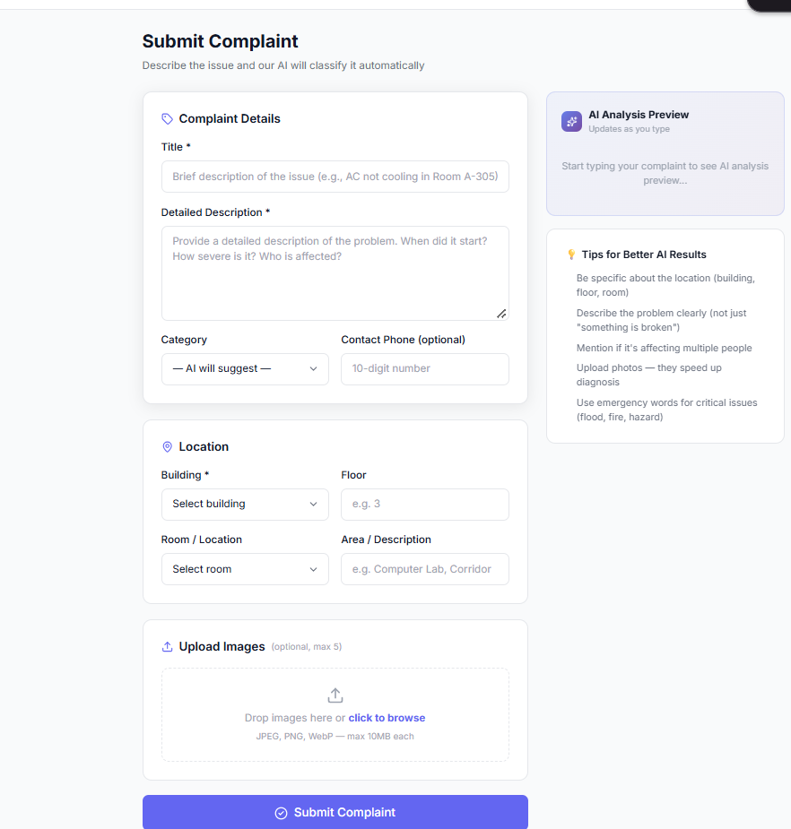
Figure 9: Complaint submission form with AI analysis preview and image upload.

Manager View: All Complaints
Figure 10 shows the All Complaints page of a manager. The page reports how many complaints were found (16 in the test database) and offers Refresh, Filters and New Complaint buttons and a search box for title or description. The table shows, for every complaint, its number, title, reporter, category, location, priority, status, the staff member it is assigned to, the submission date and the SLA indicator. Unassigned pending complaints are clearly visible, while resolved and verified ones show the technician who handled them. The SLA column shows OK for complaints within their deadline, Near for complaints close to the deadline and Breached for those that have exceeded it, which lets the manager concentrate on the complaints that need attention first.
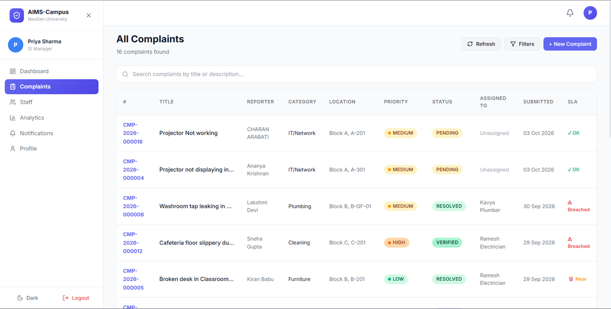
Figure 10: Manager's complaint list with priority, status, assignment and SLA indicators.

Analytics: Monthly Complaint Trend
Figure 11 shows the Monthly Complaint Trend chart for 2026, produced from the aggregation pipeline described earlier. The chart plots three series for each month: the total number of complaints, the number resolved and the number of critical complaints. In the test data no complaints exist from January to August, September has 14 complaints in total, of which 6 are resolved and 4 are critical, and October has 2 complaints so far. The 14 and 2 add up to the 16 complaints seen in the complaint list, which shows that the dashboard and the list are consistent with each other and with the stored data.
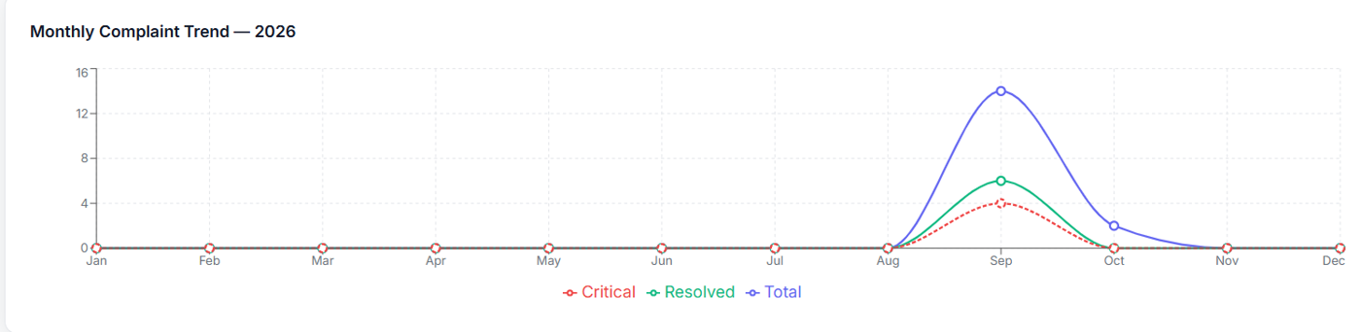
Figure 11: Monthly complaint trend for 2026 (total, resolved and critical).

Observed System Behaviour
The implemented system delivers the complete workflow described in the methodology. Complaints are created with a unique number and receive an AI-generated category, priority, department and suggested action; managers can override the classification; assignment, acceptance, progress updates, resolution and verification each update the status in the database and are visible to the concerned roles; and unresolved complaints are flagged when their SLA deadline passes. Each role sees only the dashboard and actions permitted to it, as the different menus of the student and manager screens show.

Comparison with the Manual Process
Table 8 compares the manual process that AIMS-Campus replaces with the new system.
Table 8: Manual complaint handling versus AIMS-Campus
Aspect | Manual process | AIMS-Campus
Recording | Registers, calls and messages; easily lost | Stored centrally in MongoDB with a unique complaint number
Classification | Done by a person, inconsistent | AI-assisted category, priority and department, with manager override
Routing | Forwarded manually | Instant routing to the correct department and workload-aware assignment
Status visibility | Student must ask | Real-time status and notifications through the whole lifecycle
Accountability | No deadlines or evidence | SLA indicators (OK, Near, Breached), work records and audit logs
Management insight | Little or no data | Live KPIs, trends, category and workload analytics
Security | Not applicable | RBAC, JWT, bcrypt, rate limiting and input sanitisation

Advantages
- A single, searchable source of truth replaces scattered registers and messages.
- AI-assisted classification and prioritisation reduce manual triage and make urgent issues visible immediately.
- Role-specific dashboards give every stakeholder exactly the information and actions they need.
- SLA indicators and work records create accountability for maintenance teams.
- Database-level aggregation keeps analytics fast and the application server light.
- A layered architecture and modern, well-supported technologies make the system easy to extend.

Limitations
The classification quality depends on the wording of the complaint and on a small language model, which is why manager review and override are retained. The system currently provides in-app notifications only, and it is designed for a single campus. The test data set is small compared with a full semester of real complaints, so performance under heavy load has still to be measured. These points are addressed in the future work below.

Discussion
The use of aggregation pipelines keeps dashboard queries efficient because summarisation happens inside the database. The embedded-document design makes a complaint readable in a single query, while references to users and departments avoid duplication. The rule-based fallback guarantees availability of the core function even when the AI service is down, and the layered security measures protect both the data and the service.

CONCLUSION and FUTURE WORK
In this project we designed and implemented AIMS-Campus, an AI-powered intelligent maintenance and smart complaint management system for NexGen University. The project shows how a well-structured database, a clear workflow and a modest amount of AI can together replace a slow and opaque manual process. MongoDB Atlas stores users, departments and complaints with their relationships; the Groq LLM classifies and prioritises complaints with a dependable rule-based fallback; Role-Based Access Control and JWT authentication protect the data; SLA tracking enforces accountability; and aggregation pipelines supply real-time analytics for decision making.
Beyond the software itself, the project gave the team practical experience of the central ideas of a database course: modelling entities and relationships, choosing between embedding and referencing, enforcing integrity, indexing for queries, summarising data with a pipeline, and securing stored data.
The work can be extended in several directions. Planned and possible enhancements include:
- E-mail, SMS and push notifications, and automatic escalation when an SLA deadline is about to be breached.
- A mobile application for students and technicians, with offline support and camera integration.
- Predictive maintenance: analysing historical complaint data to forecast recurring failures and schedule preventive work.
- Automatic detection of duplicate complaints for the same location and issue.
- Multilingual complaint submission and AI analysis of the uploaded images as well as the text.
- Automated test suites, caching and database index tuning for larger campuses with higher load.
- Integration with asset-management and inventory systems so that parts used by technicians update stock automatically.

References
- R. Elmasri and S. B. Navathe, Fundamentals of Database Systems, 7th ed. Pearson, 2016.
- A. Silberschatz, H. F. Korth and S. Sudarshan, Database System Concepts, 7th ed. McGraw-Hill, 2019.
- MongoDB, Inc., "MongoDB Manual: Aggregation Pipeline and Data Modeling," MongoDB Documentation. Available: https://www.mongodb.com/docs/manual/
- N. Provos and D. Mazieres, "A Future-Adaptable Password Scheme," in Proc. USENIX Annual Technical Conference (FREENIX Track), 1999.
- M. Jones, J. Bradley and N. Sakimura, "JSON Web Token (JWT)," RFC 7519, IETF, 2015.
- OWASP Foundation, "OWASP Top 10 Web Application Security Risks." Available: https://owasp.org/www-project-top-ten/
- Meta Platforms, Inc., "React Documentation." Available: https://react.dev/
- OpenJS Foundation, "Express.js Documentation." Available: https://expressjs.com/
- Groq, Inc., "GroqCloud API Documentation." Available: https://console.groq.com/docs
- Cloudinary Ltd., "Cloudinary Image and Video Upload Documentation." Available: https://cloudinary.com/documentation

Appendix A: Glossary of Terms
Term | Meaning
DBMS | Database Management System: software that stores, organises, protects and queries data.
ODM | Object Document Mapper: a library (Mongoose) that maps JavaScript objects to MongoDB documents.
Aggregation pipeline | A sequence of stages in MongoDB that filters, groups and reshapes documents to produce summaries.
RBAC | Role-Based Access Control: permissions are given to roles, and users get permissions through their role.
JWT | JSON Web Token: a signed token that proves who the user is without a server-side session.
SLA | Service Level Agreement: the target time within which a complaint should be resolved.
LLM | Large Language Model: an AI model that understands and generates text; here, Groq's llama3-8b-8192.
REST API | A web interface in which resources are accessed through standard HTTP methods and URLs.
KPI | Key Performance Indicator: a figure, such as the number of open complaints, that summarises performance.
NoSQL injection | An attack in which query operators are sent as input to change the meaning of a database query.
SPA | Single-Page Application: a web app that loads once and updates the page dynamically.

