LABORATORY REPORT
Computer Networks Laboratory

Experiment 1

Connecting Two PCs through a Switch and Verifying Connectivity

Experiment 2

Connecting Three PCs through a Switch (Star Topology) and Verifying Connectivity

Simulation Tool: Cisco Packet Tracer

Name: J Sri Charan Tej
Roll Number: RA2411030050029
Class / Section: Cybersecurity A
Course Code: 21CSC302J

Table of Contents
- Introduction 3
- Experiment 1: Connecting Two PCs through a Switch 4
  - Aim 4
  - Requirements / Tools Used 4
  - Step-by-Step Procedure 5
  - Result 9
- Experiment 2: Connecting Three PCs through a Switch (Star Topology) 10
  - Aim 10
  - Requirements / Tools Used 10
  - Step-by-Step Procedure 11
  - Result 16
- Overall Conclusion 16

Introduction

This report documents two laboratory experiments carried out in Cisco Packet Tracer, a network simulation tool. Both experiments build a small local area network (LAN) in which end devices are connected to a Layer 2 switch, are given static IPv4 addresses in the same subnet, and are then tested for connectivity using the ping command.
Switch. A switch connects devices within one LAN and forwards frames only to the port where the destination device is located. Each device is joined to the switch by its own cable, so the devices form a star topology.
Straight-through cable. A copper straight-through cable is used to connect an end device (PC) to a switch port. This is the cable type selected in the Packet Tracer cable palette in all the screenshots of this report.
Static IPv4 addressing. For two devices to communicate directly, they must be in the same IP network. In both experiments the network 192.168.1.0 with the subnet mask 255.255.255.0 (/24) is used, and every PC is assigned a unique host address manually.
Ping. The ping command sends ICMP echo request packets to a destination address and reports whether echo replies are received, together with the round-trip time. It is used here to verify end-to-end connectivity.
Experiment 1 uses two PCs and one switch. Experiment 2 extends the same design to three PCs and one switch.

Experiment 1: Connecting Two PCs through a Switch

Aim
To build a network of two PCs connected to a switch, assign static IPv4 addresses to the PCs, and verify connectivity between them using the ping command.

Requirements / Tools Used
    - Software: Cisco Packet Tracer
    - Network device: one Cisco 2960-24TT switch (Switch0)
    - End devices: two PCs (PC-PT), named PC0 and PC1
    - Cabling: Copper Straight-Through cables
    - Addressing: network 192.168.1.0 with subnet mask 255.255.255.0
The IP addresses configured in this experiment (as shown in the screenshots) are:

Device | Interface | IPv4 Address | Subnet Mask
PC0 | FastEthernet0 | 192.168.1.1 | 255.255.255.0
PC1 | FastEthernet0 | 192.168.1.2 | 255.255.255.0
Table 1: IP addressing used in Experiment 1

Step-by-Step Procedure

Step 1: Place the switch in the workspace
Open Packet Tracer and select Network Devices from the device-type panel at the bottom-left, then choose Switches. The 2960 switch (shown as "2960 IOS15" in the selection bar) is dragged into the workspace. It appears as Switch0 with the model name 2960-24TT.

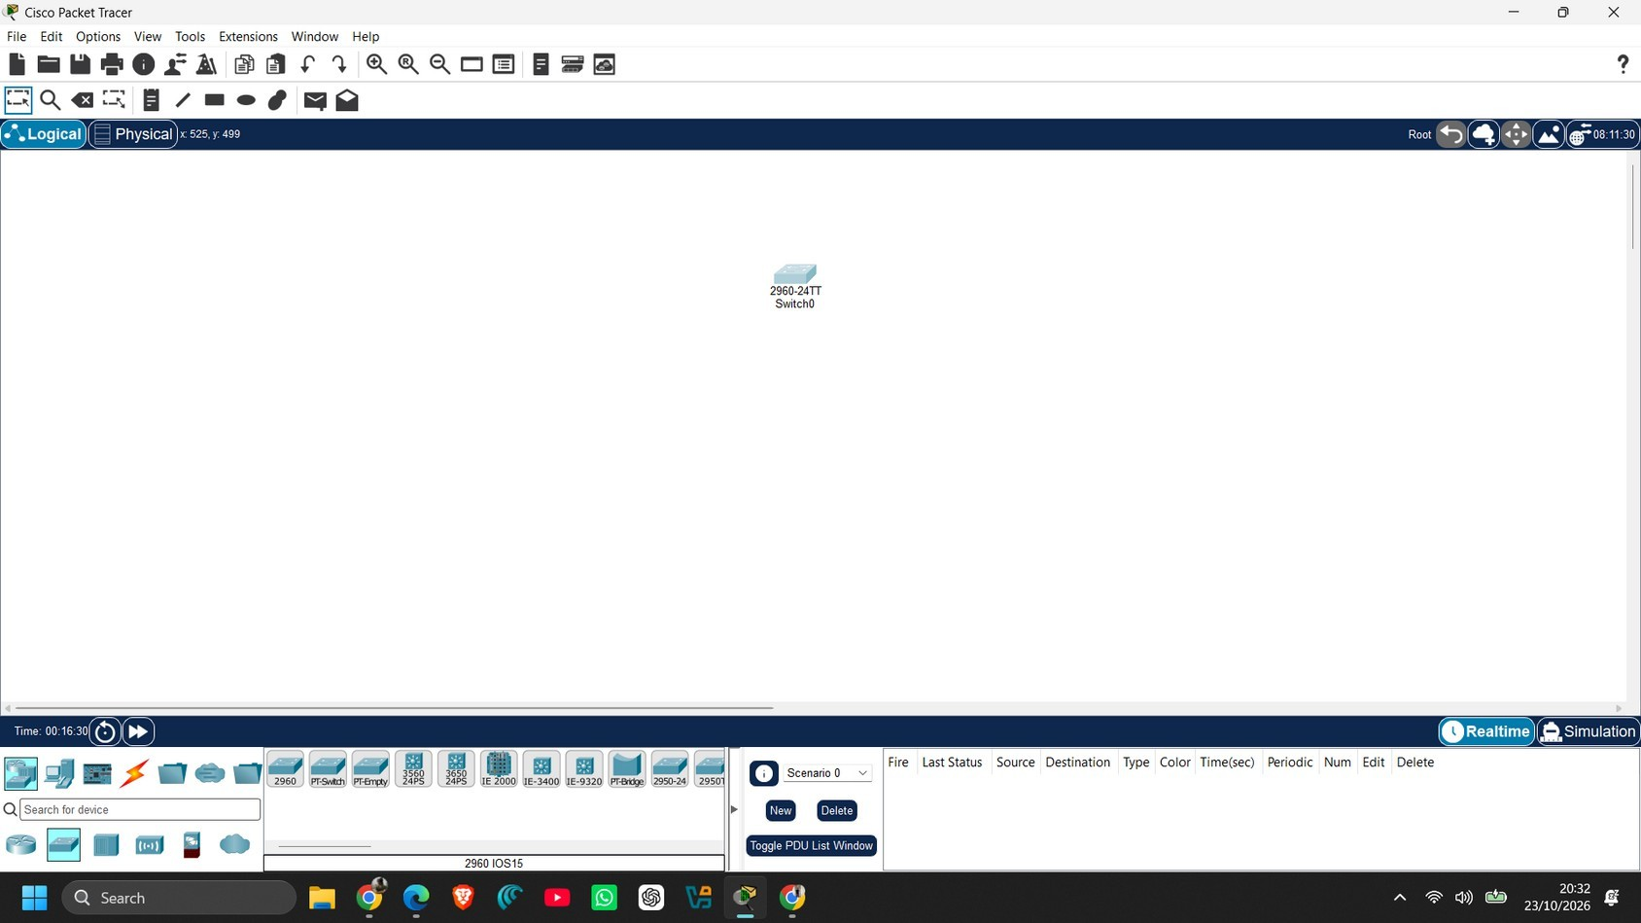
Figure 1: Switch0 (2960-24TT) placed in the workspace
Step 2: Place the first PC (PC0)
Select End Devices from the device-type panel, choose the PC (PC-PT) and drag it into the workspace below the switch. Packet Tracer names it PC0.

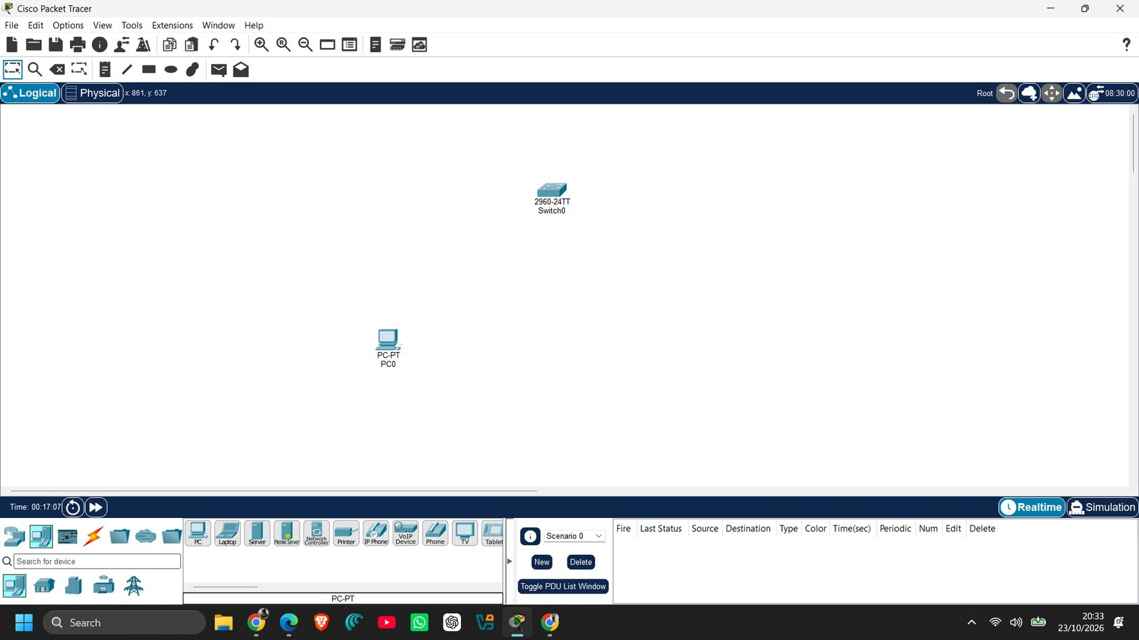
Figure 2: PC0 added to the workspace

Step 3: Place the second PC (PC1)
Drag a second PC from the End Devices panel into the workspace. It is named PC1. The topology now has one switch and two PCs, not yet connected.

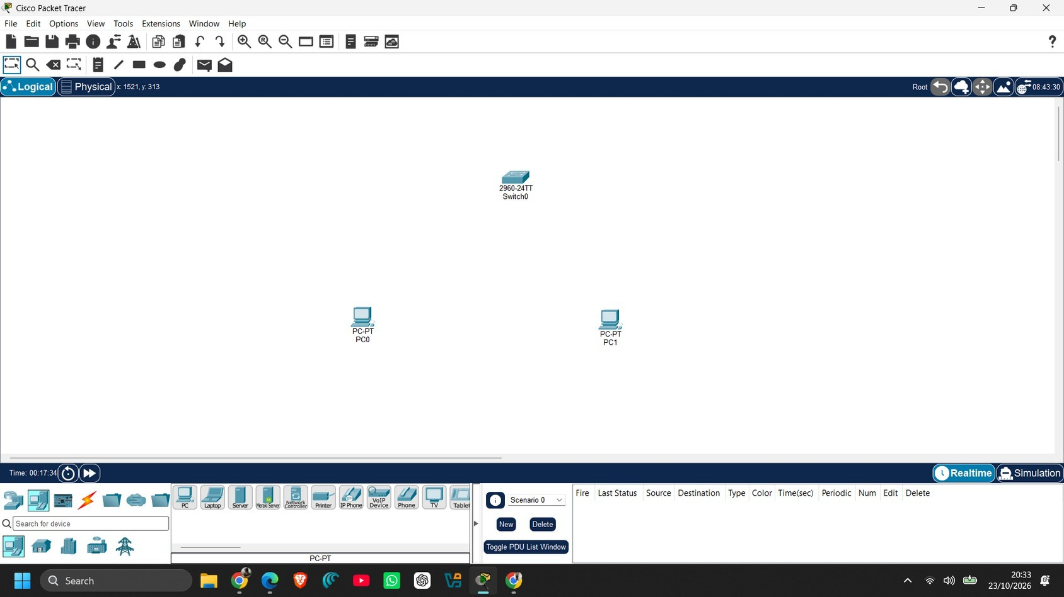
Figure 3: PC1 added; all three devices are in place
Step 4: Connect the PCs to the switch
Select Connections and choose Copper Straight-Through (its name is shown at the bottom of the cable palette). Click PC0, choose its FastEthernet0 interface, and then click the switch and choose a free port. Repeat the same process for PC1. In the screenshot, the link at PC0 shows a green indicator, while the switch end of the PC1 link still shows an orange indicator because that port had only just been connected and was still coming up.

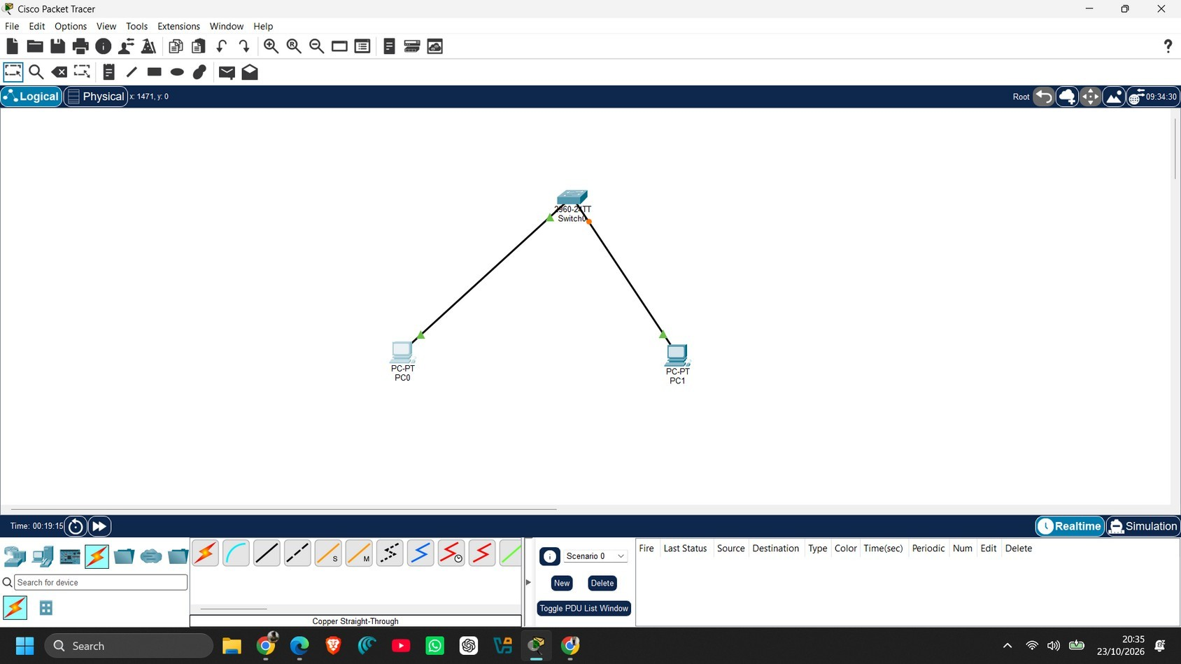
Figure 4: PC0 and PC1 connected to Switch0 using straight-through cables

Step 5: Configure the IP address of PC0
Click PC0 and open the Config tab. Under INTERFACE select FastEthernet0. In IP Configuration select Static, then enter IPv4 Address 192.168.1.1 and Subnet Mask 255.255.255.0. The configuration is applied as soon as the values are entered.

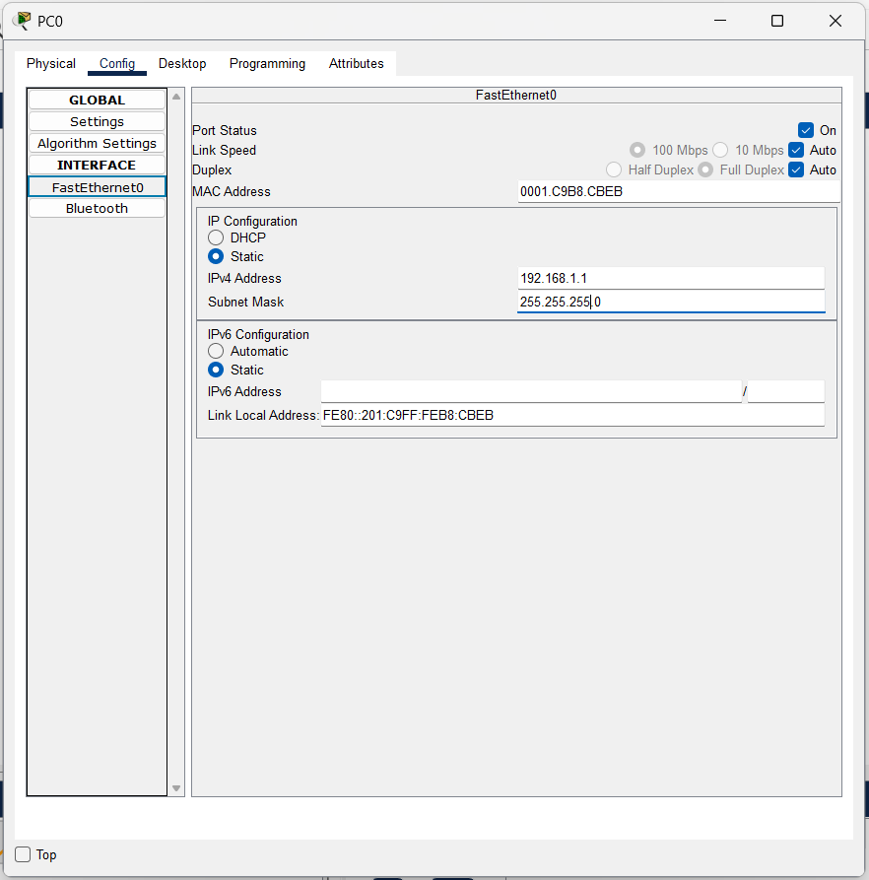
Figure 5: IP configuration of PC0 (192.168.1.1 / 255.255.255.0)
Step 6: Configure the IP address of PC1
Repeat the same procedure on PC1: open Config, select FastEthernet0, choose Static and enter IPv4 Address 192.168.1.2 with Subnet Mask 255.255.255.0. PC1 is now in the same network as PC0.

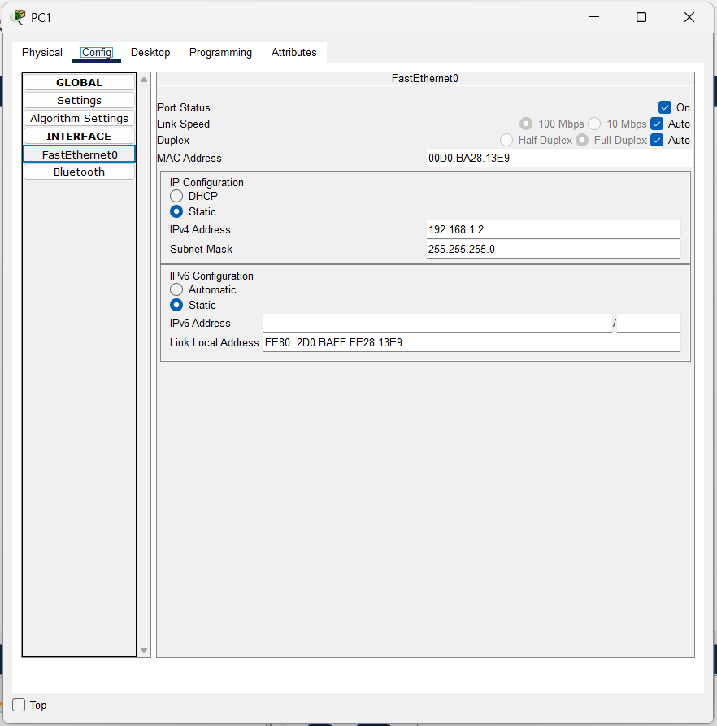
Figure 6: IP configuration of PC1 (192.168.1.2 / 255.255.255.0)

Step 7: Test connectivity using ping
Open PC0, select the Desktop tab and click Command Prompt. Type ping 192.168.1.2 (the address of PC1) and press Enter. Four ICMP echo requests are sent and all four replies are received, which confirms that PC0 can reach PC1 through the switch.

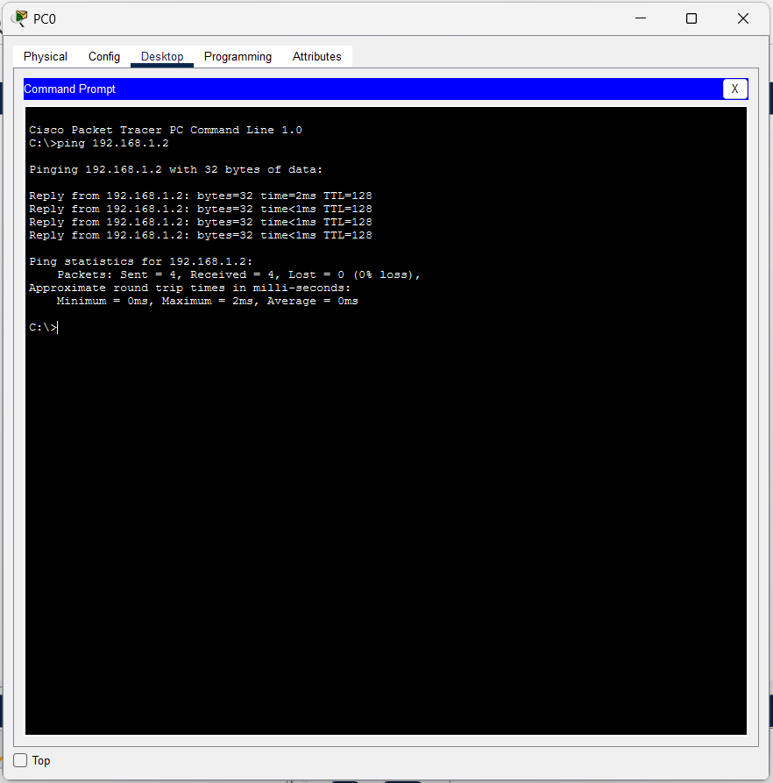
Figure 7: Successful ping from PC0 to PC1 (192.168.1.2)
Step 8: Final topology and project file
The final topology shows both PCs connected to Switch0 with green link indicators on both links. The Packet Tracer title bar shows the project file name CN EXP -1.pkt.

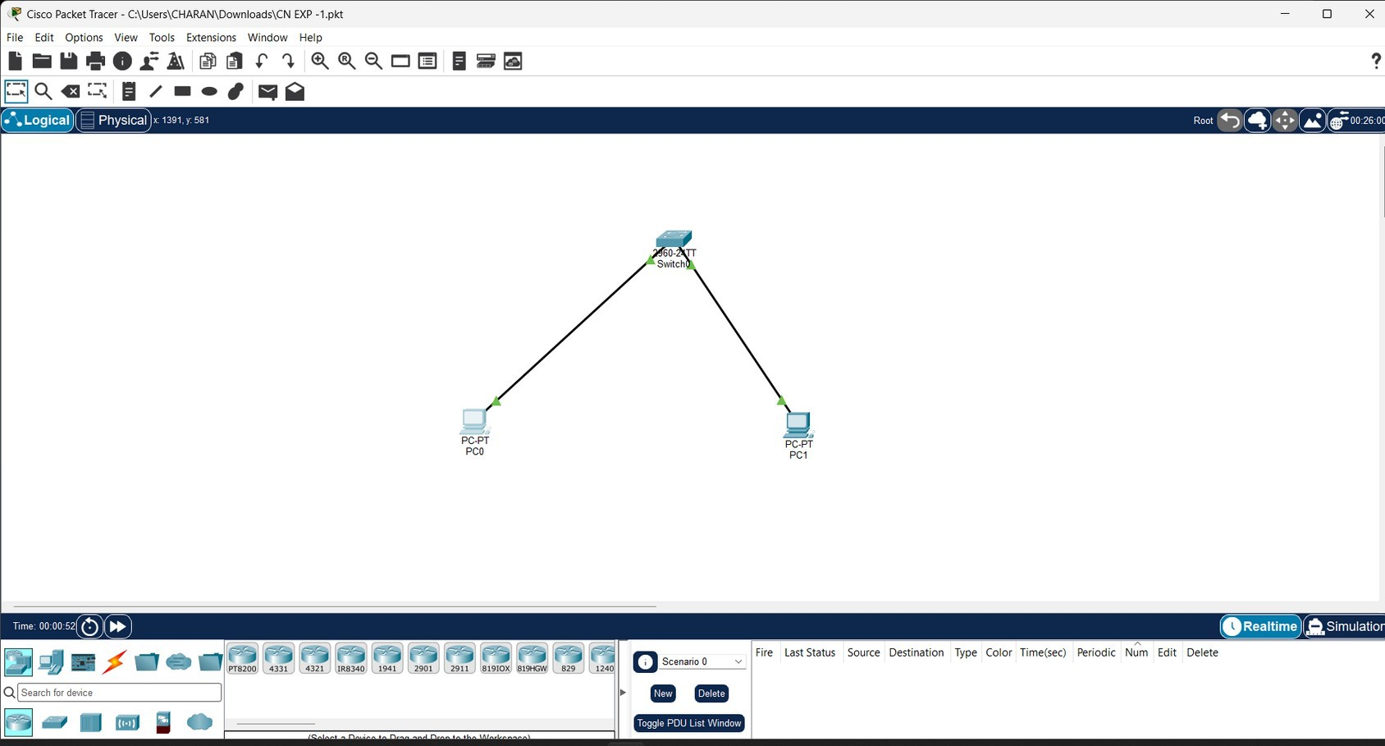
Figure 8: Final topology of Experiment 1 with both links up

Result
The ping from PC0 to PC1 was successful, as summarised below.

Source | Destination | Sent | Received | Lost | Min / Max / Avg RTT
PC0 | 192.168.1.2 (PC1) | 4 | 4 | 0 (0% loss) | 0 ms / 2 ms / 0 ms
Table 2: Ping result for Experiment 1
All replies were received with TTL = 128. The first reply took 2 ms and the remaining three took less than 1 ms. Hence, two PCs connected to a switch and configured with addresses in the same subnet can communicate successfully.

Experiment 2: Connecting Three PCs through a Switch (Star Topology)

Aim
To build a star topology with three PCs connected to a single switch, assign static IPv4 addresses to all the PCs, and verify connectivity using the ping command.

Requirements / Tools Used
    - Software: Cisco Packet Tracer
    - Network device: one Cisco 2960-24TT switch (Switch0)
    - End devices: three PCs (PC-PT), named PC0, PC1 and PC2
    - Cabling: Copper Straight-Through cables
    - Addressing: network 192.168.1.0 with subnet mask 255.255.255.0
The IP addresses configured in this experiment (as shown in the screenshots) are:

Device | Interface | IPv4 Address | Subnet Mask
PC0 | FastEthernet0 | 192.168.1.1 | 255.255.255.0
PC1 | FastEthernet0 | 192.168.1.2 | 255.255.255.0
PC2 | FastEthernet0 | 192.168.1.3 | 255.255.255.0
Table 3: IP addressing used in Experiment 2

Step-by-Step Procedure

Step 1: Place the first PC (PC0)
Select End Devices from the device-type panel, choose the PC (PC-PT) and drag it into an empty workspace. Packet Tracer names it PC0.

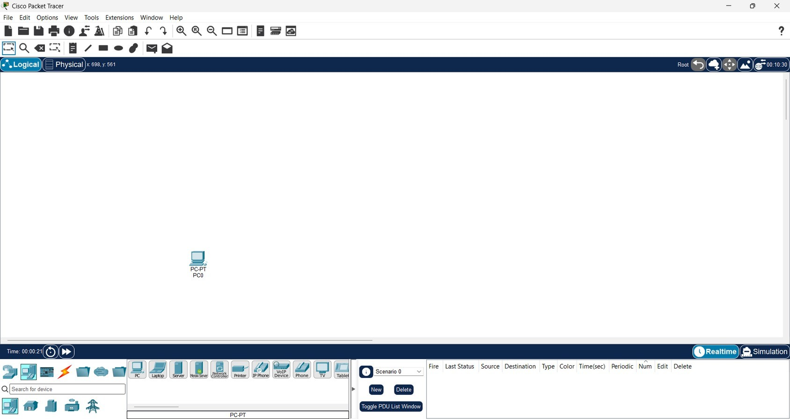
Figure 9: PC0 added to an empty workspace
Step 2: Place the second PC (PC1)
Drag a second PC from the End Devices panel into the workspace. It is named PC1.

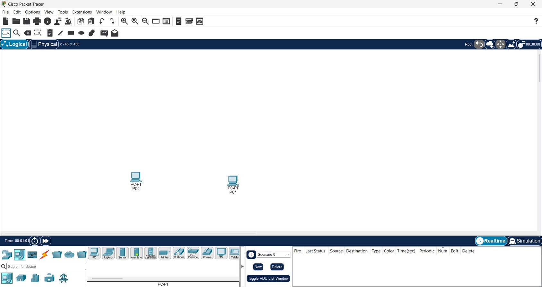
Figure 10: PC1 added next to PC0

Step 3: Place the third PC (PC2)
Drag a third PC into the workspace. It is named PC2. All three end devices are now in place.

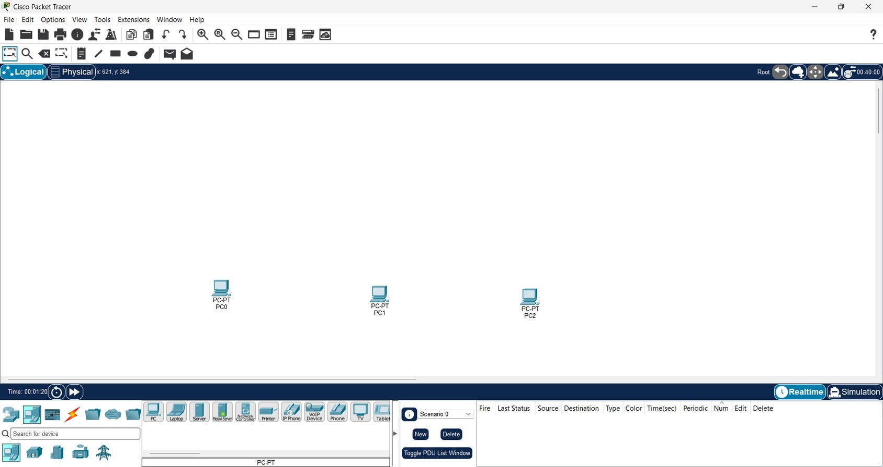
Figure 11: PC2 added; three PCs are in the workspace
Step 4: Place the switch
Select Network Devices and then Switches, and drag the 2960 switch (shown as "2960 IOS15" in the selection bar) into the workspace above the PCs. It appears as Switch0 (2960-24TT).

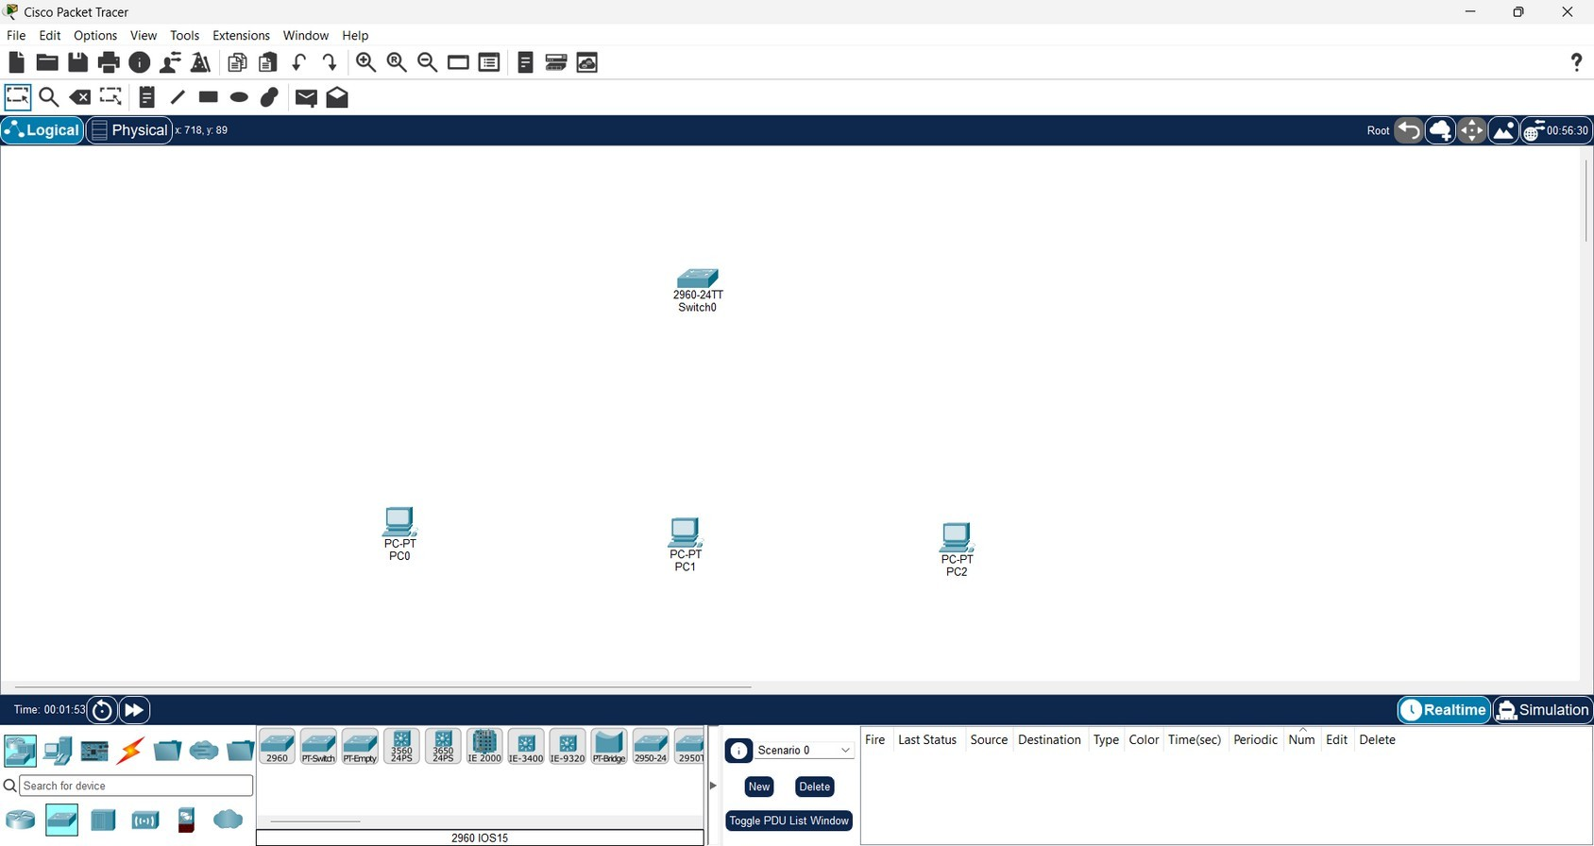
Figure 12: Switch0 (2960-24TT) added above the three PCs

Step 5: Connect the PCs to the switch
Select Connections and choose Copper Straight-Through. Connect the FastEthernet0 interface of each PC (PC0, PC1 and PC2) to a free port on Switch0, forming a star topology. In this screenshot, the PC0 link is green while the PC1 and PC2 ports on the switch still show orange indicators, as the ports were still coming up right after being connected.

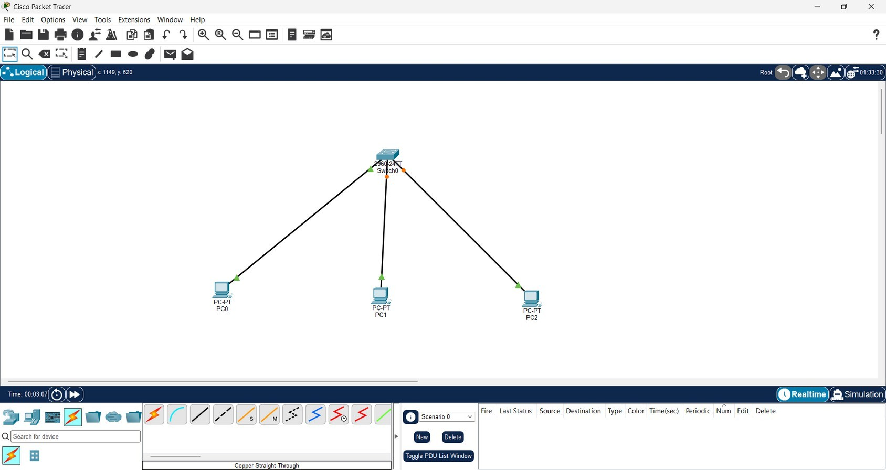
Figure 13: All three PCs cabled to Switch0 (links still initialising)
Step 6: Verify that all links are up
After a short time the link indicators on all three connections change to green, which shows that the switch ports are active and the physical connections are working.

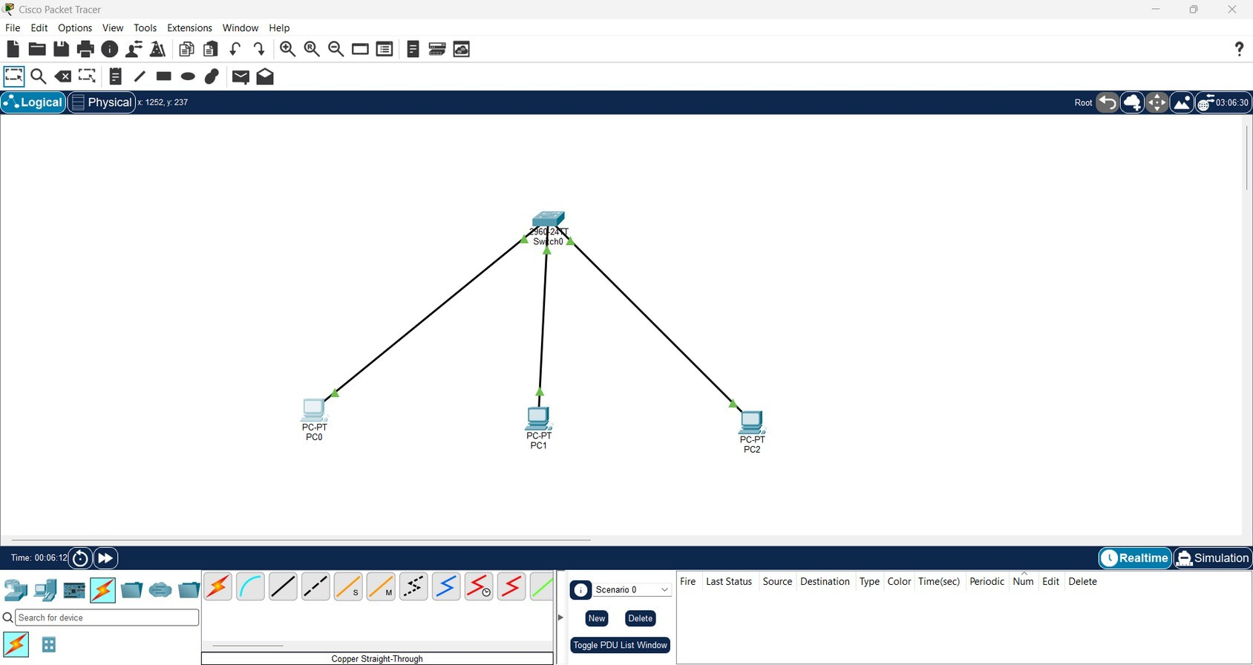
Figure 14: Star topology with all links showing green

Step 7: Configure the IP address of PC0
Click PC0 and open the Config tab. Under INTERFACE select FastEthernet0, choose Static, and enter IPv4 Address 192.168.1.1 with Subnet Mask 255.255.255.0.

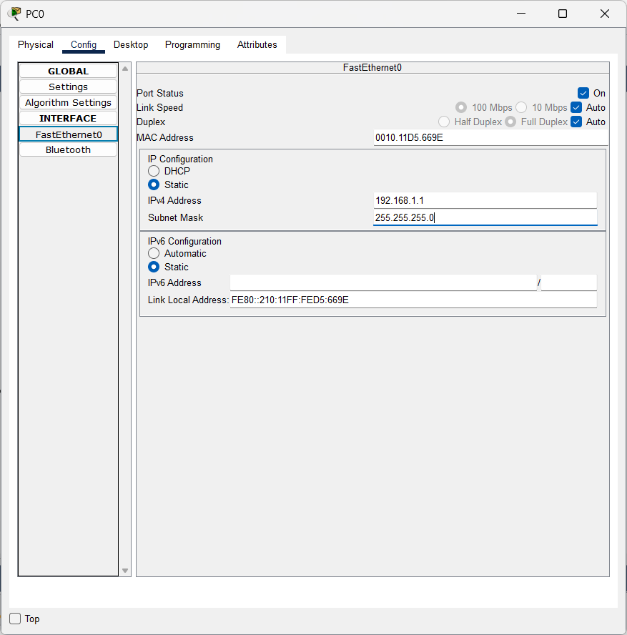
Figure 15: IP configuration of PC0 (192.168.1.1 / 255.255.255.0)
Step 8: Configure the IP address of PC1
Open the Config tab of PC1, select FastEthernet0, choose Static and enter IPv4 Address 192.168.1.2 with Subnet Mask 255.255.255.0.

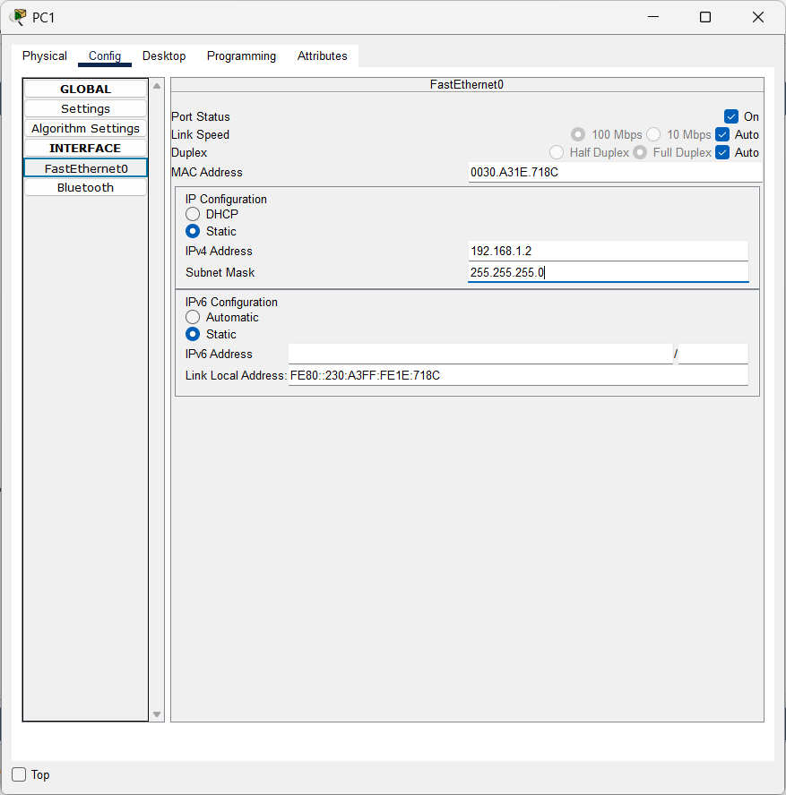
Figure 16: IP configuration of PC1 (192.168.1.2 / 255.255.255.0)

Step 9: Configure the IP address of PC2
Open the Config tab of PC2, select FastEthernet0, choose Static and enter IPv4 Address 192.168.1.3 with Subnet Mask 255.255.255.0.
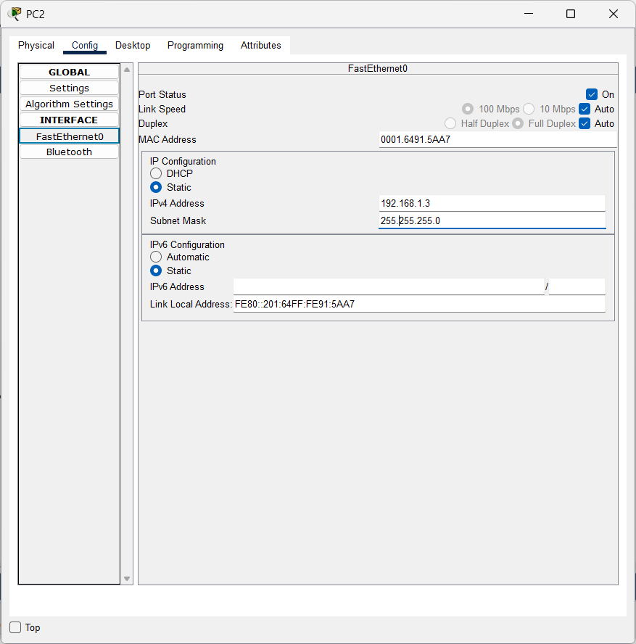
Figure 17: IP configuration of PC2 (192.168.1.3 / 255.255.255.0)

Step 10: Test connectivity using ping
Open PC0, select the Desktop tab and click Command Prompt. Three ping commands were run, in this order: (a) ping 19.168.1.2, which was typed incorrectly and does not match any device in the network, so all four requests timed out (100% loss); (b) ping 192.168.1.2 (PC1), which succeeded; and (c) ping 192.168.1.3 (PC2), which also succeeded.
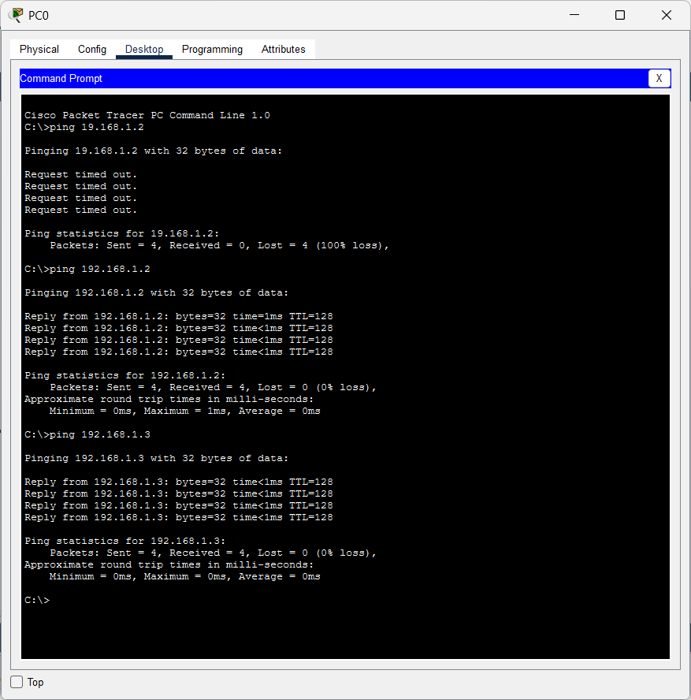
Figure 18: Ping results from PC0 to PC1 and PC2

Result

Source | Destination | Sent | Received | Lost | Min / Max / Avg RTT
PC0 | 19.168.1.2 (mistyped) | 4 | 0 | 4 (100% loss) | Not applicable
PC0 | 192.168.1.2 (PC1) | 4 | 4 | 0 (0% loss) | 0 ms / 1 ms / 0 ms
PC0 | 192.168.1.3 (PC2) | 4 | 4 | 0 (0% loss) | 0 ms / 0 ms / 0 ms
Table 4: Ping results for Experiment 2
PC0 received all replies from both PC1 and PC2 (TTL = 128), so the star topology works correctly. The first ping failed only because the address 19.168.1.2 was mistyped; it does not belong to this network, and the correct address 192.168.1.2 was reachable. The ping tests in the screenshots were run from PC0 only.

Overall Conclusion

In Experiment 1, two PCs were connected to a 2960 switch using straight-through cables, assigned the static addresses 192.168.1.1 and 192.168.1.2 with the mask 255.255.255.0, and verified with a ping that showed 0% packet loss.
In Experiment 2, the same design was extended to a star topology of three PCs (192.168.1.1, 192.168.1.2 and 192.168.1.3). PC0 reached both PC1 and PC2 with 0% packet loss, while a ping to a mistyped address failed, showing that correct IP addressing is required for communication.
Together, the experiments show that devices connected to the same switch can communicate directly when they use unique IP addresses in the same subnet. The link indicators and ping replies served as the checks for the physical connection and for network-layer connectivity respectively.

