DWDM_MODEL_EXAM_10.04.2021

18BCS050

Charan A B

SET 6

1.Download a suitable dataset for clustering from any Repository. List the attributes and its type in a word doc.

Credit Card Dataset for Clustering:

The Credit Card Dataset is downloaded from Kaggle repository.

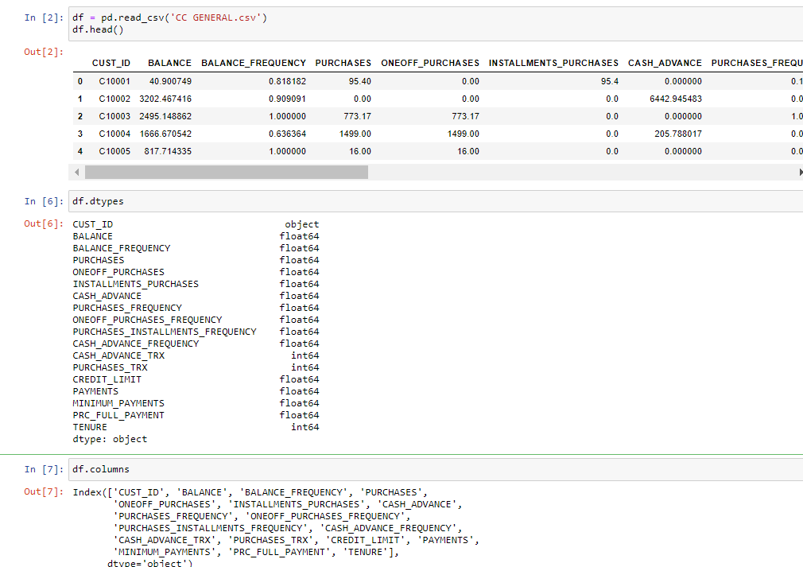

Attributes and their types:

CUST_ID - Categorical,Nominal

BALANCE - Numerical,Continuous

BALANCE_FREQUENCY - Asymmetric Binary

PURCHASES - Numerical,Continuous

ONEOFF_PURCHASES - Numerical,Continuous

INSTALLMENTS_PURCHASES - Numerical,Continuous

CASH_ADVANCE - Numerical,Continuous

PURCHASES_FREQUENCY - Asymmetric Binary

ONEOFF_PURCHASES_FREQUENCY - Asymmetric Binary

PURCHASES_INSTALLMENTS_FREQUENCY - Asymmetric Binary

CASH_ADVANCE_FREQUENCY - Asymmetric Binary

CASH_ADVANCE_TRX - Numerical,Continuous

PURCHASES_TRX - Numerical,Continuous

CREDIT_LIMIT - Numerical,Continuous

PAYMENTS - Numerical,Continuous

MINIMUM_PAYMENTS - Numerical,Continuous

PRC_FULL_PAYMENT - Numerical,Continuous

TENURE - Numerical,Continuous

2. Apply DBSCAN algorithm to make clusters to identify dense region using the dataset.

