Global Happiness Trends: A Power BI Data Analysis Report

Introduction
The aim of this project is to examine the happiness and well-being levels across the globe through interactive Power BI dashboards. It will identify the main drivers of happiness and how they vary from nation to nation and across regions. This research will provide figures that will be extremely valuable in policymaking, social advancement, and efforts in world well-being.
Dataset Description
- What it is: The data introduces the World Happiness Report 2024, based on life satisfaction scores (Ladder Score) and some explanatory variables at the country level.
- Source URL to dataset: Retrieved from Kaggle — [ https://www.kaggle.com/datasets/ajaypalsinghlo/world-happiness-report-2024 ].
- Column headers: Include Country, Region, Ladder Score, Explained by: Log GDP per capita, Social support, Healthy life expectancy, Freedom to make life choices, Generosity, Perceptions of corruption, and Dystopia + residual.
- -Data rows: Over 1,000 rows from a number of countries with complete well-being indicator data.

Methodology
Tool utilized
Power BI was chosen because of its advanced data modeling, simple dash boarding, and strong interactive visualization features. Its DAX calculations, slicers, and custom visuals also positioned it to be effective in analyzing well-being data and communicating dynamic insights in an effective way.

Visualization Creation Process
The information was exported to Power BI and purified using Power Query for data validity and consistency. Several types of visualizations such as bar charts, pie charts, map charts, line charts, and donut charts were used to graph the happiness trends of nations and regions. Slicers and tooltips have also been used in the dashboards to allow dynamic filtering and additional analysis of the outcome. Standard color schemes and appropriately captioned graphs were employed to enhance readability, comprehensibility, and effective communication of pertinent results.

Analysis Results Table

Dashboard 1:Global Happiness Overview
Positive Insights | Negative Insight | Additional Comments
Europe and the "Other" region contribute the highest ladder scores, indicating stronger well-being across those areas. | Oceania records the smallest share of the total ladder score, possibly reflecting lower life satisfaction or underrepresentation. | Treemap allows for quick , comparative regional overview
North America & South America show consistent ladder score contributions, indicating social and economic stability.

Asia and Africa exhibit moderate scores, revealing varied but improving well-being levels across emerging nations.

Map visualization helps geographically contextualize well-being across continents

Dashboard 1

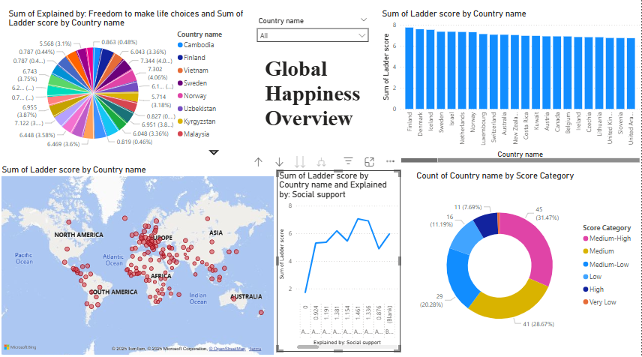

Dashboard 2: Economic & Social Influence
Positive Insights | Negative Insight | Additional comments
GDP is a consistently influential factor across all regions, highlighting the importance of economic stability. | Africa and the Middle East exhibit relatively low social support scores, which may impact overall happiness. | The stacked column format is effective in comparing multiple variables by region.
Social support is most prominent in North America and Oceania, aligning with their higher ladder score.
Healthy life expectancy remains relatively balanced, showing baseline health equity across several regions.
Visuals provide clear comparisons, with line charts emphasizing disparities between contributing factors.

Dashboard 2
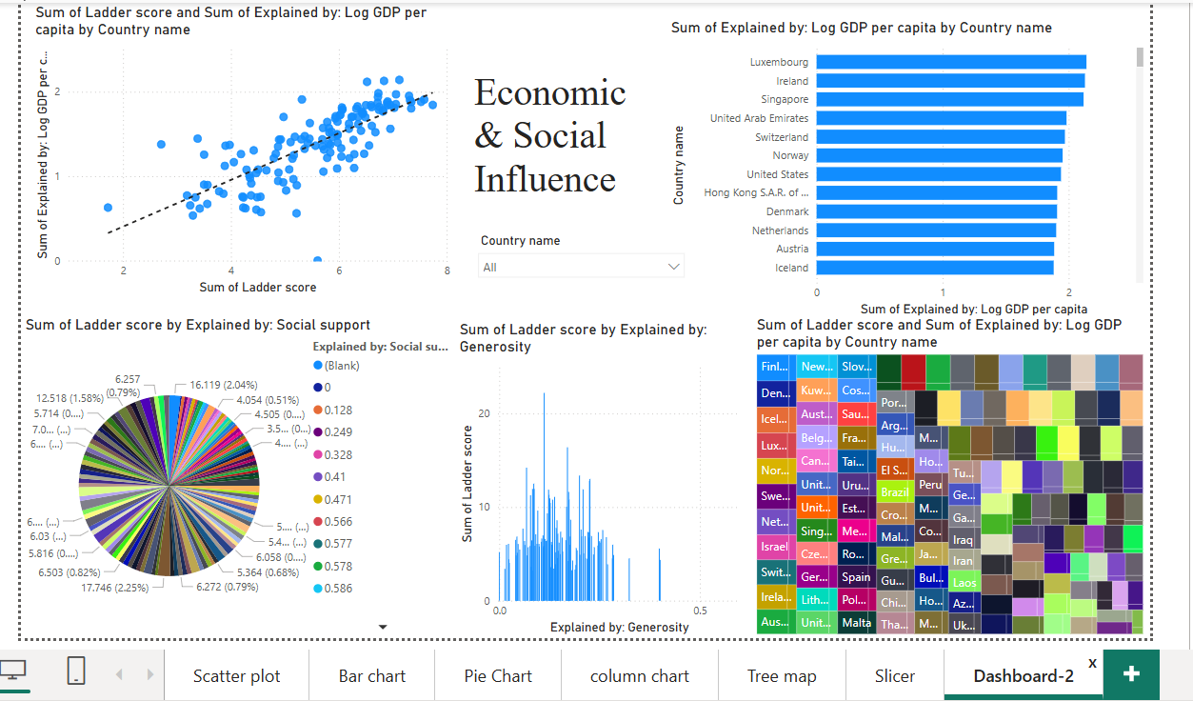

Dashboard 3: Global Happiness Trends by Region

Positive Insights | Negative Insight | Additional Comments
Europe and "Other" regions contribute the highest ladder scores, reflecting strong well-being and social stability. | Oceania, Africa, and the Middle East show lower ladder scores and weaker contributions from key well-being factors like social support and freedom. | The treemap and map visuals effectively highlight regional disparities.
Social support and healthy life expectancy remain key happiness drivers in North America, Oceania, and Europe.
Freedom to make life choices shows higher influence in "Other" regions and Europe, enhancing life satisfaction.
The line chart clearly displays factor-wise variations across regions, showing consistent patterns among higher-scoring regions.

Dashboard 3

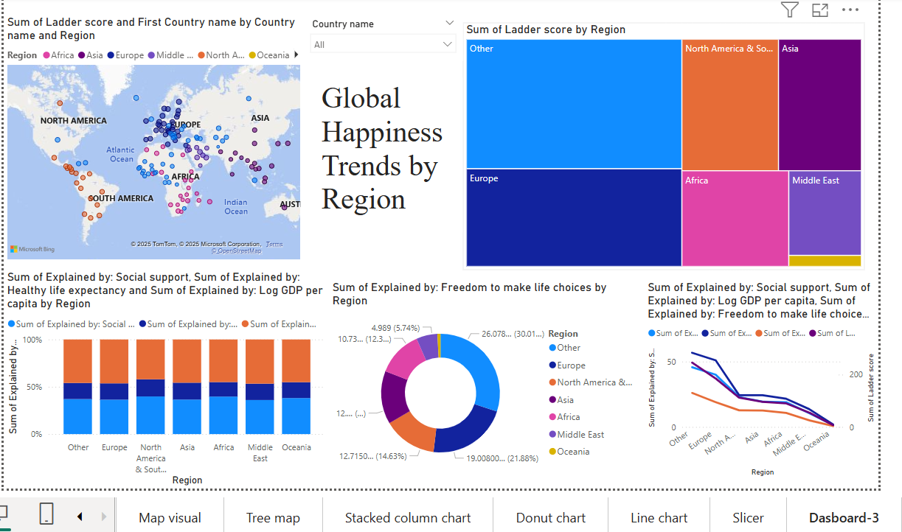

Conclusion
Power BI examination of global patterns in well-being identified striking differences between countries and between areas of the state of well-being. Social support, healthy life expectancy, ability to make choices, and GDP drive these scores of well-being. The developed world nations and western world nations have high, stable scores whereas the scores of Oceania region, Africa, and Middle East on determinants that satisfy are poor and hence low scores. Interactive dashboards provided easy and interactive analysis of such trends, which allowed evidence-based conclusions. The project outlines the social investment role and specific policies to increase happiness, especially low-scoring dimensions of happiness. In all, this discussion demonstrates how data visualization can facilitate to view and lead to meaningful conclusions.

