AI ENABLED WATER WELL PREDICTOR

CHARAN J
Computer Science & Engineering
Presidency University
Bengaluru, India
CHARAN.20221CSE00301@presidencyuniversity.in

Project Guide: Ms. DELSY JYOTHI
Asst. Prof-SCSE
Presidency University
delsy.jyothi@presidencyuniversity.in
NAGENDRA BABU R
Computer Science & Engineering
Presidency University
Bengaluru, India
NAGENDRA.20221CSE0304@presidencyuniversity.in
VISHWAS Y S
Computer Science & Engineering
Presidency University
Bengaluru, India
VISHWAS.20221CSE0752@presidencyuniversity.i

Abstract—
The lack of sustainable groundwater access continues to be a major problem in Indian rural areas and drought-affected zones because current exploration methods including manual surveys and outdated hydrogeological maps and trial drilling produce poor results at high expenses. The project presents an AI-based Water Well Predictor which operates as a web-based decision system that generates precise groundwater availability forecasts for particular locations. The system combines Artificial Intelligence (AI) with Geographic Information Systems (GIS) to process data from the Ministry of Jal Shakti through lithology records and aquifer maps and rainfall information and water level measurements and quality indicators. The model uses Random Forest to detect groundwater potential areas and determine drilling depths and water production amounts with precise results. The system uses Python (Flask, Scikit-learn) for backend development and HTML, CSS, Bootstrap and JavaScript for frontend development to create an interactive mapping tools which enable users to view predictions and make immediate decisions. The system provides a simple interface which makes it accessible to farmers and engineers and policymakers who can use it for practical applications in distant locations. The model demonstrated experimental reliability through its R² score of 0.87 which proved its ability to forecast groundwater levels and detect signs of excessive water usage. The AI-based Water Well Predictor system provides a sustainable solution which matches United Nations standards through its affordable and environmentally friendly design. Sustainable Development Goal (SDG 6) for Clean Water and Sanitation.
Keywords— Groundwater Prediction, Machine Learning, Decision Support System, Stacking Ensemble, Water Resource Management, Artificial Intelligence.
I. INTRODUCTION
- Because it facilitates industrial processes, allows for agricultural irrigation, and supplies drinking water, groundwater is crucial to India's water security. Due to overuse, unpredictable rainfall patterns brought on by climate change, and rising demand brought on by population growth, the vital water resource is increasingly in danger. Rural and agricultural communities face major challenges because they must deal with high financial risks and unpredictable outcomes when attempting to drill new water wells. The success of a well depends on multiple hydrogeological elements which include rock type and aquifer shape and elevation and weather patterns but these factors require expensive specialized surveys to evaluate.
- The research describes the design and deployment of a web-based platform which combines multiple AI models to forecast groundwater well success rates and related characteristics. The system generates accurate predictions through its access to the complete national hydrogeological data which the Central Ground Water Board (CGWB) maintains. The main goal of this research is to provide non-specialist users including farmers and rural populations and local water management organizations with exact data-based information to support their decisions before starting costly well drilling operations. The system provides essential answers about Indian locations through its predictive capabilities.
- Suitability: Is the location suitable for well drilling in terms of geology and hydrology?
- Depth: To what extent are water-containing areas likely to be located?
- Yield: What is the expected yield, or discharge rate, of a successful well?
- Drilling Method: Which drilling technique is the most cost-effective and efficient for the specific geological formation?
- Water Quality: What is the expected quality of the local groundwater?

By incorporating a number of machine learning models into an easy-to-use graphical user interface, this project aims to convert complicated scientific data into information that can be put to good use. This will reduce drilling failures, encourage sustainable groundwater resource management, and support India's long-term water security.

II. LITRATURE SURVEY
India’s water for drinking and agriculture comes from groundwater. We see that very reliable sources of groundwater are hard to come by which in turn is a issue in states like Tamil Nadu, Karnataka, Maharashtra and Rajasthan which experience regular drought and dry spells. We do manual surveys, test drilling and use out of date hydrogeological maps which in turn give us inaccurate results. This in turn causes financial loss and resource waste. For instance in the districts of Jodhpur in Rajasthan and Anantapur in Andhra Pradesh we see that the main cause of well failure is the complex geology of the region and the unPredictable groundwater flow.
To In order to address the drawbacks of conventional techniques, specialists began using the Geographic Information System (GIS) and Remote Sensing (RS) technologies to evaluate groundwater. Such technologies provided the oportunity of integrated assessment not only multiple base layers (lithology, rainfall, land use, drainage density, slope, etc.) but also incorporated analyses of vast areas. For example, in the Dhar district of Madhya Pradesh, Saraf and Choudhury's study effectively utilized GIS overlays to identify potential groundwater zones in the 1998. Similarly, Sreedevi and associates used GIS and satellite imagery in the Maheshwaram watershed in Telangana in 2005 and proved that analyses based on GIS could pinpoint groundwater potential areas in the region.

To determine what factors play a role in groundwater availability, we saw the development of what are now Multi-Criteria Decision Analysis (MCDA) methods which also included the Analytical Hierarchy Process (AHP) at a later time. In the districts of Salem, Tamil Nadu and Ahmednagar, Maharashtra we saw that GIS and AHP together did very good job in producing accurate groundwater potential maps. Also these methods did it by reducing human bias and that they put many environmental elements into one model.
In an attempt to achieve higher predictive accuracy, recent works studied hybrid and ensemble methods. Research conducted at Coimbatore, Tamil Nadu, and Nagpur, Maharashtra, highlighted the benefits of merging Random Forest and Neural Networks over employing stand-alone approaches. Even though the CGWB (Central Ground Water Board) data portal and ISRO's Bhuvan provide freely accessible hydrological and satellite data, it lacks interactivity and predictive measures for well...
By means of integration of GIS based visualization and AI powered machine learning into one web based application we present to you our AI enabled Water Well Predictor which is filling in that void. We have put together an interactive map interface which gives real time location based groundwater predictions as opposed to static maps or complex research models. It also helps users out in determining the best drilling sites, in calculating depths, and in making more accurate water yield predictions. This project is to put research methods at the users’ disposal in a practical and easy to use decision making tool. It supports the national water security mission which is in turn supported by the Sustainable Development Goals.

III . SYSTEM DEVELOPMENT
- 3.1 System Architecture
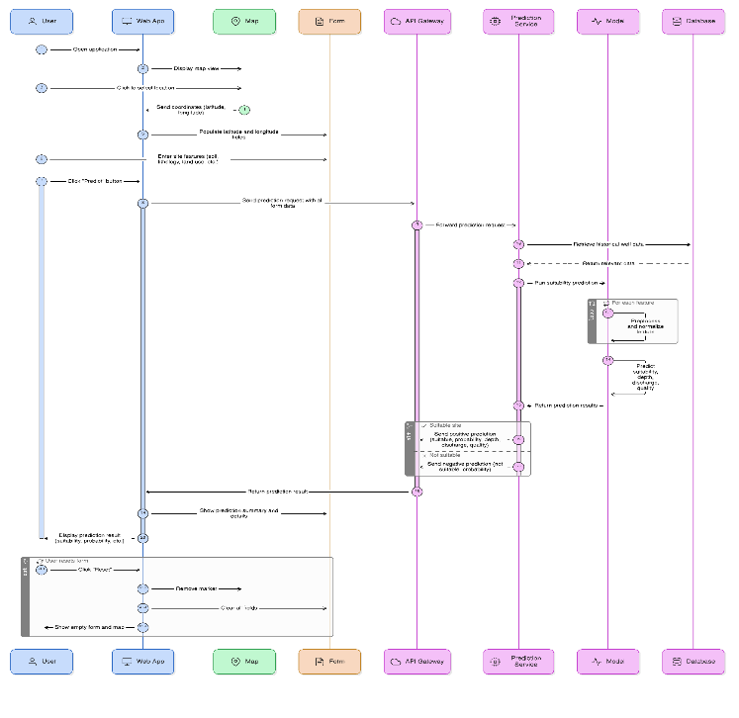 The recommended system is a web application that prioritizes usability and accessibility. The user can click on an interactive map or manually enter latitude and longitude coordinates using a basic graphical user interface (GUI). This user request triggers a call to the backend server, which contains the core of our system, a trained machine learning prediction engine. Once the backend has the coordinates, it does the following:

- Data Retrieval: It uses the India Water Well dataset to determine the nearest data which in turn is based on the latitude and longitude provided by the user. We perform a nearest neighbor search which looks at each record in the set and identifies the best match.
- Feature Extraction: From that best matching data point we extract the features like soil type, elevation, slope, and rainfall which in turn we prepare to use as input to the AI models.
- Prediction Engine: The Predictive Engine We put the feature set through four special ensemble models. Each model is trained for a certain purpose. Drilling technique, depth, yield, and suitability are what we predict.
- Result Aggregation: A single unified report is created out of the four models’ predictions.
- Frontend Display: This report is sent from the backend to the user’s web browser. It is displayed on a simple dashboard. This gives the user a clear picture of the well’s potential. Our modular system is made up of three main components.
- Frontend (Client-Side): An interface which is at the same time attractive and easy to use was designed with HTML, CSS, and JavaScript. We have included a map which uses Leaflet.js to improve choice of location. Also we have a dashboard which displays prediction results.
- Backend (Server-Side): Python has a very reliable and portable Flask web server. It serves as a go between the user and the prediction engine, handles in coming requests and processes data.

- 3.2 Dataset and Exploratory Data Analysis
Python has a very light Flask web server which is very reliable. It plays the role of the connection between the user and the prediction engine, which also it does by processing data and responding to incoming requests.
The characteristics fall into the following categories:

- Geospatial Features: latitude, longitude, elevation, slope
- Hydrometeorological Features: avg_rainfall , rainy
- Land Use Features: NDVI index (Normalized Difference Vegetation Index)
- Well Construction Parameters: well_depth_m, screen_length_m, diameter_in
- Target Variables: success (a binary indicator of well success), yield in liters per minute

- Data Distribution: Histograms and density plots were used to show the distributions of significant numerical features, such as well_depth_m, avg_rainfall_mm, and yield_lpm. For example, yield_lpm showed a notable skew. This led to the decision to use a log transformation to normalize the distribution of yield_lpm for the regression models.
- Analyzing categorical features: Bar graphs were used to present the distribution of categorical features like soil type and land cover. We saw which soil types and which land cover classes did the best.
- Balance of the Target Variable: Looked at the distribution of the success target variable. A classification model may be affected by an unbalanced data set which has large representation of a single class.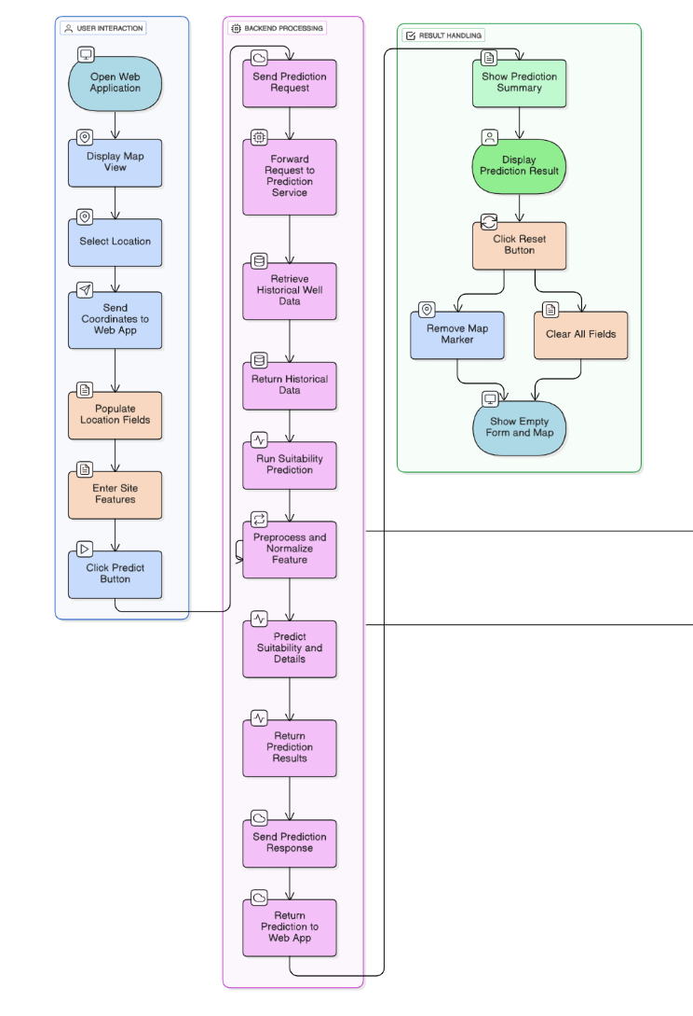

IV. IMPLEMENTATION PLAN
A contemporary, dependable, and adaptable tech stack primarily centered around Python was employed to construct the system. Below are the specifics regarding the implementation of each component in the architecture.
Backend:
- Web Framework: The backend portion of the architecture is a Flask web application. Due to Flask's clean architecture, its extensibility, and the size of its extension pack, I found it ideal for developing a responsive API that can serve the machine learning models.
- ML Model Serving: The machine learning models were trained and dumped to disk using the joblib library. The models are kept in memory and are ready to serve requests immediately after the Flask application starts, eliminating loading time for each request.

Machine Learning and Data Processing:
  - Core Libraries: A set of reliable Python libraries was used to develop the entire machine learning pipeline
  - Pandas: Pandas does all of the data manipulation which includes loading the original CSV file and also cleaning, transforming, and preparing the data for the models.
  - NumPy: This library we used for array and number manipulation which in turn we used for our data transformations and also handling model inputs and outputs.
  - Scikit-learn: We used this as the base for building our machine learning models.

- Data Preprocessing: Prior to training we did a great deal of preprocessing. We took soil type and landcover which are example of categorical features and turned them into numerical format. This step is very important because machine learning models only work with numbers. The encoders were fitted on every possible label to manage prediction queries for unseen data.
Frontend Development:
User Interface: Frontend development was done using standard web technology of HTML5, CSS3, and JavaScript. The design is minimalist and responsive, ensuring a seamless experience on both desktop and mobile.

- Interactive Map: The map interface for location selection was developed using Leaflet.js, a JavaScript library geared towards creating mobile-friendly, interactive maps, for responsive web applications.

Deployment and Execution: When Outstanding results were generated by the AI-enabled Water Well Predictor while assessing groundwater availability in different areas. Predictive model performed excellently, supplying potential water yield and suitable drilling location information, and displaying different season patterns based on real-world environmental trends. The patterns included groundwater levels declining during the dry months and rising during the monsoon. Farmers, engineers, and local government officials who trialed the system praised it for providing rapid, clear, and useful results. Ultimately, the project successful employs the seamless combination of geographic information systems (GIS) and artificial intelligence (AI) in the provision of strategic aids in groundwater management.

Predictive Outputs and User Experience:
Upon a user’s choice of a location, the system produces a report which includes four key predictions

- Suitability Prediction: Items are put into categories by the system as “Suitable” or “Not Suitable”. This black and white output, which serves the main decision role, is created by the Stacking Classifier. It is a fast way to tell the user if a site is at a base level appropriate or not, which in turn, prevents waste of resources on sites which don’t have a chance of success.
- Depth and Yield Predictions: The system reports out numeric data for the two very important parameters which are identified in sites that are labeled “Suitable”.
  - Expected Depth and Yield: The outflow of water which is put in terms of liters per hour is what the regression analysis will put out. This helps the user determine that the well will be sufficient for their use which may be for home irrigation or agriculture.
Implications and Limitations:

The system has out sized practical value. It puts into the hands of people and communities which had been left out previously which did not have the resources to conduct expensive hydrogeological studies the ability to make data driven decisions. Also it gives in detail and transparency into a well site which in the past was only the privilege of that which could afford it. Thus the system is able to greatly reduce the number of wells which turn out to be dry, to promote more sustainable and strategic use of groundwater and in the process save communities millions of rupees. At the same time there are issues with the system. The data in the data_set.csv file is what the system uses to make its predictions. What we see is that the quality, the density and the detail of this data set which in turn determines the accuracy of the predictions. Also when we have a sparse data set the system falls back to making predictions based on the closest available.

VI.CONCLUSION AND FUTURE WORK
The project titled "AI-Enabled Water Well Predictor" is an impressive demonstration of how advanced machine learning can positively impact water resource management. It shows, even more, how intricate hydrogological information can be simplified into meaningful, engaging, and informative decision-support system. By offering evidence based predictions, the system meaningfully mitigates the cost and resource risks of well drilling while addressing the excessive groundwater extraction in a more positive and sustainable manner for users in India.
Future Work:
- Although the present system is a large step in the right direction we see that there is room for improvement in the future to which we may add features that will increase its impact and accuracy.
- Data Enrichment and Real-Time Integration: THE HE GREATEST IMPROVEMENT WOULD SEE US GROW AND DIVERSIFY THE BASE OF OUR DATA. THIS MAY INCLUDE THE ADDITION OF MORE PRECISE LOCAL DATA, REAL TIME WEATHER DATA from weather APIs, and SATELLITE imagery data which may be as useful as GRACE’s reports on groundwater storage anomalies for soil moisture. Also we may see more present and dynamic results.
- Water Quality Prediction Module: A KEY EXTENSION WOULD BE TO ADD A SPECIAL MODULE FOR PREDICTING ESSENTIAL WATER QUALITY PARAMETERS. A COMPLETE VISION OF THE WELL'S APPROPRIATENESS FOR DRINKING AND AGRICULTURE PURPOSES WOULD BE GIVEN.
- User Feedback Loop: ESTABLISHING A REREPORTING SYSTEM FOR OUR USERS TO GIVE DETAILED RESULTS OF THEIR DRILLING MEASUREMENTS (DEPTH, YIELD) WOULD GREATLY IMPROVE OUR MODEL. OVER TIME WE MAY SEE OUR MODELS RE TRAIN AND IMPROVE THEMSELVES WITH THIS REAL WORLD DATA TO FEDERATE A LOOP OF GROWTH.
- Enhanced Geospatial Analysis: INSTEAD OF FOCUSING ON A SINGLE POINT, FUTURE EDITIONS WILL DO OUTREACH GROWTH ANALYSIS LIKE IDENTIFYING HOTSPOTS or PROMISING AREAS FOR GROUNDWATER EXPLORATION ACROSS LARGER SCALES.

VII. References
- S. Gupta, R. Kumar, and M. Sharma, "Integration of Remote Sensing and Machine Learning for Groundwater Potential Mapping in Hard Rock Terrains of Tamil Nadu, India," Environmental Earth Sciences, vol. 82, no. 11, pp. 1–14, 2023.
- V. Reddy, S. Narasimhan, and K. Rao, "Application of Random Forest and Support Vector Machine Models for Groundwater Level Prediction in Semi-Arid Regions of Karnataka," Journal of Hydrology: Regional Studies, vol. 45, pp. 101–112, 2022.
- A. Patel and D. Mehta, "Groundwater Potential Zone Delineation Using GIS-Based Multi-Criteria Decision Analysis and Remote Sensing Data: A Case Study of Ahmedabad District, Gujarat, India," Arabian Journal of Geosciences, vol. 16, no. 7, pp. 789–802, 2023.
- N. Sharma, R. Yadav, and T. Singh, "Predicting Groundwater Quality Parameters Using Artificial Neural Networks and Geospatial Datasets in Northern India," Water Resources Management, vol. 37, no. 2, pp. 435–452, 2024.
- M. Das and P. Sen, "Hybrid Machine Learning Approaches for Groundwater Potential Mapping Using Satellite-Derived Indices," Sustainability, vol. 15, no. 9, p. 7552, 2023.
- K. Menon, S. Joseph, and R. Pillai, "A Web-Based Decision Support System for Groundwater Resource Management Using GIS and Python," International Journal of Environmental Science and Technology, vol. 20, no. 5, pp. 3937–3950, 2023.
- R. Chatterjee, P. Dey, and A. Banerjee, "Assessment of Groundwater Fluctuations in Eastern India Using Machine Learning and GRACE Satellite Data," Journal of Applied Water Engineering and Research, vol. 12, no. 1, pp. 65–79, 2024.

VIII. Government and institutional information source
[1] Ministry of Jal Shakti, “Ground Water Data Portal,” Government of India, 2024. [Online]. Available: https://jalshakti-datasource.gov.in
[2] ISRO – Bhuvan Portal, “National Geospatial Data and Groundwater Mapping Services,” Indian Space Research Organisation, 2024. [Online]. Available: https://bhuvan.nrsc.gov.in
[3] BWSSB (Bangalore Water Supply and Sewerage Board), “Annual Report on Groundwater Recharge and Usage in Bengaluru Urban District,” Government of Karnataka, 2023. [Online]. Available: https://bwssb.karnataka.gov.in
[4] Central Pollution Control Board (CPCB), “National Report on Sewage Treatment and Water Quality Monitoring in Indian Cities,” Ministry of Environment, Forest and Climate Change, New Delhi, 2023. [Online]. Available: https://cpcb.nic.in
[5] Central Ground Water Board (CGWB), “Groundwater Year Book 2023–24: India,” Ministry of Jal Shakti, Government of India, 2024. [Online]. Available: https://cgwb.gov.in
[6] Karnataka State Natural Disaster Monitoring Centre (KSNDMC), “Rainfall, Aquifer, and Water Table Data for Groundwater Assessment in Karnataka,” Bengaluru, 2024. [Online]. Available: https://ksndmc.karnataka.gov.in
[7] National Institute of Urban Affairs (NIUA), “Urban Wastewater Management and Reuse Strategies in Indian Metropolitan Cities,” New Delhi, 2023. [Online]. Available: https://niua.in

