**MAGNETO METER TECHNOLOGY**

The magnetometer, also known as a **magnetic sensor**, is a sensor for measuring magnetic induction (magnetic field intensity), which is an important sensor component in all types of aircraft and spacecraft. It also has been widely used in other fields, such as industry, agriculture, national defense, as well as biology, medicine, aerospace, interplanetary research, etc., and currently almost no field of technology is immune from magnetic field measurement.

The magnetometer plays a more important role in the development, research, operation, management, and maintenance of defense equipment and weapons. For example, magnetic sweeping, ship degaussing, weapons search, magnetic wave communication, magnetic detection, magnetic guided missiles, as well as underwater mines, landmines, bomb detectors, and magnetic navigation, etc., are all inseparable from magnetic field measurement techniques. In addition, the magnetometer has the characteristic that other types of sensors do not have of being able to work normally under severe and limited conditions.

In the field of aeronautics, the magnetometer can be used to measure the geomagnetic field vector information of the position of the aircraft body, such as airplanes and satellites. And, according to the reference model for the Earth’s magnetic field and local magnetic field, the angle information of a certain precision can be obtained through an algorithm, therefore, the magnetometer is widely used in aircraft attitude determination systems, especially in microsatellites, such as [nanosatellites](https://www.sciencedirect.com/topics/engineering/nanosatellites) and [picosatellites](https://www.sciencedirect.com/topics/engineering/picosatellites), etc.

Magnetometers can be classified according to different criteria.

According to its physical effects, magnetometers can be classified as follows: sensors made according to Faraday’s electromagnetic induction law are called **Induction magnetometers**; magnetometers working by the principle that current in the magnetic field can generate a [**Lorentz force**](https://www.sciencedirect.com/topics/engineering/lorentz-force) are called magnetic magnetometers; where the resistivity of the conductor changes in the magnetic field, this type of sensor is called a **magneto-resistive** magnetometer; magnetometers based on the Faraday magneto-optical effect are called **magneto-optical magnetometers**, such as the optical pump magnetometer; magnetic sensors based on the Josephson effect are called superconducting quantum interference devices (SQUID), etc.

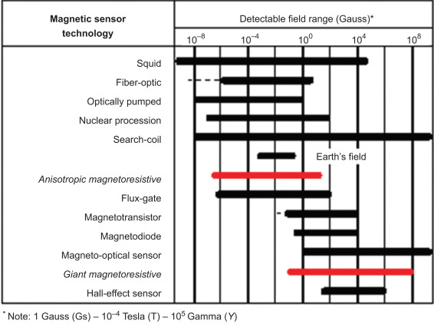

Fig: Sensitive range of different types of magnetometer.

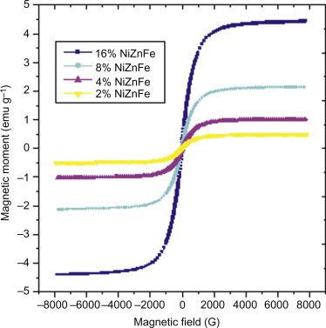

Fig: The magnetic moment of PAN nanocomposite fibers as a function of applied fields.

**10−5 Gs 1 Gs**

**Category 3**  **Category 2**   **Category 1**

**High Sensitivity**  **Medium Sensitivity**  **Low Sensitivity**

*Definition: Definition: Definition:*

• Measuring field gradients •Measuring perturbations •Measuring fields or differences due to induced in the magnitudes and/or stronger than the

(In Earth’s field) or direction of Earth’s field due Earth’s field.

dipole moments. to induced or permanent dipoles.

***Major applications*** ***Major applications******Major applications***

• Brain function mapping • Magnetic compass • Noncontact switching

• Magnetic anomaly detection • Munitions fuzing • Current measurement • Mineral prospecting • Magnetic memory read

***Most common sensors*** ***Most common sensors***  ***Most common sensors***

•SQUID gradiometer •Search-coil magnetometer •Search-coil

Magnetometer

•Optically pumped •Flux-gate magnetometer •Hall-effect sensor

magnetometer