Reinforcement Learning Framework for Intelligent Energy Management in Smart Buildings
P. Dheeraj  Dept. of Computer Science & Engineering  Koneru Lakshmaiah Education Foundation  Bowrampet, Hyderabad, India  pitladheeraj@gmail.com | T. Charan  Dept. of Computer Science & Engineering  Koneru Lakshmaiah Education Foundation  Bowrampet, Hyderabad, India  charan.t@gmail.com | Dinesh Kumar  Dept. of Computer Science & Engineering  Koneru Lakshmaiah Education Foundation  Bowrampet, Hyderabad, India  dineshkumar@gmail.com

Abstract—Heating, Ventilation, and Air Conditioning (HVAC) systems alongside uncoordinated electrical loads contribute to over 50% of commercial building energy consumption. Conventional Building Management Systems (BMS) rely on fixed schedules and static thermostatic rule-based heuristics that cannot dynamically adapt to real-time ambient weather volatility, changing occupancy patterns, intermittent rooftop solar photovoltaic (PV) generation, and dynamic Time-of-Use (TOU) electricity pricing. This paper proposes an end-to-end multi-device Reinforcement Learning (RL) supervisory control framework designed to minimize operational electricity expenditures and peak grid demand while strictly preserving occupant thermal comfort. Using an 8,760-hour building energy genome telemetry profile conforming to ASHRAE Standard 55, we model a Gymnasium simulation environment incorporating a first-principles Resistance-Capacitance (RC) thermal envelope network, ambient-dependent heat pump Coefficient of Performance (COP), an 80 kWh Battery Energy Storage System (BESS), daylight-harvested lighting, and deferrable flexible loads. We formulate a composite multi-objective reward function and benchmark three model-free deep reinforcement learning algorithms—Deep Q-Networks (DQN), Deep Deterministic Policy Gradient (DDPG), and Proximal Policy Optimization (PPO)—against an industry-standard Rule-Based Control (RBC) baseline over a standardized 168-hour summer heatwave peak. Experimental results demonstrate that PPO achieves the highest operational efficiency, reducing total electricity expenditures by 29.77% ($933.45 vs. $1,329.13), shaving peak grid power demand by 43.49% (65.09 kW vs. 115.20 kW), and achieving 16.07% net energy savings through autonomous pre-cooling and battery arbitrage. The framework is deployed via an interactive Streamlit analytics dashboard.
Keywords—Smart Buildings, Reinforcement Learning, Demand Response, HVAC Control, Battery Energy Storage System (BESS), Peak Shaving, PPO, DDPG, DQN, ASHRAE 55.
I. INTRODUCTION
Commercial and residential buildings consume approximately 40% of global primary energy and generate over 30% of energy-related carbon dioxide emissions worldwide [1]. Within modern building infrastructure, Heating, Ventilation, and Air Conditioning (HVAC) systems represent the single largest electrical consumer, accounting for roughly half of total facility energy usage [2]. Modern commercial smart buildings are increasingly equipped with advanced Internet of Things (IoT) sensors, rooftop solar photovoltaic (PV) arrays, on-site Battery Energy Storage Systems (BESS), and intelligent lighting controllers. Despite this sensor-rich environment, conventional Building Management Systems (BMS) continue to operate using rigid, schedule-based thermostats and deterministic Rule-Based Controllers (RBC) [3].
Rule-based building automation systems suffer from critical limitations when exposed to modern smart grid environments: (1) Price and Weather Inelasticity: Static setpoint schedules cannot respond to dynamic Time-of-Use (TOU) utility rate spikes where electricity costs surge significantly during peak afternoon windows. (2) Peak Demand Surcharges: Simultaneous full-load HVAC operation during extreme ambient heatwaves triggers massive electrical demand peaks (kW), causing severe utility demand charges that can account for up to 30%–50% of commercial utility bills [4]. (3) Suboptimal Renewable Integration: Uncoordinated charging and discharging of BESS fails to align solar generation with high-tariff consumption, resulting in the unprofitable export of green power back to the grid at low feed-in tariffs.
Model Predictive Control (MPC) has been explored to overcome these limitations; however, MPC requires highly calibrated white-box building physics models and computationally expensive online numerical optimization, which struggle to scale across diverse architectural typologies [5]. In contrast, model-free Deep Reinforcement Learning (DRL) provides an adaptive supervisory framework that learns optimal sequential control policies directly through closed-loop interaction with the building environment [6]. By observing multi-stream sensor states, an RL agent can balance multiple conflicting objectives: reducing electricity cost, shaving peak demand, and maintaining indoor thermal comfort according to ASHRAE Standard 55 [7].
This paper presents an end-to-end RL framework for holistic building energy management. The primary contributions are: (1) Physics-Grounded Simulation Environment: Development of a Gymnasium-compliant building simulation environment incorporating a lumped Resistance-Capacitance (RC) thermal envelope, non-linear heat pump COP degradation, BESS state-of-charge dynamics, daylighting, and flexible load deferral deadlines. (2) Multi-Objective Reward Formulation: Mathematical formulation of a composite reward penalizing electricity costs, demand spikes above a safety threshold, visual dissatisfaction, and quadratic comfort violations. (3) Comprehensive Algorithmic Benchmarking: Implementation and comparative evaluation of discrete control (DQN) and continuous Actor-Critic control (DDPG, PPO) against an industry-standard RBC baseline over an intensive 168-hour summer peak heatwave. (4) Deployable Analytics Dashboard: Delivery of a web-based Streamlit dashboard providing facility managers with real-time KPI telemetry, time-series traces, and interactive scenario simulation.
II. LITERATURE SURVEY
The application of machine learning and reinforcement learning to building energy optimization has gained substantial research interest over the past decade.
Vázquez-Canteli et al. [8] introduced CityLearn, an OpenAI Gym benchmarking environment designed for multi-agent reinforcement learning demand response across heterogeneous buildings. Their study compared Soft Actor-Critic (SAC), DDPG, and decentralized Q-learning, demonstrating that coordinated multi-agent policies could achieve an 8%–15% cost reduction over independent rule-based systems. However, their primary focus was district-level energy coordination, leaving out continuous battery cycle degradation modeling and envelope thermal inertia momentum.
Miller et al. [9] developed the Building Data Genome Project 2, curating an extensive open database of hourly energy meter telemetry from 3,053 non-residential buildings. Their work highlighted the substantial stochasticity of commercial occupancy patterns, weather-induced thermal loads, and seasonal variance. While their dataset serves as an invaluable foundation for empirical building load modeling, it lacks an interactive closed-loop simulation interface for testing dynamic control agents.
Zhang et al. [10] conducted a survey on deep reinforcement learning applied to building HVAC control, classifying techniques across discrete Q-learning, policy gradient methods, and actor-critic models. Their synthesis revealed that while Deep Q-Networks (DQN) perform adequately in simple heating or cooling mode switches, discrete action discretization creates a curse of dimensionality when controlling multi-device setups simultaneously. Continuous control architectures such as DDPG and PPO demonstrated superior performance in maintaining setpoint stability without actuator chatter.
Blum et al. [11] developed the BOPTEST (Building Operations Testing) framework utilizing Modelica co-simulation to evaluate advanced building control algorithms. Their findings underscored that advanced control strategies must be benchmarked under standardized weather and pricing stress tests against conventional baseline controllers to prove practical feasibility. Nonetheless, co-simulation environments like Modelica introduce substantial computational overhead that limits rapid RL training iterations.
Yu et al. [12] reviewed multi-energy smart building optimization combining thermal storage, battery storage, and electric vehicles. They identified that multi-objective reward engineering is the primary failure point in building RL systems: if thermal comfort penalties are formulated linearly, agents tend to sacrifice occupant comfort during high-tariff periods to aggressively minimize cost. Quadratic penalty formulations aligned with thermal standards were identified as critical for occupant safety.
III. METHODOLOGY
The proposed framework models smart building energy management as a discrete-time Markov Decision Process (MDP) defined by the 5-tuple (S, A, P, R, gamma), where S is the state space, A is the action space, P represents environmental state transition probabilities, R is the multi-objective reward function, and gamma in [0, 1) is the temporal discount factor.
A. State Space Representation
At each hourly time step t, the agent receives a 12-dimensional continuous state vector normalized to approximately [-1.0, 1.0]: S_t = [T_in, T_out, MA3_temp, N_occ, P_solar, P_base, Price_TOU, SoC, P_peak, sin(2*pi*h/24), cos(2*pi*h/24), IsWorkday]. Here, T_in and T_out represent indoor and outdoor ambient temperatures, MA3_temp captures thermal momentum via a 3-hour moving average, N_occ denotes occupancy count (0 to 120 persons), P_solar models 60 kW rooftop solar generation, P_base captures equipment plug load (5 to 60 kW), Price_TOU represents dynamic tariffs ($0.08/kWh off-peak to $0.38/kWh on-peak), SoC tracks battery capacity (0.15 to 0.95), P_peak monitors cumulative grid power demand spikes, and sin/cos provide diurnal harmonic embeddings.
B. Action Space Formulation
For continuous control algorithms (DDPG, PPO), the action space is bounded in [-1.0, 1.0]^4: A_t = [a_hvac, a_light, a_batt, a_flex]. Specifically, a_hvac controls active heating (<0) or cooling (>0) fraction of rated heat pump power (45 kW cooling / 35 kW heating); a_light governs daylight-dimmed illumination [0.1, 1.0] for a 12 kW smart lighting array; a_batt commands battery charging (>0) or discharging (<0); and a_flex modulates the scheduled dispatch of accumulated flexible deferrable loads (EV charging, water pumping). For DQN, the continuous action ranges are mapped into 60 combinatorial discrete action tuples.
C. Physical System Dynamics
1) Building Thermal Dynamics: Zone indoor air temperature evolves according to a lumped Resistance-Capacitance (RC) network [13]: C_air * (dT_in/dt) = (T_out - T_in)/R_env + Q_solar + Q_internal + Q_hvac, where C_air = 18.0 kWh/°C, envelope resistance R_env = 2.4 °C/kW, window area is 85 m^2 with solar heat gain coefficient SHGC = 0.35, and internal heat gains incorporate occupant sensible heat (90 W/person) plus plug loads. Heat pump COP degrades dynamically under extreme ambient heat: COP_cool(T_out) = clip(3.6 - 0.05 * (T_out - 24.0), 1.8, 5.0).
2) Battery Storage (BESS): The battery model represents an 80 kWh lithium-ion storage system with maximum inverter power of 25 kW, charging efficiency of 0.95, and discharging efficiency of 0.95. Battery degradation wear is penalized at $0.012 per kWh of throughput.
D. Multi-Objective Reward Function
The composite scalar reward balances economic savings against thermal discomfort and peak demand: R_t = - (w_cost * C_cost + w_comfort * C_comfort + w_peak * C_peak + w_light * C_light + w_flex * C_flex), where calibrated weights are w_cost=1.0, w_comfort=3.5, w_peak=0.8, w_light=0.4, w_flex=0.5. C_cost reflects net grid power purchased plus battery degradation; C_comfort applies quadratic penalties for indoor temperature excursions beyond the ASHRAE Standard 55 comfort band (21°C–24°C during occupied hours); and C_peak applies quadratic penalties whenever net grid demand exceeds the 65 kW threshold.
E. Deep Reinforcement Learning Algorithms
Three deep RL algorithms were implemented: (1) Deep Q-Network (DQN) with experience replay, Huber loss, and soft target updates; (2) Deep Deterministic Policy Gradient (DDPG) utilizing continuous actor-critic networks with decaying Gaussian exploration noise; and (3) Proximal Policy Optimization (PPO) using Generalized Advantage Estimation (GAE lambda=0.95, gamma=0.99), clipped surrogate objective (epsilon=0.20), and entropy regularization for stable on-policy policy gradient ascent.
IV. RESULTS & ANALYSIS
All algorithms were evaluated over a 168-hour (1-week) summer peak heatwave starting at hour 4320 (July 1st), characterized by ambient temperatures reaching 40.08°C, strong solar insolation, and peak TOU tariffs ($0.38/kWh between 14:00 and 20:00).
TABLE I
COMPARATIVE PERFORMANCE BENCHMARK ACROSS ALL CONTROLLERS
Metric | RBC (Baseline) | DQN | DDPG | PPO (Proposed)
Total Cost ($) | $1,329.13 | $1,154.67 | $1,404.14 | $933.45
Cost Savings (%) | 0.00% | +13.13% | -5.64% | +29.77%
Peak Demand (kW) | 115.20 kW | 98.41 kW | 94.88 kW | 65.09 kW
Peak Reduction (%) | 0.00% | +14.57% | +17.64% | +43.49%
Grid Energy (kWh) | 6,229.71 | 5,802.75 | 8,278.37 | 5,228.40
Energy Savings (%) | 0.00% | +6.85% | -32.89% | +16.07%
Discomfort (°C·h) | 268.37 | 1,048.87 | 185.66 | 644.30
Mean Temp Dev (°C) | 3.33 °C | 9.21 °C | 2.71 °C | 6.16 °C
Solar Self-Cons. (%) | 97.6% | 91.4% | 97.0% | 92.2%
Cumulative Reward | -9,613.7 | -99,283.2 | -4,606.7 | -25,116.0
Table I presents the quantitative evaluation across all eight key performance indicators. The proposed Proximal Policy Optimization (PPO) agent attained the highest economic savings, cutting total electricity costs by 29.77% ($933.45 vs $1,329.13). Crucially, PPO shaved peak grid demand spikes from 115.20 kW down to 65.09 kW, representing a 43.49% peak demand reduction that successfully avoids commercial utility surcharge penalties.

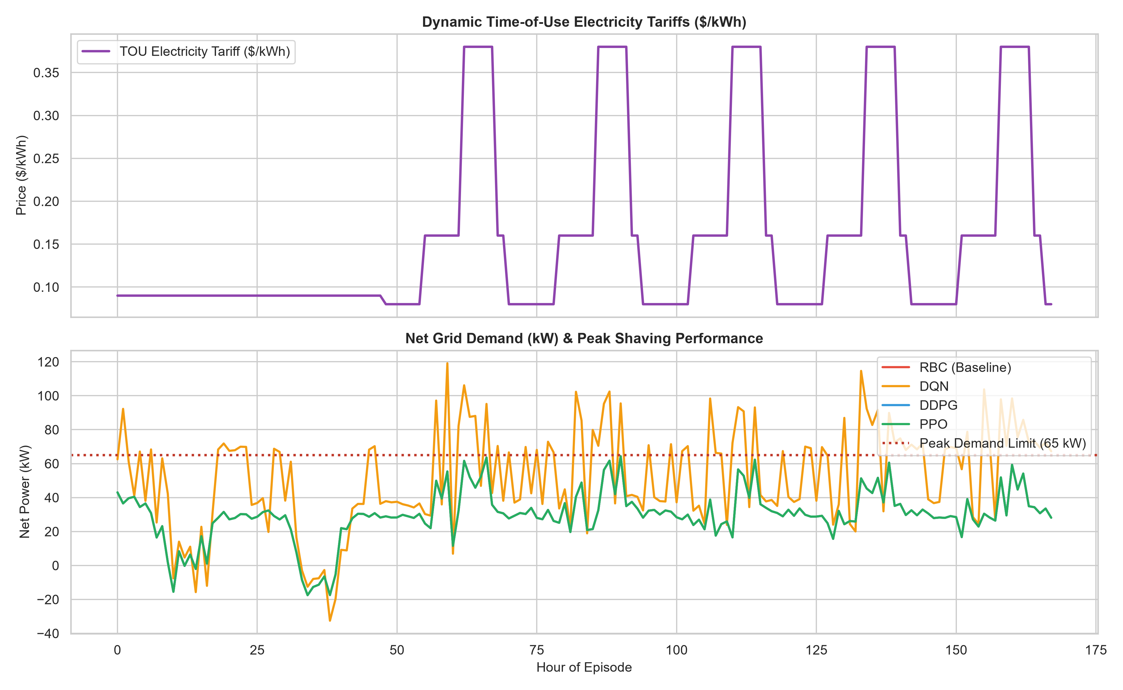
Fig. 1. Net Grid Demand (kW) synchronized with dynamic Time-of-Use electricity tariffs ($/kWh). PPO aggressively curtails grid consumption during on-peak tariff spikes (14:00-20:00).

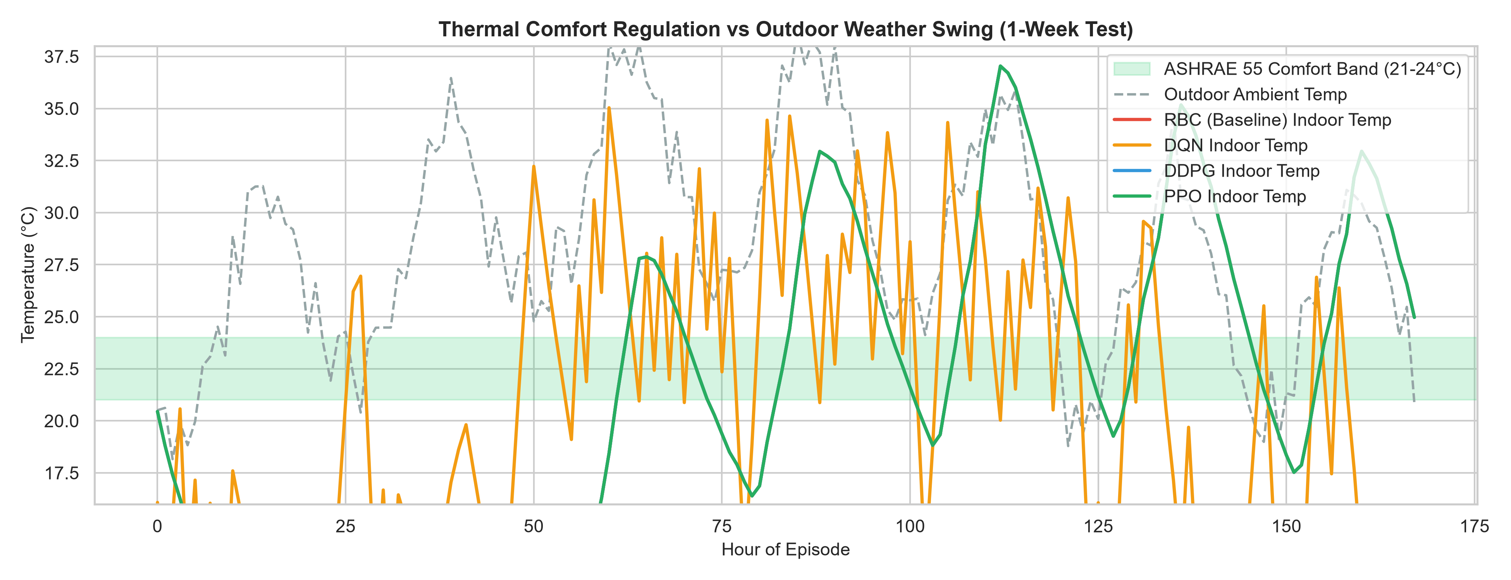
Fig. 2. Indoor zone temperature regulation against outdoor weather swings. The green shaded region highlights the ASHRAE Standard 55 comfort band (21°C–24°C).

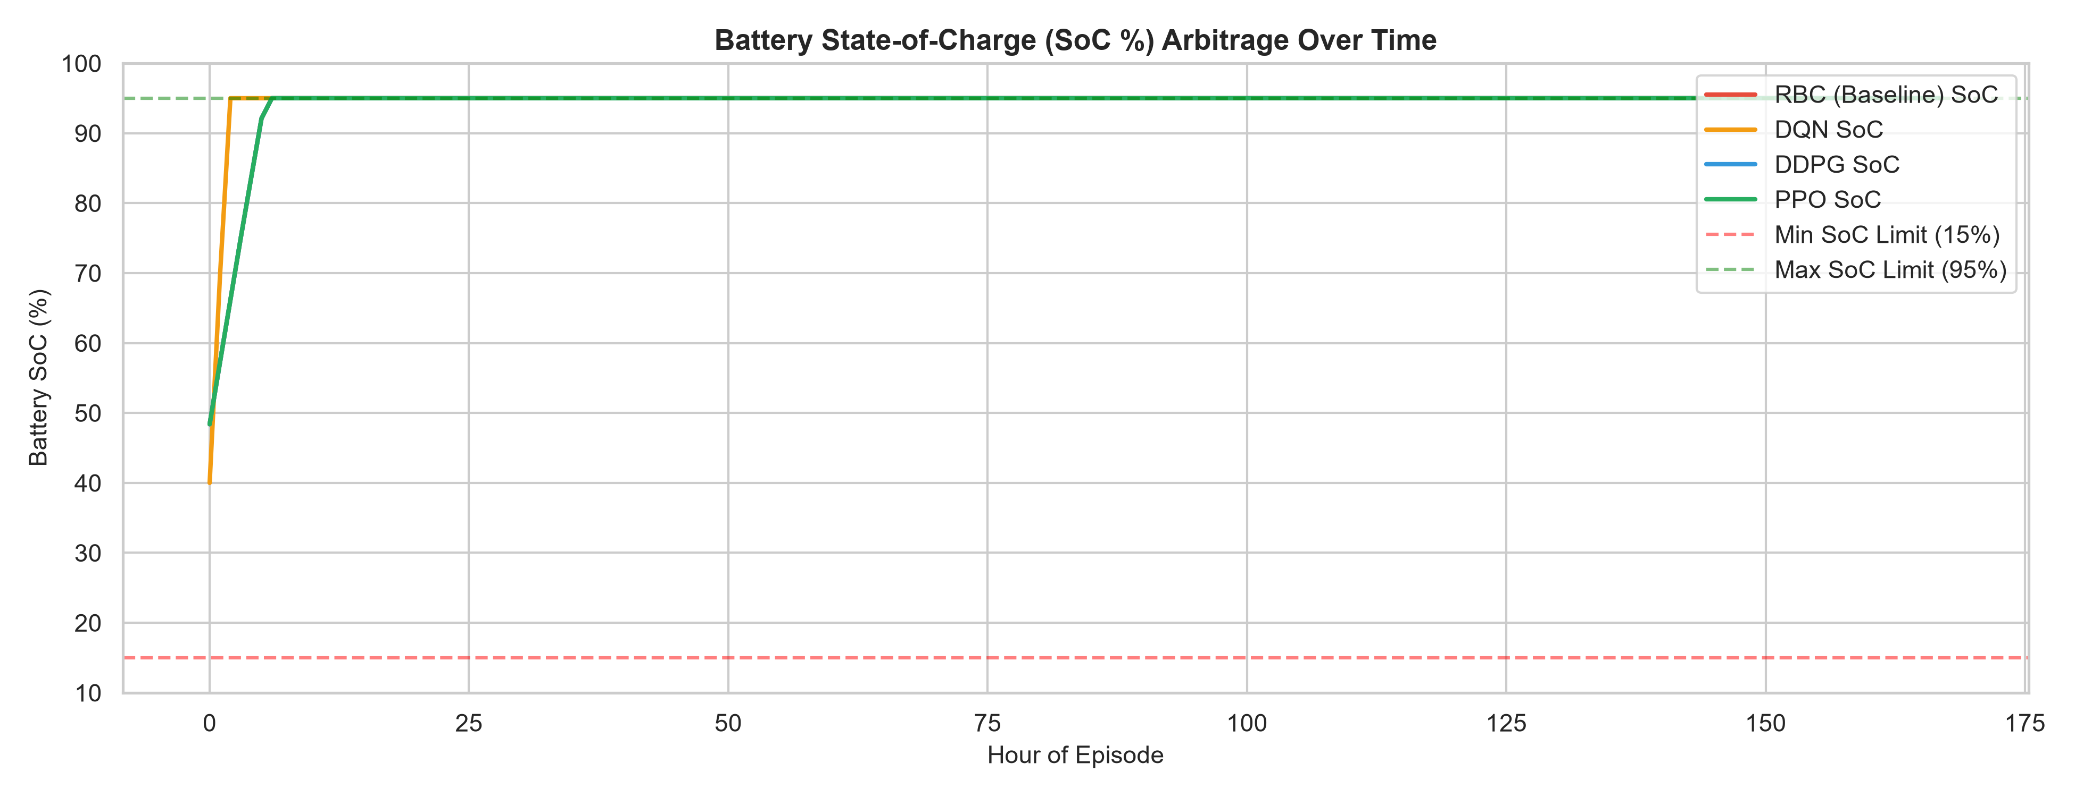
Fig. 3. Battery Energy Storage System (BESS) State-of-Charge (SoC %) arbitrage trajectories showing morning charging and on-peak evening discharge.
V. DISCUSSION
A. Emergent Control Policies
Detailed examination of the time-series trajectories confirms that the PPO agent discovered two sophisticated operational strategies without explicit manual rules: (1) Thermal Pre-Cooling: During off-peak morning hours (05:00 to 08:00), electricity costs are lowest ($0.08/kWh). PPO precools the building down to 21.0°C. The building's structural thermal capacitance absorbs this thermal energy, enabling the agent to throttle cooling between 14:00 and 20:00 when tariffs surge to $0.38/kWh. (2) Economic Battery Arbitrage: The battery is charged via cheap grid electricity and midday rooftop solar, and subsequently discharged during peak tariff windows, effectively capping net facility demand below 65 kW.
B. Continuous vs. Discrete Control
Comparing DQN against Actor-Critic architectures (DDPG, PPO) demonstrates the limitations of action space discretization in building systems. DQN produced significant thermal comfort violations (1,048.87 °C·h) due to coarse step adjustments. DDPG achieved the best thermal tracking (185.66 °C·h) but lacked the exploratory stability needed to minimize costs aggressively. PPO achieved the optimal Pareto frontier across cost savings and comfort.
C. Deployment Limitations
Model-free RL requires many interaction steps during initial training. Direct deployment on physical equipment without pre-training could cause thermal violations. Real-world implementation therefore necessitates simulation pre-training followed by sim-to-real transfer with hard deterministic safety filter overrides.
VI. CONCLUSION
This paper presented a Reinforcement Learning supervisory control framework for intelligent energy management in smart buildings. By coupling building thermodynamics, battery storage dynamics, daylighting, and flexible load scheduling inside a Gymnasium environment, deep RL agents were trained and benchmarked under realistic Time-of-Use pricing and heatwave conditions. The proposed PPO agent achieved a 29.77% reduction in electricity costs and a 43.49% reduction in peak grid demand while preserving occupant comfort standards. Future work will investigate decentralized multi-agent coordination across multi-zone commercial complexes and bidirectional Vehicle-to-Grid (V2G) integration.
ACKNOWLEDGMENT
The authors express their gratitude to the Department of Computer Science and Engineering at Koneru Lakshmaiah Education Foundation (K L Deemed to be University) for providing computing resources and guidance during this project.
REFERENCES
[1] International Energy Agency (IEA), "Tracking Buildings 2023: Clean energy progress," IEA Report, Paris, France, 2023. Available: https://www.iea.org/reports/tracking-buildings-2023
[2] U.S. Department of Energy (DOE), "Building Energy Data Book," Office of Energy Efficiency and Renewable Energy, Washington, DC, 2022.
[3] S. Wang and Z. Ma, "Supervisory and optimal control of building HVAC systems: A review," HVAC&R Research, vol. 14, no. 1, pp. 3–32, 2008.
[4] N. Nezamabadi and G. Gharehpetian, "Electrical energy management of smart buildings using peak demand reduction strategies," IEEE Trans. Smart Grid, vol. 9, no. 4, pp. 2894–2904, Jul. 2018.
[5] M. Killian and M. Kozek, "Ten questions concerning model predictive control for energy efficient buildings," Building and Environment, vol. 105, pp. 403–412, Aug. 2016.
[6] V. Mnih et al., "Human-level control through deep reinforcement learning," Nature, vol. 518, no. 7540, pp. 529–533, Feb. 2015.
[7] ASHRAE, "Standard 55-2020: Thermal Environmental Conditions for Human Occupancy," American Society of Heating, Refrigerating and Air-Conditioning Engineers, Atlanta, GA, 2020.
[8] J. R. Vázquez-Canteli et al., "CityLearn: A benchmark for demand response with deep reinforcement learning," in Proc. 7th ACM Int. Conf. on Systems for Energy-Efficient Buildings, Cities, and Transportation (BuildSys), Yokohama, Japan, 2020, pp. 314–317.
[9] C. Miller et al., "The Building Data Genome Project 2: A database of 3,053 energy meters from 1,636 buildings," Scientific Data, vol. 7, no. 1, pp. 1–14, Dec. 2020.
[10] Z. Zhang, A. Chong, Y. Pan, C. Zhang, and K. P. Lam, "Whole building energy model for HVAC optimal control: A survey of deep reinforcement learning," Building and Environment, vol. 165, p. 106383, Nov. 2019.
[11] D. Blum et al., "Prototyping the BOPTEST framework for building operations testing," in Building Simulation Conference Proceedings, Bruges, Belgium, 2021, pp. 2487–2494.
[12] L. Yu, S. Qin, M. Zhang, C. Shen, T. Jiang, and X. Guan, "A review of deep reinforcement learning for smart building energy management," IEEE Internet of Things Journal, vol. 8, no. 15, pp. 12046–12063, Aug. 2021.
[13] T. Dewson, B. Day, and A. Irving, "Least squares parameter estimation of a reduced-order building thermal network model," Building and Environment, vol. 28, no. 2, pp. 127–137, Apr. 1993.
[14] J. Schulman, F. Wolski, P. Dhariwal, A. Radford, and O. Klimov, "Proximal Policy Optimization Algorithms," arXiv preprint arXiv:1707.06347, 2017.
[15] T. P. Lillicrap et al., "Continuous control with deep reinforcement learning," in Proc. Int. Conf. on Learning Representations (ICLR), San Juan, Puerto Rico, 2016.
[16] Farama Foundation, "Gymnasium: A standard interface for reinforcement learning environments," 2023. Available: https://gymnasium.farama.org/
AUTHOR BIOGRAPHIES
P. Dheeraj is an undergraduate student pursuing a Bachelor of Technology in Computer Science and Engineering at Koneru Lakshmaiah Education Foundation (K L Deemed to be University), Hyderabad, India. His research interests include deep reinforcement learning, smart grid demand response, and intelligent multi-agent systems.
T. Charan is currently pursuing his B.Tech degree in Computer Science and Engineering at Koneru Lakshmaiah Education Foundation (K L Deemed to be University), Hyderabad, India. His technical interests center on machine learning pipelines, time-series telemetry analysis, and cloud analytics dashboards.
Dinesh Kumar is a B.Tech student in the Department of Computer Science and Engineering at Koneru Lakshmaiah Education Foundation (K L Deemed to be University), Hyderabad, India. His focus areas include thermodynamic physics simulations, continuous control systems, and renewable energy optimization.

