**Contents**

|  |  |  |
| --- | --- | --- |
| **Sl. No.** | **Details** | **Page No.** |
| **1** | **Introduction** | **01** |
| **2** | **Analysis** | **02** |
|  | **2.1 Existing System** | **02** |
|  | **2.2 Proposed System** | **02** |
| 1. **Z** | **2.3 System requirements** | **02** |
| **3** | **System Design** | **04** |
|  | **3.1 Introduction** | **04** |
|  | **3.2 Uml Diagrams** | **04** |
| **4** | **Implementation** | **09** |
|  | **4.1 System Modules** | **09** |
|  | **4.2 Introduction to Technologies Used** | **10** |
|  | **4.3 Sample Code** | **12** |
| **5** | **Screen Shots** | **19** |
| **6** | **Conclusion and future enhancements** | **26** |
| **7** | **References** | **27** |

**1. INTRODUCTION**

“Online Birth Certificate Issual Website” provides birth certificate .Through this website one can apply for the birth certificate online without going to mee seva. Initially one who requires birth certificate should get themselves registered in the website by providing user name, password , mobile number and email. Once after the completion of registration process user enters into login page by providing mail and password with which user has registered. Then user enters into applicant page where details such as gender, registration number, date of birth, parents name, hospital name, location etc are provided. Admin also has his own user name and password to login into the website. Only admin has the privileges to update and insert into database. Functionality involved here is if the details in the applicant page gets matched with the details present in the database then birth certificate will be generated. If details in the applicant page doesn’t gets matched with the details in the database then “Details not found” message would be displayed. Original birth certificate will be issued only once. If the applicant tries to apply again then only duplicate birth certificate will be issued.

**2. ANALYSIS**

**2.1 EXISTING SYSTEM :**

In the existing system, it has become very difficult for the applicant to obtain birth certificate from mee seva. It is consuming and lots of patience is required to receive the birth certificate at the appropriate time suggested by the user.

**2.2. PROPOSED SYSTEM :**

We are proposing a procedure which provides birth certificate with in no time after the completion of registration into the website. This system works effectively and efficiently.

**2.3. SYSTEM REQUIREMENTS :**

**2.3.1 Software Requirements:**

* Languages : HTML,CSS,PHP
* Operating System :Windows XP

**2.3.2 Hardware Requirements:**

* Processor: Pentium 4(minimum)
* RAM: 512MB
* Hard disk: 40GB

## 2.3.3 Operating Environment:

Software Requirements are Windows as Operating System. HTML,Cascading Style Sheets as Front-End designing tools. MySql is used as Database Server. PHP is used as a middle end to connect to database.

Hardware Requirements are P2 above processor, 128MB+ of main memory (RAM) and 100MB hard disk and data base memory.

**3. SYSTEM DESIGN**

**3.1 Introduction:**

System design is transition from a user oriented document to programmers or data base personnel. The design is a solution, how to approach to the creation of a new system. This is composed of several steps. It provides the understanding and procedural details necessary for implementing the system recommended in the feasibility study. Designing goes through logical and physical stages of development, logical design reviews the present physical system, prepare input and output specification, details of implementation plan and prepare a logical design walk- through.

The database tables are designed by analyzing functions involved in the system and format of the fields is also designed. The fields in the database tables should define their role in the system. The unnecessary fields should be avoided because it affects the storage areas of the system. Then in the input and output screen design, the design should be made user friendly. The menu should be precise and compact.

**3.2 UML Diagrams:**

UML is a language to specifying, visualizing and constructing the artifacts of software system as well as for business models. The UML notation is useful for graphically depicting object oriented analysis and object oriented design modules. Each UML diagram is designed for developers and customers to view a software system from a different perspective and in varying degrees of abstraction.

**3.2.1 Use Case Diagrams:**

Use case Diagrams represent the functionality of the system from a user’s point of view. Use cases are used during requirements elicitation and analysis to represent the functionality of the system. Use cases focus on the behavior of the system from external point of view.

Actors are external entities that interact with the system. Examples of actors include users like administrator, user …etc., or another system like central database. Based on number of different scenarios, we have come across the following uses of system.

**3.2.1.1 Use case diagram for registration**

**Fig3.2.1.1: Use Case diagram for registration.**

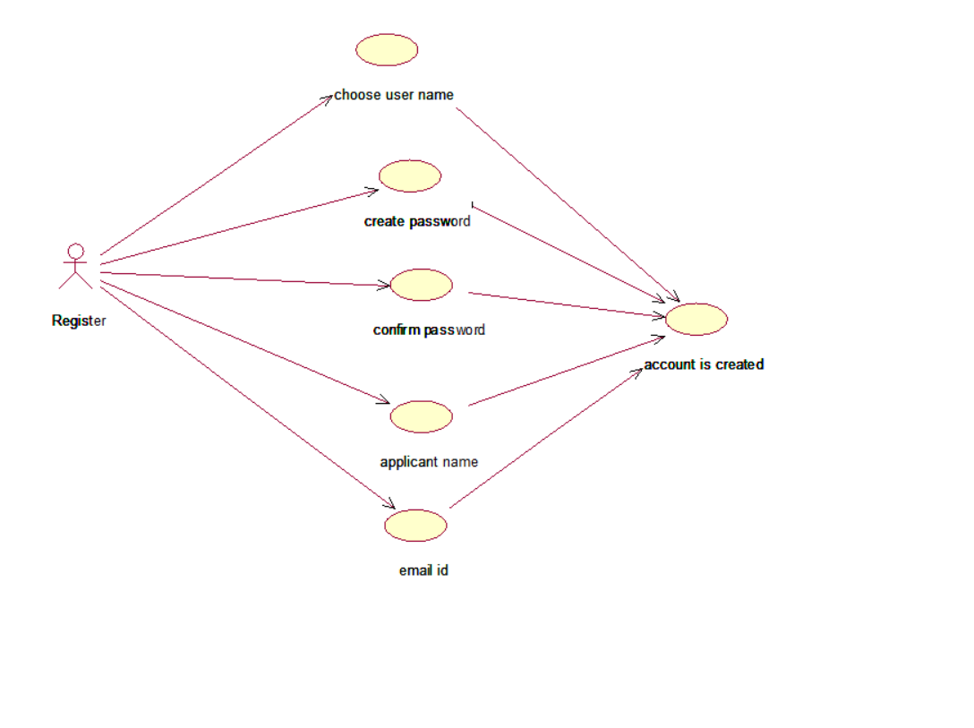

**3.2.1.2 Use case diagram for providing applicant details**

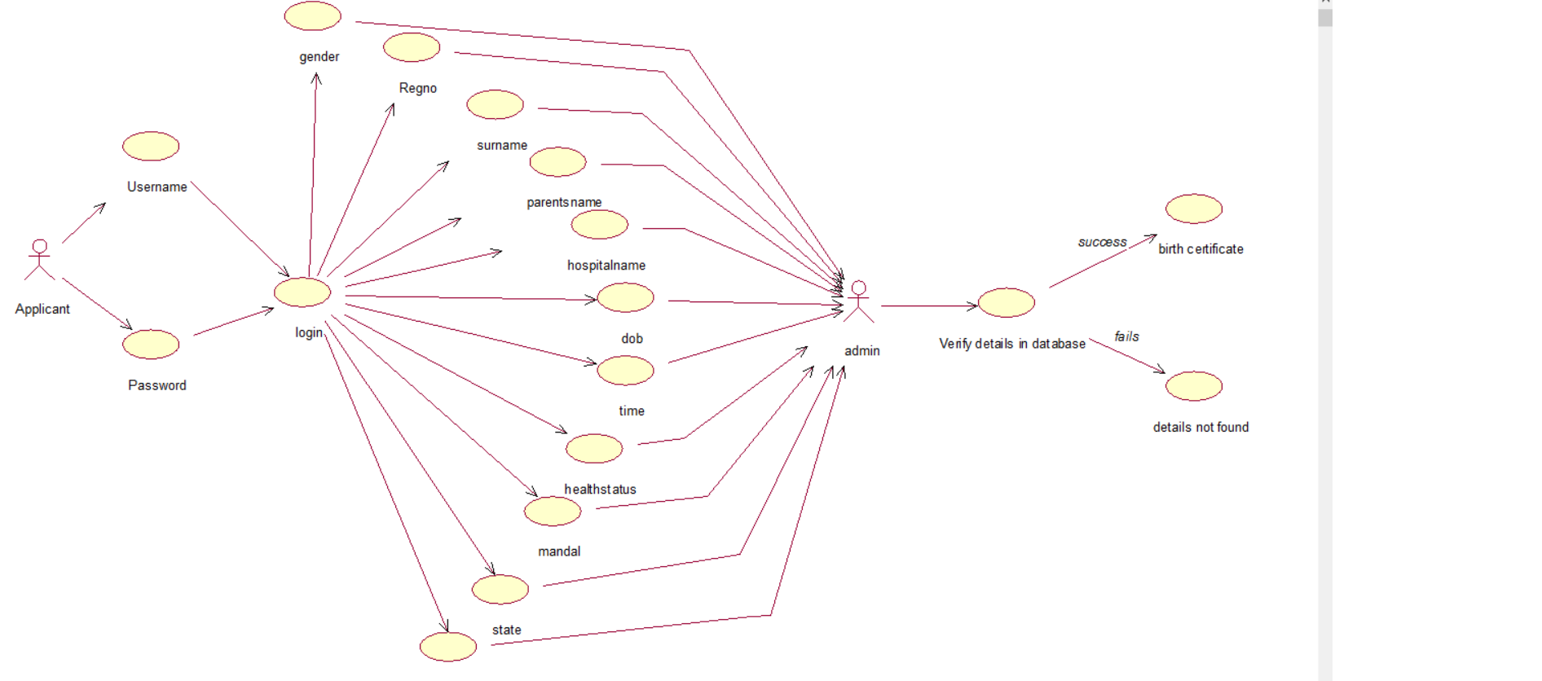

**Fig3.2.1.2: Use Case diagram for providing applicant details**

**3.2.1.3 Use case diagram for admin**

**Fig3.2.1.3: Use Case diagram for admin**

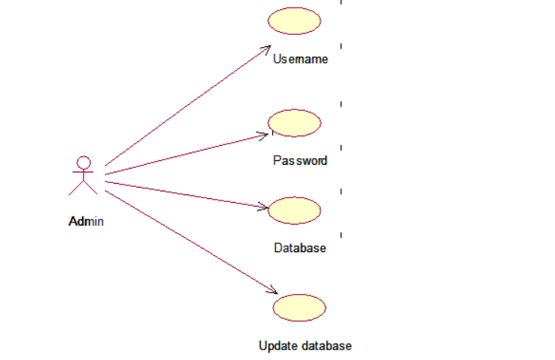

**4. IMPLEMENTATION**

**4.1 SYSTEM MODULES:**

This website consists of three modules. They are

* Register
* Login
* Administrator

**Register:**

* The user who require birth certificate should make themselves register into the website.
* The user registers with his own user name and password.

**Login:**

* After the completion of the registration process the students should login into the website.
* After login into the website the applicant should provide the details such as gender, registration number, parent’s name, hospital name.

**Administrator:**

* The primary focus of the administrator is to manage the administrative tasks that are required to ensure the smooth operation of website.
* The tasks/responsibilities of admin includes getting information from hospital and uploading it into database.

**4.2. INTRODUCTION TO TECHNOLOGY USED**

**4.2.1 HTML:**

* Hyper Text Markup Language ,commonly referred to as HTML ,is the standard markup language used to create web pages
* Along with CSS and java script, HTML is a cornerstone technology used by most websites to create visually engaging web pages, user interfaces for web applications and user interfaces for many mobile applications.

**4.2.2 CSS:**

* CSS is a style sheet language that describes the presentation of an HTML (or XML) document.
* CSS describes how elements must be rendered on screen, on paper, or in other media.
* CSS is used to define styles for your web pages, including the design, layout and variations in display for different devices and screen sizes.

**4.2.3 PHP:**

* PHP is a server scripting language, and a powerful tool for making dynamic and interactive Web pages.
* PHP is an acronym for "PHP: Hypertext Preprocessor"
* PHP is a widely-used, open source scripting language
* PHP scripts are executed on the server
* PHP is free to download and use
* PHP files can contain text, HTML, CSS, JavaScript, and PHP code
* PHP code are executed on the server, and the result is returned to the browser as plain HTML.PHP files have extension as .php

**4.2.4 MySQL:**

The database has become an integral part of almost every human's life. Without it, many things we do would become very tedious, perhaps impossible tasks. Banks, universities, and libraries are three examples of organizations that depend heavily on some sort of database system. On the Internet, search engines, online shopping, and even the website naming convention (http://www...) would be impossible without the use of a database. A database that is implemented and interfaced on a computer is often termed a database server.  
One of the fastest SQL (Structured Query Language) database servers currently on the market is the MySQL server.MySQL, available for download, offers the database programmer with an array of options and capabilities rarely seen in other database servers. What's more, MySQL is free of charge for those wishing to use it for private and commercial use.

Those wishing to develop applications specifically using MySQL should consult MySQL's licensing section, as thereis a charge for licensing the product.

These capabilities range across a number of topics, including the following:

* Ability to handle an unlimited number of simultaneous users.
* Capacity to handle 50,000,000+ records.
* Very fast command execution, perhaps the fastest to be found on the market.
* Easy and efficient user privilege system.

**4.3. Sample Code**

<?php

//step1

$db = mysql_connect("localhost","root","");

if (!$db) {

die("Database connection failed miserably: " . mysql_error());

}

//step2

$db_select = mysql_select_db("charan",$db);

if (!$db_select) {

die("Database selection also failed miserably: " . mysql_error());

}

?>

<?php

include "logout.html";

session_start();

$name = $_SESSION['name'];

$regno = $_SESSION['regno'];

$sql="select *from birth_certificate where Regno=$regno";

$result=mysql_query($sql);

if($row=mysql_fetch_array($result))

{

if($row['issued']==0)

{

?>

<!doctype html>

<html>

<head>

<meta charset="utf-8">

<title>Certificate</title>

<style>

body{

margin:0 auto;

width:700px;

}

#main{

border:1px solid #000;

width:700px;

}

</style>

</head>

<body align="center">

<div id="main">

<div class="div"> <img src="birth.png" width="610" height="200" alt="" border="0px"/></div>

</body>

<div id="div2">

<?php

$sql="SELECT * FROM birth_certificate WHERE Name='".$name."' && Regno=".$regno."";

$result=mysql_query($sql);

if($row=mysql_fetch_array($result))

{

echo"<table align='center' width=610 cellspacing='2'><tr><td align='center'><u>BIRTH CERTIFICATE</u></tr></td>";

echo"<tr><td align='center'>(Issued Under Section 12/17)</tr></td>";

echo"<tr><td align='center'>This is to certify the following information is taken from original record of birth which is register for 8C, circle 10 of Greater Muncipality of Corporation,Telangana State,India</td></tr>";

echo"</table>";

echo"<table align=center width=610 cellspacing='2'><tr><td align='left'>Child Name</td><td align='left'>".$row[0]."</td></tr>";

echo"<tr><td align='left'>Registration number</td><td align='left'>".$row[3]."</td></tr>";

echo"<tr><td align='left'>Gender</td><td align='left'>".$row[1]."</td></tr>";

echo"<tr><td align='left'>Name of Father </td><td align='left'>".$row[5]."</td></tr>";

echo"<tr><td align='left'>Name of Mother</td><td align='left'>".$row[4]."</td></tr>";

echo"<tr><td align='left' >Date Of Birth</td><td align='left'>".$row[7]."</td></tr>";

echo"<tr><td align='left'>Hospital Address</td><td align='left'>".$row[6]."</td></tr>";

echo"<tr><td align='left'>Location</td><td align='left'>".$row[10]."</td></tr>";

echo"<tr><td align='left'>City</td><td align='left'>".$row[11]."</td></tr>";

echo"<tr><td align='left'>Date </td><td align='left'>".date("d-m-Y")."</td></tr>";

echo"</table>";

}

$queryUp="UPDATE `birth_certificate` SET `issued` = '1' WHERE `birth_certificate`.`Regno` = $regno";

mysql_query($queryUp);

echo "</div><div class='div3'><img src='birth2.png' width=650 height=240 alt='' border='0px'/></div>";

}

else

{

echo""

?>

<html>

<head>

<meta charset="utf-8">

<title>Certificate</title>

<style>

body{

margin:0 auto;

width:700px;

}

#main{

border:2px solid #000;

width:700px;

}

</style>

</head>

<body align="center">

<div id="main">

<div class="div"> <img src="birth3.png" width="610" height="200" alt="" border="0px"/></div>

</body>

<div id="div2" >

<?php

$sql="SELECT * FROM birth_certificate WHERE Name='".$name."' && Regno=".$regno."";

$result=mysql_query($sql);

if($row=mysql_fetch_array($result))

{

echo"<table align='center' width=610 cellspacing='2'><tr><td align='center'><u>BIRTH CERTIFICATE</u></tr></td>";

echo"<tr><td align='center'>(Issued Under Section 12/17)</tr></td>";

echo"<tr><td align='center'>This is to certify the following information is taken from original record of birth which is register for 8C, circle 10 of Greater Muncipality of Corporation,Telangana State,India</td></tr>";

echo"</table>";

echo"<table align=center width=570 cellspacing='2' ><tr><td align='left'>Child Name</td><td align='left'>".$row[0]."</td></tr>";

echo"<tr><td align='left'>Registration number</td><td align='left'>".$row[3]."</td></tr>";

echo"<tr><td align='left'>Gender</td><td align='left'>".$row[1]."</td></tr>";

echo"<tr><td align='left'>Name of Father </td><td align='left'>".$row[5]."</td></tr>";

echo"<tr><td align='left'>Name of Mother</td><td align='left'>".$row[4]."</td></tr>";

echo"<tr><td align='left' >Date Of Birth</td><td align='left'>".$row[7]."</td></tr>";

echo"<tr><td align='left'>Hospital Address</td><td align='left'>".$row[6]."</td></tr>";

echo"<tr><td align='left'>Location</td><td align='left'>".$row[10]."</td></tr>";

echo"<tr><td align='left'>City</td><td align='left'>".$row[11]."</td></tr>";

echo"<tr><td align='left'>Date </td><td align='left'>".date("d-m-Y")."</td></tr>";

echo"</table>";

}

echo "<div class='div3'><img src='birth2.png' width=670 height=240 alt='' border='0px'/></div>";

}

}

?>

</div>

</body>

</html>

5. Screenshots

**5.1. Main page**

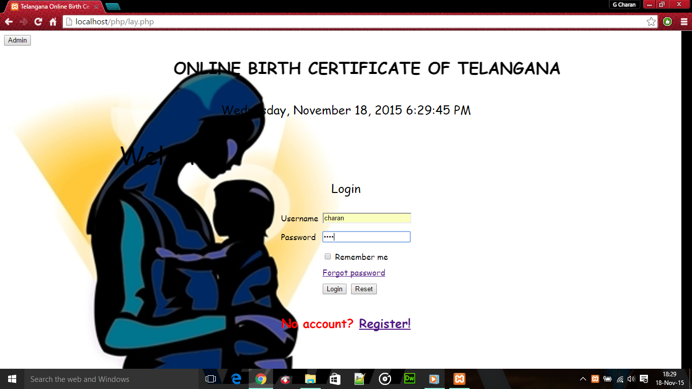

Fig: 5.1. Main page

**5.2. Registration page**

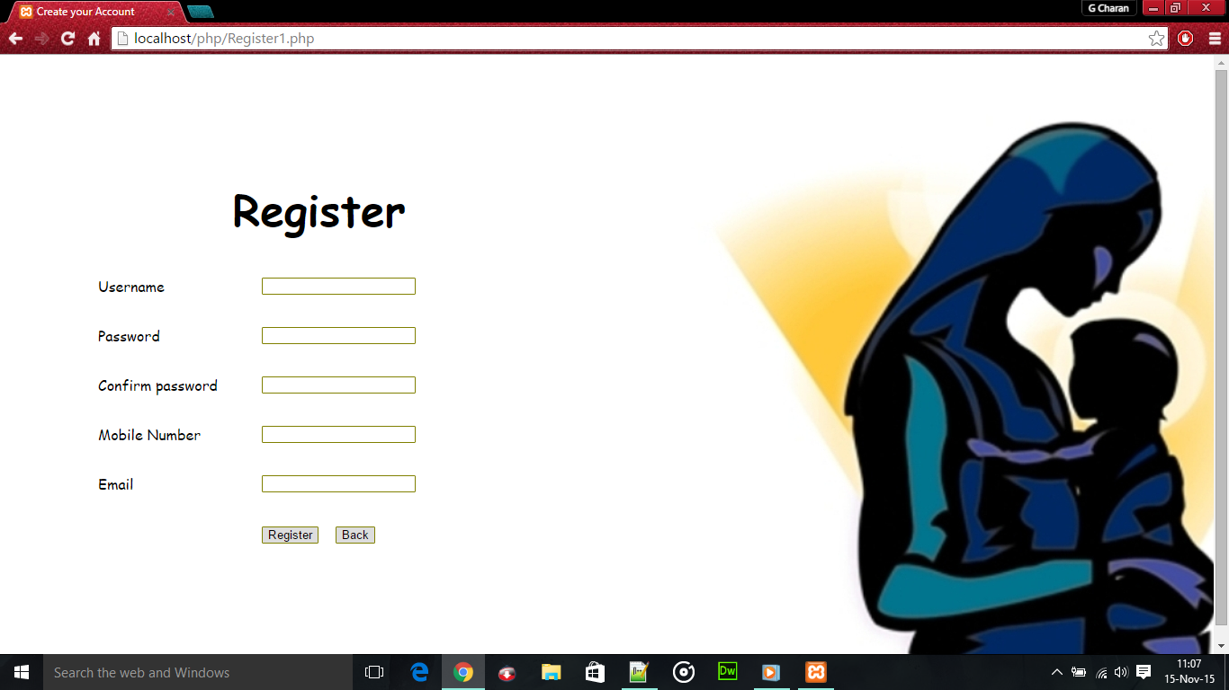

Fig.5.2.Registration Page

**5.3. Login page for applicant**

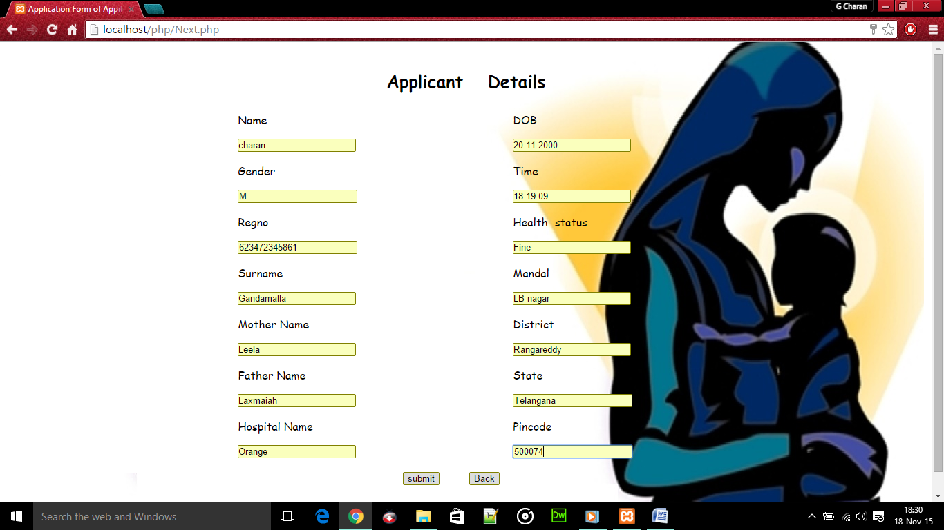

**Fig.5.3.Login page for applicant**

## 5.4. Admin page

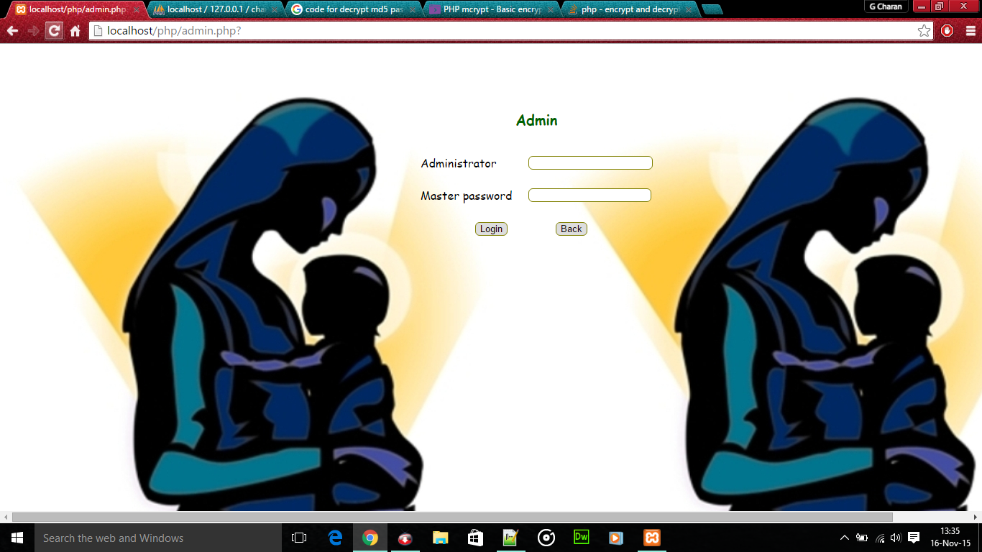

**Fig.5.4. admin page**

**5.5. Applicant providing details after login**



**Fig.5.5 Applicant providing details**

**5.7. Original birth certificate**

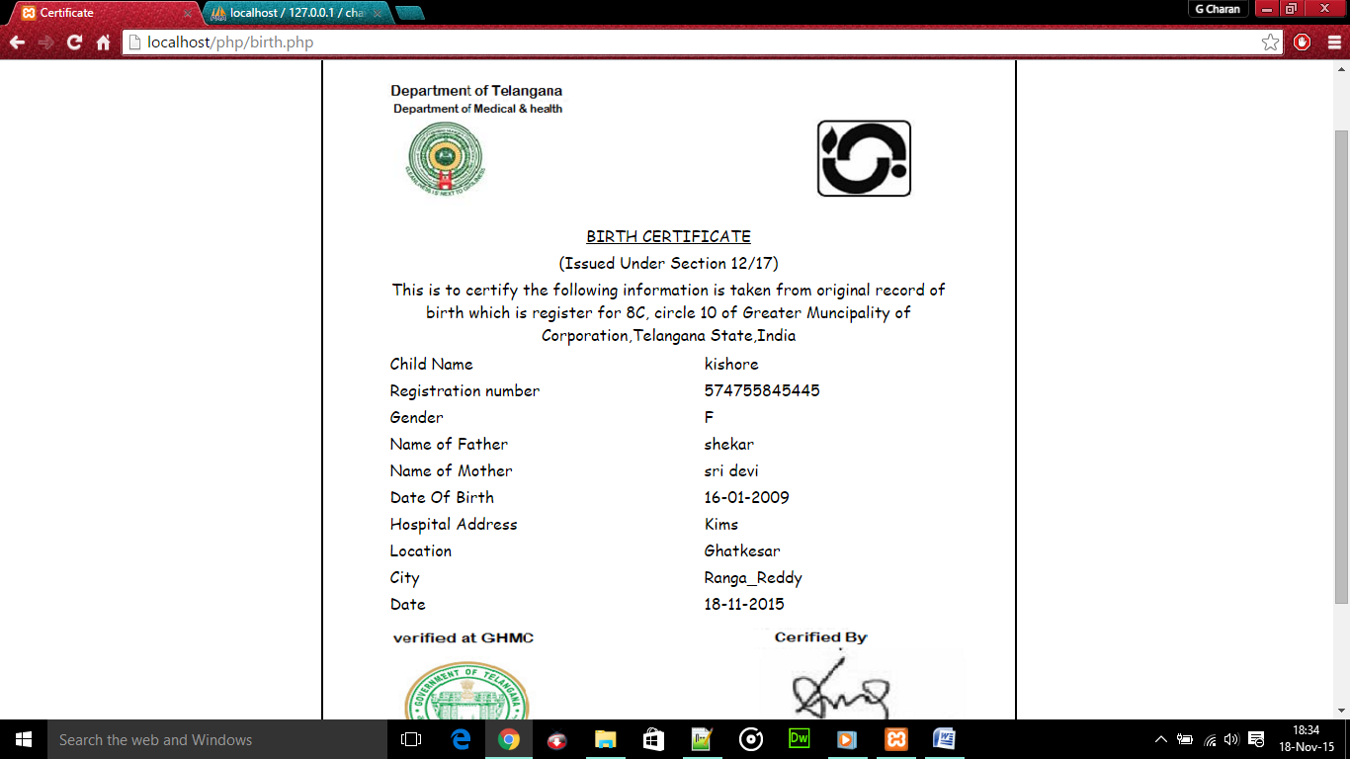

**Fig.5.7. Original Birth Certificate**

**5.8. Duplicate birth certificate**

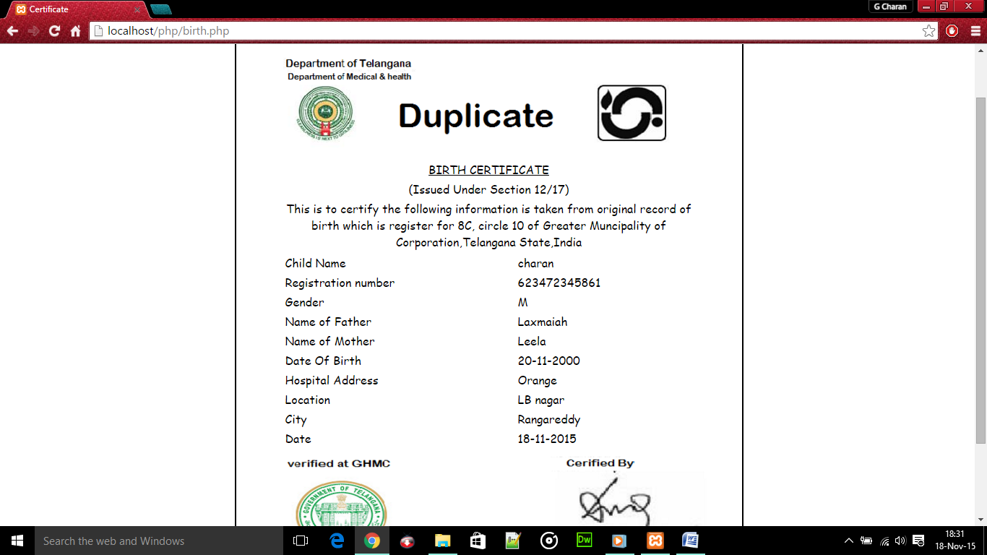

**Fig.5.8.Duplicate Birth Certificate**

# 5. CONCLUSION AND FUTURE ENHANCEMENTS

This project has found a solution for that by providing the user birth certificate online. This method satisfies the user by issuing birth certificate without delay and following the old method of receiving it from mee seva. Thus this website provides a easy access to the user to obtain birth certificate.

Further we would provide websites for not only birth but also death certificate etc. Instead of providing website app can also be made for issuing certificates.

**6. REFERENCES**

## BOOKS:

1. [PHP and MySQL by Example](http://www.abebooks.com/servlet/BookDetailsPL?bi=17209680364&searchurl=isbn%3D9780131875081)Ellie Quigley; Marko GargentaPublished by Prentice Hall (2006)
2. PHP programming solutions, v.Vaswani,TMH

3. PHP and MySql , 3rd edition ,Jason Gilmore, Apress publication

## WEBSITE:

http//:www.w3schools.com

http//:www.php videos