- Install python (Any version from 3+)
  - Refer INSTALL_PYTHON.docx document for installation steps

- Install Notepad++ Editor
  - Refer INSTALL_NOTEPAD++.docx document for installation steps

- Create PYTHON_WORLD folder in Desktop
- Create a Python file name as number.py inside PYTHON_WORLD folder
SELECT SAVE AS TYPE ALL TYPE
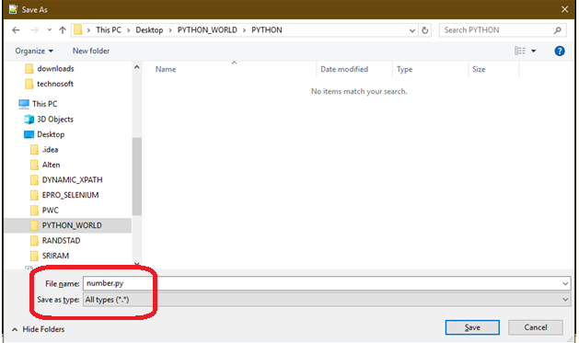

- Write a program to Print HELLO WORLD
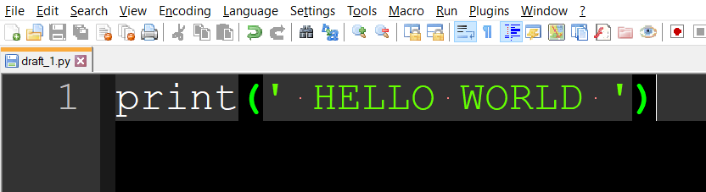
- Execute number.py file in CMD
To open command prompt from notepad++
Right click on number.py file name Open into Then Click on “Open Containing Folder in cmd”

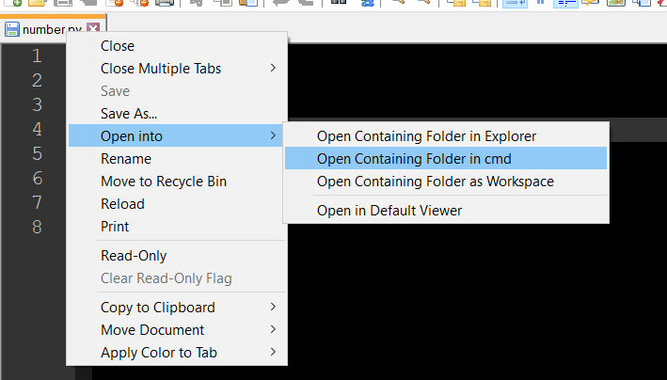

- Run Python file like below
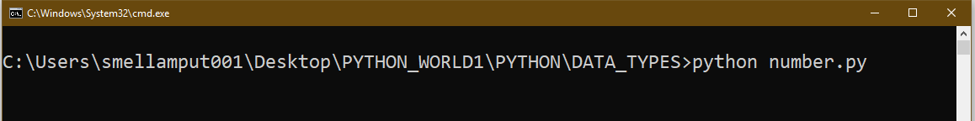
- DOWNLOAD FILES FORM WHATSAPP INTO LAPTOP
Refer WHATSAPP_WEB.docx document for WHATSAPP WEB

- TO OPEN PYTHON FILE IN NOTEPAD ++

RIGHT CLICK ON PYTHON FILE THEN CLICK ON Edit with Notepad++

