1. Open Below Link on browser
https://www.python.org/downloads/
2. click on Download Python 3.10.2 button
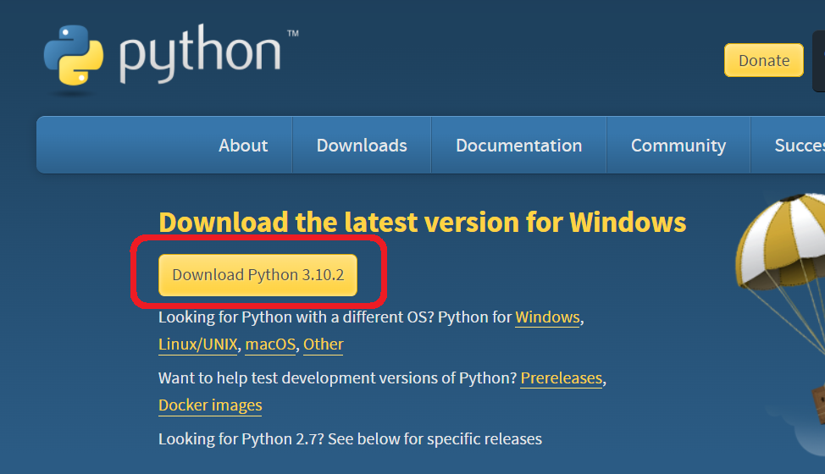

It will download python-3.10.5-AMD64.exe file
Double click on python-3.10.5-AMD64.exe file

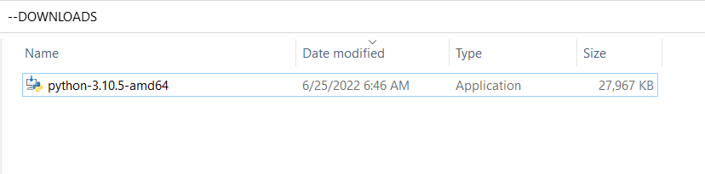
- Select Add python 3.10 to PATH check box
- Then Click on Install Now

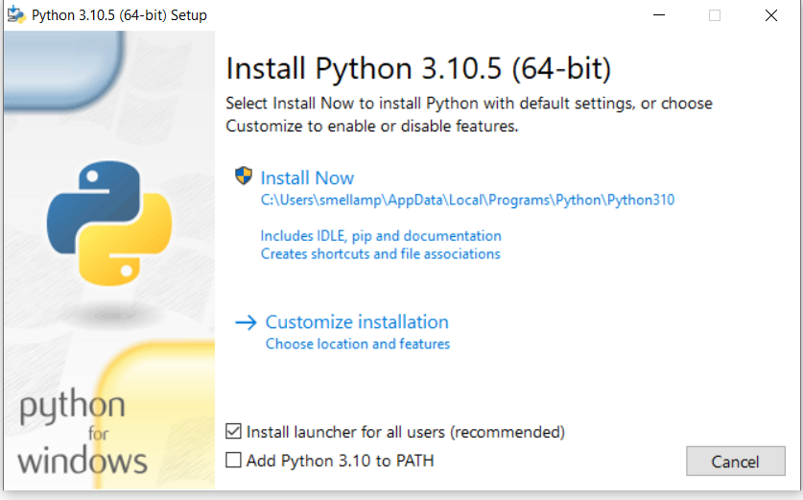
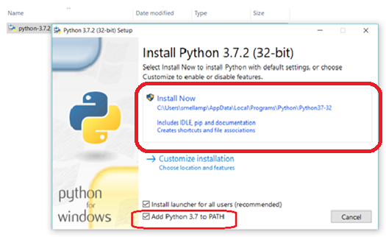

- Then Click on YES
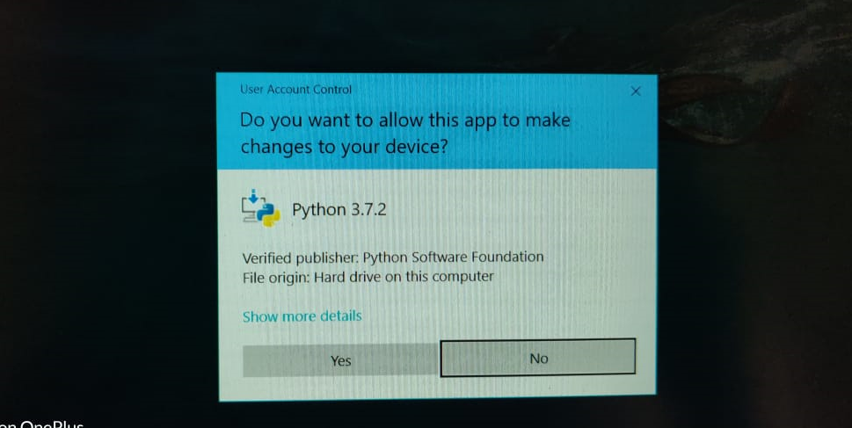

INSTALLATION IN PROGRESS
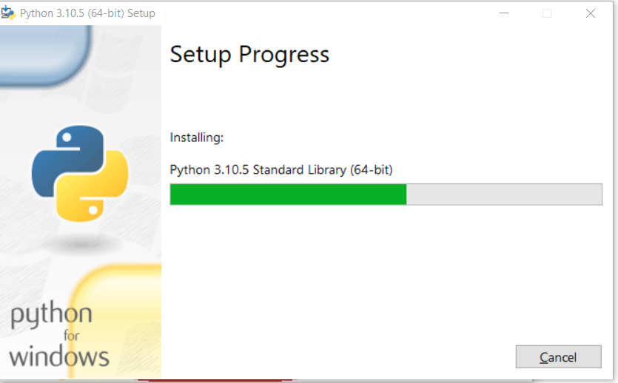

INSTALLATION IS COMPLETED CLICK ON CLOSE BUTTON
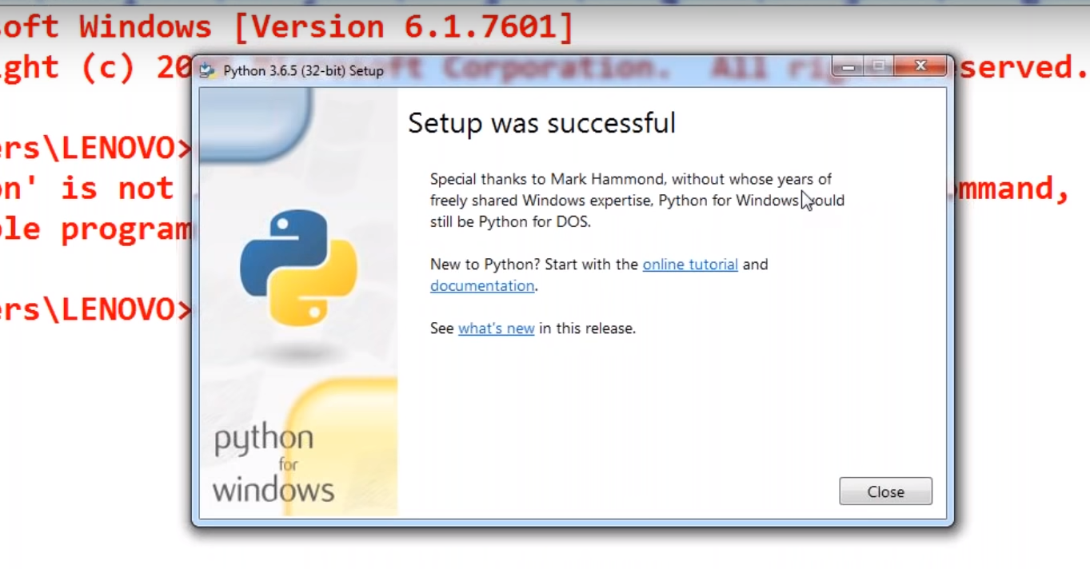

- Run below command in CMD (command prompt) to know python is installed or not

python –V

