Open Below Link on browser
https://notepad-plus-plus.org/downloads/

CLICK ON LATEST ONE

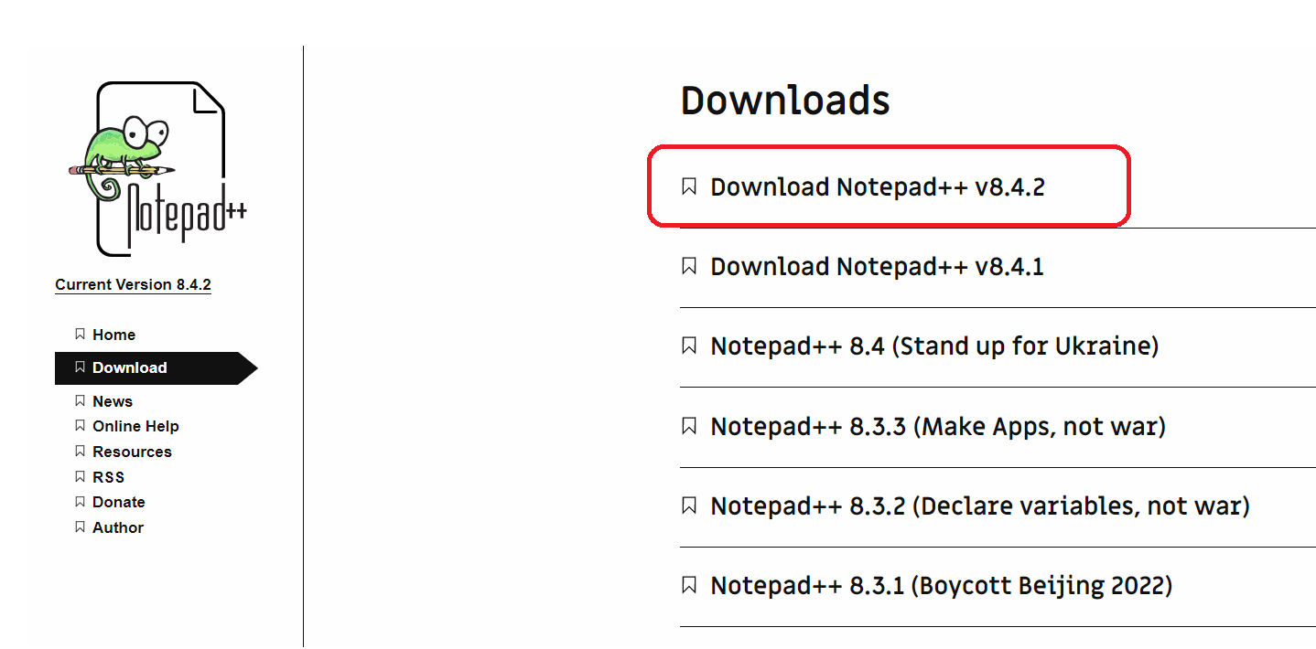

- Click on DOWNLOAD button

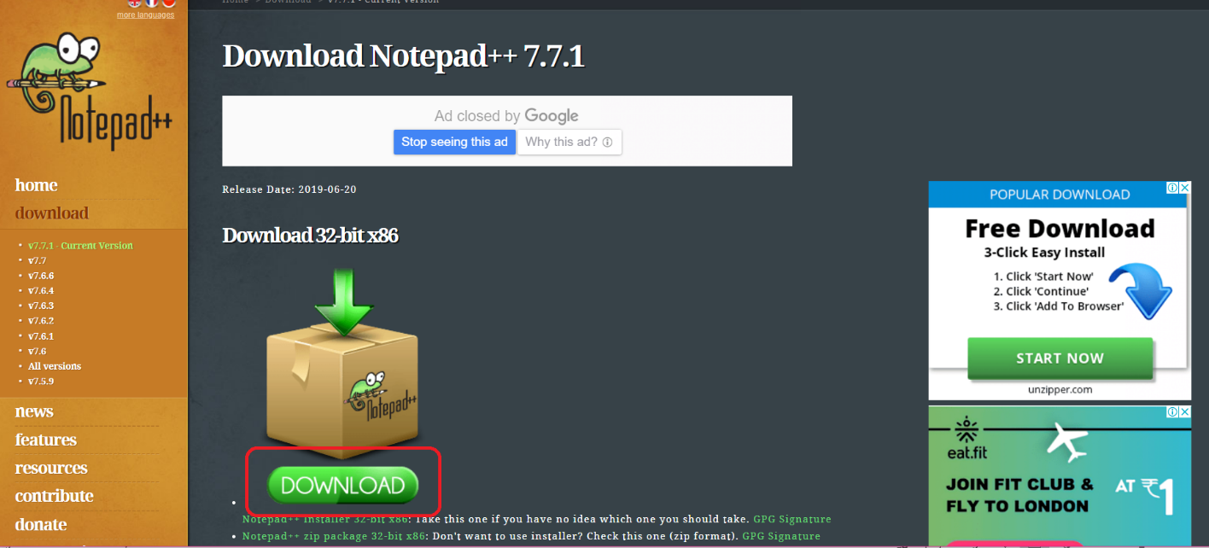

- It will download installer file in downloads path
- Double click on this file
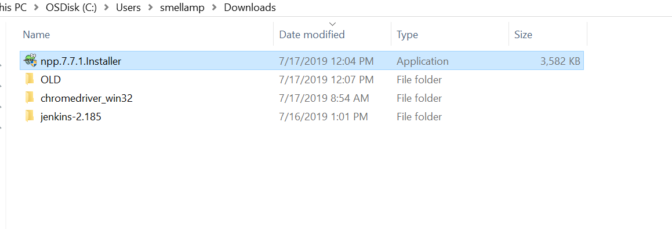

- Then it will raise a popup like below
- Click on Yes
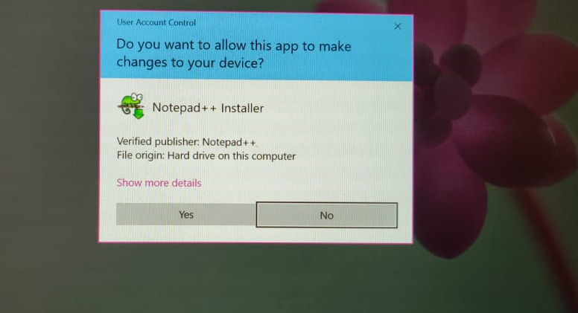

- Then click on OK
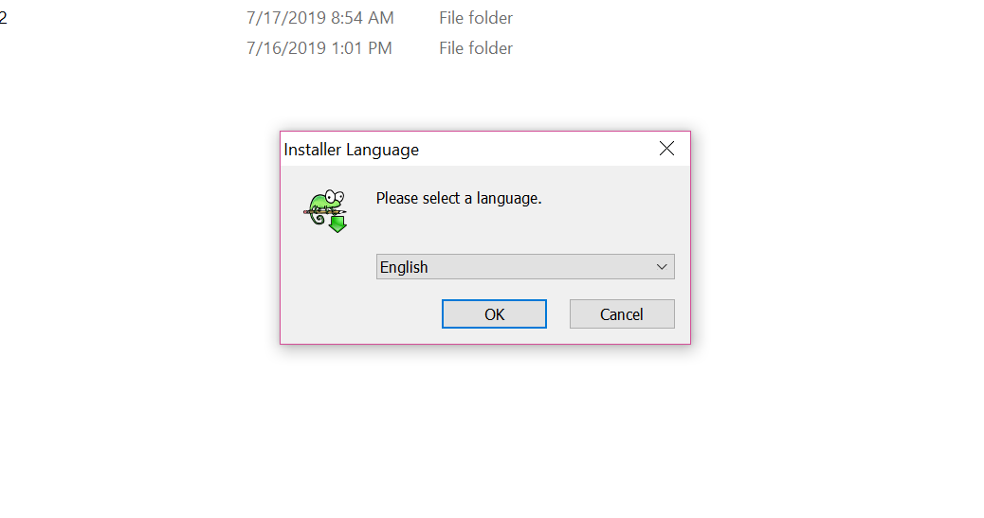

- Click on Next

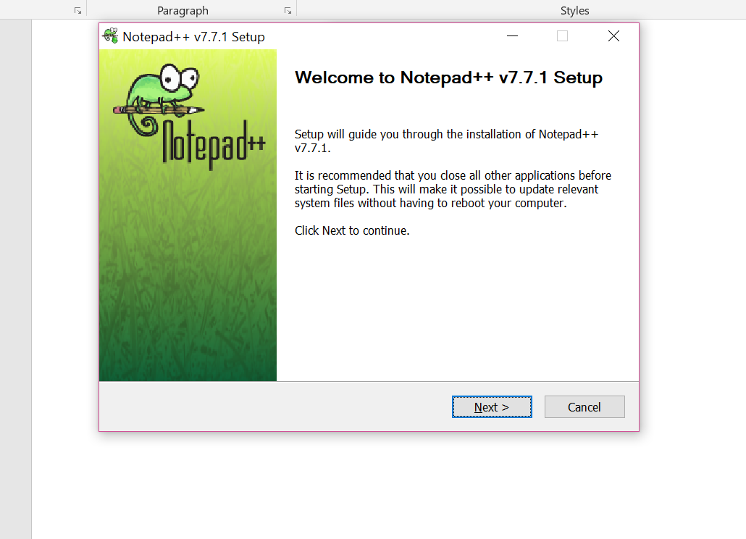

- Then click on I Agree button
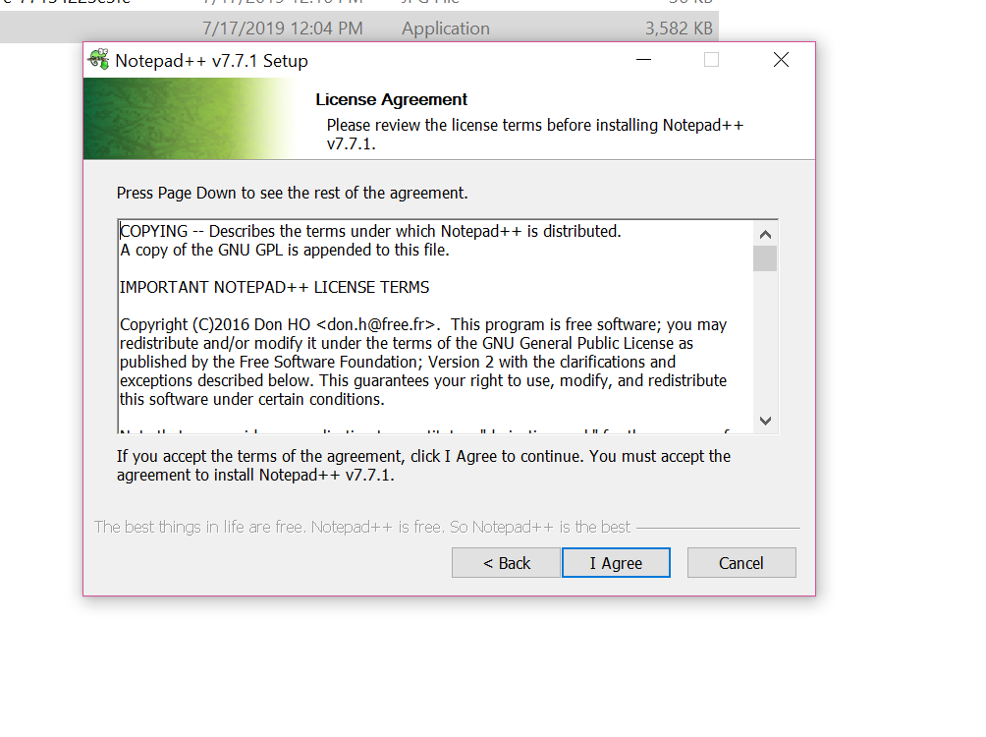

- Click on Next
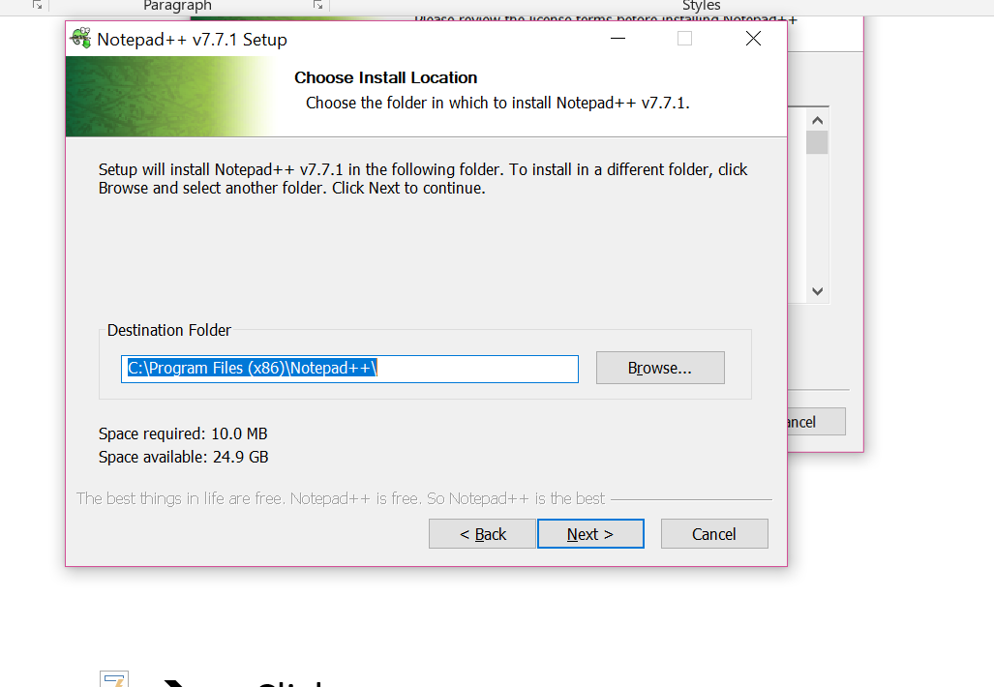

- Then click on Next
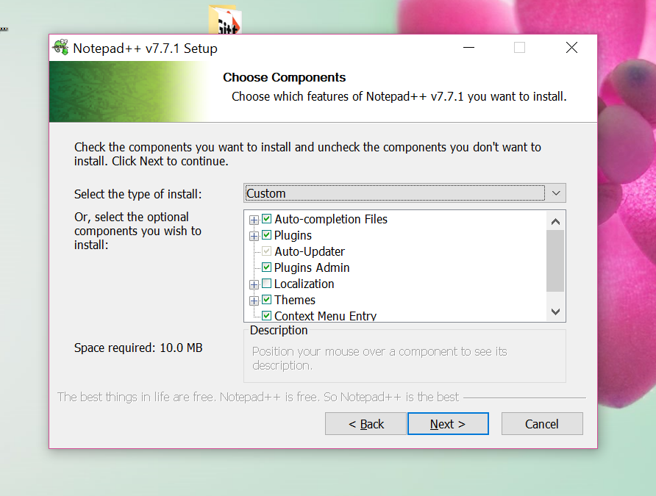

Select Create shortcut on desktop check box
- Then click on Install
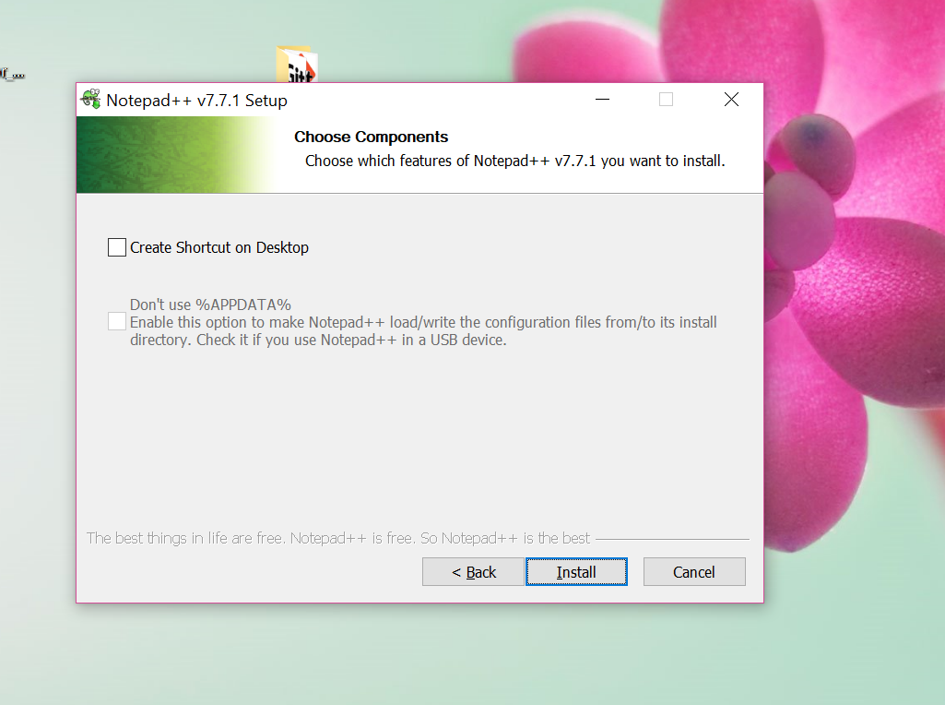

- Then click on Finish
