TO OPEN WHATSAPP IN LAPTOP BROWSER

- Use below link to open WHATSAPP IN BROWSER
https://web.whatsapp.com/
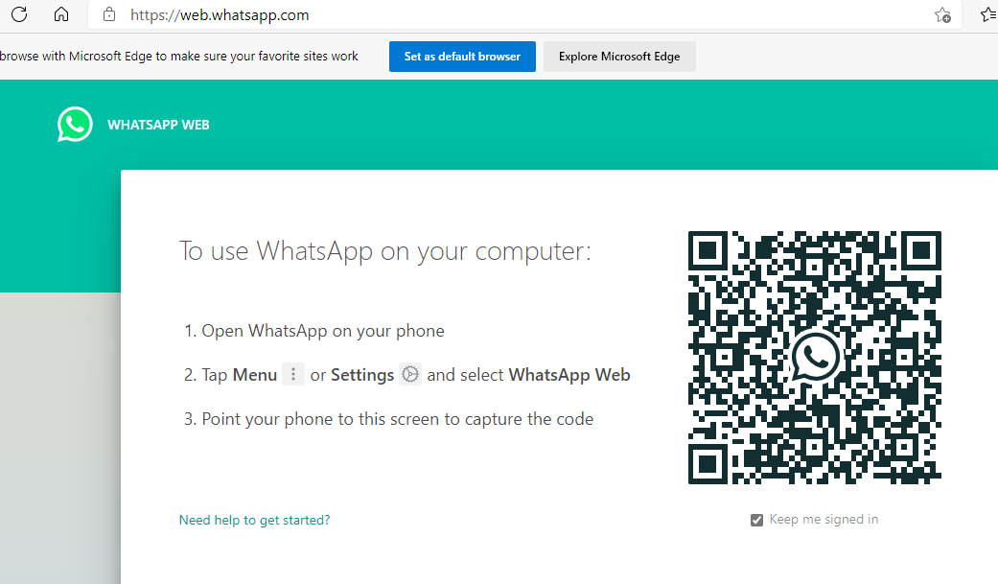

- OPEN WHATSAPP IN MOBILE THEN CLICK ON THREE DOTS SYMBOL THEN CLICK ON Linked devices
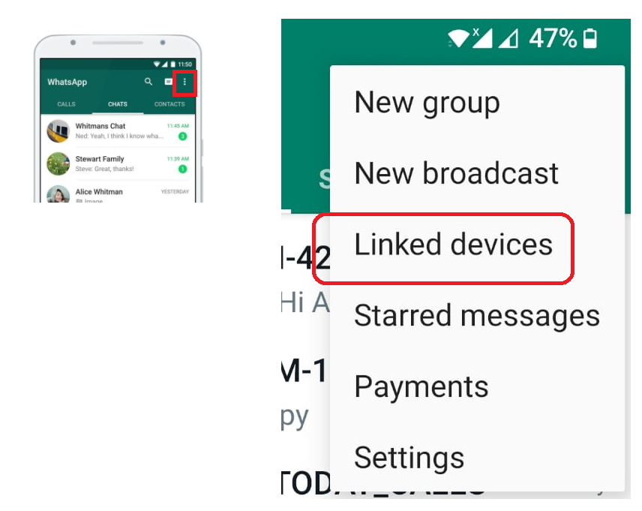

- THEN CLICK ON LINK A DEVICE THEN SCAN QR code
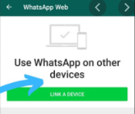

- SCAN QR CODE
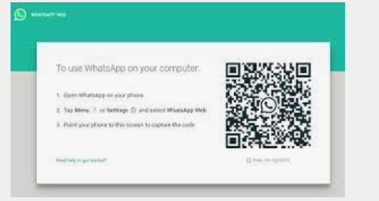

- TO DOWNLOAD FILES FROM WHATS APP WEB
Click on download icon then it will download into download folder
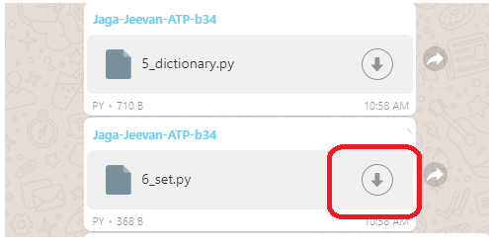

- TO OPEN PYTHON FILE IN NOTEPAD ++

RIGHT CLICK ON PYTHON FILE THEN CLICK ON Edit with Notepad++
