What is .pyc file and Use?
.pyc file contains BYTE code.

What is BYTE code?
Byte code is an intermediate code between the source code and machine code.
It is a platform independent and efficient which is easily to read by machine

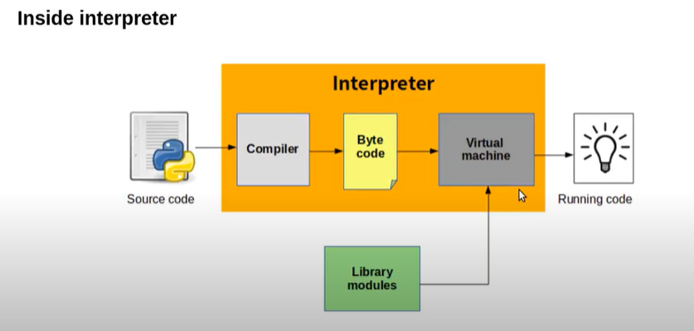

Use of BYTE code?
By creating .pyc file no need to craete byte code for every execution.

