**Vel Tech Rangarajan Dr. Sagunthala R&D Institute of Science and Technology**

**(Deemed to be University Estd. u/s 3 of UGC Act, 1956)**

**School of Computing**

**B.Tech. – Computer Science and Engineering**

**VTR UGE2021- (CBCS)**

Academic Year: 2025–2026

SUMMER SEMESTER - SS2526

Course Code : 10211CS207

Course Name: Database Management Systems

Slot No : S2L5

DBMS TASK - 1 REPORT

**Title:** Conceptual Design through FTR

**Submitted by:**

|  |  |  |
| --- | --- | --- |
| **VTUNO** | **REGISTER NUMBER** | **STUDENT NAME** |
| VTU29510 | 24UECS0249 | P RAM CHARAN |

**🎯 1.a – Identifying Entities**

These are the main objects or concepts that store data:

* **CricketBoard**
* **Team**
* **Player**
* **Match**
* **Ground**
* **Umpire**

**📋 1.b – Identifying Attributes**

Here are attributes for each entity (primary key underlined):

* **CricketBoard**(BoardID, Name, Address, Contact_No)
* **Team**(TeamID, Name, Coach, Captain)
* **Player**(PlayerID, FName, LName, Age, DateofBirth, PlayingRole)
* **Match**(MatchID, Date, Time, Result)
* **Ground**(GroundID, Name, Location, Capacity)
* **Umpire**(UmpireID, FName, LName, Age, DateofBirth, Country)

**🔗 1.c – Relationships, Cardinality, and Type**

| **Relationship** | **Entities Involved** | **Cardinality** | **Type** |
| --- | --- | --- | --- |
| Board-Manages-Team | CricketBoard – Team | 1 : M (One board manages many teams) | 1 to Many |
| Team-Has-Player | Team – Player | 1 : M (One team has many players) | 1 to Many |
| Match-Includes-Team | Match – Team | M : M (Matches involve multiple teams) | Many to Many |
| Match-IsHeldAt | Match – Ground | M : 1 (Many matches can be held at one ground) | Many to One |
| Match-Has-Umpire | Match – Umpire | M : M (Each match has multiple umpires, and an umpire can officiate many matches) | Many to Many |

Here is an image representing the **ER Diagram** for the cricket database model you described:

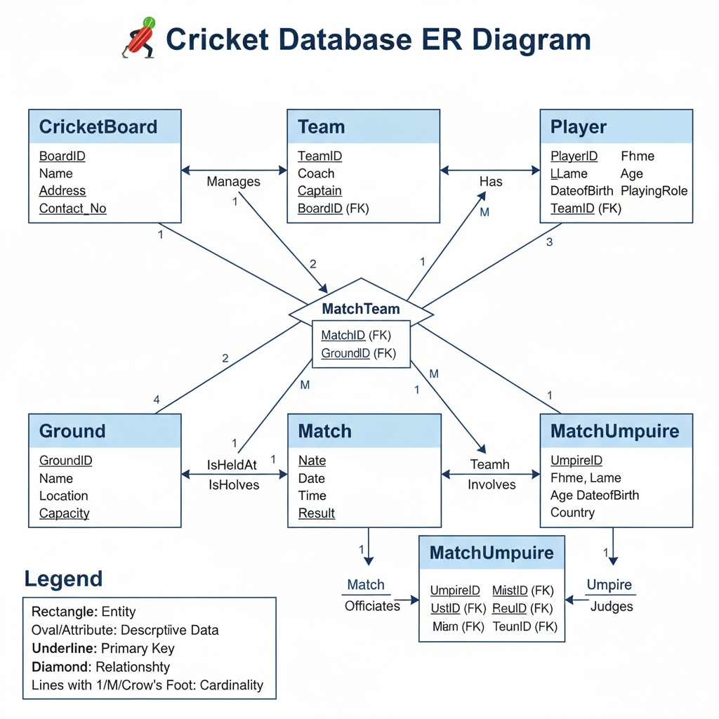

**RESULT:** Thus the task is executed and verified sucessfully