**Vel Tech Rangarajan Dr. Sagunthala R&D Institute of Science and Technology**

**(Deemed to be University Estd. u/s 3 of UGC Act, 1956)**

**School of Computing**

**B.Tech. – Computer Science and Engineering**

**VTR UGE2021- (CBCS)**

Academic Year: 2025–2026

SUMMER SEMESTER - SS2526

Course Code : 10211CS207

Course Name: Database Management Systems

Slot No : S2L5

DBMS TASK - 3 REPORT

**Title:** Using Clauses, Operators, and Functions in Queries System Nam**e**: Online Food Ordering System

**Submitted by:**

|  |  |  |
| --- | --- | --- |
| **VTUNO** | **REGISTER NUMBER** | **STUDENT NAME** |
| VTU29510 | 24UECS0249 | P.RAM CHARAN |

**Task 3: Using Clauses, Operators, and Functions in Queries System Name**: Online Food Ordering System

**Aim**: To perform query processing on databases for different retrieval results using **DML** and **DRL operations** with aggregate functions, date functions, string functions, set clauses, and operators.

CREATE TABLE Customer ( Cust_ID INT PRIMARY KEY,

Cust_Name VARCHAR(100), Cust_Contact VARCHAR(10) UNIQUE, Cust_Email VARCHAR(100) NOT NULL,

Cust_Address VARCHAR(100)

);

CREATE TABLE Restaurant ( Rest_ID INT PRIMARY KEY,

Rest_Name VARCHAR(100), Rest_Location VARCHAR(200), Rest_Contact VARCHAR(10)

);

CREATE TABLE Menu_Item ( Item_ID INT PRIMARY KEY,

Item_Name VARCHAR(100), Price INT CHECK (Price > 0), Category VARCHAR(50), Rest_ID INT,

FOREIGN KEY (Rest_ID) REFERENCES Restaurant(Rest_ID)

);

CREATE TABLE OrderTable ( Order_ID INT PRIMARY KEY,

Cust_ID INT, Order_Date DATE, Order_Total INT,

Payment_Status VARCHAR(50),

FOREIGN KEY (Cust_ID) REFERENCES Customer(Cust_ID)

);

CREATE TABLE Delivery ( Delivery_ID INT PRIMARY KEY, Order_ID INT,

Delivery_Status VARCHAR(50), Delivery_Time DATE,

FOREIGN KEY (Order_ID) REFERENCES OrderTable(Order_ID)

);

1. **Insert Values into Customer Table**

INSERT INTO Customer VALUES (1, 'Alice', '9876543210', ['alice@example.com',](mailto:%27alice@example.com) 'Street 123');

INSERT INTO Customer VALUES (2, 'Bob', '9123456789', ['bob@example.com',](mailto:%27bob@example.com) 'Street 456');

INSERT INTO Customer VALUES (3, 'Charlie', '9988776655', ['charlie@example.com',](mailto:%27charlie@example.com) 'Street 789');

1. **Insert Values into Restaurant Table**

INSERT INTO Restaurant VALUES (1, 'Food Paradise', 'Downtown', '9988771234'); INSERT INTO Restaurant VALUES (2, 'Tasty Treats', 'Uptown', '8877664321'); INSERT INTO Restaurant VALUES (3, 'Global Eats', 'City Center', '7766552211');

1. **Insert Values into Menu_Item Table**

INSERT INTO Menu_Item VALUES (1, 'Pizza', 500, 'Italian', 1); INSERT INTO Menu_Item VALUES (2, 'Burger', 300, 'Fast Food', 1); INSERT INTO Menu_Item VALUES (3, 'Sushi', 800, 'Japanese', 2);

INSERT INTO Menu_Item VALUES (4, 'Pasta', 400, 'Italian', 1);

INSERT INTO Menu_Item VALUES (5, 'Noodles', 350, 'Chinese', 3);

1. **Insert Values into OrderTable Table**

INSERT INTO OrderTable VALUES (1, 1, '2025-01-20', 800, 'Paid');

INSERT INTO OrderTable VALUES (2, 2, '2025-01-21', 500, 'Unpaid');

INSERT INTO OrderTable VALUES (3, 3, '2025-01-22', 700, 'Paid');

1. **Insert Values into Delivery Table**

INSERT INTO Delivery VALUES (1, 1, 'Delivered', '2025-01-20 14:30:00');

**First insert into OrderTable**

INSERT INTO OrderTable VALUES (2, 2, '2025-01-25', 500, 'Pending');

**-- Then insert into Delivery**

INSERT INTO Delivery VALUES (2, 2, 'Pending', NULL);

INSERT INTO Delivery VALUES (3, 3, 'Delivered', '2025-01-22 16:00:00');

**Task 3: Using Clauses, Operators, and Functions in Queries Queries and Outputs**

1. ***Aggregate Functions***

**Query 1: Find the total revenue generated by all orders.**



**Output:**



**Query 2: Find the total number of menu items offered by each restaurant.**

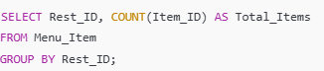

**Output:**

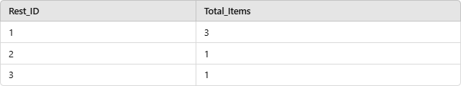

**Query 3: Find the average price of all menu items.**



**Output:**



1. ***Date Functions***

**Query 1: Retrieve orders placed in the last 7 days.**

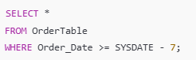

**Output:**

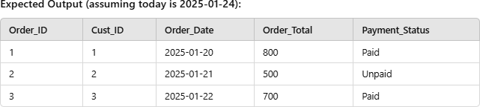

**Query 2: Find the orders and their delivery time if delivered today.**

**SELECT OrderTable.Order_ID, Delivery.Delivery_Time**

**FROM OrderTable**

**INNER JOIN Delivery**

**ON OrderTable.Order_ID = Delivery.Order_ID;**

**Output:**



1. ***String Functions***

**Query 1: Find all customers whose names contain the letter 'a'.**

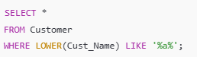

**Output:**

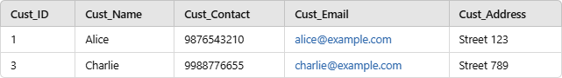

**Query 2: Display all menu item names in uppercase.**



**Output:**

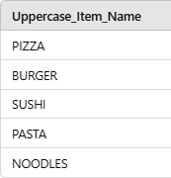

1. ***Set Clauses***

**Query 1: Update the payment status of all unpaid orders to 'Paid'.**

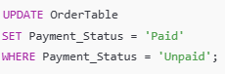

**Output:**

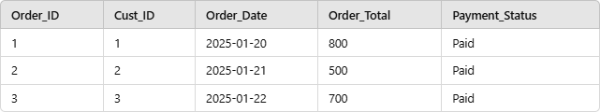

**Query 2: Reduce the price of all menu items by 10%.**



**Output:**

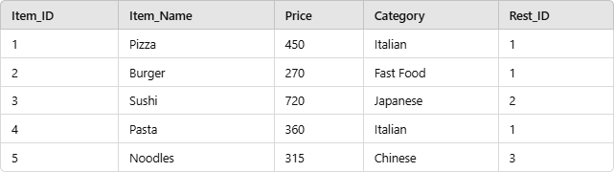

1. ***Operators***

**Query 1: Retrieve orders where the total is greater than 600.**

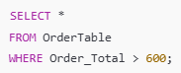

**Output:**

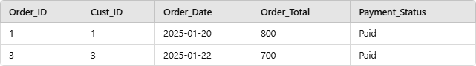

**Query 2: Retrieve menu items that belong to category 'Italian' or have a price less than 350.**

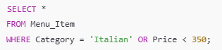

**Output:**

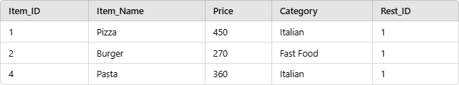**RESULT:**Thus the task has executed and verifed sucessfully successfully**.**