HI,

I hope this Report finds you well. I wanted to share my today work report with you.

Name: Bhargavi Mangipudi

Shift Timings: 09:30A.M – 06-30P.M Date: 11-06-2024

**Yesterday’s Work : (10-06-2024):**

I Have Learned the Topics locators of selenium and installation of eclipse.

**Today’s Work : (11-06-2024):**

I Have Learned the Topics of types of testing and Types of X-Path.

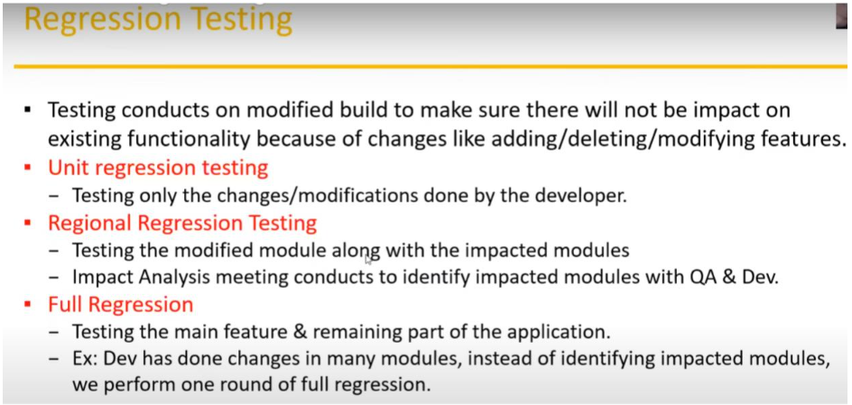

Thanks & Regards

Bhargavi.