Student ID: Charan Sai Prakash Thimma reddy

Student Name: 21071658

7PAM2000 Applied Data Science 1

Assignment 1: Visualisation

Table of Contents

Data Source Link 2

Visualization No. 1 – Line Plot 2

Visualization No. 2 – Pie Chart 3

Visualization No. 3 – Horizontal Bar Graph 5

References 6

# Data Source Link

<https://www.hesa.ac.uk/data-and-analysis/students/table-11.csv>

GitHub Repository Link:

<https://github.com/Charan91120/Applied_data_science_1_assignment>

# Visualization No. 1 – Line Plot

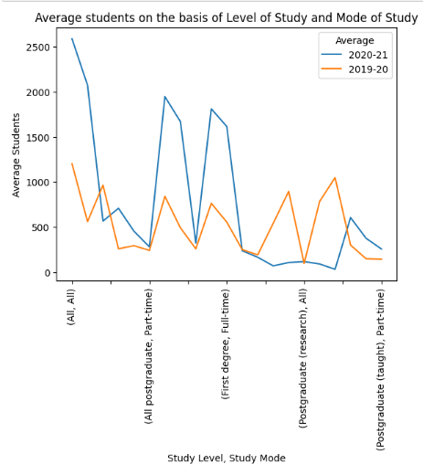

Figure : Multiple lines chart

The line plot has been used to visualize the data based on 2 criteria which are “Level of Study” and “Mode of Study”. The column “Level of Study” contains 'All', 'All postgraduate', ‘All undergraduate', 'First degree', 'Other undergraduate', 'Postgraduate (research)', and 'Postgraduate (taught)'. The column “Mode of study” contains “All”, “Part-time” and “Full-time”. The y axis of this graph indicates the average number of students for each criteria. The blue line here depicts average students in 2020-21 and the orange line, on the contrary, depicts average students in 2019-20 (Chauhan, 2022).

# 

# Visualization No. 2 – Pie Chart

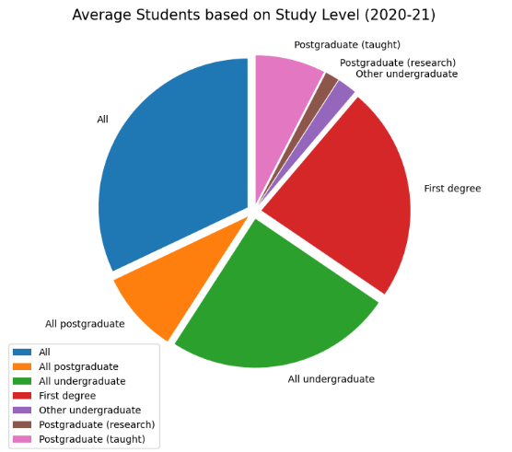

Figure : Pie chart 1

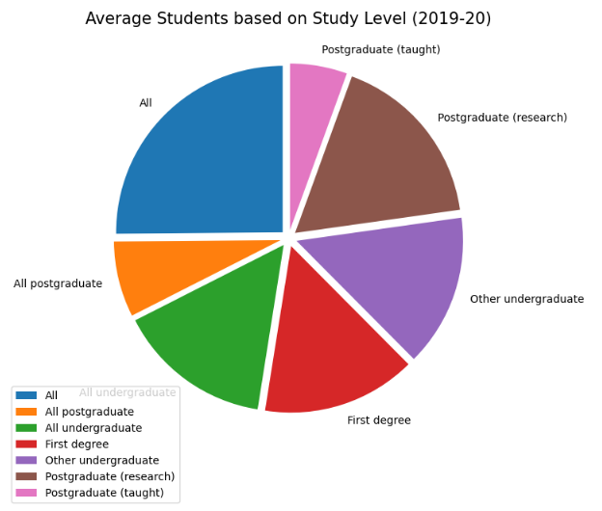

Figure : Pie chart 2

Here, using the pie_plot function, 2 pie charts have been created to visualize the data on the basis of “Level of study” column alone but both the charts depict data for different time periods. Fig 2 represents the data for 2020-21 and fig 3 represents the data for 2019-20. The students in “Postgraduate (Research)” have declined from 2019-2020 to 2020-21. Same has happened with the students belonging to “Other undergraduate”. On the contrary, the average number of students doing “First Degree” have increased from 2019-20 to 2020-21. Same has happened with the students belonging to “All Undergraduate” category (Soares, 2021).

# Visualization No. 3 – Horizontal Bar Graph

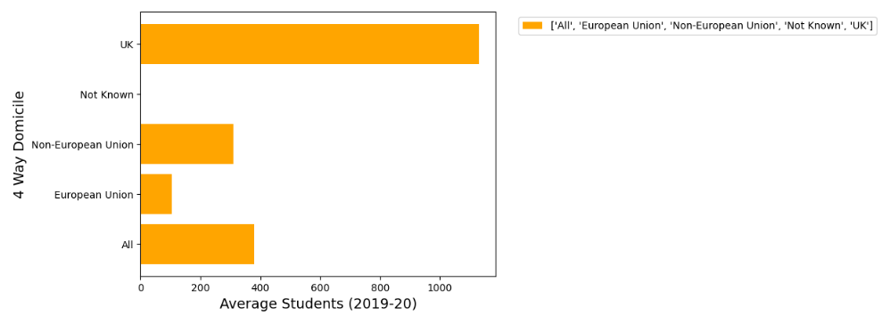

Figure : Horizontal bar chart 1

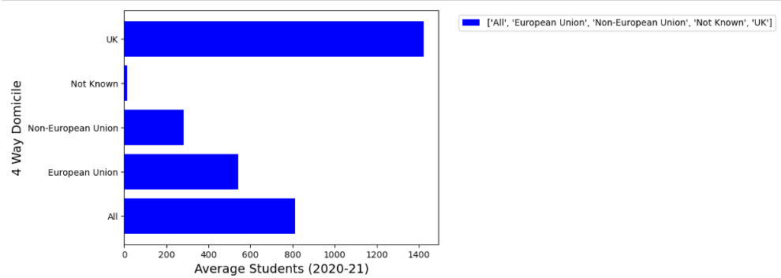

Figure : Horizontal bar chart 2

The horizontal bar graphs have been used to visualize the average number of students in 2019-20 on the basis of “4 way domicile”. Fig 4 here represents the data of students in 2019-20 and fig 5 represents the data of students in 2020-21. The x-axis determines the average number of students in both the bar graphs. The y-axis, on the other hand, determines the domicile of students (Soares, 2021).

It can be clearly seen that the average number of students have increased from 2019-20 to 2020-21. In both the years, maximum students belong to the “UK” domicile. In the year 2019-20, students from “Non-European Union” domicile exceed the students belonging to the “European Union” domicile. But in 2020-21, the case has reversed. Also, looking at the “Not known” label, it can be said that in 2020-21, more students belong to “Not Known” category which clearly indicates that either students have voluntarily not disclosed their domicile or there is data inconsistency in the dataset (Chauhan, 2022).

# References

Chauhan, A. (2022) *Step-by-step depth introduction of Matplotlib with Python*. Medium. The Pythoneers. [Online] [Accessed on November 9, 2022]https://medium.com/pythoneers/step-by-step-depth-introduction-of-matplotlib-with-python-8386d75b361d.

Soares, L. (2021) *A practical summary of matplotlib in 13 python snippets*. towardsdatascience. [Online] [Accessed on November 9, 2022]https://towardsdatascience.com/a-practical-summary-of-matplotlib-in-13-python-snippets-4d07f0011bdf.