**Week-1**

**Design Patterns, Data Structures & Algorithms**

1. **Singleton Pattern**

**Scenario:** You need to ensure that a logging utility class in your application has only one instance throughout the application lifecycle to ensure consistent logging.

**Logger.java:-**

package singleton;

public class Logger {

private static Logger *singleInstance*;

private Logger() {

System.*out*.println("Logger instance created.");

}

public static Logger getInstance() {

if (*singleInstance* == null) {

*singleInstance* = new Logger();

}

return *singleInstance*;

}

public void log(String message) {

System.*out*.println("Log: " + message);

}

}

**Main.java :-**

package singleton;

public class Main {

public static void main(String[] args) {

Logger logger1 = Logger.*getInstance*();

Logger logger2 = Logger.*getInstance*();

logger1.log("First message.");

logger2.log("Second message.");

if (logger1 == logger2) {

System.*out*.println("Both logger instances are the same.");

} else {

System.*out*.println("Different logger instances exist!");

}

}

}

**Output :-** 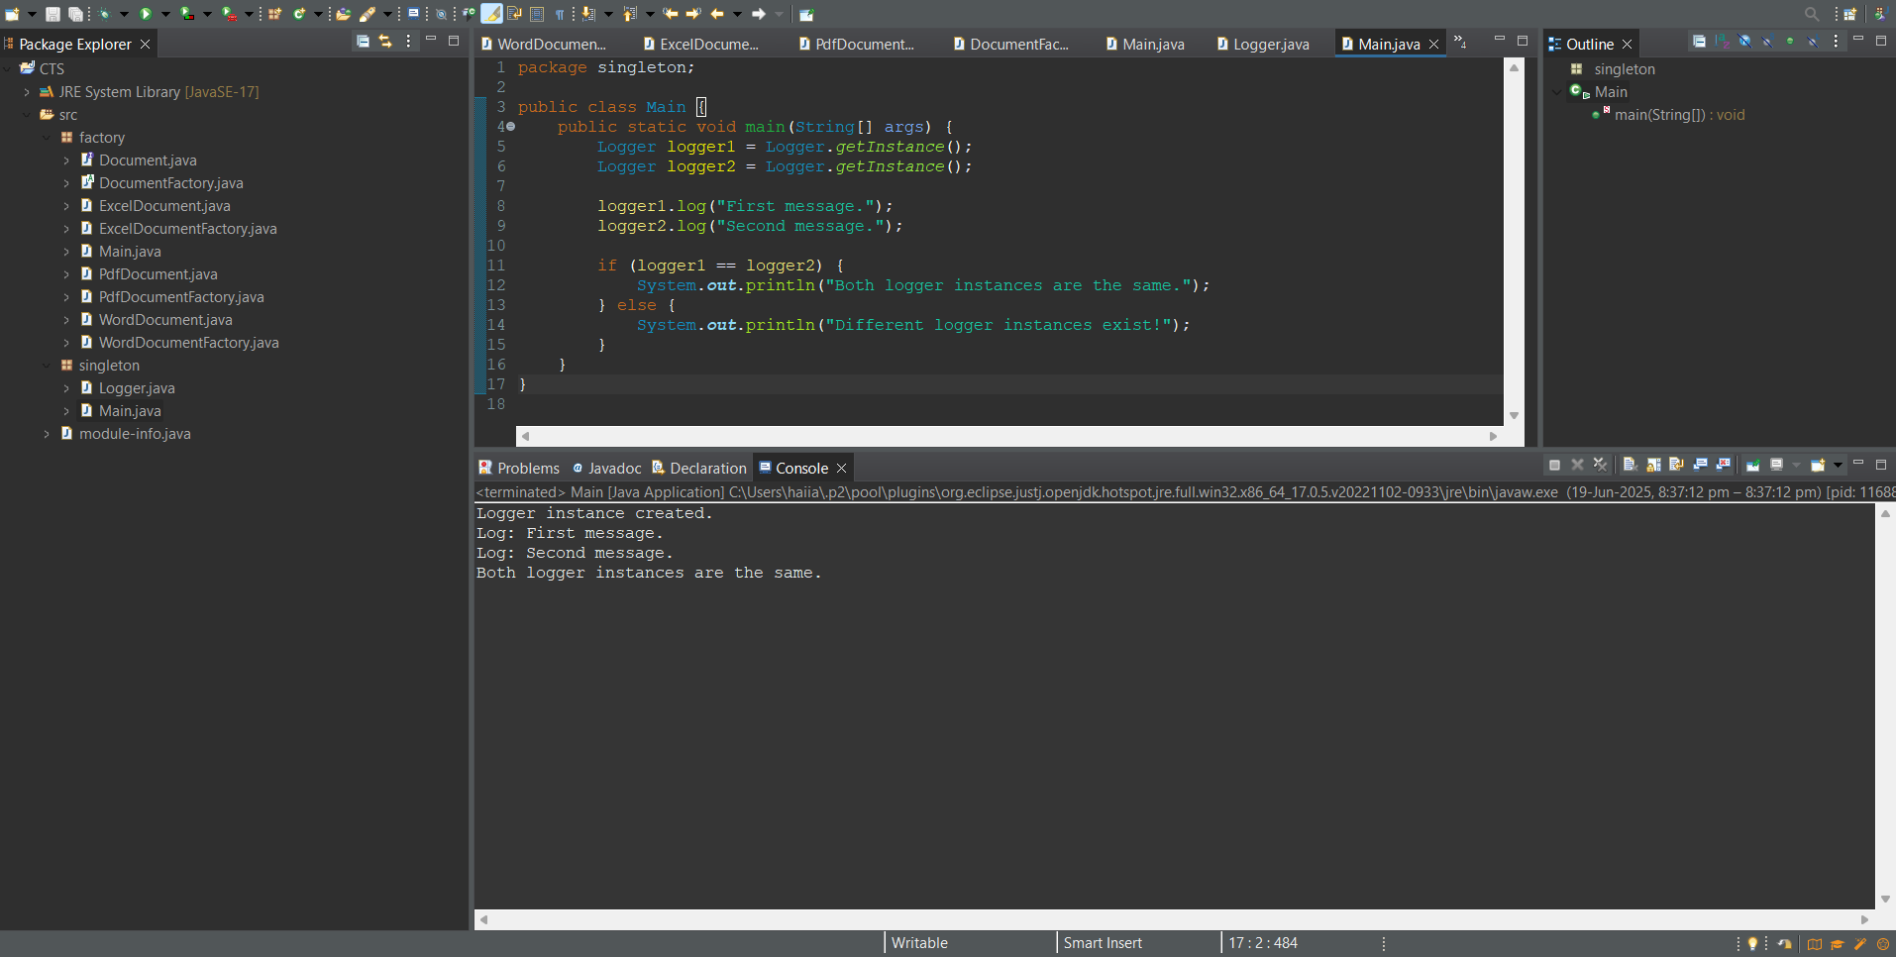

1. **Factory Method Pattern**

**Scenario:** You are developing a document management system that needs to create different types of documents (e.g., Word, PDF, Excel). Use the Factory Method Pattern to achieve this.

**Document.java:-**

package factory;

public interface Document {

void open();

}

**WordDocument.java:-**

package factory;

public class WordDocument implements Document {

public void open() {

System.out.println("Opening a Word document.");

}

}

**PdfDocument.java:-**

package factory;

public class PdfDocument implements Document {

public void open() {

System.out.println("Opening a PDF document.");

}

}

**ExcelDocument.java:-**

package factory;

public class ExcelDocument implements Document {

public void open() {

System.out.println("Opening an Excel document.");

}

}

**DocumentFactory.java:-**

package factory;

public abstract class DocumentFactory {

public abstract Document createDocument();

}

**WordDocumentFactory.java:-**

package factory;

public class WordDocumentFactory extends DocumentFactory {

public Document createDocument() {

return new WordDocument();

}

}

**PdfDocumentFactory.java:-**

package factory;

public class PdfDocumentFactory extends DocumentFactory {

public Document createDocument() {

return new PdfDocument();

}

}

**ExcelDocumentFactory.java:-**

package factory;

public class ExcelDocumentFactory extends DocumentFactory {

public Document createDocument() {

return new ExcelDocument();

}

}

**Main.java:-**

package factory;

public class Main {

public static void main(String[] args) {

DocumentFactory wordFactory = new WordDocumentFactory();

Document wordDoc = wordFactory.createDocument();

wordDoc.open();

DocumentFactory pdfFactory = new PdfDocumentFactory();

Document pdfDoc = pdfFactory.createDocument();

pdfDoc.open();

DocumentFactory excelFactory = new ExcelDocumentFactory();

Document excelDoc = excelFactory.createDocument();

excelDoc.open();

}

}

**Output :-**

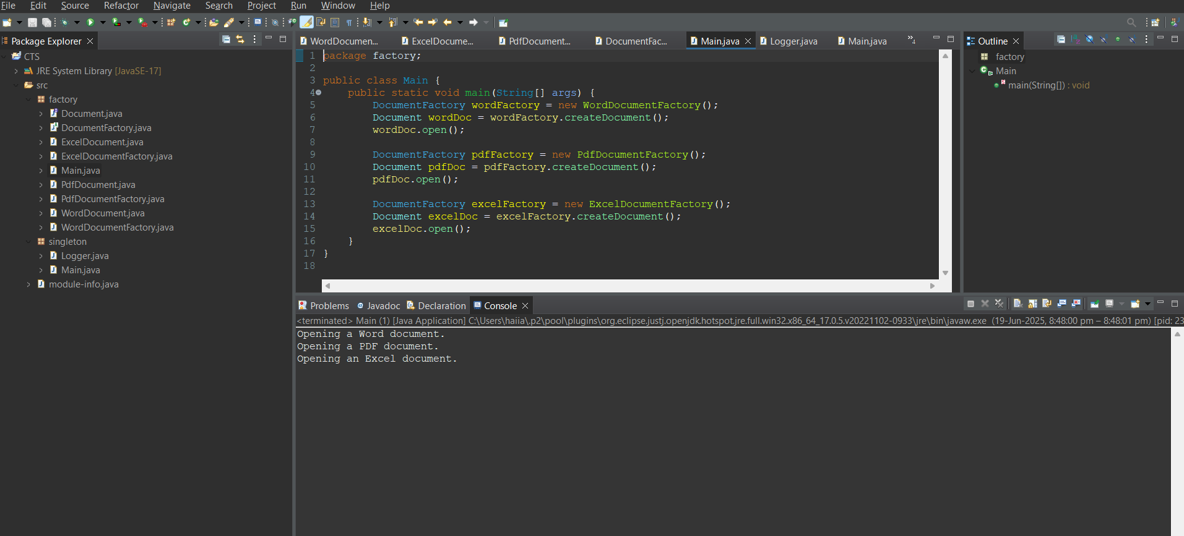

1. **E-commerce Platform Search Function:-**

**Scenario:** You are working on the search functionality of an e-commerce platform. The search needs to be optimized for fast performance.

**Product.java:-**

package E_Commmerece_Search;

public class Product {

int productId;

String productName, category;

public Product(int productId, String productName, String category) {

this.productId = productId;

this.productName = productName;

this.category = category;}

public String toString() {

return "[" + productId + ", " + productName + ", " + category + "]";

}

}

**SearchFunc.java:-**

package E_Commmerece_Search;

import java.util.*;

public class SearchFunc {

public static Product linearSearch(Product[] products, String productName) {

for (Product product : products) {

if (product.productName.equalsIgnoreCase(productName)) {

return product;}}

return null;

}

public static Product binarySearch(Product[] products, String productName) {

int left = 0, right = products.length - 1;

while (left <= right) {

int mid = (left + right) / 2;

int cmp = products[mid].productName.compareToIgnoreCase(productName);

if (cmp == 0) return products[mid];

else if (cmp < 0) left = mid + 1;

else right = mid - 1;}

return null;}

public static void sortProducts(Product[] products) {

Arrays.*sort*(products, Comparator.*comparing*(p -> p.productName.toLowerCase()));

}

}

**Main.java:-**

package E_Commmerece_Search;

import java.util.Scanner;

public class Main {

public static void main(String[] args) {

Scanner sc = new Scanner(System.*in*);

Product[] products = {

new Product(101, "Laptop", "Electronics"),

new Product(102, "Shoes", "Footwear"),

new Product(103, "Phone", "Electronics"),

new Product(105, "Watch", "Accessories")

};

System.*out*.print("Enter product name to search: ");

String inputProduct = sc.nextLine();

Product result1 = SearchFunc.*linearSearch*(products, inputProduct);

if (result1 != null) {

System.*out*.println("Product found using Linear Search: " + result1);

} else {

System.*out*.println("Product not found using Linear Search.");}

SearchFunc.*sortProducts*(products);

Product result2 = SearchFunc.*binarySearch*(products, inputProduct);

if (result2 != null) {

System.*out*.println("Product found using Binary Search: " + result2);

} else {

System.*out*.println("Product not found using Binary Search.");

}

sc.close();

}

**Output:-**

1. **Financial Forecasting**

**Scenario:** You are developing a financial forecasting tool that predicts future values based on past data.

**Forecast.java:-**

package Financial_Forecasting;

import java.util.Scanner;

public class Forecast {

public static void main(String[] args) {

Scanner sc = new Scanner(System.*in*);

System.*out*.print("Enter current value: ");

double currentValue = sc.nextDouble();

System.*out*.print("Enter annual growth rate (e.g., 0.05 for 5%): ");

double growthRate = sc.nextDouble();

System.*out*.print("Enter number of years to forecast: ");

int years = sc.nextInt();

double futureValue = Forecast.*calculateFutureValue*(currentValue, growthRate, years);

System.*out*.printf("Predicted future value after %d years: %.2f\n", years, futureValue);

sc.close();

}

public static double calculateFutureValue(double currentValue, double growthRate, int years) {

if (years == 0) {

return currentValue;

}

return *calculateFutureValue*(currentValue, growthRate, years - 1) * (1 + growthRate);

}

}

