BOCK Ai

INTERNSHIP COMPLETION LETTER

{XDATEX}
Greetings {XLAMAX},

I am pleased to inform you that you have successfully completed your internship at BOCK Ai from {XNOXNOXXXXOXX} to {YNOXNOXXXXOXY}. Over the course of these {XOX} months, you have demonstrated exceptional dedication, a strong work ethic, and an eagerness to learn, which have significantly contributed to our team’s success. Your ability to quickly adapt to our fast-paced work environment and take on complex projects has been commendable. Your work on {XVARIXBLEX} was particularly impressive, showcasing your analytical skills and creativity. We are grateful for the fresh perspective you brought to our company and the high-quality work you consistently delivered.

During your internship, you have effectively applied the knowledge and skills acquired from your academic studies to real-world challenges. Your proficiency in as {NOXIXON} has been evident and beneficial to our team. You have shown excellent teamwork abilities, collaborating seamlessly with colleagues across various departments. Your proactive approach in seeking feedback and your commitment to continuous improvement have not gone unnoticed. It is clear that you have a bright future ahead of you, and we are confident that the experience gained during your time with us will serve you well in your career.

On behalf of the entire team at BOCK Ai, I want to extend our heartfelt appreciation for your hard work and dedication. We hope that this internship has been a valuable learning experience for you, and we are certain that you will continue to excel in your future endeavors. Should you need any further assistance or a recommendation letter, please do not hesitate to contact us. We wish you all the best in your future career and personal growth.

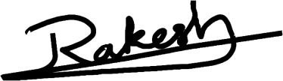

Sincerely BOCK Ai
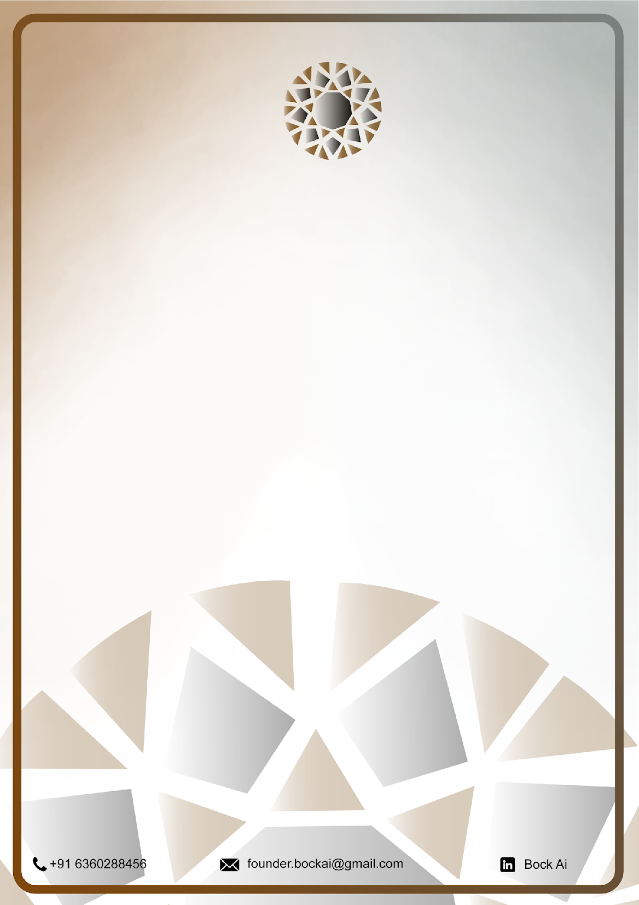
Director/Founder

