S Super Design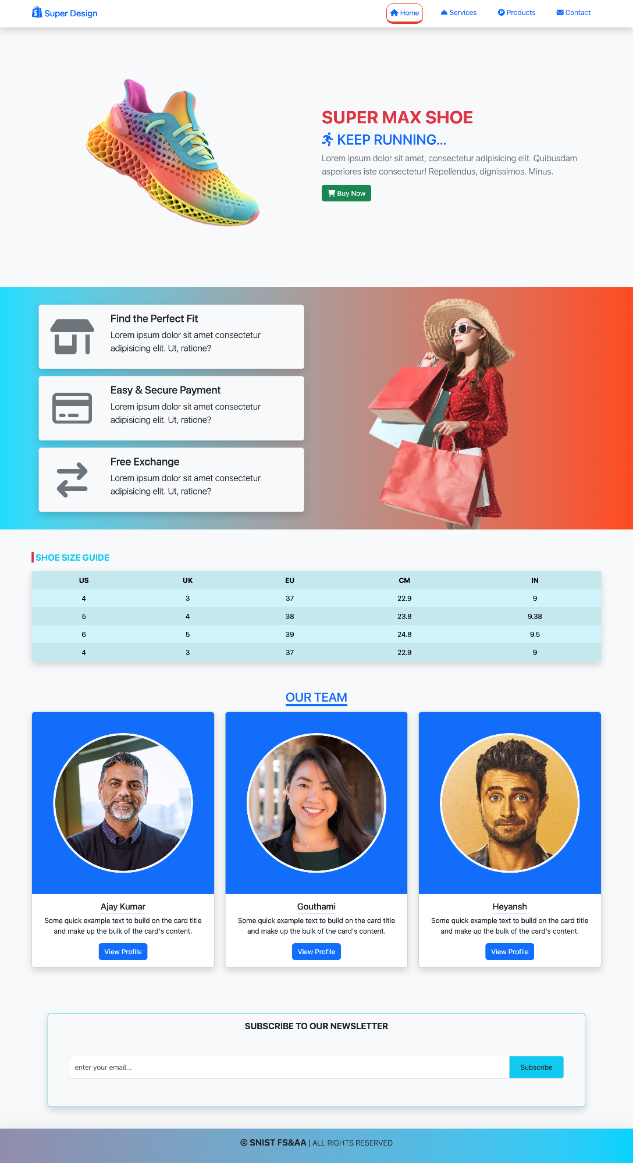

15

**↑↓**

**Find the Perfect Fit**

Lorem ipsum dolor sit amet consectetur adipisicing elit. Ut, ratione?

**Easy & Secure Payment**

Lorem ipsum dolor sit amet consectetur

adipisicing elit. Ut, ratione?

**Free Exchange**

Lorem ipsum dolor sit amet consectetur

adipisicing elit. Ut, ratione?

**SHOE SIZE GUIDE**

Home

Services

P Products

Contact

**SUPER MAX SHOE**

**ॐ KEEP RUNNING...**

Lorem ipsum dolor sit amet, consectetur adipisicing elit. Quibusdam asperiores iste consectetur! Repellendus, dignissimos. Minus.

Buy Now

**US**

**UK**

**EU**

**CM**

**IN**

4 5 6

LO

3

37

22.9

9

4

38

23.8

9.38

5

39

24.8

9.5

4

3

37

22.9

9

**OUR TEAM**

**Ajay Kumar**

Some quick example text to build on the card title and make up the bulk of the card's content.

View Profile

Gouthami

Some quick example text to build on the card title and make up the bulk of the card's content.

View Profile

Heyansh

Some quick example text to build on the card title and make up the bulk of the card's content.

View Profile

enter your email...

**SUBSCRIBE TO OUR NEWSLETTER**

SNIST FS&AA | ALL RIGHTS RESERVED

Subscribe