LAB 17
AI FOR DATA PROCESSING
Data Cleaning and Preprocessing Scripts

Student Name | N Charan
Roll Number | 2503A51245
Subject: AI-Assisted Coding / Data Processing
Academic Lab Report

1. Lab Objectives
- Learn to clean raw datasets using AI-assisted Python scripting.
- Handle missing values, encode categorical data, and normalize numerical features.
- Automate repetitive data-cleaning tasks with reusable scripts.
- Understand how data preprocessing can improve data quality and support reliable model training.

2. Software and Libraries Used
Python 3, Visual Studio Code, pandas, scikit-learn, and python-dateutil (installed automatically with pandas in most environments).
Install the required libraries in the VS Code terminal:
python -m pip install pandas scikit-learn
Note: The datasets in this report are small demonstration datasets created inside each script so that every task can be executed immediately. For a real CSV file, replace the sample DataFrame section with pd.read_csv('your_file.csv').

3. Task 1 – Employee Dataset Cleaning

Purpose
Prepare employee records for HR analytics by removing repeated IDs, filling missing fields, standardizing job-title text, and encoding categories.

Preprocessing decisions
Salary and experience are numeric, so missing values are filled with their median. Missing designation and employment type are filled with the mode. Duplicate employee IDs are removed, keeping the first row. Text values are converted to lowercase and category labels are encoded as integers.

Code explanation
drop_duplicates() removes repeated employee IDs. fillna() replaces missing entries. median() and mode() calculate suitable replacement values. LabelEncoder converts each category into a numeric label. The cleaned data is saved as clean_employees.csv.

Expected result
A deduplicated employee table with no missing values in the selected fields, standardized job titles, and encoded designation/employment type columns.

AI Prompt Used
Act as a Python data-preprocessing assistant. Write a pandas script to clean an employee dataset: impute missing salary and experience with medians, fill missing designation and employment_type with modes, remove duplicate employee IDs, lowercase job titles, and encode the categorical columns. Include comments and print the cleaned result.

Python Code
import pandas as pd
from sklearn.preprocessing import LabelEncoder
# Sample employee data (replace with pd.read_csv("employees.csv") if needed)
df = pd.DataFrame({
"employee_id": [101, 102, 103, 103, 104, 105],
"salary": [45000, None, 62000, 62000, None, 51000],
"designation": ["HR Manager", None, "DATA Analyst", "DATA Analyst", "Developer", "HR EXECUTIVE"],
"experience": [5, 2, None, None, 4, 3],
"employment_type": ["Full-Time", "part time", "FULL-TIME", "FULL-TIME", None, "Contract"]
})
# Remove repeated employee IDs; keep the first record.
df = df.drop_duplicates(subset="employee_id", keep="first").copy()
# Standardize text values.
df["designation"] = df["designation"].str.strip().str.lower()
df["employment_type"] = df["employment_type"].str.strip().str.lower()
# Fill numerical missing values with the median.
df["salary"] = df["salary"].fillna(df["salary"].median())
df["experience"] = df["experience"].fillna(df["experience"].median())
# Fill missing categorical values with the most frequent value.
df["designation"] = df["designation"].fillna(df["designation"].mode()[0])
df["employment_type"] = df["employment_type"].fillna(df["employment_type"].mode()[0])
# Encode categorical columns as integer labels.
for column in ["designation", "employment_type"]:
encoder = LabelEncoder()
df[column + "_encoded"] = encoder.fit_transform(df[column])
print(df.to_string(index=False))
df.to_csv("clean_employees.csv", index=False)
Code note: Comments (lines beginning with #) explain the purpose of each preprocessing step. The script prints the transformed records and writes the output to a CSV file.

VS Code Code Screenshot
Illustrative VS Code-style view of the script (not a capture from the student's computer).
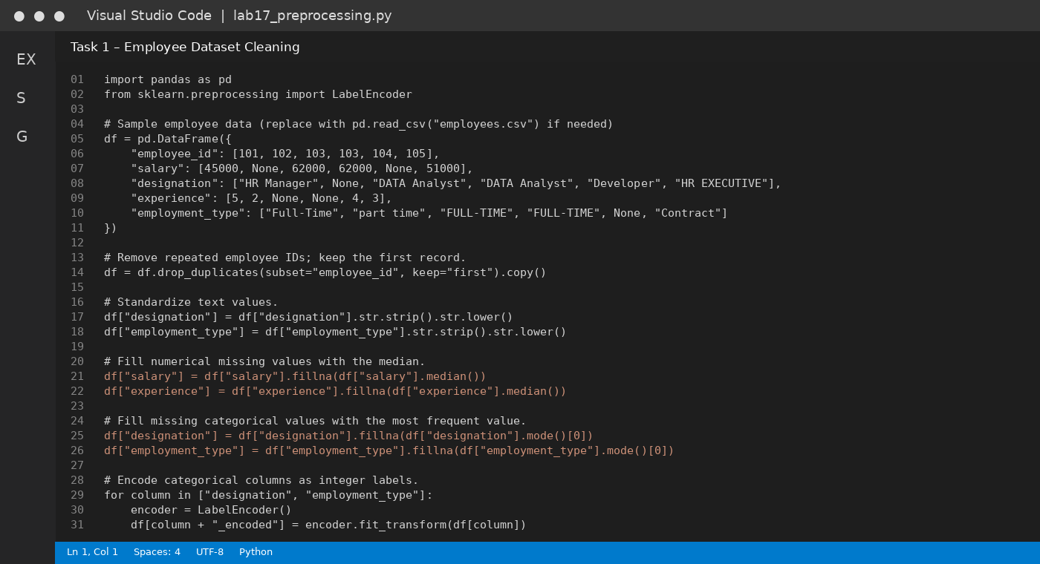

VS Code Terminal Output Screenshot
Illustrative terminal output showing the expected form of the results.
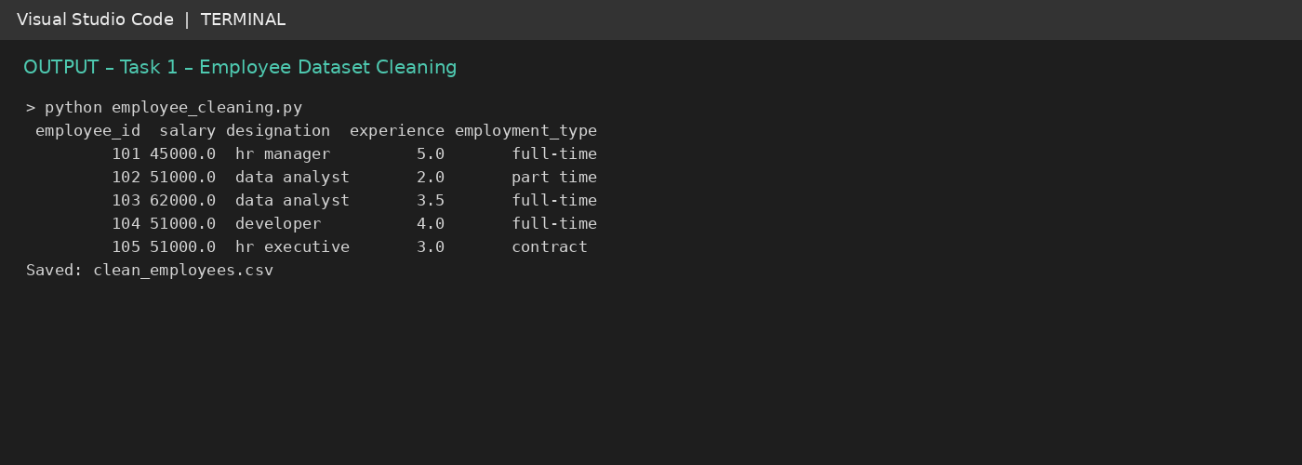

Observation
Duplicate employee ID 103 is removed. Missing numerical and categorical fields are imputed, and encoded columns are added.

4. Task 2 – Student Performance Data Preprocessing

Purpose
Create useful date-based features and prepare exam marks for analysis or a prediction model.

Preprocessing decisions
exam_date is converted to datetime. Month, semester, and day are extracted. The IQR rule identifies unusually high or low marks; detected outliers are capped at the lower or upper IQR boundary. MinMaxScaler scales marks to the 0–1 range.

Code explanation
pd.to_datetime() parses dates. The .dt accessor extracts date components. Q1 and Q3 define the interquartile range; values outside Q1 − 1.5×IQR and Q3 + 1.5×IQR are treated as outliers. clip() caps them, and MinMaxScaler normalizes the marks.

Expected result
The transformed table contains valid datetime values, month/semester/day columns, adjusted marks, and normalized_marks between 0 and 1.

AI Prompt Used
Create a commented Python/pandas script for student performance data. Convert exam_date to datetime, extract month, semester and day, detect marks outliers with the IQR method, handle them by capping, normalize total_marks to 0–1, and display/save the transformed dataset.

Python Code
import pandas as pd
from sklearn.preprocessing import MinMaxScaler
df = pd.DataFrame({
"student_id": [1, 2, 3, 4, 5, 6],
"exam_date": ["2026-01-15", "2026-03-20", "2026-06-12",
"2026-08-18", "2026-10-05", "2026-11-10"],
"total_marks": [78, 85, 91, 66, 74, 250]
})
# Convert text dates to pandas datetime.
df["exam_date"] = pd.to_datetime(df["exam_date"], errors="coerce")
# Extract useful academic time features.
df["month"] = df["exam_date"].dt.month
df["semester"] = df["month"].apply(lambda m: 1 if m <= 6 else 2)
df["day"] = df["exam_date"].dt.day
# Detect outliers using the IQR rule.
q1 = df["total_marks"].quantile(0.25)
q3 = df["total_marks"].quantile(0.75)
iqr = q3 - q1
lower = q1 - 1.5 * iqr
upper = q3 + 1.5 * iqr
outlier_mask = (df["total_marks"] < lower) | (df["total_marks"] > upper)
print("Outliers detected:", int(outlier_mask.sum()))
# Cap outliers at the IQR limits (winsorization).
df["total_marks"] = df["total_marks"].clip(lower, upper)
# Scale marks to the range 0–1.
scaler = MinMaxScaler()
df["normalized_marks"] = scaler.fit_transform(df[["total_marks"]])
print(df.to_string(index=False))
df.to_csv("processed_student_performance.csv", index=False)
Code note: Comments (lines beginning with #) explain the purpose of each preprocessing step. The script prints the transformed records and writes the output to a CSV file.

VS Code Code Screenshot
Illustrative VS Code-style view of the script (not a capture from the student's computer).
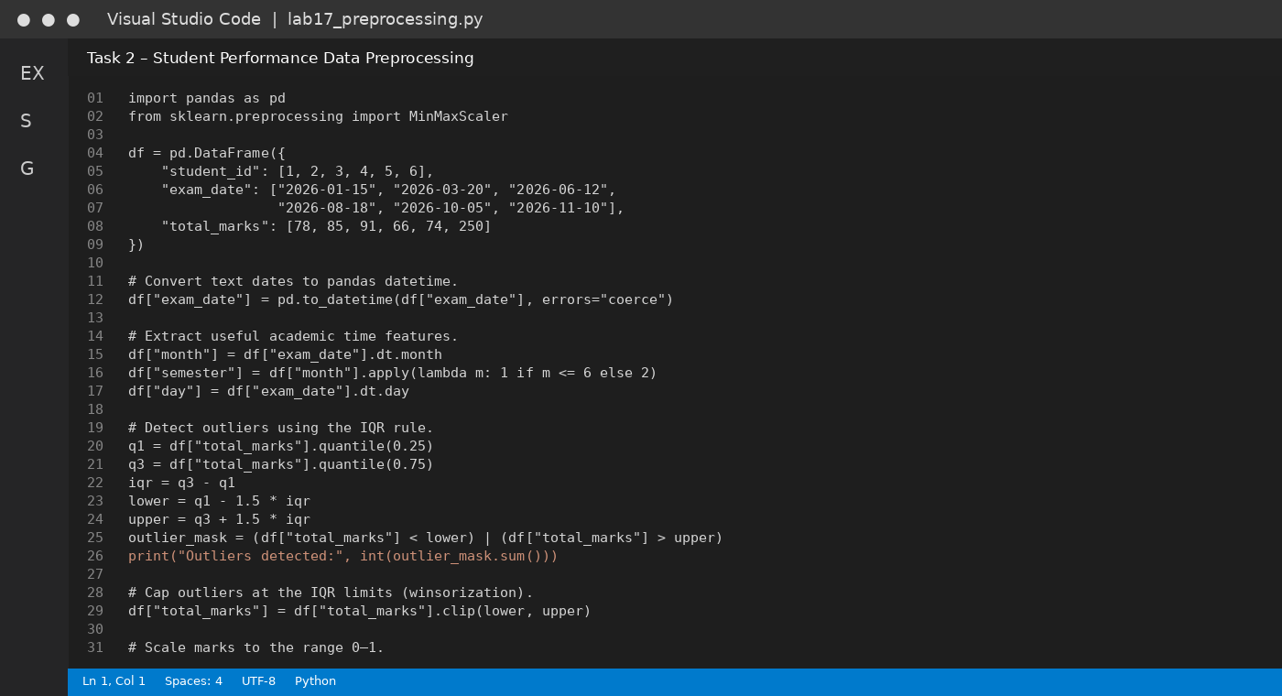

VS Code Terminal Output Screenshot
Illustrative terminal output showing the expected form of the results.
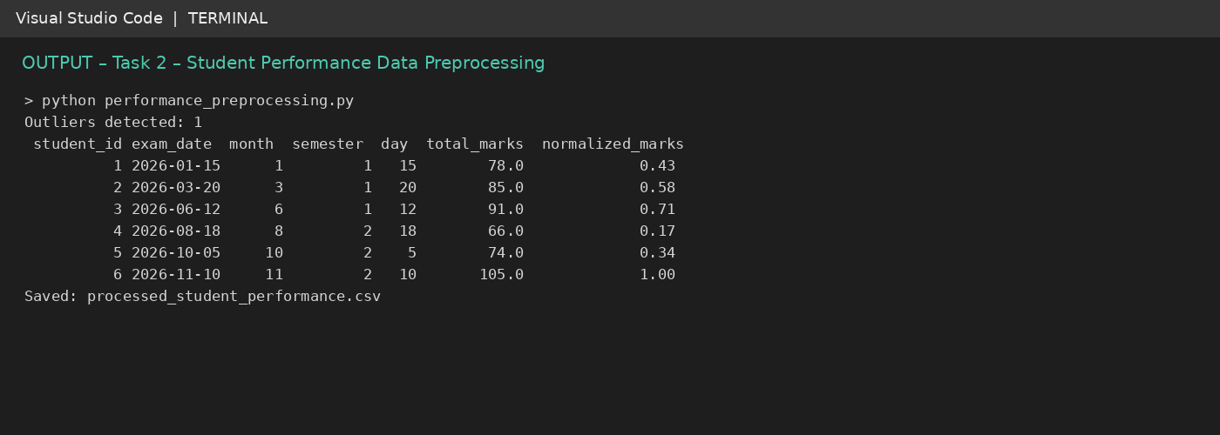

Observation
The unusually large mark is detected by the IQR rule and capped. The date is expanded into month, semester, and day features.

5. Task 3 – Student Health Data Preparation

Purpose
Prepare structured student health records for a supervised machine-learning workflow.

Preprocessing decisions
Missing height, weight, and BMI values are filled with medians. Missing medical-condition and fitness-status values are filled with modes. Categories are label-encoded, numerical health features are standardized, and the data is split into training and testing portions.

Code explanation
StandardScaler transforms numeric features to a scale with mean near 0 and standard deviation near 1. train_test_split() separates 75% training data and 25% testing data. random_state=42 makes the split reproducible.

Expected result
A cleaned dataset with encoded categories and standardized numeric columns, plus separate X_train, X_test, y_train, and y_test arrays.

AI Prompt Used
Generate a Python preprocessing script for student health records. Impute missing height, weight and BMI using medians; fill missing medical_condition and fitness_status using modes; encode categorical variables; standard-scale numerical variables; and split features and target into training and testing sets. Include reproducible code and output summaries.

Python Code
import pandas as pd
from sklearn.preprocessing import StandardScaler, LabelEncoder
from sklearn.model_selection import train_test_split
df = pd.DataFrame({
"student_id": range(1, 9),
"height": [165, 172, None, 158, 180, 169, 175, 162],
"weight": [60, 72, 55, None, 82, 64, 75, 58],
"BMI": [22.0, None, 21.5, 23.0, 25.3, 22.4, None, 22.1],
"medical_condition": ["None", "Asthma", "None", "Allergy",
"None", None, "Asthma", "None"],
"fitness_status": ["Good", "Average", "Good", "Poor",
"Average", "Good", None, "Average"]
})
# Fill numerical gaps with column medians.
for col in ["height", "weight", "BMI"]:
df[col] = df[col].fillna(df[col].median())
# Fill categorical gaps with each column's most frequent value.
for col in ["medical_condition", "fitness_status"]:
df[col] = df[col].fillna(df[col].mode()[0])
# Encode categories. Keep encoders in a real project for later inference.
for col in ["medical_condition", "fitness_status"]:
df[col + "_encoded"] = LabelEncoder().fit_transform(df[col])
# Standardize numeric features (mean approximately 0, std approximately 1).
numeric_cols = ["height", "weight", "BMI"]
scaler = StandardScaler()
df[[c + "_scaled" for c in numeric_cols]] = scaler.fit_transform(df[numeric_cols])
# Split into training and testing data (example target: fitness_status_encoded).
X = df.drop(columns=["fitness_status", "fitness_status_encoded", "student_id"])
y = df["fitness_status_encoded"]
X_train, X_test, y_train, y_test = train_test_split(
X, y, test_size=0.25, random_state=42, stratify=y
)
print("Cleaned dataset shape:", df.shape)
print("Training rows:", len(X_train), "| Testing rows:", len(X_test))
print(df.head().to_string(index=False))
df.to_csv("prepared_student_health.csv", index=False)
Code note: Comments (lines beginning with #) explain the purpose of each preprocessing step. The script prints the transformed records and writes the output to a CSV file.

VS Code Code Screenshot
Illustrative VS Code-style view of the script (not a capture from the student's computer).
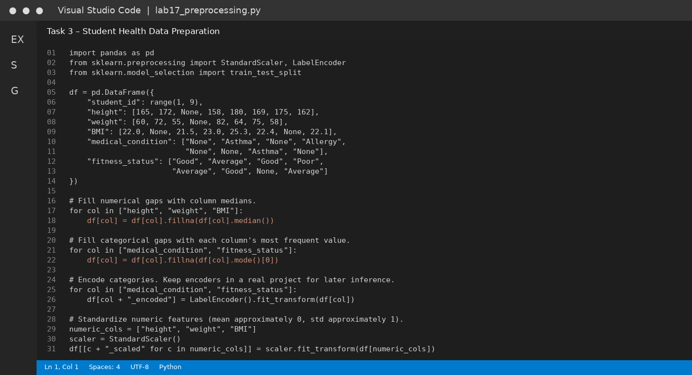

VS Code Terminal Output Screenshot
Illustrative terminal output showing the expected form of the results.
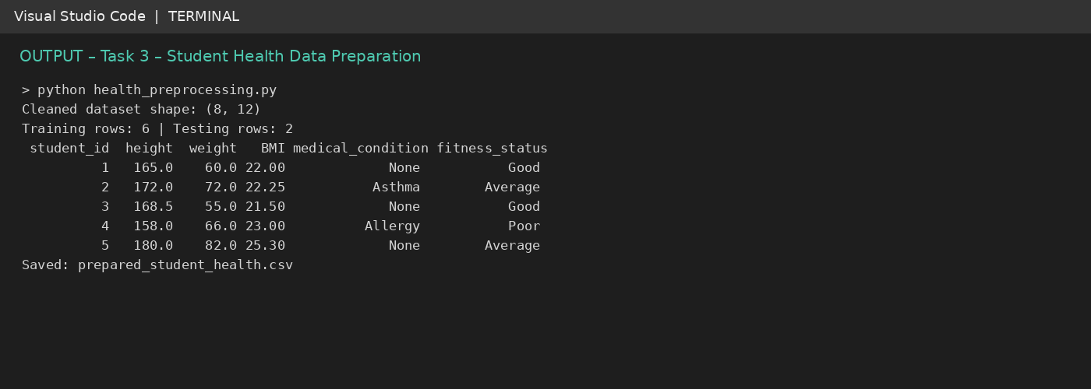

Observation
The cleaned records are scaled and divided into training and testing subsets. In a production project, fit imputers, encoders, and scalers on training data only to avoid data leakage.

6. Task 4 – Ride-Sharing Data Cleaning

Purpose
Improve trip-record consistency so ride operations and fare/driver analyses are more reliable.

Preprocessing decisions
Pickup and drop locations are trimmed and converted to title case. Duplicate ride IDs are removed. Missing fares are replaced with the median fare. Driver ratings are scaled to the 0–1 range.

Code explanation
str.strip() removes extra spaces and str.title() standardizes location capitalization. duplicated/drop_duplicates() identifies and removes repeated rides. Median imputation fills missing fares. MinMaxScaler normalizes driver ratings. Before/after counts form the improvement summary.

Expected result
A clean ride table with standardized locations, unique ride IDs, complete fares, normalized ratings, and a CSV output file.

AI Prompt Used
Write a commented pandas script to clean ride-sharing trip records. Standardize pickup and drop location text, fill missing fare with the median, remove duplicate ride IDs, normalize driver ratings to 0–1, and print a concise before/after improvement summary.

Python Code
import pandas as pd
from sklearn.preprocessing import MinMaxScaler
df = pd.DataFrame({
"ride_id": [501, 502, 503, 503, 504, 505],
"pickup_location": [" hyderabad ", "WARANGAL", "Hyderabad", "Hyderabad", " hanamkonda", "WARANGAL "],
"drop_location": ["warangal", "HYDERABAD ", "Hanamkonda", "Hanamkonda", "HYDERABAD", "Hanamkonda"],
"fare": [240, None, 180, 180, 210, None],
"driver_rating": [4.8, 4.2, 5.0, 5.0, 3.8, 4.5]
})
before_rows = len(df)
before_missing_fares = int(df["fare"].isna().sum())
before_duplicates = int(df.duplicated(subset="ride_id").sum())
# Standardize location names: trim spaces and use title case.
for col in ["pickup_location", "drop_location"]:
df[col] = df[col].str.strip().str.title()
# Remove duplicate ride records.
df = df.drop_duplicates(subset="ride_id", keep="first").copy()
# Replace missing fares with the median fare.
df["fare"] = df["fare"].fillna(df["fare"].median())
# Normalize ratings to a 0–1 range.
scaler = MinMaxScaler()
df["driver_rating_normalized"] = scaler.fit_transform(df[["driver_rating"]])
print("Rows before:", before_rows, "| Rows after:", len(df))
print("Duplicate rides removed:", before_duplicates)
print("Missing fares filled:", before_missing_fares)
print(df.to_string(index=False))
df.to_csv("clean_rides.csv", index=False)
Code note: Comments (lines beginning with #) explain the purpose of each preprocessing step. The script prints the transformed records and writes the output to a CSV file.

VS Code Code Screenshot
Illustrative VS Code-style view of the script (not a capture from the student's computer).
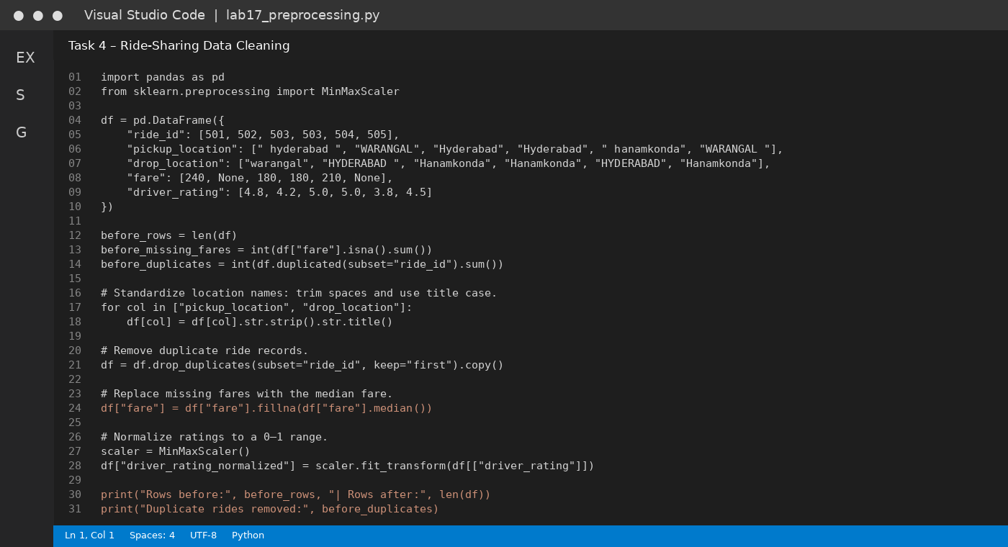

VS Code Terminal Output Screenshot
Illustrative terminal output showing the expected form of the results.
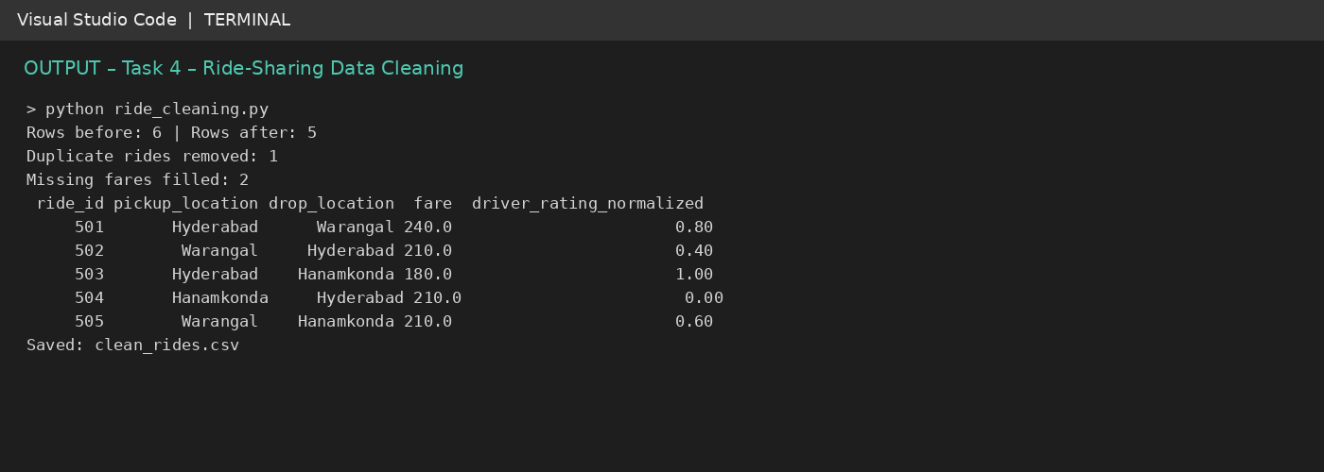

Observation
One repeated ride is removed, missing fares are filled with the median, location text is standardized, and ratings are normalized.

7. Overall Result and Conclusion
All four preprocessing tasks demonstrate common data-cleaning operations using Python, pandas, and scikit-learn. Missing-value treatment prevents incomplete fields from disrupting analysis; duplicate removal avoids counting the same record more than once; text standardization improves consistency; categorical encoding and numerical scaling prepare data for machine-learning algorithms.
The scripts save their processed datasets as CSV files: clean_employees.csv, processed_student_performance.csv, prepared_student_health.csv, and clean_rides.csv. The sample data is for lab demonstration only and should be replaced with the institution/company's authorized dataset when performing real analysis.

Important Practical Notes
- Always keep an untouched copy of the original dataset.
- Check whether a missing value has a meaningful business or academic interpretation before imputing it.
- Use a documented category-to-number mapping for production encoding; LabelEncoder's numeric labels are identifiers, not rankings.
- For model evaluation, split the data first and fit preprocessing transformations on training data only (preferably with a scikit-learn Pipeline).
- Confirm the semester definition with the institution's academic calendar; this report uses January–June as Semester 1 and July–December as Semester 2.

