LAB 19
CODE TRANSLATION: CONVERTING BETWEEN PROGRAMMING LANGUAGES
Week 10 – Tuesday

Student Name | N. Charan
Roll Number | 2503A51245

Lab Objectives
- Understand how AI tools assist in translating code between programming languages.
- Verify correctness and functionality after code translation.
- Explore syntax and semantic differences between Python, Java, C++, SQL, and Pandas.
- Practice debugging, testing, and improving AI-translated programs.

Introduction
Code translation is the process of rewriting a program in another programming language while preserving its intended behavior. AI assistance can speed up translation, but the translated program must still be reviewed, executed, and tested. This report presents five translation exercises with prompts, source and translated code, explanations, and expected outputs.
Note about screenshots: The images in this report are illustrative VS Code-style code/terminal previews prepared for the report. They are not captured from a live VS Code session. Run the supplied code in VS Code and replace these previews with your own screenshots if your instructor requires actual IDE captures.

Task 1 – Python to Java Conversion (File Handling)
Aim: Translate a Python program that reads text from input.txt, converts it to uppercase, and writes the result to output.txt.

AI Prompt Used
Translate the following Python file-handling program into Java. Preserve the file names, UTF-8 encoding, uppercase transformation, output-file content, and console messages. Use safe file APIs and handle file-related exceptions. Explain the Java code.
Python source code
# Python: read from input.txt and write to output.txt
try:
with open("input.txt", "r", encoding="utf-8") as source:
content = source.read()
result = "Processed file content:\n" + content.upper()
with open("output.txt", "w", encoding="utf-8") as destination:
destination.write(result)
print("File processed successfully.")
print(result)
except FileNotFoundError:
print("Error: input.txt was not found.")
except OSError as error:
print("File error:", error)
Equivalent Java code (save as FileTranslation.java)
// Java: equivalent file handling program
import java.io.IOException;
import java.nio.charset.StandardCharsets;
import java.nio.file.Files;
import java.nio.file.Path;
public class FileTranslation {
public static void main(String[] args) {
Path input = Path.of("input.txt");
Path output = Path.of("output.txt");
try {
String content = Files.readString(input, StandardCharsets.UTF_8);
String result = "Processed file content:\n" +
content.toUpperCase();
Files.writeString(output, result, StandardCharsets.UTF_8);
System.out.println("File processed successfully.");
System.out.println(result);
} catch (IOException error) {
System.out.println("File error: " + error.getMessage());
}
}
}

Code Explanation
- The Python with statement automatically closes files. Java Files.readString() and Files.writeString() provide a concise way to read and write UTF-8 text.
- Both programs read input.txt, convert its content to uppercase, and save the processed text in output.txt.
- Java catches IOException, which covers common file access and input/output errors. Python handles a missing file separately and other OSError cases.

Sample Input File
input.txt
Hello Students!\nWelcome to Lab 19.

Expected Console Output
Output
File processed successfully.\nProcessed file content:\nHELLO STUDENTS!\nWELCOME TO LAB 19.
Expected output.txt content is the same processed text shown above.
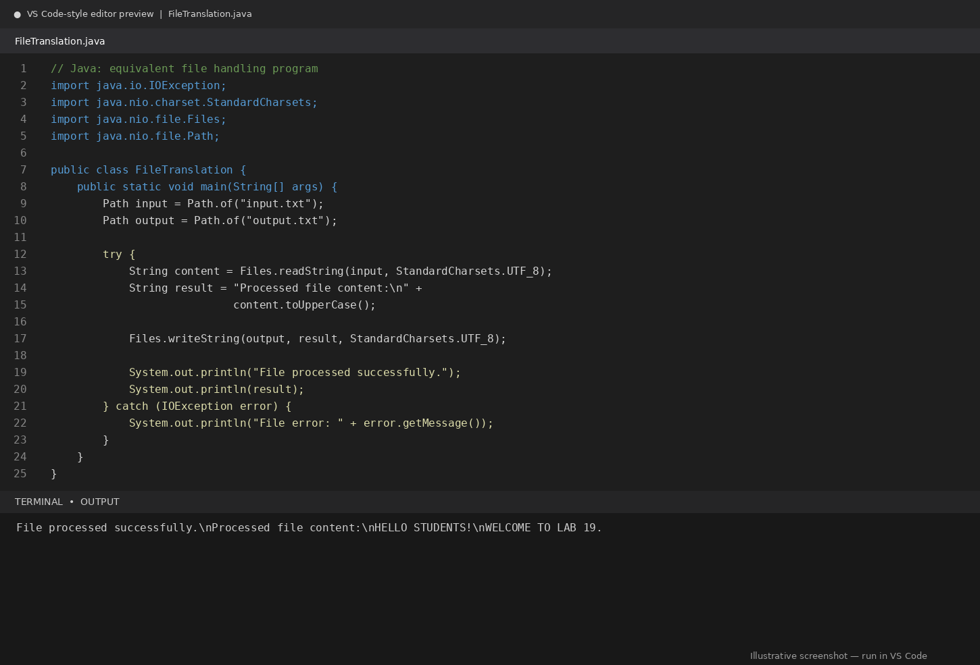
Figure 1. Java file-handling code and representative terminal output (illustrative).

How to Run in VS Code
- Create a folder named Lab19_Task1 and open it in VS Code.
- Create input.txt in that folder and enter the sample text shown above.
- Create FileTranslation.java and paste the Java code.
- Open the VS Code terminal in that folder and run: javac FileTranslation.java
- Run: java FileTranslation. Check that output.txt is created with uppercase text.

Verification
The Java program should create output.txt and display the same processed text as the Python version. Test once with the sample file and once after renaming input.txt to confirm that the error is handled.

Task 2 – C++ to Python Function Conversion (Bubble Sort)
Aim: Convert a C++ Bubble Sort implementation into Python and verify that both versions sort values in ascending order.

AI Prompt Used
Convert this C++ Bubble Sort program into Python. Preserve the nested-loop comparison and swapping logic, sort in ascending order, and provide a Python function that returns a sorted list without modifying the original input. Test normal, duplicate, empty, and single-element lists. Explain the algorithm.
C++ source code
// C++: Bubble Sort
#include <iostream>
using namespace std;
void bubbleSort(int arr[], int n) {
for (int i = 0; i < n - 1; i++) {
for (int j = 0; j < n - i - 1; j++) {
if (arr[j] > arr[j + 1]) {
int temp = arr[j];
arr[j] = arr[j + 1];
arr[j + 1] = temp;
}
}
}
}
int main() {
int arr[] = {64, 25, 12, 22, 11};
int n = sizeof(arr) / sizeof(arr[0]);
bubbleSort(arr, n);
cout << "Sorted array: ";
for (int i = 0; i < n; i++) {
cout << arr[i] << " ";
}
cout << endl;
return 0;
}
Equivalent Python code (save as bubble_sort.py)
# Python: equivalent Bubble Sort
def bubble_sort(values):
"""Sort a list in ascending order using Bubble Sort."""
arr = values.copy()
n = len(arr)
for i in range(n - 1):
for j in range(n - i - 1):
if arr[j] > arr[j + 1]:
arr[j], arr[j + 1] = arr[j + 1], arr[j]
return arr
tests = [
[64, 25, 12, 22, 11],
[5, 1, 4, 2, 8],
[3, 3, 2, 1],
[],
[7]
]
for test in tests:
print("Input:", test, "-> Sorted:", bubble_sort(test))

Code Explanation
- Bubble Sort repeatedly compares adjacent elements and swaps them when they are in the wrong order.
- After each outer-loop pass, the largest remaining unsorted value moves to its correct position at the end.
- The Python function copies the input list first, so the caller's original list is unchanged.
- The algorithm has O(n²) average and worst-case time complexity and O(n) extra space here because of the copy.

Test Cases and Expected Results
Test results
Input: [64, 25, 12, 22, 11] -> [11, 12, 22, 25, 64]\nInput: [5, 1, 4, 2, 8] -> [1, 2, 4, 5, 8]\nInput: [3, 3, 2, 1] -> [1, 2, 3, 3]\nInput: [] -> []\nInput: [7] -> [7]
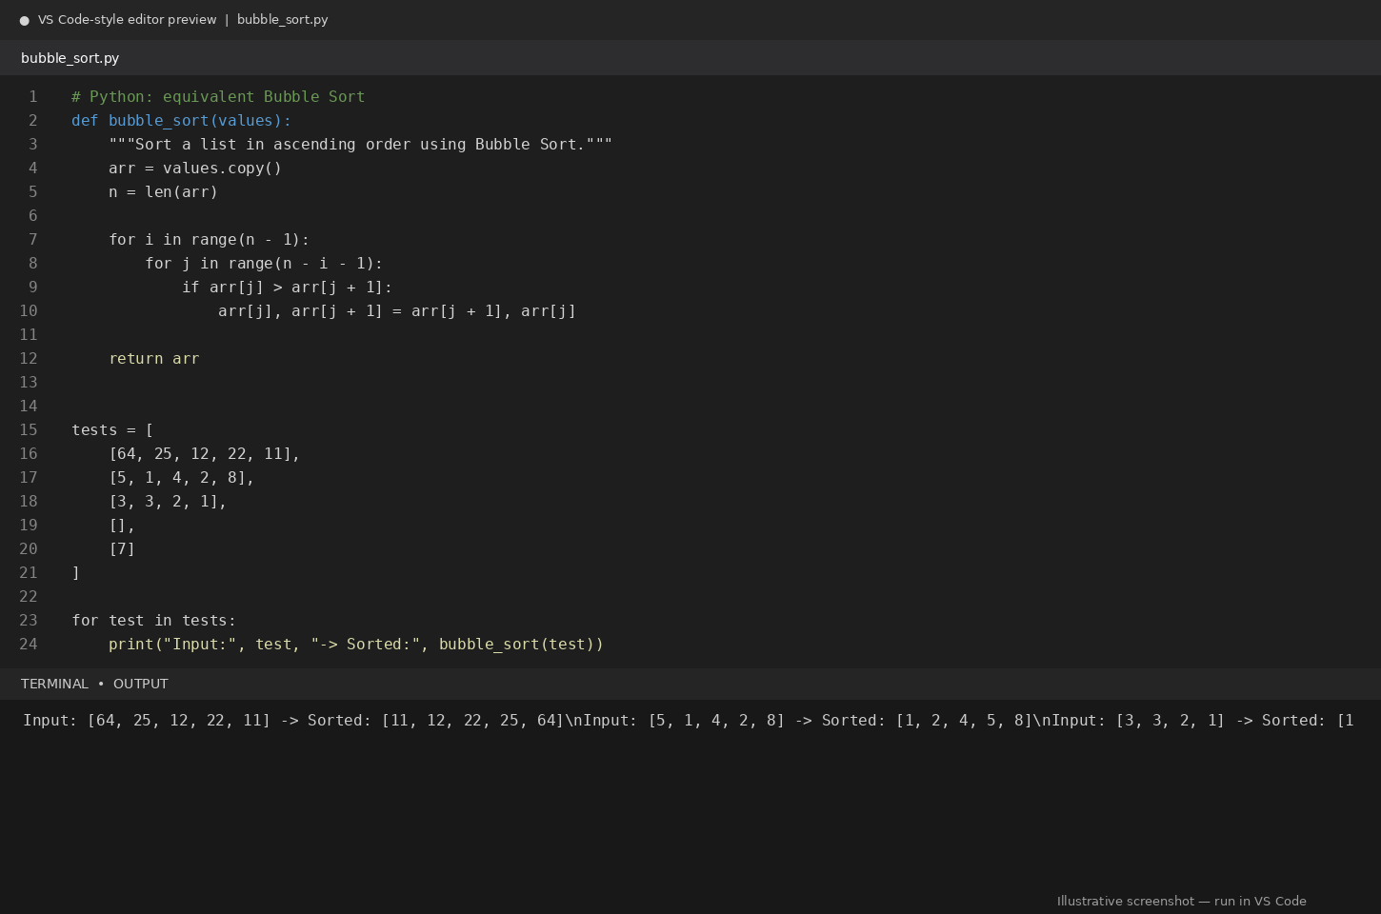
Figure 2. Python Bubble Sort implementation and representative test output (illustrative).

How to Run in VS Code
- Create bubble_sort.py in VS Code and paste the Python code.
- Open Terminal → New Terminal.
- Run: python bubble_sort.py (on some systems use: py bubble_sort.py).
- Compare the printed sorted lists with the expected results.

Verification
The Python implementation preserves the C++ algorithm's ascending-order behavior. The test cases cover an ordinary list, a second list, duplicates, an empty list, and one element.

Task 3 – SQL to Pandas Query (GROUP BY and Aggregates)
Aim: Translate an SQL query that calculates total sales, average sales, and number of sales per department into Pandas.

AI Prompt Used
Translate this SQL GROUP BY query into equivalent Python Pandas code. Use groupby() and agg() to calculate SUM(amount), AVG(amount), and COUNT(*) for each department. Sort the result by department and demonstrate it with a small sample dataset. Explain how SQL aggregates map to Pandas.
SQL query
-- SQL: total sales for each department
SELECT department,
SUM(amount) AS total_sales,
AVG(amount) AS average_sales,
COUNT(*) AS number_of_sales
FROM sales
GROUP BY department
ORDER BY department;
Equivalent Pandas code (save as sales_summary.py)
# Pandas: equivalent GROUP BY and aggregate query
import pandas as pd
data = {
"department": ["Sales", "IT", "Sales", "HR", "IT", "HR"],
"amount": [1200, 1500, 800, 700, 500, 300]
}
df = pd.DataFrame(data)
summary = (
df.groupby("department", as_index=False)
.agg(
total_sales=("amount", "sum"),
average_sales=("amount", "mean"),
number_of_sales=("amount", "count")
)
.sort_values("department")
)
print(summary.to_string(index=False))

Sample Dataset
sales table
department | amount\nSales | 1200\nIT | 1500\nSales | 800\nHR | 700\nIT | 500\nHR | 300

Expected Pandas Output
Output
department total_sales average_sales number_of_sales\nHR 1000 500.0 2\nIT 2000 1000.0 2\nSales 2000 1000.0 2

Code Explanation
- pd.DataFrame(data) creates a DataFrame from the sample records.
- groupby('department') creates one group for each department.
- agg() applies sum, mean, and count to the amount column. These correspond to SQL SUM(), AVG(), and COUNT(*).
- sort_values('department') orders the rows consistently with the SQL ORDER BY clause.
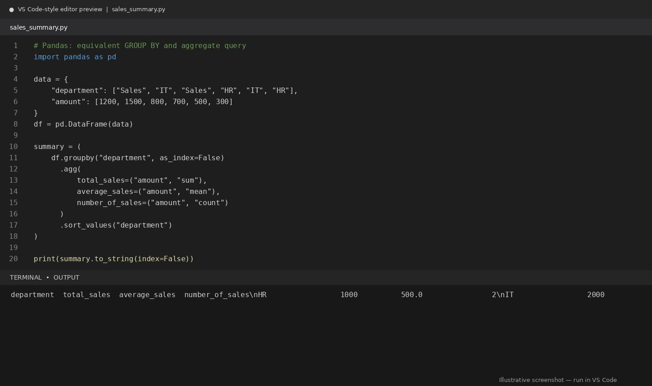
Figure 3. Pandas groupby aggregation and representative output (illustrative).

How to Run in VS Code
- Create sales_summary.py and paste the Pandas code.
- Install Pandas in the VS Code terminal if needed: python -m pip install pandas
- Run: python sales_summary.py
- Compare each department's total, average, and count with the SQL result.

Verification
For HR the total is 1000, average is 500, and count is 2. For IT and Sales, the total is 2000, average is 1000, and count is 2. The Pandas result matches the SQL aggregation.

Task 4 – Real-Time Application: Multi-Language Snippet Converter
Selected application: Discount calculator. The same business rule is implemented in Python and Java.

AI Prompt Used
Convert this Python discount-calculation function into Java. Preserve the formula: final price = original price - (original price × discount percentage / 100). Use double values, a reusable method, and output formatted to two decimal places. Include a main method and explain syntax differences.
Python implementation
# Python: calculate the final price after discount
def final_price(price, discount_percent):
"""Return the price after applying a percentage discount."""
return price - (price * discount_percent / 100)
price = 1000.0
discount = 15.0
print(f"Final price: {final_price(price, discount):.2f}")
Equivalent Java implementation (save as DiscountCalculator.java)
// Java: same discount calculation
public class DiscountCalculator {
static double finalPrice(double price, double discountPercent) {
return price - (price * discountPercent / 100.0);
}
public static void main(String[] args) {
double price = 1000.0;
double discount = 15.0;
System.out.printf("Final price: %.2f%n",
finalPrice(price, discount));
}
}

Code Explanation
- Both implementations accept an original price and a discount percentage.
- Both calculate the discount amount and subtract it from the original price.
- Python defines a function with def and uses indentation for blocks. Java declares a method with a return type and places statements inside braces.
- Python uses an f-string for formatting. Java uses System.out.printf() with %.2f to display two decimal places.

Test Case and Expected Output
Input and calculation
Original price = 1000.00\nDiscount = 15%\nDiscount amount = 150.00\nFinal price = 850.00
Console output
Final price: 850.00
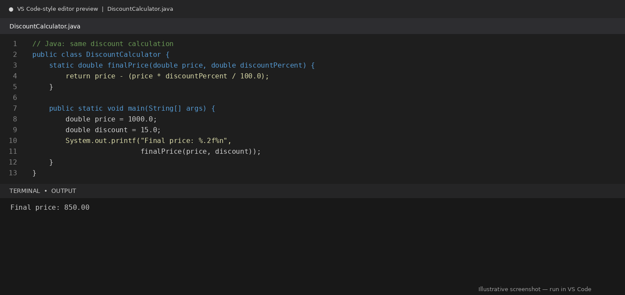
Figure 4. Java discount calculator and representative output (illustrative).

How to Run in VS Code
- Run the Python version with: python discount_calculator.py
- Save the Java version as DiscountCalculator.java.
- Compile with: javac DiscountCalculator.java
- Run with: java DiscountCalculator.
- Both versions should print Final price: 850.00.

Observed Language Differences
- Python is dynamically typed; Java requires declared types such as double.
- Python uses def and indentation; Java uses typed method declarations and braces.
- Both languages support floating-point arithmetic, but formatted output uses different syntax.
- The calculation and final result remain the same in both languages.

Task 5 – Basic Function Translation (Python to C++)
Aim: Translate a Python function that identifies even and odd integers into C++.

AI Prompt Used
Translate this Python even-or-odd function into C++. Use the modulo operator, create a reusable function returning a string, read or test integer values, and print clear output. Include at least three test values and explain the translation.
Python source code
# Python: even or odd
def even_or_odd(number):
"""Return whether number is even or odd."""
if number % 2 == 0:
return "Even"
return "Odd"
for value in [4, 7, 0]:
print(value, "is", even_or_odd(value))
Equivalent C++ code (save as even_odd.cpp)
// C++: equivalent even-or-odd program
#include <iostream>
using namespace std;
string evenOrOdd(int number) {
if (number % 2 == 0) {
return "Even";
}
return "Odd";
}
int main() {
int values[] = {4, 7, 0};
for (int number : values) {
cout << number << " is " << evenOrOdd(number) << endl;
}
return 0;
}

Code Explanation
- The modulo operator (%) returns the remainder after division by 2.
- If number % 2 equals 0, the number is even; otherwise, it is odd.
- The C++ function returns a string and is called for each value in the array.
- The values 4, 7, and 0 test an even number, an odd number, and zero.

Test Cases and Expected Output
Output
4 is Even\n7 is Odd\n0 is Even
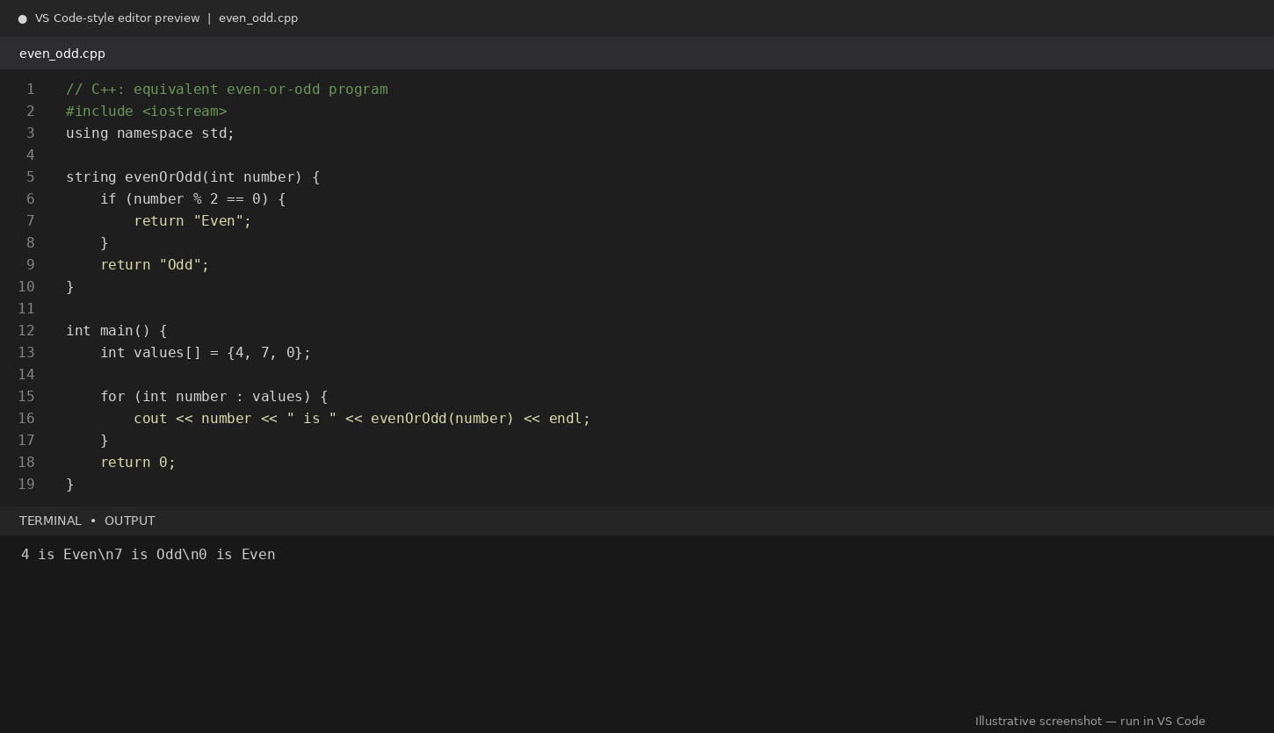
Figure 5. C++ even-or-odd program and representative output (illustrative).

How to Run in VS Code
- Save the program as even_odd.cpp.
- Ensure a C++ compiler such as g++ is installed and available in the terminal PATH.
- Compile with: g++ even_odd.cpp -o even_odd
- Run on Windows: .\\even_odd.exe (or run ./even_odd in a compatible shell).
- Confirm that all three values produce the expected classifications.

Verification
The Python and C++ versions use the same divisibility rule and produce matching results for all three test values.

Overall Comparison
Translation | Main language difference | Verification
Python → Java | with/open vs Java Files API; exception handling | Same transformed file content and message
C++ → Python | Arrays and loops vs Python lists and tuple swap | Same ascending sorted values
SQL → Pandas | GROUP BY and aggregate functions vs groupby().agg() | Same totals, averages, and counts
Python → Java | Dynamic typing vs declared types; formatting syntax | Same final discounted price
Python → C++ | def and indentation vs typed function and braces | Same even/odd classifications

Conclusion
All five exercises demonstrate that code can be translated between languages while preserving its intended logic. However, syntax, libraries, data types, file APIs, and output formatting differ. AI-generated translations should always be reviewed and tested with multiple cases. The file-handling task verifies matching file behavior, Bubble Sort verifies algorithmic equivalence, the Pandas task verifies aggregate results, the discount calculator demonstrates equivalent application logic, and the even-or-odd task verifies a basic function translation.

Final Checklist
- All five tasks include an AI prompt.
- Source and translated code are included.
- Comments and code explanations are provided.
- Sample inputs, expected outputs, and verification steps are included.
- Illustrative VS Code-style code/terminal previews are included; replace with actual VS Code screenshots if required by the instructor.

