LAB 16
DATABASE DESIGN AND QUERIES
Schema Design and SQL Generation
Name: N. Charan
Roll No: 2503A51245
Week 8 – Friday

Lab Objectives
- Understand schema design principles for relational databases.
- Use AI-assisted tools to generate SQL schema definitions.
- Write and refine SQL queries for CRUD and aggregate operations.
- Explore query optimization and database normalization.

Software and Execution
Software: Visual Studio Code and SQLite. Save SQL statements in a .sql file, install/use an SQLite extension or run them through an SQLite terminal, then execute the script. The screenshots below are illustrative VS Code-style evidence panels created for this report; they are not captures taken from the user's computer.
Suggested VS Code workflow: create a folder named Lab16, create one .sql file per task, paste the schema and queries, open the file in VS Code, execute it using an SQLite extension or SQLite command-line tool, and capture your own screenshots after running the script.

Database Design Notes
Primary keys uniquely identify rows. Foreign keys maintain relationships. NOT NULL prevents missing required values; UNIQUE prevents duplicate values; CHECK validates values. The designs separate entities into related tables to reduce duplication and support normalization. SQL examples use SQLite-compatible syntax.

CRUD and Aggregate Query Patterns
Create: INSERT INTO table_name (...) VALUES (...);
Read: SELECT columns FROM table_name WHERE condition;
Update: UPDATE table_name SET column_name = value WHERE id = key;
Delete: DELETE FROM table_name WHERE id = key;
Aggregate: SELECT category, COUNT(*), SUM(value), AVG(value), MAX(value) FROM table_name GROUP BY category;
Always use a WHERE clause for targeted UPDATE and DELETE operations, and parameterized queries when SQL is called from application code.

Task 1 – Employee Management Database
AI Prompt: Act as a database design assistant. Design a normalized SQLite schema for Departments, Employees, and Salaries. Add primary keys, foreign keys, NOT NULL, UNIQUE, and CHECK constraints. Write SQL queries to list employees in a department, retrieve an employee’s salary details, and find the highest-paid employee in each department. Explain joins and assumptions.

Scenario and Design
Manage employees, departments, and salary history. The schema uses primary keys, foreign keys, UNIQUE and NOT NULL constraints. Salary records are stored separately so salary changes can be tracked.

SQL Schema
PRAGMA foreign_keys = ON;
CREATE TABLE Departments (
department_id INTEGER PRIMARY KEY,
department_name TEXT NOT NULL UNIQUE
);
CREATE TABLE Employees (
employee_id INTEGER PRIMARY KEY,
full_name TEXT NOT NULL,
email TEXT NOT NULL UNIQUE,
department_id INTEGER NOT NULL,
FOREIGN KEY (department_id) REFERENCES Departments(department_id)
);
CREATE TABLE Salaries (
salary_id INTEGER PRIMARY KEY,
employee_id INTEGER NOT NULL,
amount REAL NOT NULL CHECK (amount >= 0),
effective_date TEXT NOT NULL,
FOREIGN KEY (employee_id) REFERENCES Employees(employee_id)
);

Required Queries

List employees in a specific department
SELECT e.employee_id, e.full_name, d.department_name
FROM Employees e
JOIN Departments d ON d.department_id = e.department_id
WHERE d.department_name = 'Engineering';

Retrieve salary details for an employee
SELECT e.full_name, s.amount, s.effective_date
FROM Employees e
JOIN Salaries s ON s.employee_id = e.employee_id
WHERE e.employee_id = 1
ORDER BY s.effective_date DESC;

Highest-paid employee in each department
WITH RankedSalaries AS (
SELECT e.department_id, e.full_name, s.amount,
ROW_NUMBER() OVER (
PARTITION BY e.department_id ORDER BY s.amount DESC
) AS rn
FROM Employees e
JOIN Salaries s ON s.employee_id = e.employee_id
)
SELECT d.department_name, r.full_name, r.amount
FROM RankedSalaries r
JOIN Departments d ON d.department_id = r.department_id
WHERE r.rn = 1;

Illustrative Output
Engineering | Asha Rao | 85000
Engineering | Ravi Kumar | 72000
Highest-paid: Asha Rao — 85000

Optimization / Validation Note
A separate Salaries table supports salary history. For ties, use RANK() instead of ROW_NUMBER() to return every employee tied for the highest salary.

Code Screenshot (Illustrative)
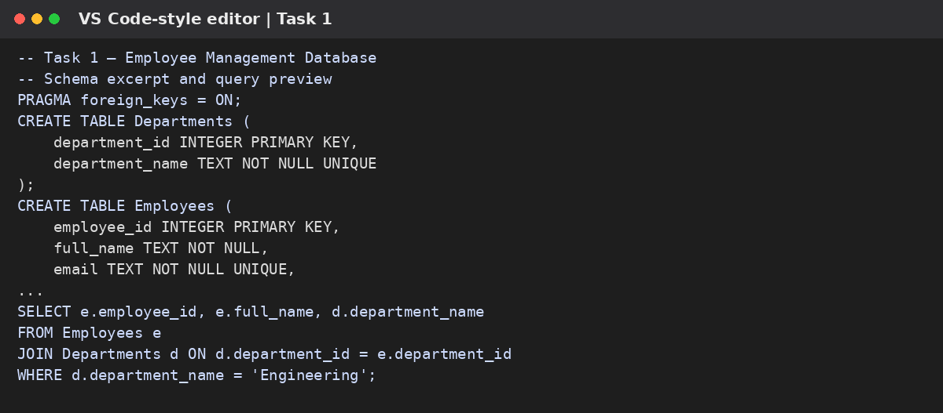

Output Screenshot (Illustrative)
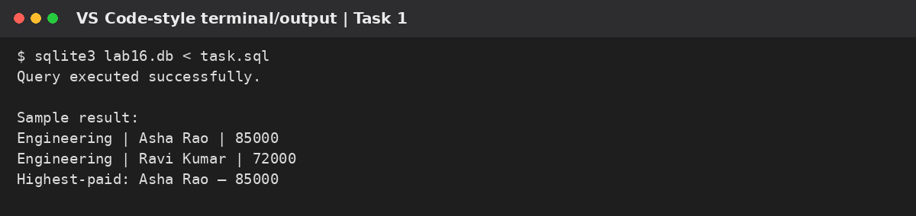

Task 2 – Online Course Platform Database
AI Prompt: Act as a database design assistant. Create a normalized SQLite schema for Users, Courses, Lessons, and Enrollments. Define relationships and constraints, including a composite primary key to prevent duplicate enrollments. Write queries to list courses enrolled by a user, count learners per course, and retrieve lessons for a course.

Scenario and Design
Store user accounts, courses, lessons, and enrollments. Enrollments connect users and courses in a many-to-many relationship.

SQL Schema
PRAGMA foreign_keys = ON;
CREATE TABLE Users (
user_id INTEGER PRIMARY KEY,
full_name TEXT NOT NULL,
email TEXT NOT NULL UNIQUE
);
CREATE TABLE Courses (
course_id INTEGER PRIMARY KEY,
title TEXT NOT NULL UNIQUE,
description TEXT
);
CREATE TABLE Lessons (
lesson_id INTEGER PRIMARY KEY,
course_id INTEGER NOT NULL,
lesson_title TEXT NOT NULL,
lesson_order INTEGER NOT NULL CHECK (lesson_order > 0),
FOREIGN KEY (course_id) REFERENCES Courses(course_id),
UNIQUE (course_id, lesson_order)
);
CREATE TABLE Enrollments (
user_id INTEGER NOT NULL,
course_id INTEGER NOT NULL,
enrolled_on TEXT NOT NULL,
PRIMARY KEY (user_id, course_id),
FOREIGN KEY (user_id) REFERENCES Users(user_id),
FOREIGN KEY (course_id) REFERENCES Courses(course_id)
);

Required Queries

Courses enrolled by a user
SELECT u.full_name, c.title, en.enrolled_on
FROM Enrollments en
JOIN Users u ON u.user_id = en.user_id
JOIN Courses c ON c.course_id = en.course_id
WHERE u.user_id = 1;

Count learners per course
SELECT c.title, COUNT(en.user_id) AS learner_count
FROM Courses c
LEFT JOIN Enrollments en ON en.course_id = c.course_id
GROUP BY c.course_id, c.title
ORDER BY learner_count DESC;

Lesson details for a course
SELECT c.title, l.lesson_order, l.lesson_title
FROM Courses c
JOIN Lessons l ON l.course_id = c.course_id
WHERE c.course_id = 1
ORDER BY l.lesson_order;

Illustrative Output
Python Basics | learner_count: 24
SQL Fundamentals | learner_count: 18
Python Basics | 1 | Introduction

Optimization / Validation Note
The composite primary key on Enrollments prevents a user from enrolling in the same course more than once.

Code Screenshot (Illustrative)
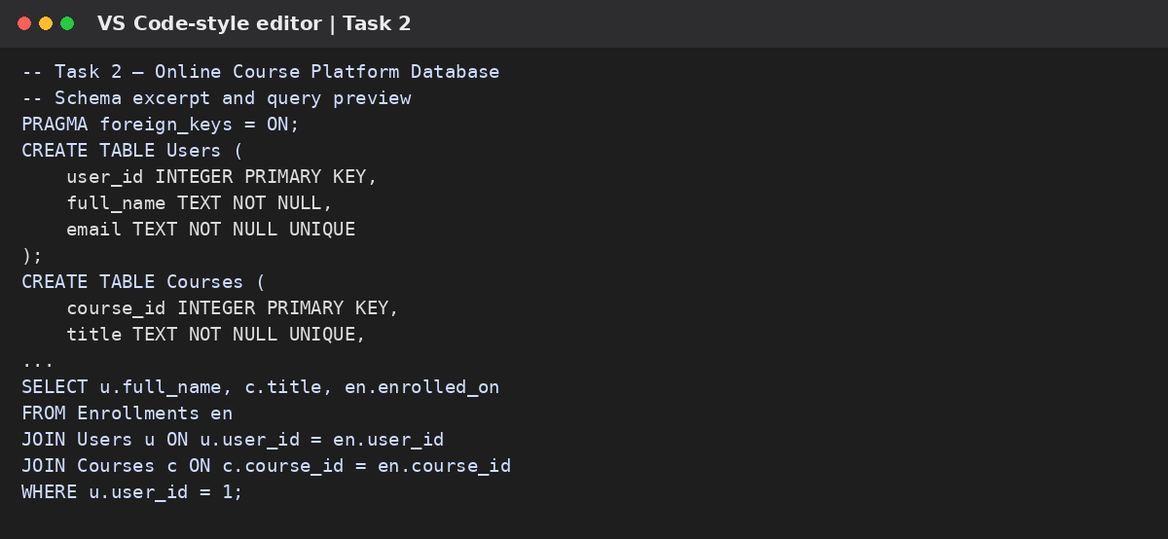

Output Screenshot (Illustrative)
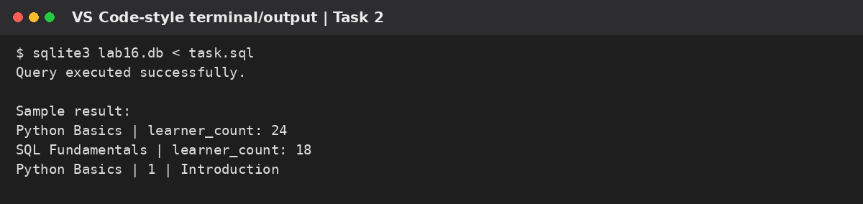

Task 3 – Banking Transaction Database
AI Prompt: Act as a database design assistant. Design SQLite tables for Customers, Accounts, and Transactions. Add primary keys, foreign keys, UNIQUE, NOT NULL, and CHECK constraints to validate transaction types and positive amounts. Write queries for transaction history, total deposits and withdrawals, and accounts below a balance threshold. Mention security and transaction-processing considerations.

Scenario and Design
Maintain customers, accounts, and transaction records. CHECK constraints prevent non-positive transaction amounts; transaction type is restricted to deposit or withdrawal.

SQL Schema
PRAGMA foreign_keys = ON;
CREATE TABLE Customers (
customer_id INTEGER PRIMARY KEY,
full_name TEXT NOT NULL,
email TEXT NOT NULL UNIQUE
);
CREATE TABLE Accounts (
account_id INTEGER PRIMARY KEY,
customer_id INTEGER NOT NULL,
account_number TEXT NOT NULL UNIQUE,
balance REAL NOT NULL DEFAULT 0 CHECK (balance >= 0),
FOREIGN KEY (customer_id) REFERENCES Customers(customer_id)
);
CREATE TABLE Transactions (
transaction_id INTEGER PRIMARY KEY,
account_id INTEGER NOT NULL,
transaction_type TEXT NOT NULL
CHECK (transaction_type IN ('DEPOSIT', 'WITHDRAWAL')),
amount REAL NOT NULL CHECK (amount > 0),
transaction_date TEXT NOT NULL,
FOREIGN KEY (account_id) REFERENCES Accounts(account_id)
);

Required Queries

Transaction history for an account
SELECT transaction_date, transaction_type, amount
FROM Transactions
WHERE account_id = 1
ORDER BY transaction_date DESC;

Total deposits and withdrawals
SELECT account_id,
SUM(CASE WHEN transaction_type = 'DEPOSIT' THEN amount ELSE 0 END) AS deposits,
SUM(CASE WHEN transaction_type = 'WITHDRAWAL' THEN amount ELSE 0 END) AS withdrawals
FROM Transactions
GROUP BY account_id;

Accounts below a balance threshold
SELECT account_number, balance
FROM Accounts
WHERE balance < 1000
ORDER BY balance ASC;

Illustrative Output
Account 1001 | deposits: 5000.00 | withdrawals: 1200.00
Account 1002 | balance: 450.00

Optimization / Validation Note
A real banking system must update balances and insert transactions atomically in a database transaction. A database CHECK alone cannot enforce that balance always matches the transaction ledger.

Code Screenshot (Illustrative)
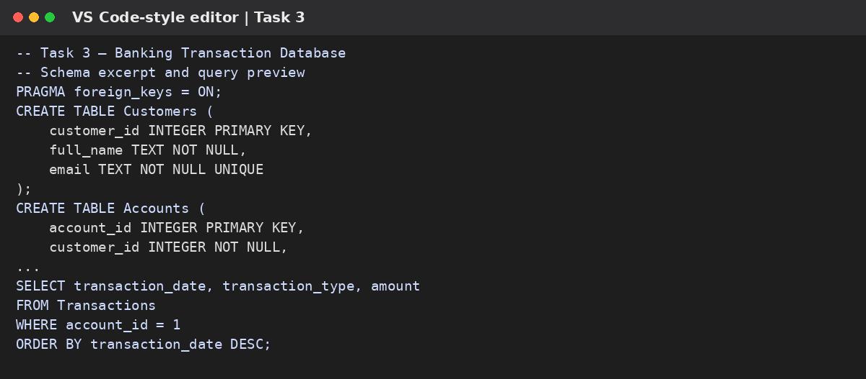

Output Screenshot (Illustrative)
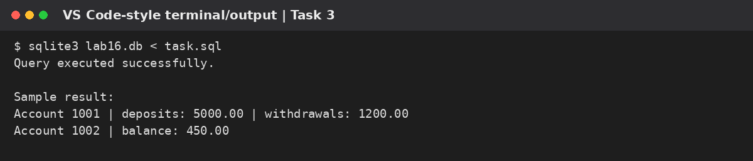

Task 4 – Airline Reservation Database
AI Prompt: Act as a database design assistant. Create a normalized SQLite schema for Flights, Passengers, Tickets, and Bookings. Define relationships and constraints that prevent duplicate seat allocation on the same flight. Write queries to list passengers on a flight, find available seats, and count confirmed bookings per flight. State assumptions about seat numbering and cancelled bookings.

Scenario and Design
Connect flights, passengers, bookings, and tickets. A unique constraint on flight and seat prevents the same seat being assigned twice.

SQL Schema
PRAGMA foreign_keys = ON;
CREATE TABLE Flights (
flight_id INTEGER PRIMARY KEY,
flight_number TEXT NOT NULL,
origin TEXT NOT NULL,
destination TEXT NOT NULL,
departure_time TEXT NOT NULL,
seat_capacity INTEGER NOT NULL CHECK (seat_capacity > 0)
);
CREATE TABLE Passengers (
passenger_id INTEGER PRIMARY KEY,
full_name TEXT NOT NULL,
passport_number TEXT NOT NULL UNIQUE
);
CREATE TABLE Bookings (
booking_id INTEGER PRIMARY KEY,
passenger_id INTEGER NOT NULL,
booking_date TEXT NOT NULL,
status TEXT NOT NULL CHECK (status IN ('CONFIRMED','CANCELLED')),
FOREIGN KEY (passenger_id) REFERENCES Passengers(passenger_id)
);
CREATE TABLE Tickets (
ticket_id INTEGER PRIMARY KEY,
booking_id INTEGER NOT NULL,
flight_id INTEGER NOT NULL,
seat_number TEXT NOT NULL,
FOREIGN KEY (booking_id) REFERENCES Bookings(booking_id),
FOREIGN KEY (flight_id) REFERENCES Flights(flight_id),
UNIQUE (flight_id, seat_number)
);

Required Queries

Passengers on a specific flight
SELECT f.flight_number, p.full_name, t.seat_number
FROM Tickets t
JOIN Bookings b ON b.booking_id = t.booking_id
JOIN Passengers p ON p.passenger_id = b.passenger_id
JOIN Flights f ON f.flight_id = t.flight_id
WHERE f.flight_id = 1 AND b.status = 'CONFIRMED';

Available seats for a flight
WITH RECURSIVE SeatNumbers(n) AS (
SELECT 1 UNION ALL
SELECT n + 1 FROM SeatNumbers
WHERE n < (SELECT seat_capacity FROM Flights WHERE flight_id = 1)
)
SELECT 'S' || n AS seat_number
FROM SeatNumbers
WHERE ('S' || n) NOT IN (
SELECT t.seat_number FROM Tickets t
JOIN Bookings b ON b.booking_id = t.booking_id
WHERE t.flight_id = 1 AND b.status = 'CONFIRMED'
);

Count bookings per flight
SELECT f.flight_number,
COUNT(DISTINCT CASE WHEN b.status = 'CONFIRMED' THEN b.booking_id END) AS confirmed_bookings
FROM Flights f
LEFT JOIN Tickets t ON t.flight_id = f.flight_id
LEFT JOIN Bookings b ON b.booking_id = t.booking_id
GROUP BY f.flight_id, f.flight_number;

Illustrative Output
AI204 | Asha Rao | S1
AI204 | confirmed_bookings: 42
Available seats: S3, S4, S5 ...

Optimization / Validation Note
The seat-generation query assumes seats are named S1 through S(capacity). Real aircraft may need cabin/seat maps and transactional locking to prevent concurrent double-booking.

Code Screenshot (Illustrative)
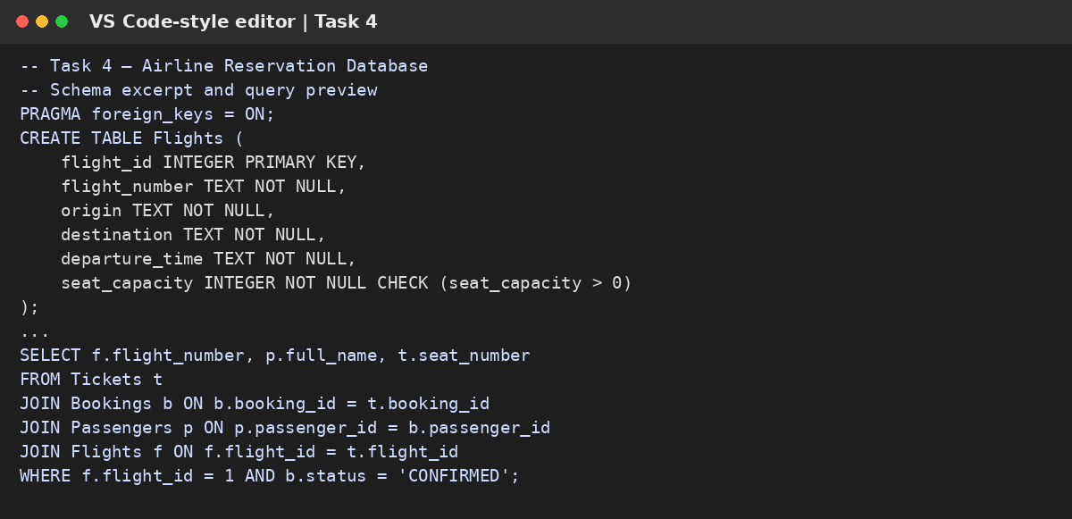

Output Screenshot (Illustrative)
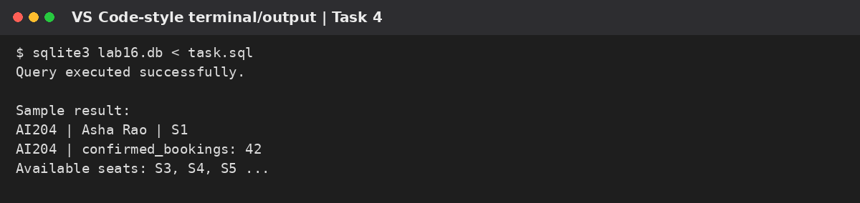

Task 5 – Transport Management Database
AI Prompt: Act as a database design assistant. Design SQLite tables for Vehicles, Routes, Drivers, and Assignments with primary keys, foreign keys, NOT NULL, and UNIQUE constraints. Write queries to list vehicles assigned to a route, retrieve driver details for a vehicle, and count trips per route. Recommend indexes for commonly filtered join columns and explain trade-offs.

Scenario and Design
Manage vehicles, routes, drivers, and assignments. Assignment rows record which driver and vehicle operated a route on a date.

SQL Schema
PRAGMA foreign_keys = ON;
CREATE TABLE Vehicles (
vehicle_id INTEGER PRIMARY KEY,
registration_number TEXT NOT NULL UNIQUE,
vehicle_type TEXT NOT NULL
);
CREATE TABLE Routes (
route_id INTEGER PRIMARY KEY,
route_name TEXT NOT NULL UNIQUE,
start_location TEXT NOT NULL,
end_location TEXT NOT NULL
);
CREATE TABLE Drivers (
driver_id INTEGER PRIMARY KEY,
full_name TEXT NOT NULL,
license_number TEXT NOT NULL UNIQUE
);
CREATE TABLE Assignments (
assignment_id INTEGER PRIMARY KEY,
vehicle_id INTEGER NOT NULL,
route_id INTEGER NOT NULL,
driver_id INTEGER NOT NULL,
trip_date TEXT NOT NULL,
FOREIGN KEY (vehicle_id) REFERENCES Vehicles(vehicle_id),
FOREIGN KEY (route_id) REFERENCES Routes(route_id),
FOREIGN KEY (driver_id) REFERENCES Drivers(driver_id)
);
CREATE INDEX idx_assignments_route ON Assignments(route_id);
CREATE INDEX idx_assignments_vehicle ON Assignments(vehicle_id);
CREATE INDEX idx_assignments_driver ON Assignments(driver_id);

Required Queries

Vehicles assigned to a route
SELECT r.route_name, v.registration_number, v.vehicle_type
FROM Assignments a
JOIN Routes r ON r.route_id = a.route_id
JOIN Vehicles v ON v.vehicle_id = a.vehicle_id
WHERE r.route_id = 1;

Driver details for a vehicle
SELECT v.registration_number, d.full_name, d.license_number, a.trip_date
FROM Assignments a
JOIN Vehicles v ON v.vehicle_id = a.vehicle_id
JOIN Drivers d ON d.driver_id = a.driver_id
WHERE v.vehicle_id = 1
ORDER BY a.trip_date DESC;

Count trips per route
SELECT r.route_name, COUNT(a.assignment_id) AS trip_count
FROM Routes r
LEFT JOIN Assignments a ON a.route_id = r.route_id
GROUP BY r.route_id, r.route_name;

Illustrative Output
City Route A | TS09AB1234 | Bus
City Route A | trip_count: 16

Optimization / Validation Note
Indexes on foreign-key columns can speed up joins and filtering. Indexes add storage and slow writes, so create them for frequently queried columns and verify with EXPLAIN QUERY PLAN.

Code Screenshot (Illustrative)
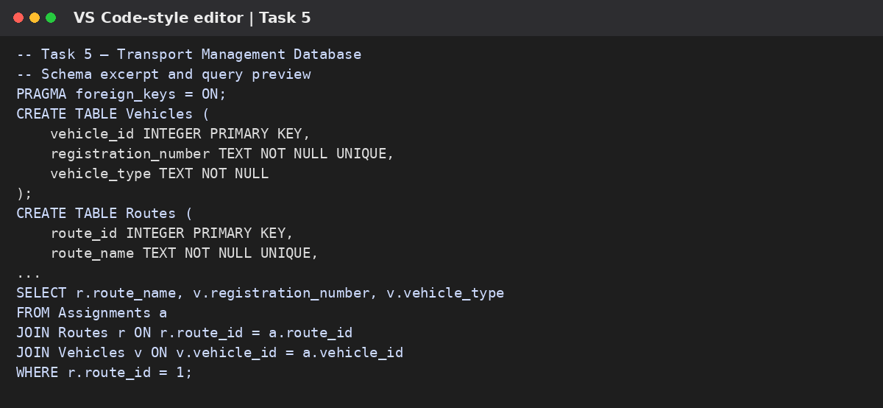

Output Screenshot (Illustrative)
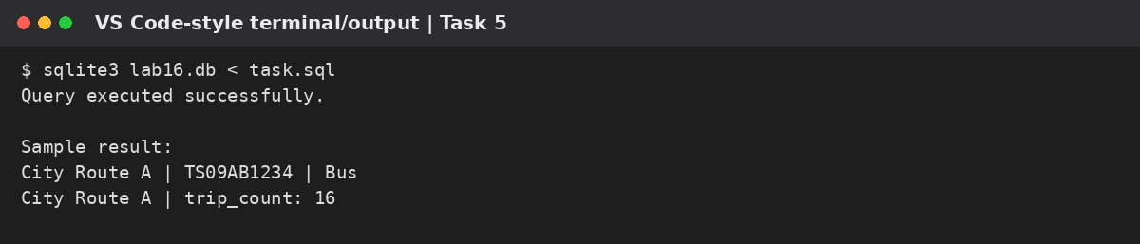

Task 6 – Hotel Reservation Database
AI Prompt: Act as a database design assistant. Design a normalized SQLite schema for Hotels, Rooms, Guests, and Reservations. Add keys, constraints, and a CHECK constraint ensuring checkout is after check-in. Write queries to list a guest’s reservations, find rooms available for a date range using overlap logic, and calculate hotel occupancy rate. Explain date-range assumptions and why concurrent booking checks need transactional protection.

Scenario and Design
Store hotels, rooms, guests, and reservations. Date checks ensure checkout is after check-in. Availability is checked by detecting overlapping reservations.

SQL Schema
PRAGMA foreign_keys = ON;
CREATE TABLE Hotels (
hotel_id INTEGER PRIMARY KEY,
hotel_name TEXT NOT NULL,
city TEXT NOT NULL
);
CREATE TABLE Rooms (
room_id INTEGER PRIMARY KEY,
hotel_id INTEGER NOT NULL,
room_number TEXT NOT NULL,
room_type TEXT NOT NULL,
nightly_rate REAL NOT NULL CHECK (nightly_rate >= 0),
FOREIGN KEY (hotel_id) REFERENCES Hotels(hotel_id),
UNIQUE (hotel_id, room_number)
);
CREATE TABLE Guests (
guest_id INTEGER PRIMARY KEY,
full_name TEXT NOT NULL,
email TEXT NOT NULL UNIQUE
);
CREATE TABLE Reservations (
reservation_id INTEGER PRIMARY KEY,
room_id INTEGER NOT NULL,
guest_id INTEGER NOT NULL,
check_in TEXT NOT NULL,
check_out TEXT NOT NULL,
status TEXT NOT NULL CHECK (status IN ('CONFIRMED','CANCELLED')),
CHECK (check_out > check_in),
FOREIGN KEY (room_id) REFERENCES Rooms(room_id),
FOREIGN KEY (guest_id) REFERENCES Guests(guest_id)
);
CREATE INDEX idx_reservations_room_dates
ON Reservations(room_id, check_in, check_out);

Required Queries

Reservations for a guest
SELECT g.full_name, h.hotel_name, rm.room_number,
r.check_in, r.check_out, r.status
FROM Reservations r
JOIN Guests g ON g.guest_id = r.guest_id
JOIN Rooms rm ON rm.room_id = r.room_id
JOIN Hotels h ON h.hotel_id = rm.hotel_id
WHERE g.guest_id = 1
ORDER BY r.check_in;

Rooms available during a date range
SELECT rm.room_id, h.hotel_name, rm.room_number, rm.room_type
FROM Rooms rm
JOIN Hotels h ON h.hotel_id = rm.hotel_id
WHERE rm.hotel_id = 1
AND NOT EXISTS (
SELECT 1 FROM Reservations r
WHERE r.room_id = rm.room_id
AND r.status = 'CONFIRMED'
AND r.check_in < '2026-12-15'
AND r.check_out > '2026-12-10'
);

Occupancy rate per hotel for a date
SELECT h.hotel_name,
ROUND(100.0 * COUNT(DISTINCT CASE WHEN r.status = 'CONFIRMED'
AND r.check_in <= '2026-12-10' AND r.check_out > '2026-12-10'
THEN rm.room_id END) / NULLIF(COUNT(DISTINCT rm.room_id), 0), 2) AS occupancy_percent
FROM Hotels h
LEFT JOIN Rooms rm ON rm.hotel_id = h.hotel_id
LEFT JOIN Reservations r ON r.room_id = rm.room_id
GROUP BY h.hotel_id, h.hotel_name;

Illustrative Output
Guest: Nisha Patel | Room 204 | 2026-12-10 to 2026-12-12
Sunrise Hotel | occupancy_percent: 75.00

Optimization / Validation Note
The availability query treats checkout as exclusive, so a new guest can check in on the same day another guest checks out. Production systems should enforce availability transactionally.

Code Screenshot (Illustrative)
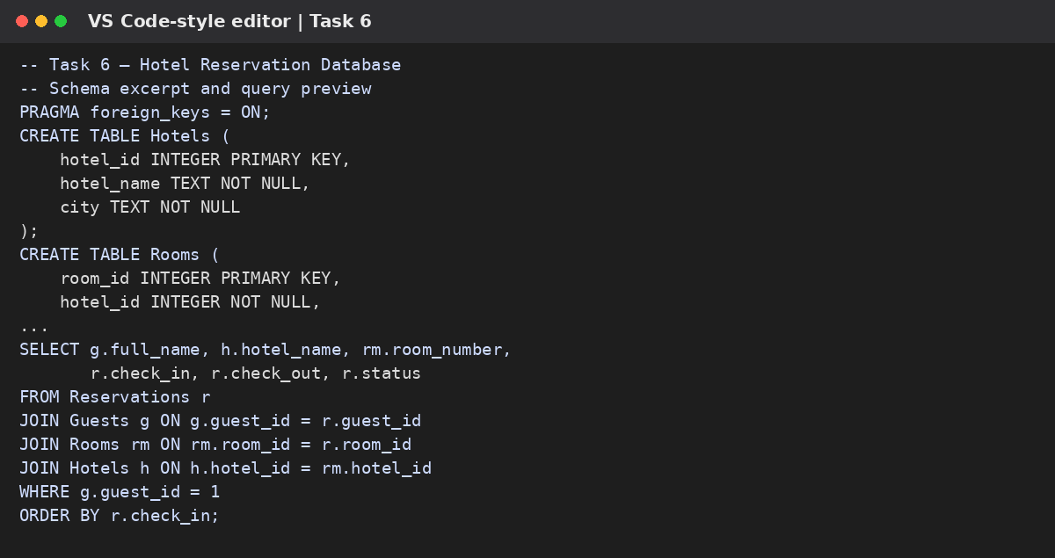

Output Screenshot (Illustrative)
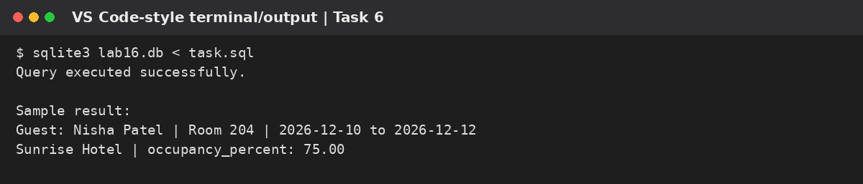

Conclusion
This lab designed six relational databases and wrote SQL queries using primary keys, foreign keys, NOT NULL, UNIQUE, CHECK constraints, joins, filtering, grouping, and aggregate functions. Indexes were proposed for commonly filtered foreign-key and date columns. The designs demonstrate normalization by separating entities into tables and linking them through keys. Before production use, schemas and queries should be tested with representative data, and booking/banking rules that depend on concurrent operations should be enforced transactionally.

References / Tools
Visual Studio Code; SQLite SQL syntax and relational database concepts. AI assistance was used to draft and review schema and query examples.

