**Problem Statement**

**Calculate the number of employees corresponding to each skill from the table 'employee' which is**

**loaded in the Demo.**

CREATE DATABASE IF NOT EXISTS demo;

USE demo;

Create Table:

create table employee

(

emp_name string,

skills string,

exp int,

location string

)

row format delimited

fields terminated by ',';

**Load Table:**

LOAD DATA LOCAL INPATH '/home/acadgild/sridhar/hive/assignment7/emp_details.txt' INTO TABLE employee;

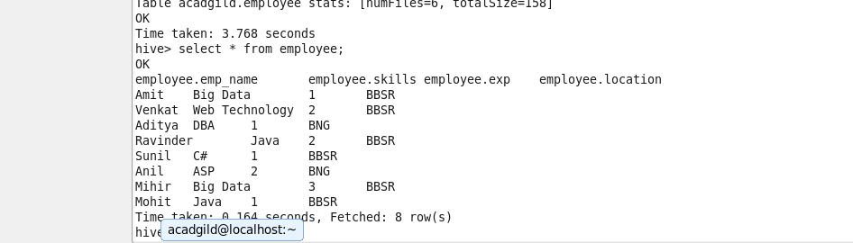

**Get the Number of employees corresponding to each skills**

select DISTINCT skill, count from

(

SELECT Skills as skill,

COUNT(emp_name) OVER (PARTITION BY(skills)) as count

from employee

)table;

