**Pwd**:- This *pwd* command is used to display the full pathname present working directory

of the user to the standard output screen

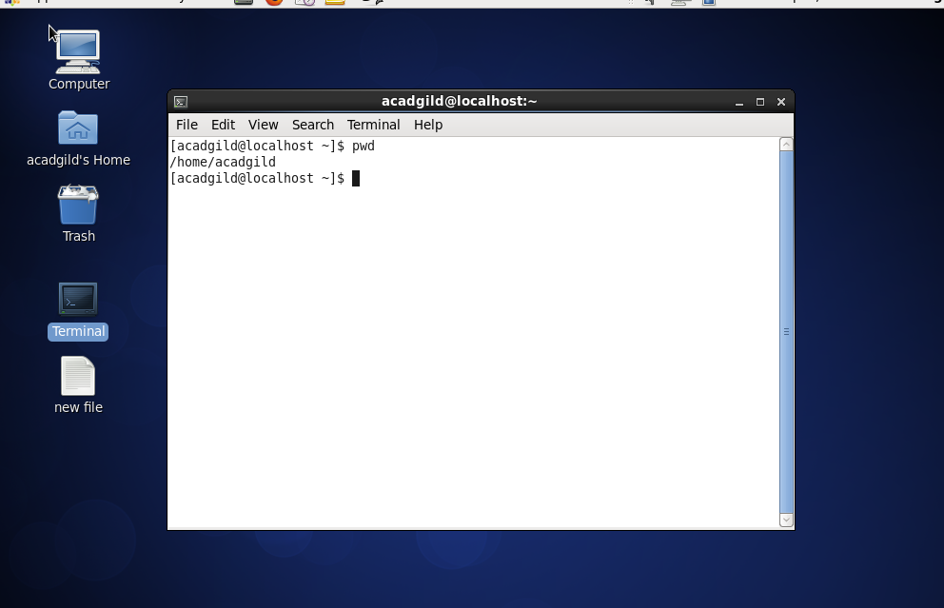

**Vi filename** :- This *vi Filename* command is used to create an newfile or modifying an existing file.

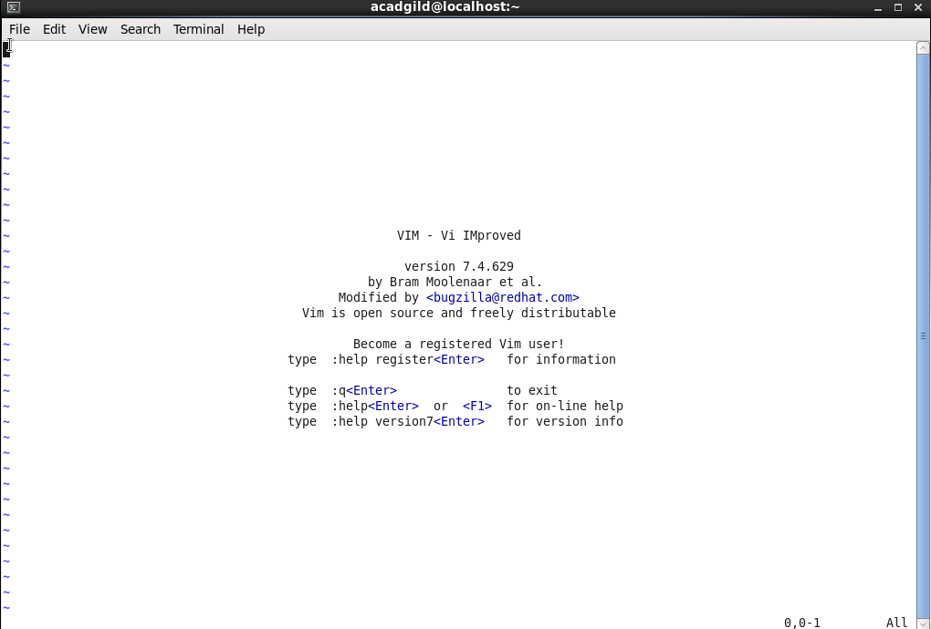

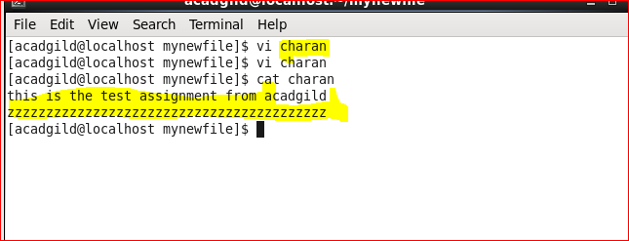

**Touch:-** This*touch*command Update the access and modification times of each FILE to the current time. A file argument that does not exist is created empty,

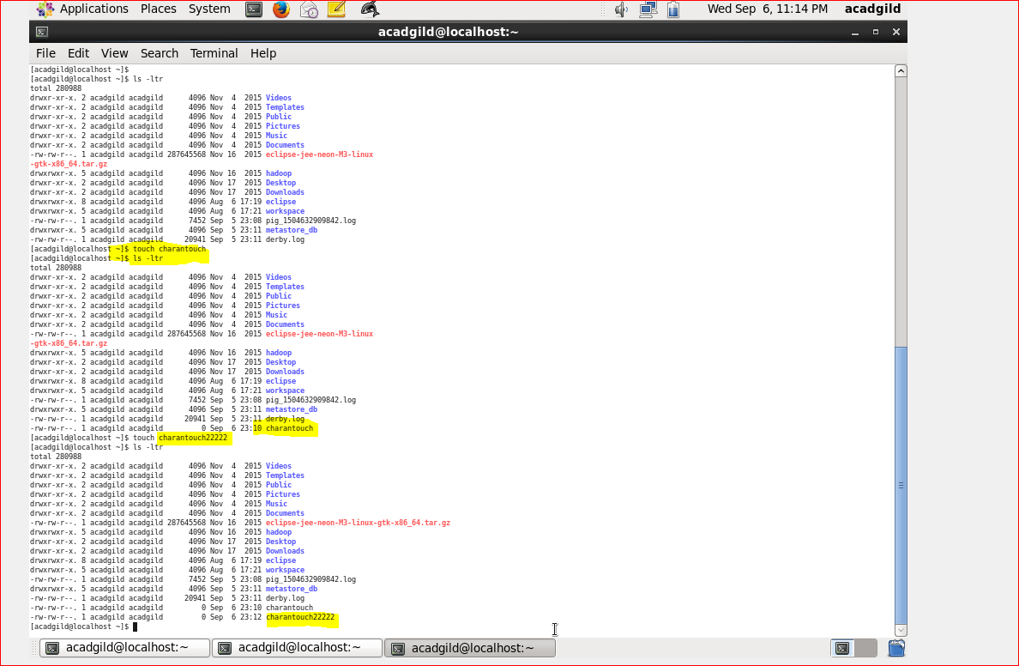

**Mkdir**:- The *mkdir* command is used to create a new directories.

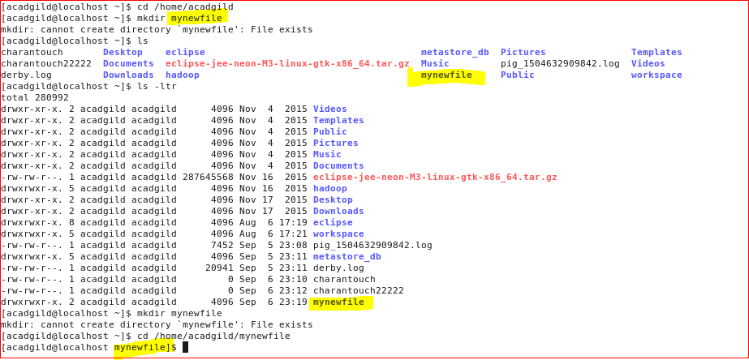

**rm**:- This *rm* file is used to remove the each file.

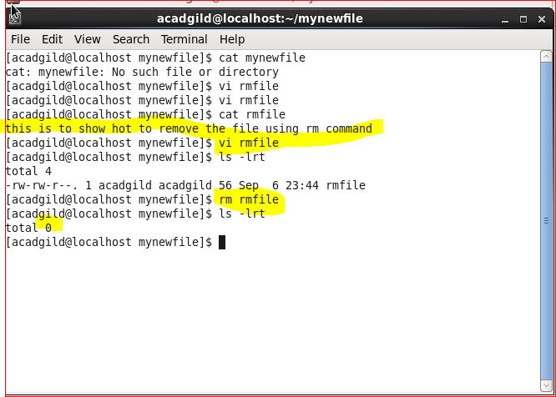

**ls** :- This *ls* command is used to list information about the FILEs (the current directory by default).

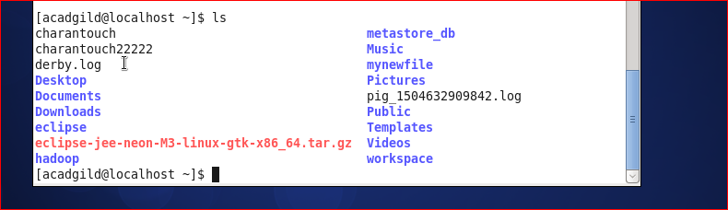

**Echo**:- This *echo* command is used to display the Strings in the standard output.

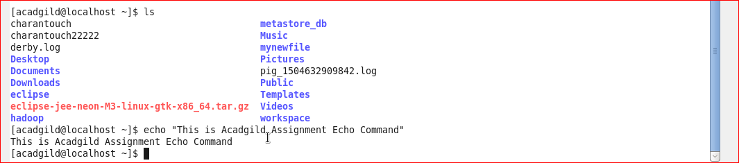

**Cat**:- This *cat* command is used to Copy standard input and to standard output.

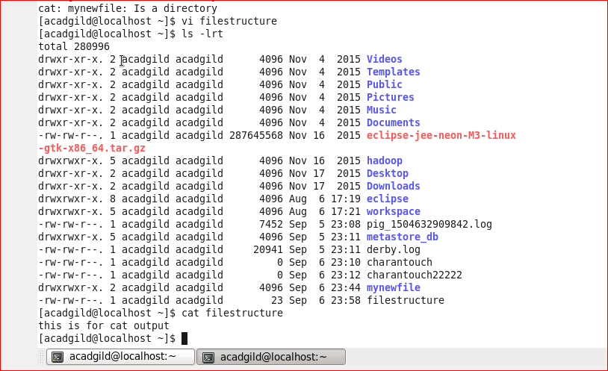

**Who**:- This *who* command shows the information of usesr who are currently logged in .

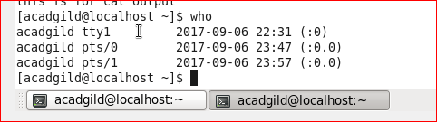

**Cd** :- This *cd* command is to change the home directory.

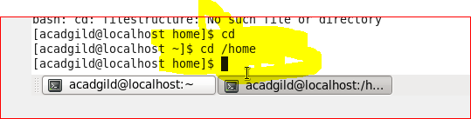

**Date**:- This *date* command is to shows the current date and time of the system.

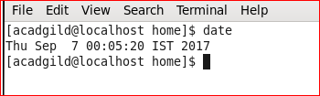

**Cal**:- This *cal* command is to shows the system calendar.

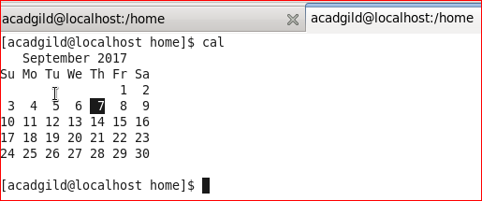

**Mv**:- This *mv* command is used to rename source file to destination file, or move source file(s) to destination directory

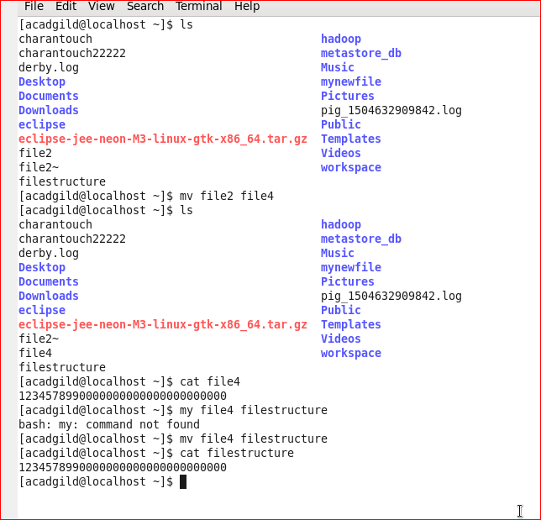

**Cp**:- This *cp* command is used to copy source file to destination file, or multiple source files to directory.

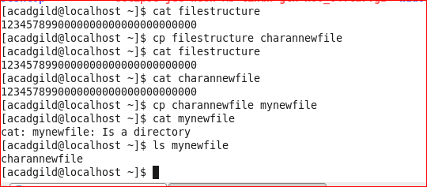

**Which**:- This *which* command takes one or more arguments. For each of its arguments it prints to stdout the full path of the executables that would have been executed when this argument had been entered at the shell prompt

