**TASK:- 1**

Create a directory /user/acadgild/hadoop.

Solution: To check whether directory exist using command: hadoop fs –ls /user/acadgild

And then to create directory : hadoop fs –mkdir –p /user/acadgild/hadoop

Using option –p since /user/acadgild directory was not present already

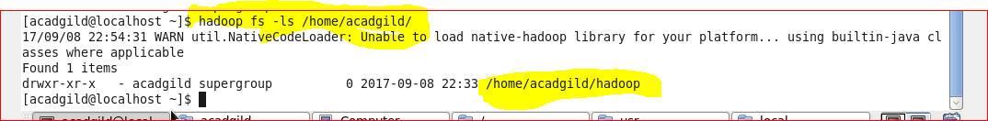

**TASK:- 2**

Create a file in HDFS under directory /user/acadgild/hadoop, with name word-count.txt.

Solution:- Create a file using command: **hadoop fs –touchz /user/acadgild/hadoop/word-count.txt**

This command will create an empty file.

To append to a file whatever we type on screen use command:

**hadoop fs –appendToFile - /user/acadgild/hadoop/word-count.txt**

**<write the contents>**

Ctrl+c to flush the text to the File

