**TASK:- 3**

Create a file max-temp.txt in local FS.

Put some 10-15 records of date and temperature example:

dd-mm-yyyy,temperature

Example:

10-01-1990,10

10-02-1991,20

Move this file to HDFS at /user/acadgild/hadoop.

**Solution:-**

Create file locally using vi editor

By using command: **vi max-temp.txt**

File created locally:

Moved the file to HDFS using :- Hadoop f -moveFromLocal [Dir]

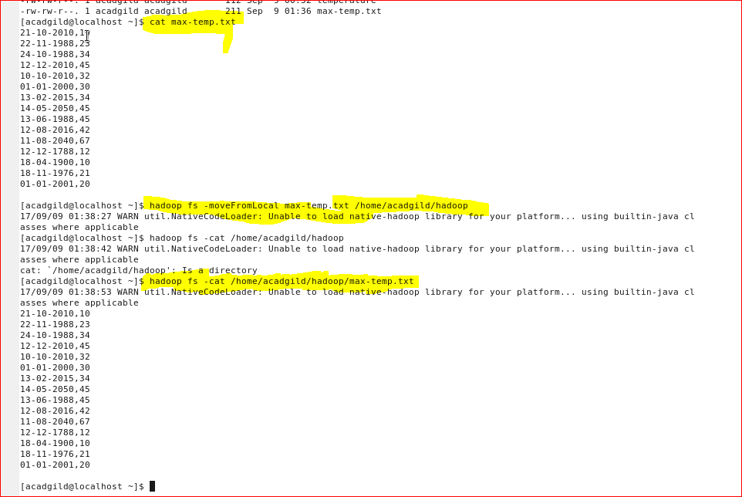

**TASK:- 4**

Change the permission of the file **/user/acadgild/hadoop/max-temp.txt** such that

only the owner and the group members have full control over the file.

Others do not have any control over it.

**Solution:-**

Syntax:- chmod [options] mode filename

Options -R (recrusive) -f(force) -v(vebrose)

Mode:- r(read) w(write) x(execute)

Octal:-

|  |  |  |
| --- | --- | --- |
| Owner | Group | Others |
| r w x | r w x | r w x |
| (4) (2) (1) | (4) (2) (1) | (4) (2) (1) |

Command:- **hadoop fs –chmod 770 /user/acadgild/hadoop/max-temp.txt**

