(a) Top 5 employees (employee id and employee name) with highest rating. (In case two

employees have same rating, employee with name coming first in dictionary should get

preference)

1. employee = LOAD '/home/acadgild/ employee_details.txt' USING PigStorage(',');
2. empOrder = ORDER employee by $3 DESC , $1 ASC;

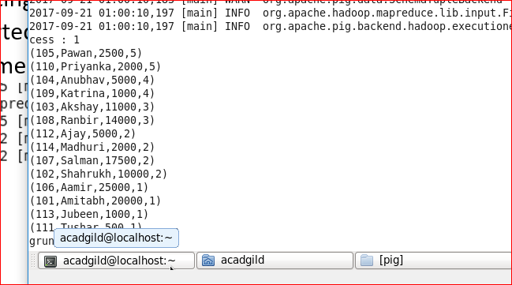

Top5 = LIMIT emporder 5;

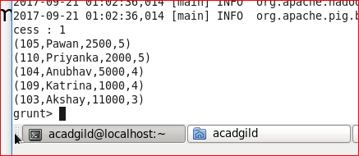

topEmpRating = FOREACH top5 GENERATE $0, $1;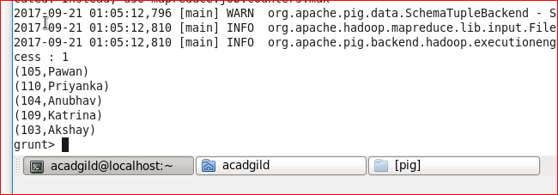

B) Top 3 employees (employee id and employee name) with highest salary, whose employee id

is an odd number. (In case two employees have same salary, employee with name coming first

in dictionary should get preference)

1. empOrderSal = ORDER empDetails by $2 desc , $1 ASC;

the relation will be sorted by salary in descending order and when the salary is same, relation will sorted based on name in ascending order

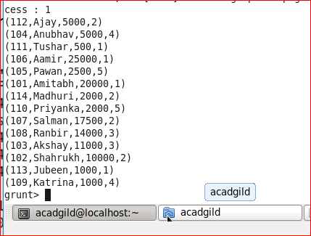

Top3 = LIMIT emporder 3;

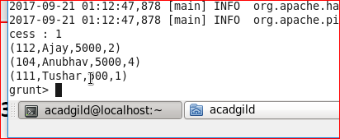

Top3salname = FOREACH top3 GENERATE $0,$1;

