1: Find the list of players that have been selected in the qualifying round (DEFENCE>55).

REGISTER ‘path-for-piggybank.jar’;

file = LOAD '/home/acadgild/Pokemon.csv' USING org.apache.pig.piggybank.storage.CSVExcelStorage(',','NO_MULTILINE','UNIX','SKIP_INPUT_HEADER');

players = FILTER file by $7 > 51;

dump selectedPlayers;

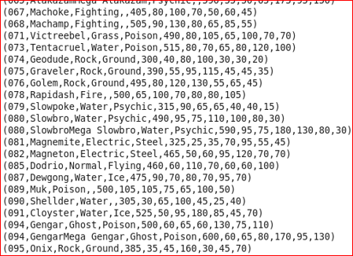

Ques 2: State the number of players taking part in the competition after getting selected in the qualifying round.

qualplayer = GROUP players ALL;

Group relation players to get the count of number of players

count = FOREACH qualplayer GENERATE COUNT(players);

Count the number of players using count()

dump count;

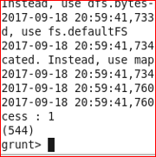

3: Using random() generate random numbers for each Pokémon on the selected list.

generate = FOREACH players GENERATE $0, $1 ,$2 ,$3 , $4, $5 , $6, $7 , $8 , $9 , $10 , RANDOM();

dump generate;

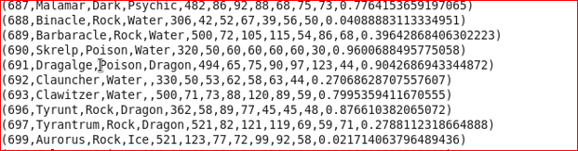

4: Arrange the new list in a descending order according to a column randomly.

desc = ORDER generate by $11 DESC;

dump desc; 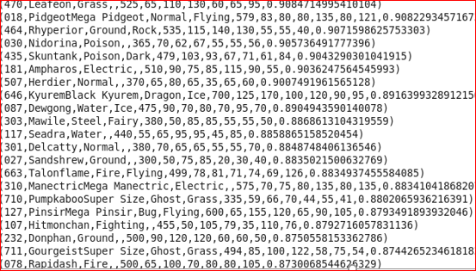

5: Now on a new relation again associate random numbers for each Pokémon and arrange in descending order according to column random.

random = FOREACH desc GENERATE $0, $1 ,$2 ,$3 , $4, $5 , $6, $7 , $8 , $9 , $10 , $11 , RANDOM();

--Get the random list again on the newly created random relation

dump random; 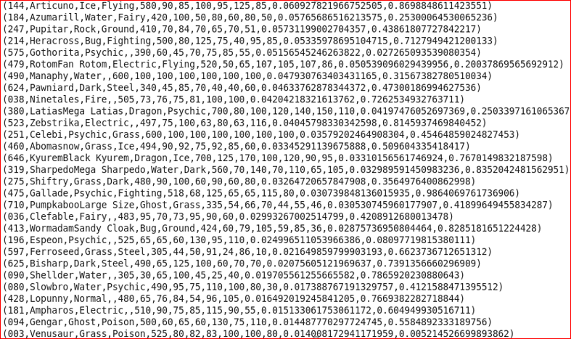

randondesc = ORDER random by $12 DESC;

--sort the relation by random column which is at $12 by using desc

dump randondesc;

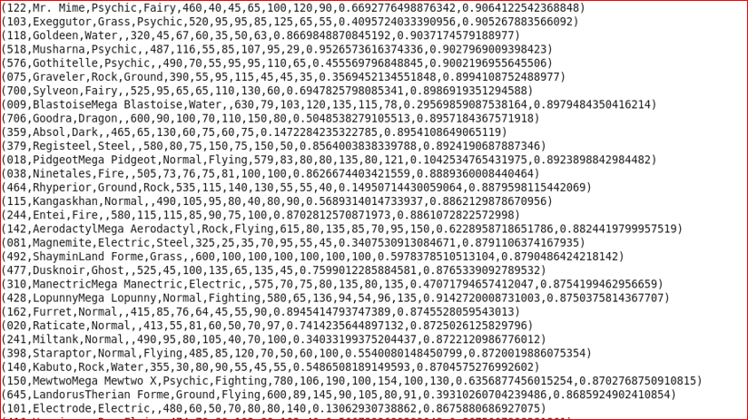

6: From the two different descending lists of random Pokémons, select the top 5 Pokémons for 2 different players.

Top5 = LIMIT desc 5;

--Get the top 5 list using limit operator

dump top5;

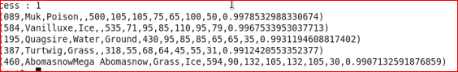

top5 = LIMIT random 5;

dump top5;

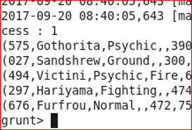

7: Store the data on a local drive to announce for the final match. By the name player1 and player2 (only show the NAME and HP).

player1 = FOREACH top5 GENERATE $1 ,$5;

dump player1;

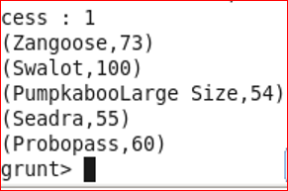

player2 = FOREACH top5 GENERATE $1 , $5;

--Fetch name($1) and HP($5) from the relation

dump player2;

