Create an HBase table named 'clicks' with a column family 'hits' such that it should be able to store last 5 values of qualifiers inside 'hits' column family

create 'clicks',{NAME=>'hits' , VERSIONS=>5}

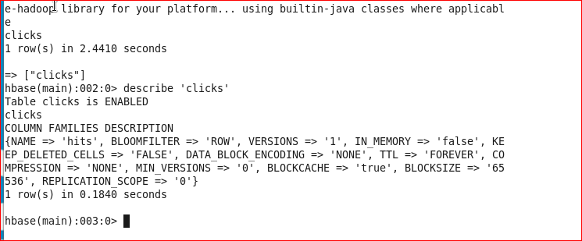

Add few records in the table and update some of them. Use IP Address as row-key. Scan the table to view if all the previous versions are getting displayed.

scan ‘clicks’

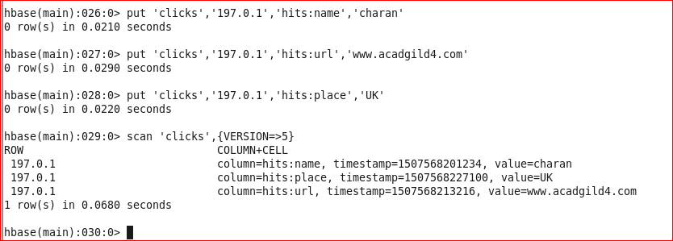

Versions for individual columns

scan 'clicks' , {COLUMN =>'hits:url', VERSIONS => 5}

scan 'clicks' , {COLUMN =>'hits:place', VERSIONS => 5}

scan 'clicks' , {COLUMN =>'hits:name', VERSIONS => 5}

