**MONGO DB**

**Assignment-2**

Name: P CHARAN RAGAVENDRA Reg No: 21BCE1932

**Questions:**

1.Find products released in the same year as "SmartTablet".

**Code**:

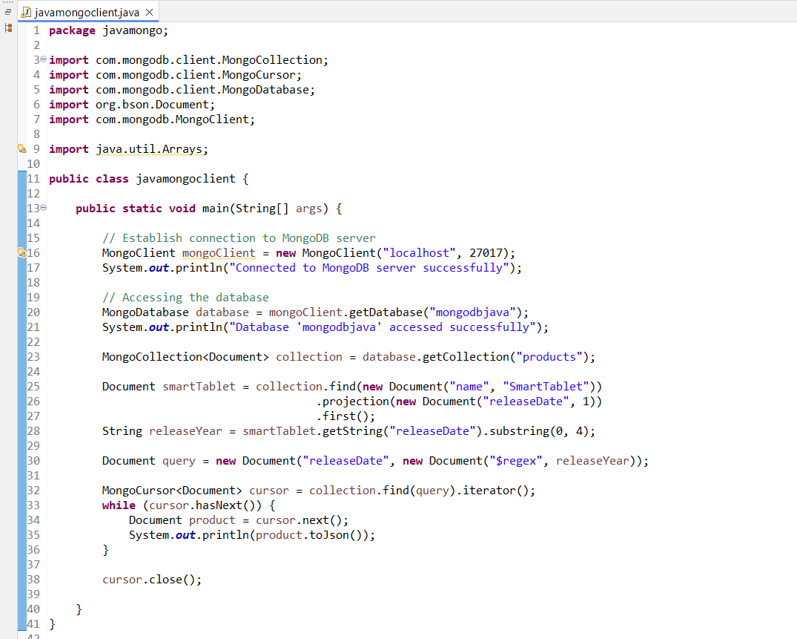

**Output**:

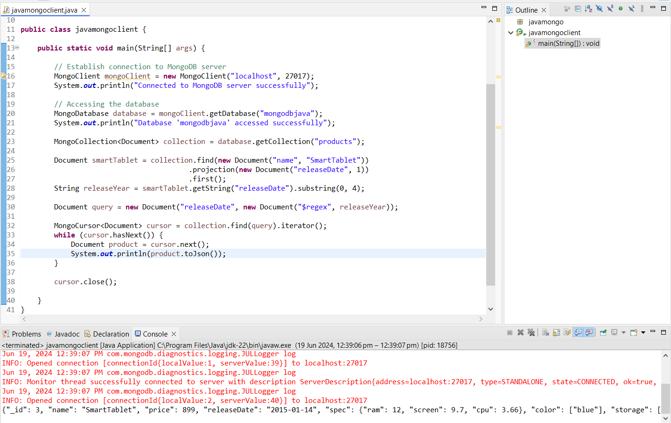

2.Find products where the price is between 600 and 900, inclusive

**Code:**

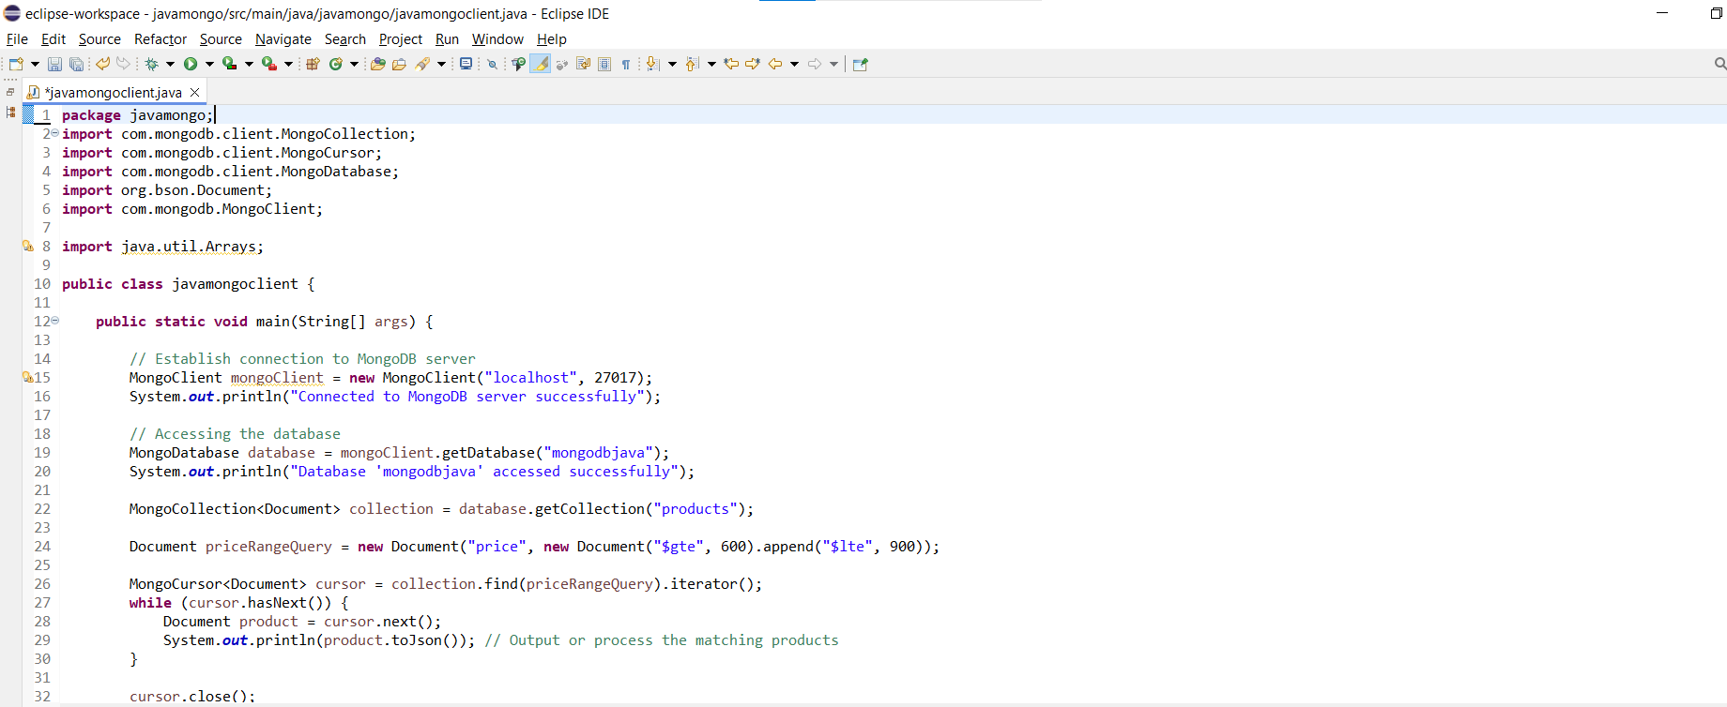

**Output:**

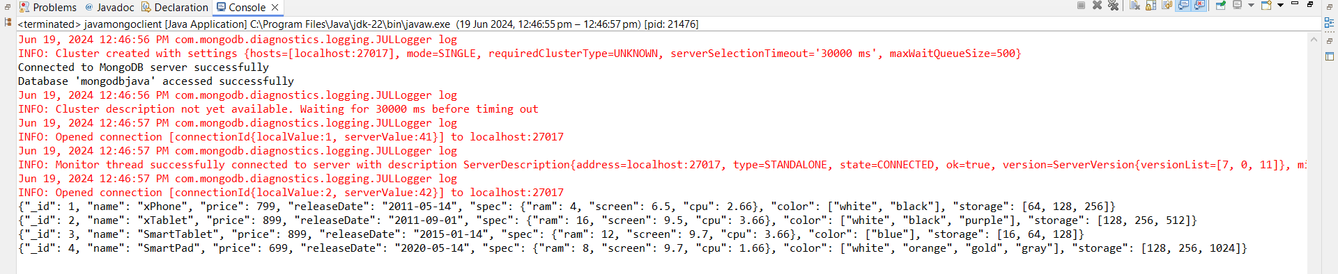

3.Find all products that have "white" as a color and a CPU speed greater than the average CPU speed of all products.

**Code:**

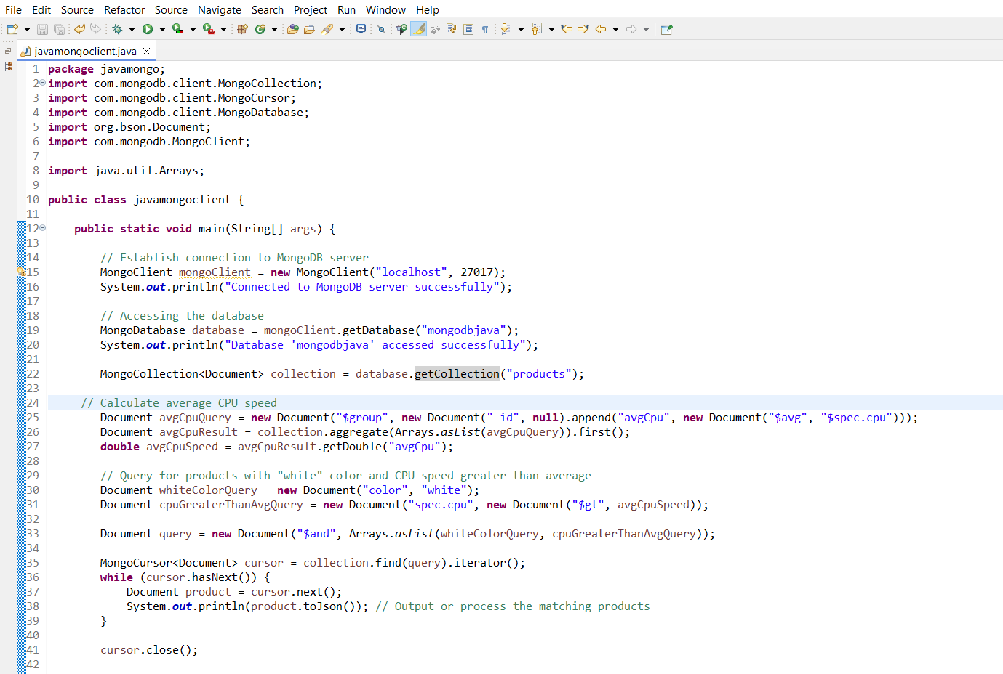

**Output:**

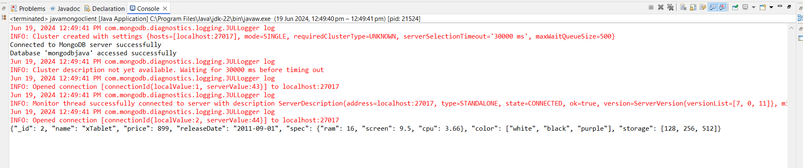

4.find name,price,storage if price is 699 or storage is 1024.

**Code:**

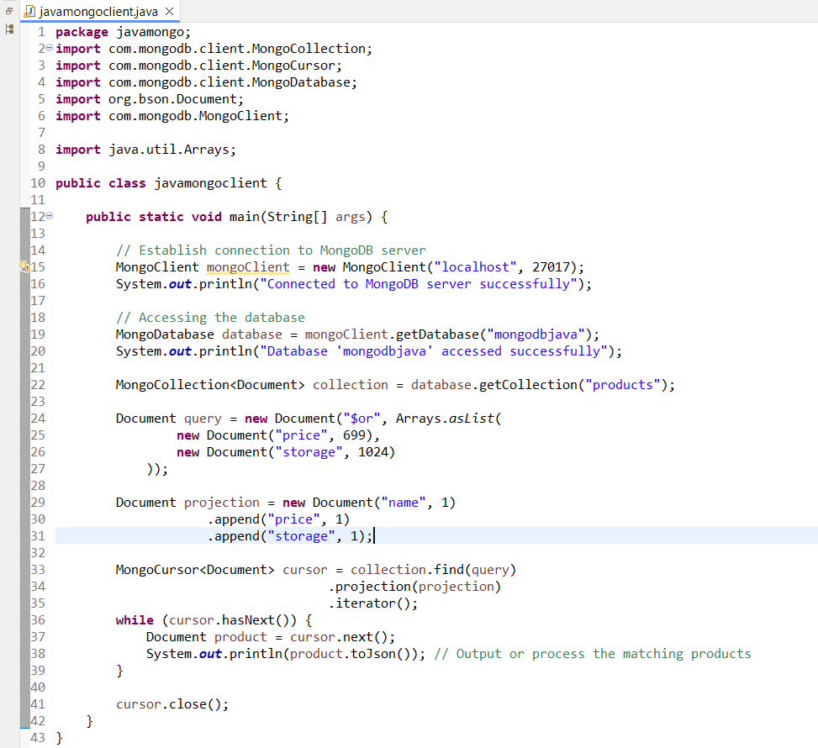

**Output:**

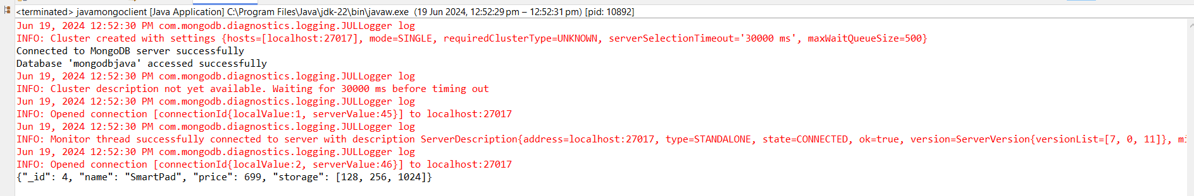

5.Find products with either cpu is greater than 2gb or ram is between 4 and 12.

**Code:**

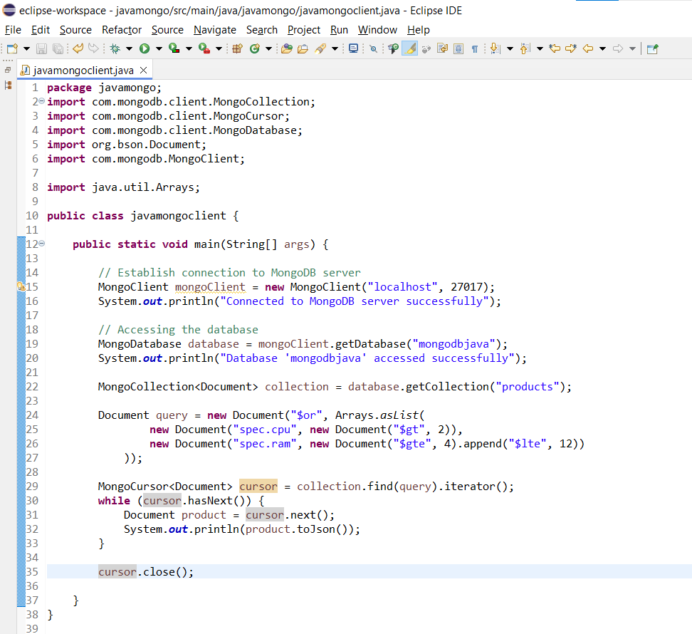

**Output:**

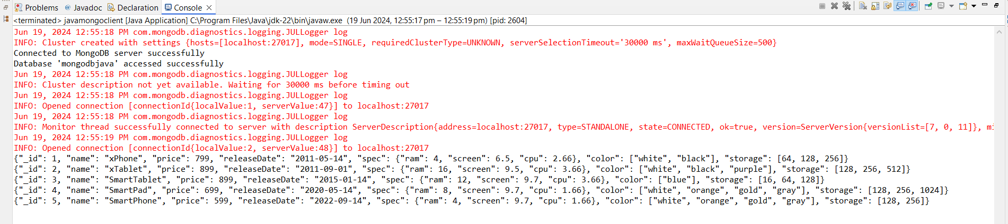

6. Find products with niether price is between 600 and 900 nor is it white or black.

**Code:**

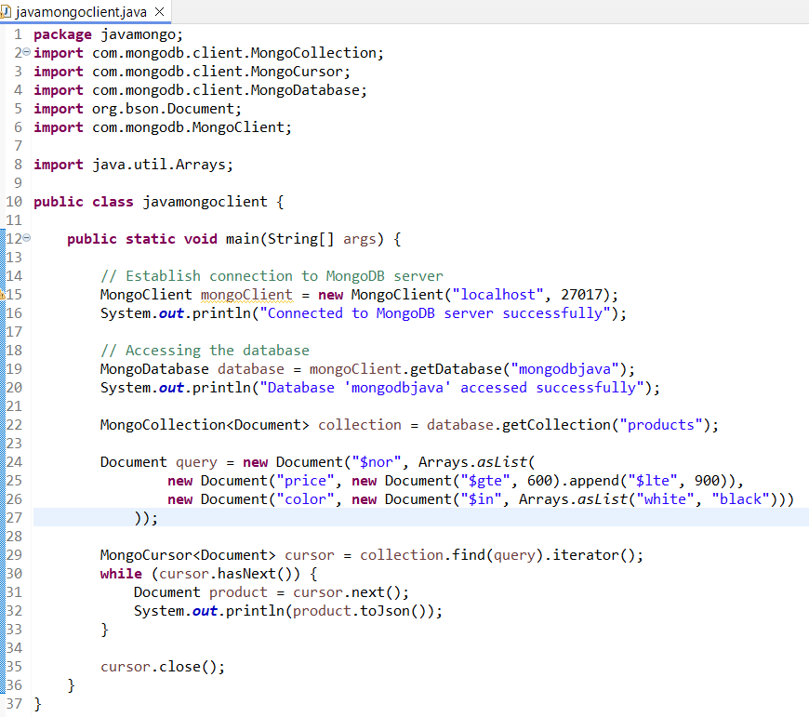

**Output:**

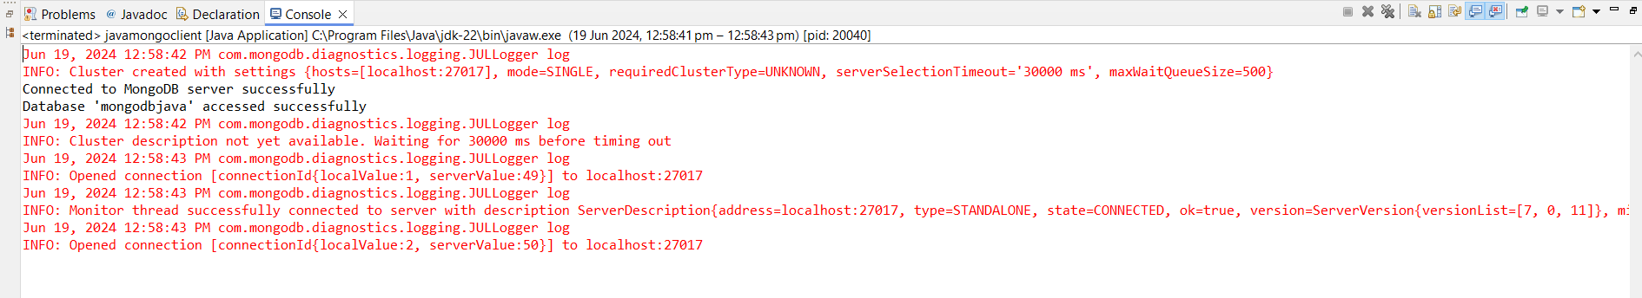

(No information is displayed.)

7. Find products where price exists and there is no gray in the colours.

**Code:**

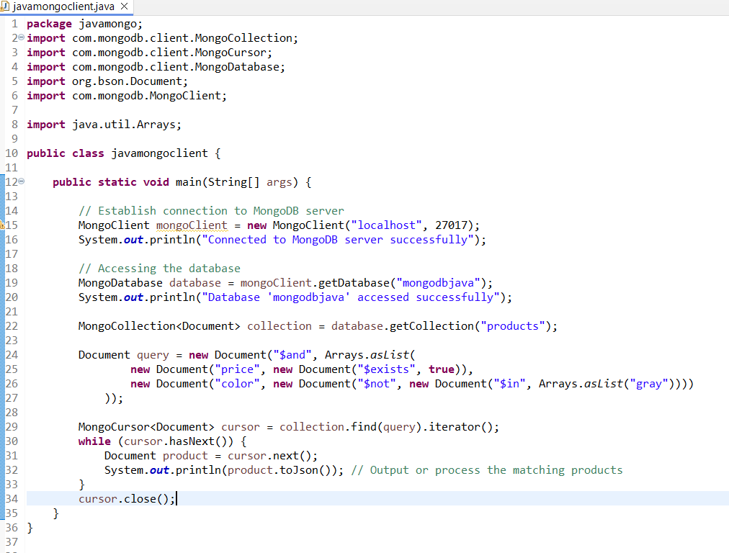

**Output:**

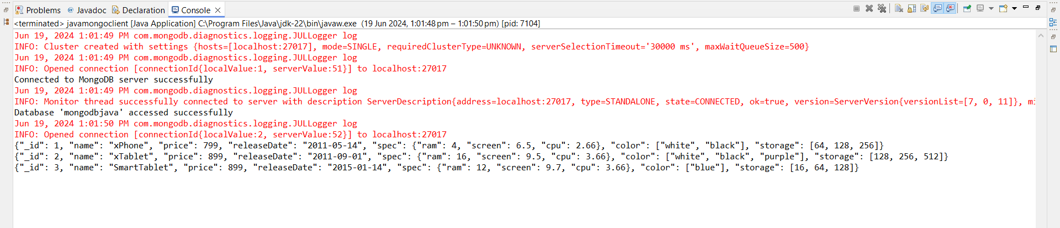

8.Find products that have either "white" or "black" as a color option and are priced below 800.

**Code:**

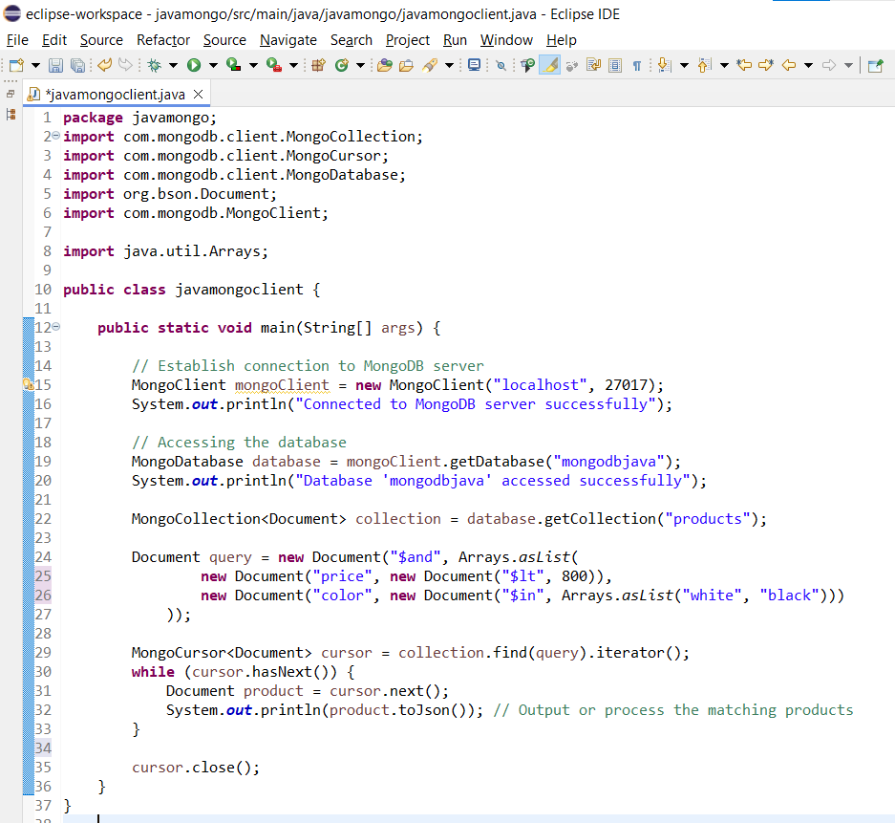

**Output:**

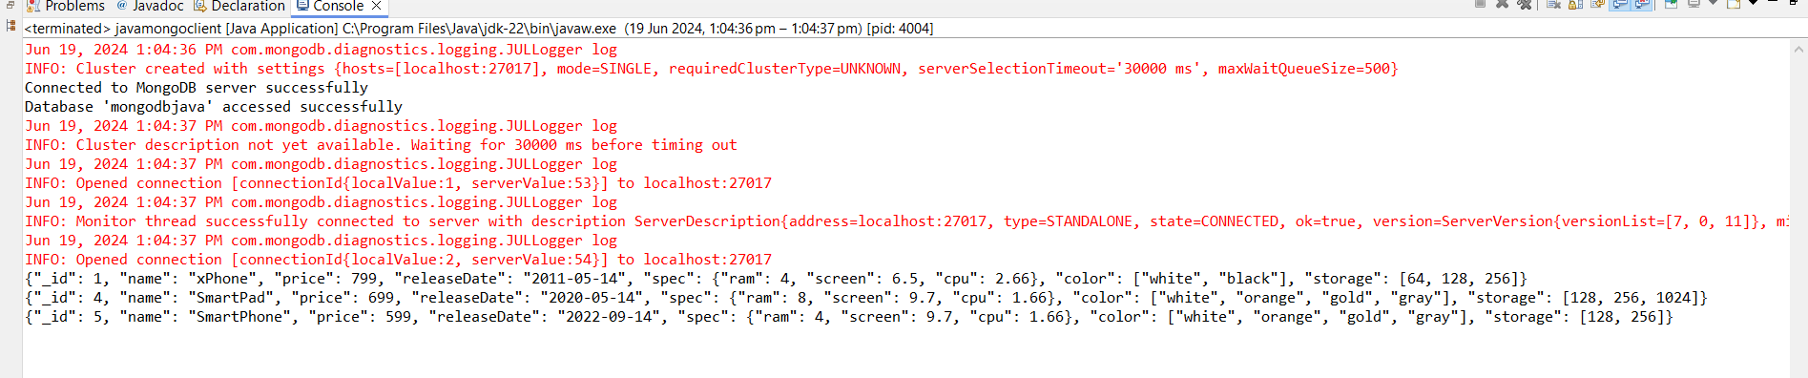

9.Find products that do not have "gold" as a color and are priced below 700 or have a storage option of 512GB.

**Code:**

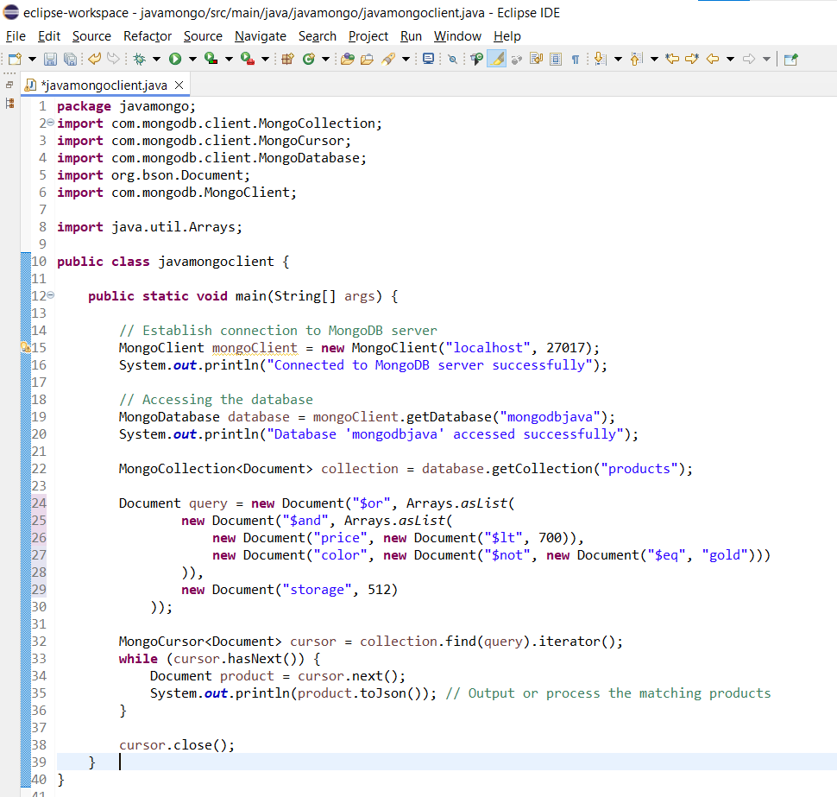

**Output:**

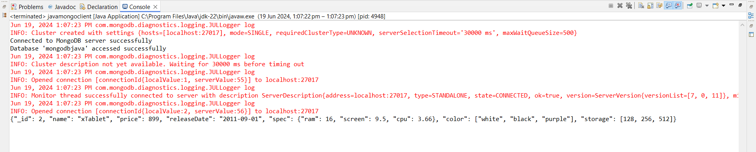

10. Find products released before 2019.

**Code:**

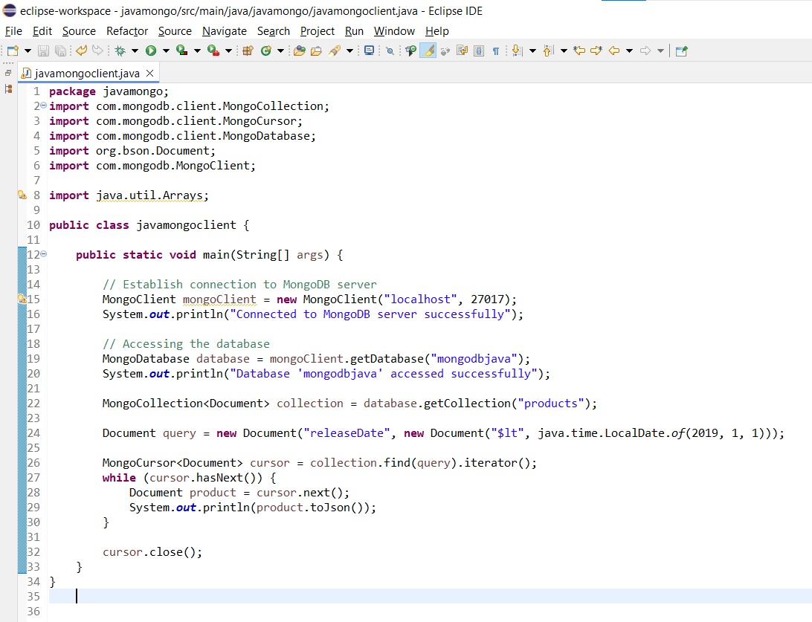

**Output:**

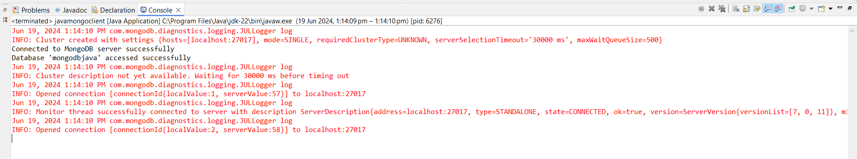

(No information displayed)

11. List products with a screen size greater than 9.5 inches.

**Code:**

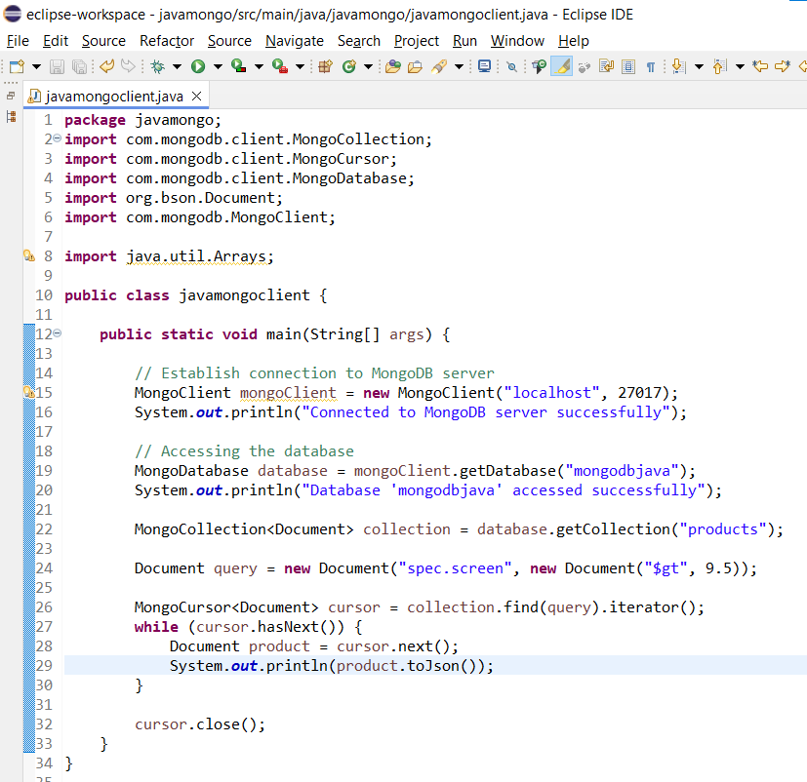

**Output:**

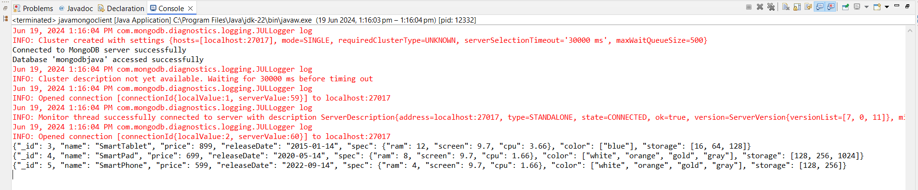

12. Retrieve products with storage options including 512 GB.

**Code:**

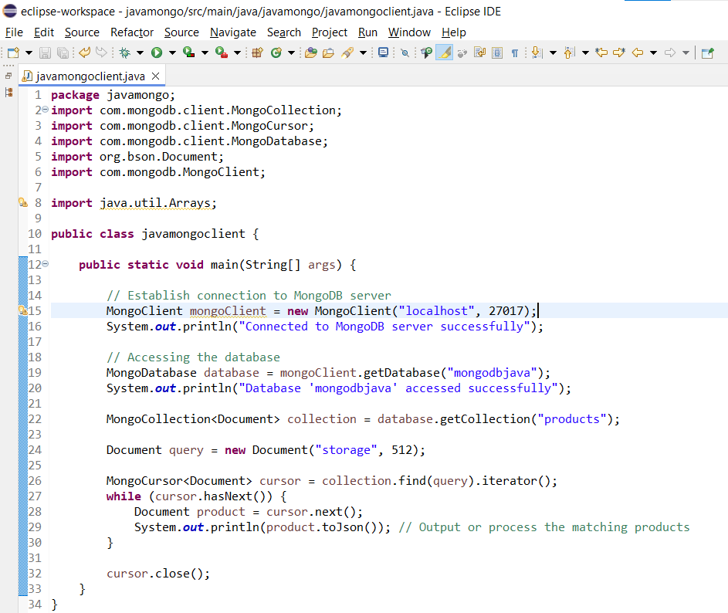

**Output:**

