**MONGO DB**

**Assignment-2**

Name: P CHARAN RAGAVENDRA Reg No: 21BCE1932

1.Calculate the average and total price of products that are either a "SmartTablet" or have a price less than $700. Sort the results by average price in descending order.

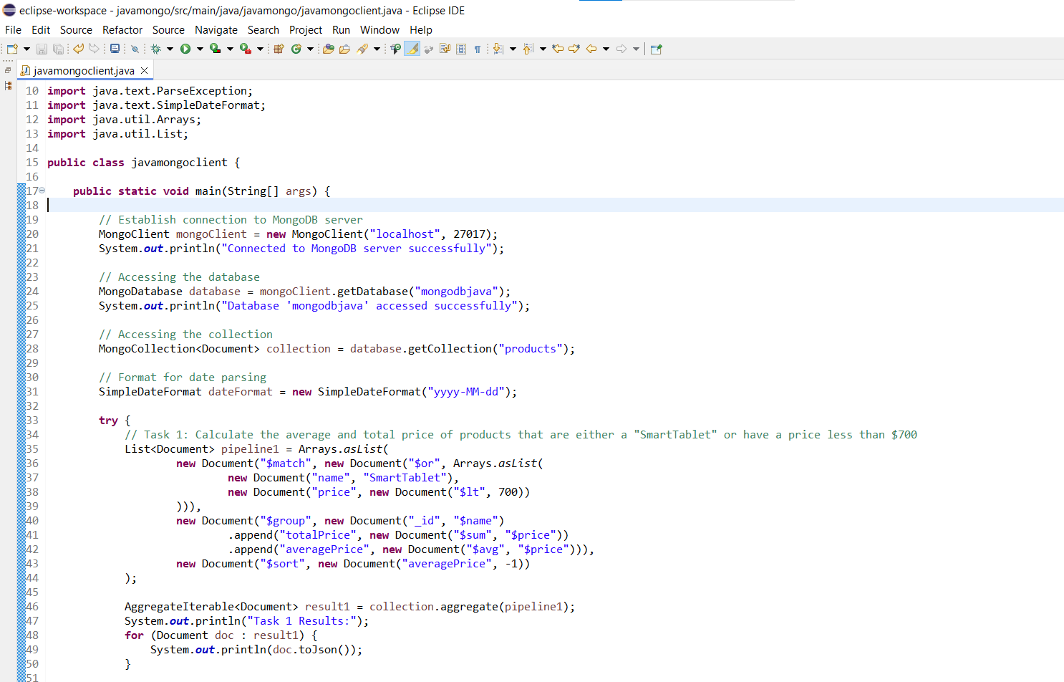

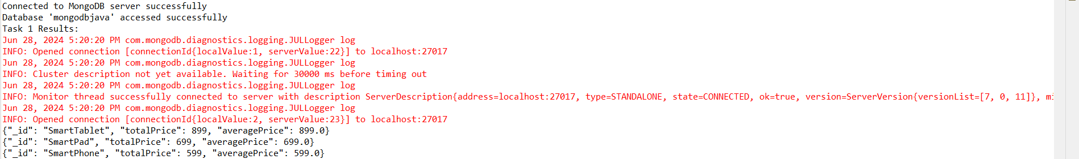

2. Find the top 3 products released after January 1, 2015, with more than 8GB of RAM. Show only the name and price fields.

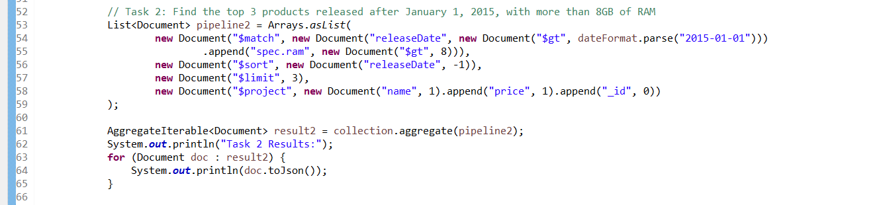

(no output shown)

3. Calculate the average screen size of all products that have storage options of either 128GB or 256GB.

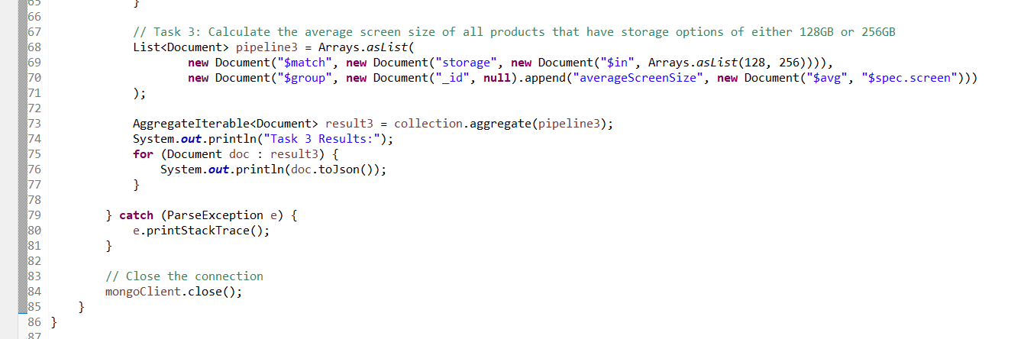



4.How many “Americanos” were sold in total?

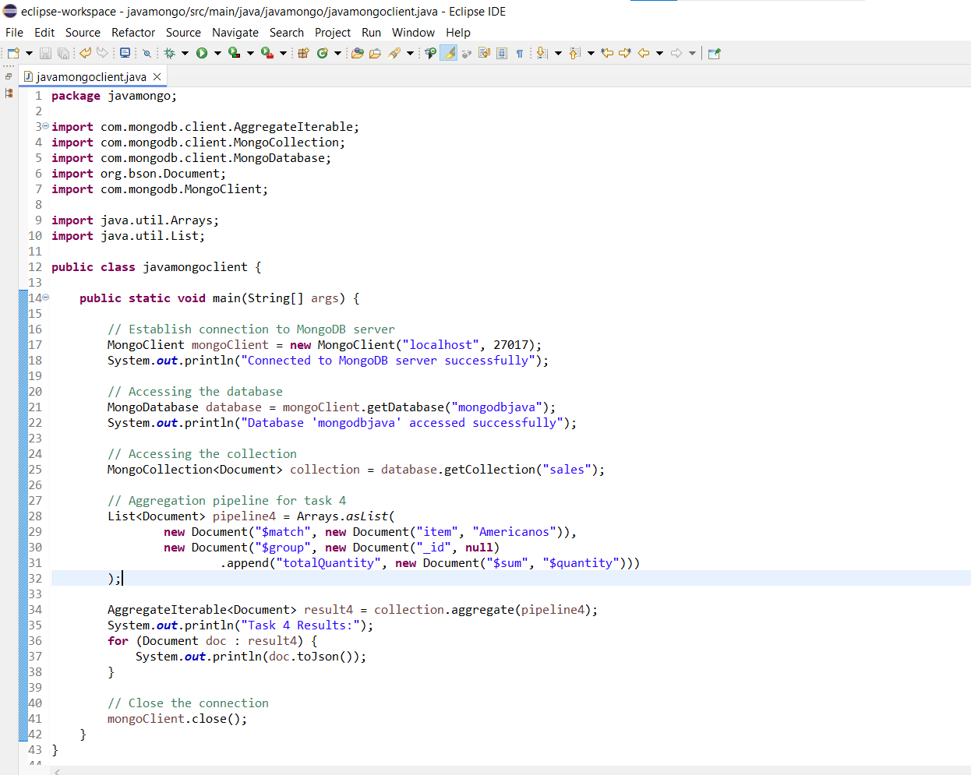

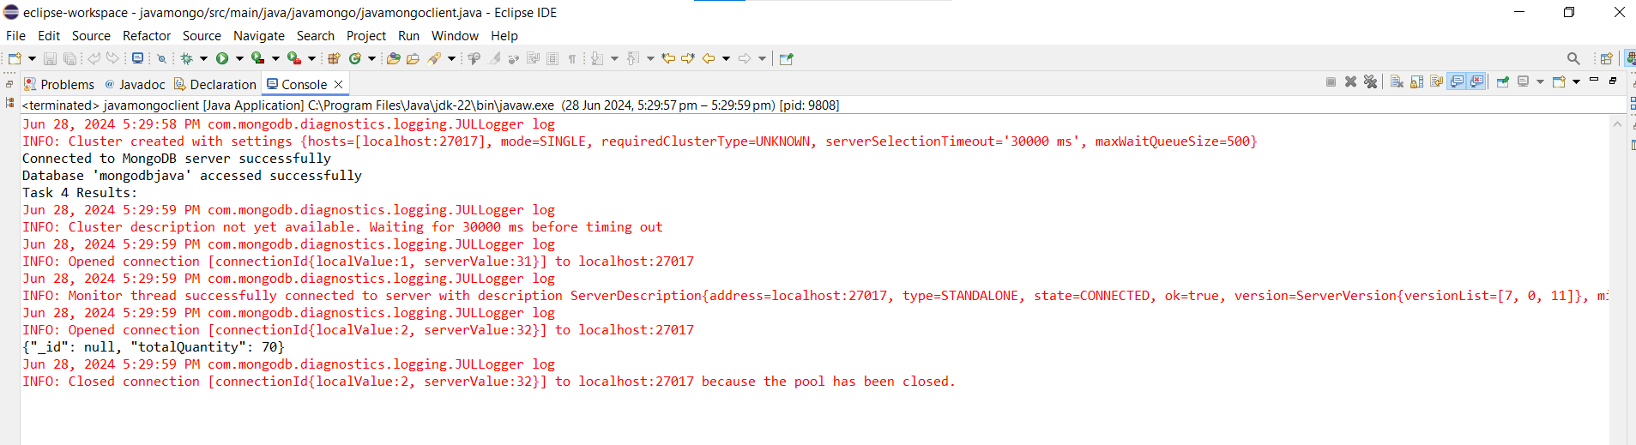

5.Increase the price of “Lattes” by 5 units

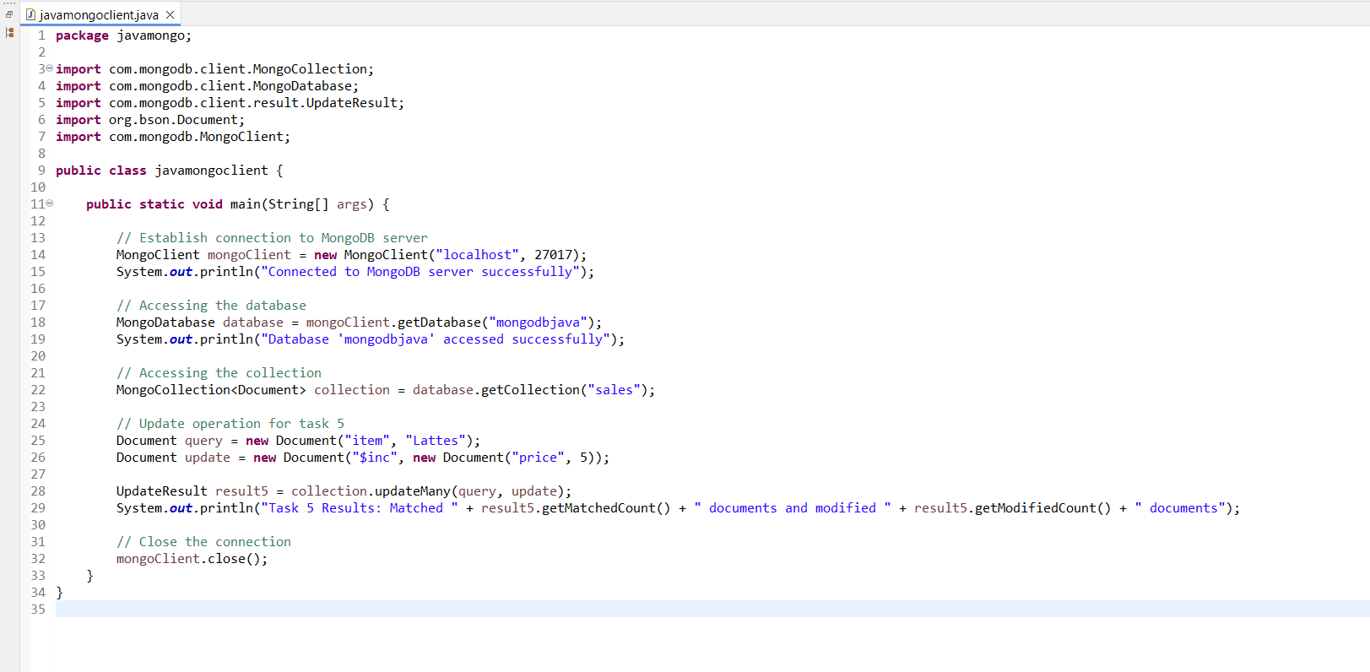

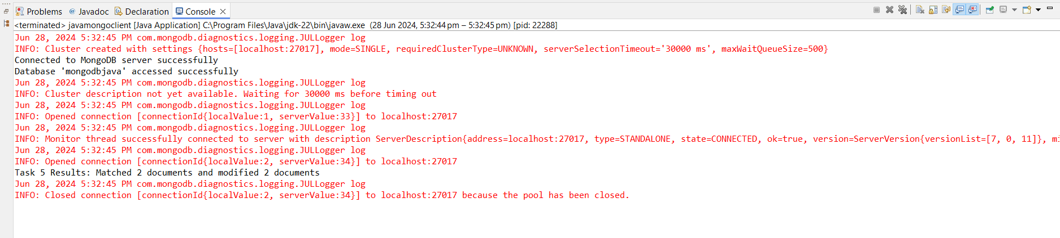

6.Unset the “size” field for all records where the price is less than 10.

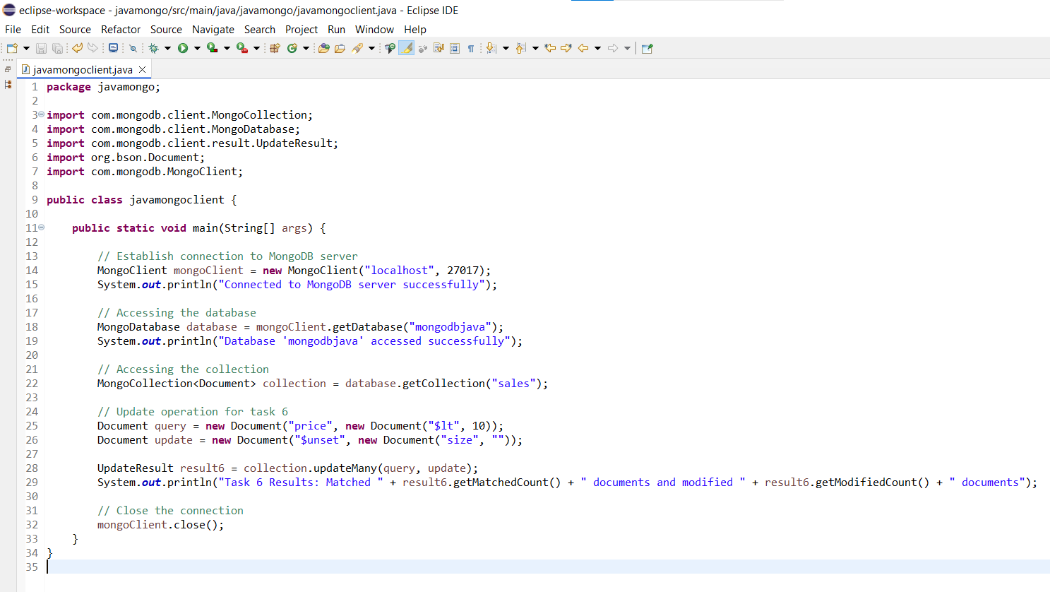

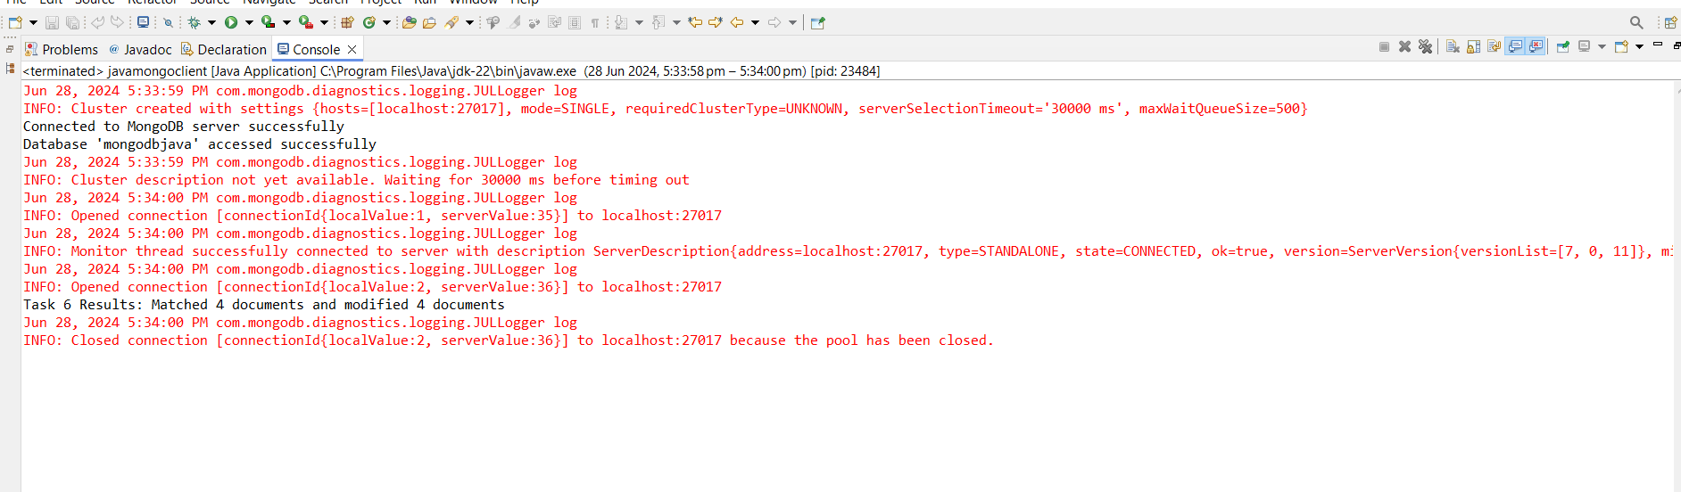

7.the total revenue generated from all sales

