**CODERSSPACE**

(A Website for getting software job.)

**A PROJECT REPORT**

***Submitted by***

**Tentu Charan Sai**

***To***

***Mrs. Gauri Thakur***

***(Asst. Professor)***

***in partial fulfilment for the award of the degree***

***of***

**BACHELOR OF TECHNOLOGY**

**IN**

**COMPUTER SCIENCE ENGINEERING**



**Lovely Professional University, Punjab**

**12413274**

**OCTOBER 2024**

### OCTOBER 2024

# Coders Space

(A website were a software languages learned persons can get a job.)

**A PROJECT REPORT**

***Submitted by***

# T.Charan Sai

**(12413274)**

***in partial fulfilment for the award of the degree*** ***of***

## BACHELOR OF TECHNOLOGY



## Lovely Professional University, Punjab

### OCTOBER 2024

**Lovely Professional University, Punjab**

## BONAFIDE CERTIFICATE

Certified that this project report is the Bonafede work of **Charan Sai** (12413274)

who carried out the project work under my supervision.

**SIGNATURE**

**CLASS MENTOR**

**HEAD OF THE DEPARTMENT**

**SIGNATURE**

**SIGNATURE**

**SUPERVISOR**

**Student Declaration**

I, **Charan Sai(12413274)**hereby declare that the work done by me on “**HTML & CSS**” from **15/10/2024** to **26/10/2024**, is a record of original work for the partial fulfilment of the requirements for the award of the degree, **B.Tech (CSE).**

Charan Sai(12413274)

Dated: 18/10/2024.

#### TABLE OF CONTENTS

|  |  |  |
| --- | --- | --- |
| **CHAPTER**  **NO.** | **CHAPTER NAME** | **PAGE NO.** |
|  | **Title Page** | **i** |
|  | **Bonafide Certificate** | **ii** |
|  | **Student Declaration** | **iii** |
|  | **Table of Contents** | **iv** |
| 1 | Introduction | **v** |
| 2 | Objective | **vi** |
| 3 | Features & technologies used | **vii** |
| 4 | Website Architecture & Challenges and Solution | **viii** |
| 5 | Code & Output | **ix** |
| 6 | Code & Output | **x** |
| 7 | Code & Output | **xi** |
| 8 | Code & Output | **xii-xvi** |
| 9 | Code & Output | **xvii** |
| 10 | Code & Output | **xviii** |
| 11 | Code & Output | **xviii** |
|  | Appendices | **xviii** |
|  | References | **ixx** |

**INTRODUCTION:**

This project is mainly about the persons who are having skills regarding coding . At CodersSpace, our mission is to bridge the gap between skilled coders and dynamic job opportunities. We understand the power of code to transform industries and change lives, and we’re committed to connecting coding professionals with companies that value their talent.

**OBJECTIVES:**

**Empower Talent:**We aim to empower coders by providing them with opportunities to showcase their skills and find rewarding positions.

**Bridge the Gap:**By linking talented individuals with top companies, we bridge the gap between supply and demand in the tech industry.

**Foster Growth:**We are dedicated to fostering professional growth by offering resources, mentorship, and career guidance.

**Features:**

### with filters for location, technology staJob Listings: Comprehensive listings  ck, experience level, etc.

### Profile Creation: Allow coders to create detailed profiles showcasing their skills, experience, projects, and certifications.

### Resume Upload: Let users upload and update their resumes, making it easier for employers to find relevant candidates.

### Skill Assessments: Integrated coding challenges or assessments to validate skills and help match the right talent with the right job.

### Company Profiles: Detailed company profiles with insights into their work culture, benefits, and team structure.

### Job Alerts: Personalized job alerts based on user preferences, ensuring they never miss an opportunity.

### Application Tracking: A dashboard for candidates to track their application status and receive feedback.

### Career Resources: Articles, tutorials, and webinars to help users improve their skills and stay updated with industry trends.

### Networking Opportunities: Forums or discussion boards for coders to connect, share knowledge, and seek advice.

### Mobile-Friendly Design: Ensure the site is mobile-responsive, providing a seamless experience across devices.

**Technologies Used:**

**~Frontend:**

**1.HTML: For structure and Coding.**

**2.CSS: Styling and formatting the webpage.**

**Website Architecture:**

**1. Home Page:** The home page of the website is where all the web pages are linked.

# 2.Job requriments: About the skills and languages that a coder should know accourding to the job.

**3. Registration form:** Fill the details if any one required the job.

**Challenges and Solutions:**

**- Data Collection:** One of the initial challenges was gathering restaurant data. This was addressed by using publicly available restaurant listings, APIs, and manual data entry.

- **Responsive Design:** Ensuring that the website was fully responsive required extra effort, which was achieved using CSS & HTML.

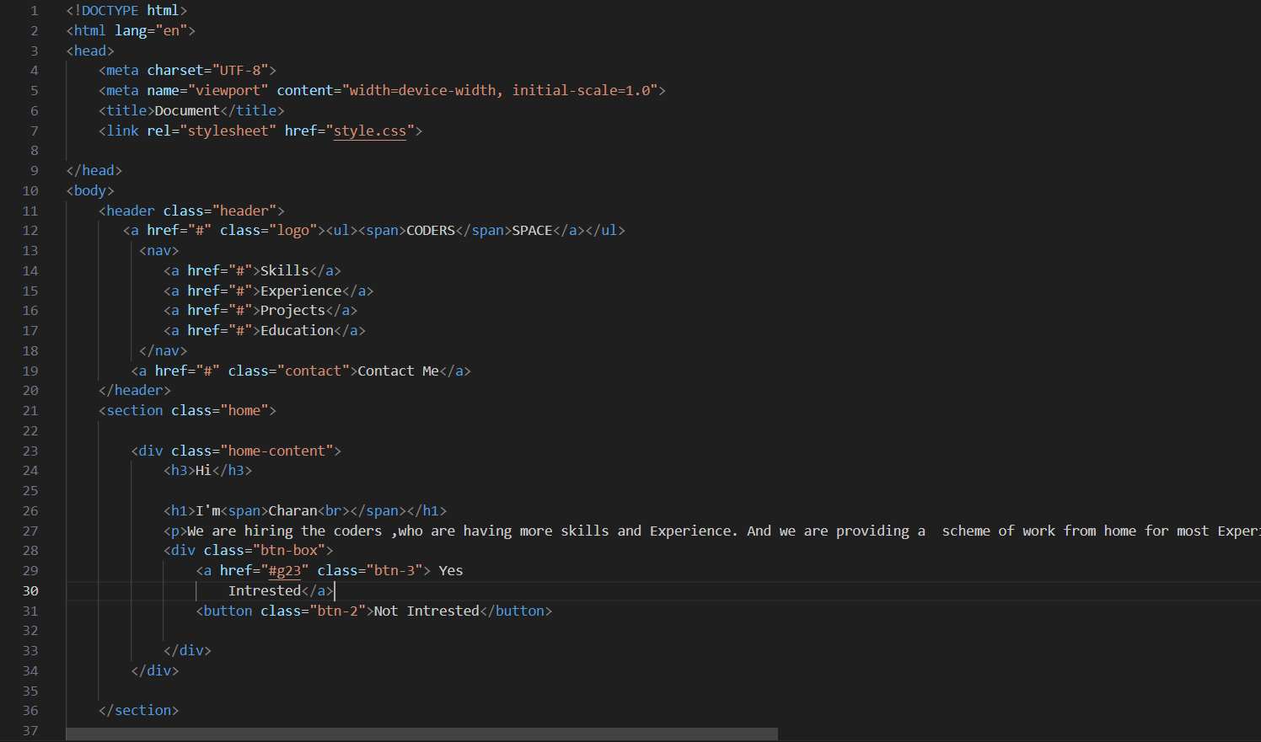

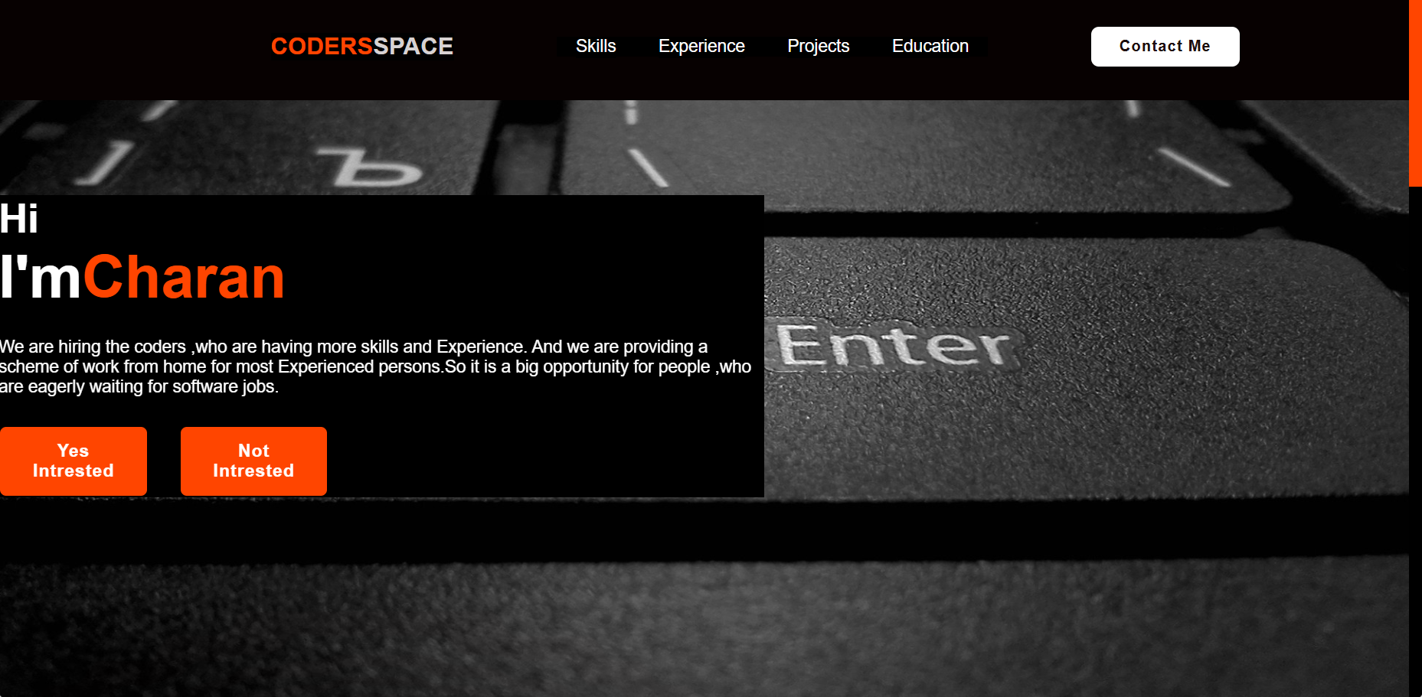

**A.1 Purpose of the Website**

The primary aim of this website is to provide jobs for the persons who was a skills and it is also good the persons who are physically hadicaped to work from home.

**A.2 Technological Framework**

The website is built with modern web technologies to ensure a seamless user experience across devices.

* Frontend: HTML & CSS
* Hosting: Yet to host with version control managed via GitHub
* APIs: Future aspects

**A.3 Key Features**

**Responsive Design:** The site is optimized for desktops ensuring an intuitive experience .

**Conclusion:**

In this stage of technology the people are not able to get a good job especialy the software jobs so here is the website to get a good job for the person who are skillful and it is the website to get a job from work from home for a people who are looking for good job and salary.

* **References:**
* W3School
* GitHub
* Previous Projects
* Chat GPT
* v0.dev