JobGuard AI — Performance Evaluation
Evaluation uses a stratified 70:30 train-test split for three pipelines: EMSCAD TF-IDF + Logistic Regression; PhiUSIIL URL features + XGBoost; and PhiUSIIL URL features + Logistic Regression.
The combined comparison is the arithmetic mean of the three scores and is not a trained model.
Dataset | Pipeline | Split | Train | Test | Accuracy | Precision | Recall | F1-score | ROC-AUC
EMSCAD | TF-IDF + Logistic Regression | 70:30 | 12,516 | 5,364 | 97.45% | 100.00% | 47.31% | 64.23% | 98.36%
PhiUSIIL | 18 URL features + XGBoost | 70:30 | 165,056 | 70,739 | 99.75% | 99.98% | 99.44% | 99.71% | 99.87%
PhiUSIIL | 18 URL features + Logistic Regression | 70:30 | 165,056 | 70,739 | 99.77% | 99.99% | 99.46% | 99.73% | 99.86%
Combined comparison (mean of 3 pipelines) | Arithmetic mean of the three pipeline scores | 70:30 | 342,628 | 146,842 | 98.99% | 99.99% | 82.07% | 87.89% | 99.36%

Graphs
Figure 1. Precision–recall scatter plot.
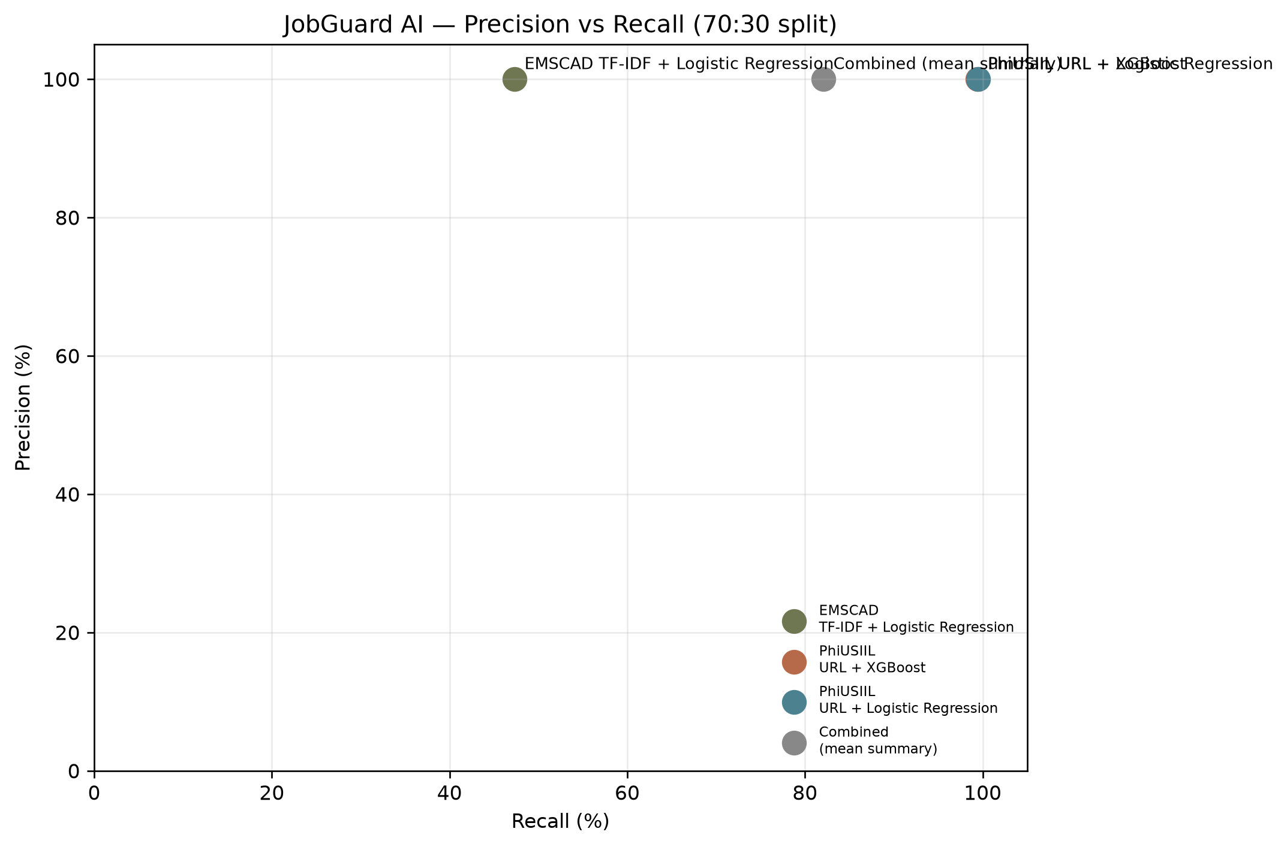
Figure 2. Metric comparison bar chart.
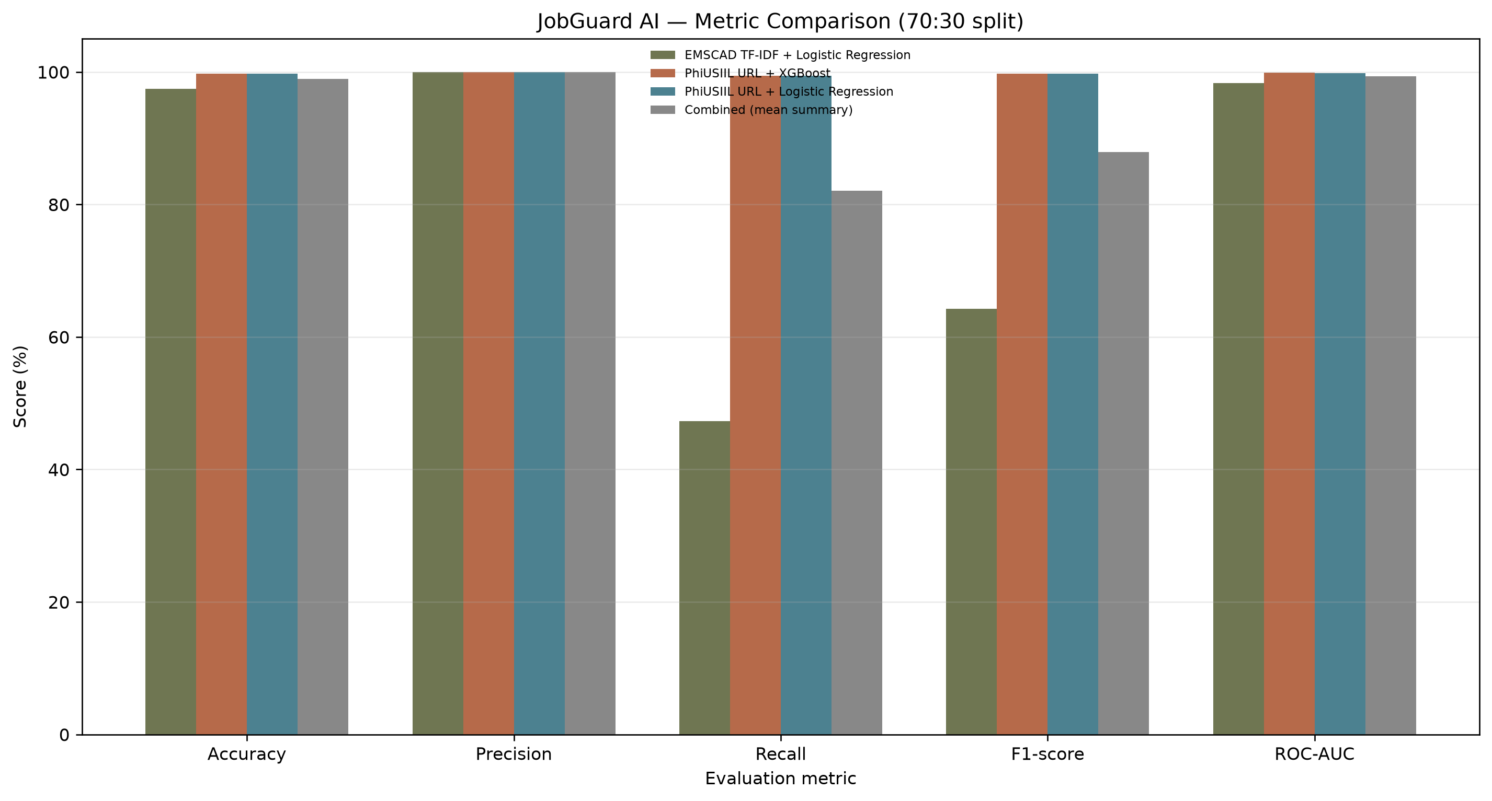
Figure 3. Metric profile line chart.
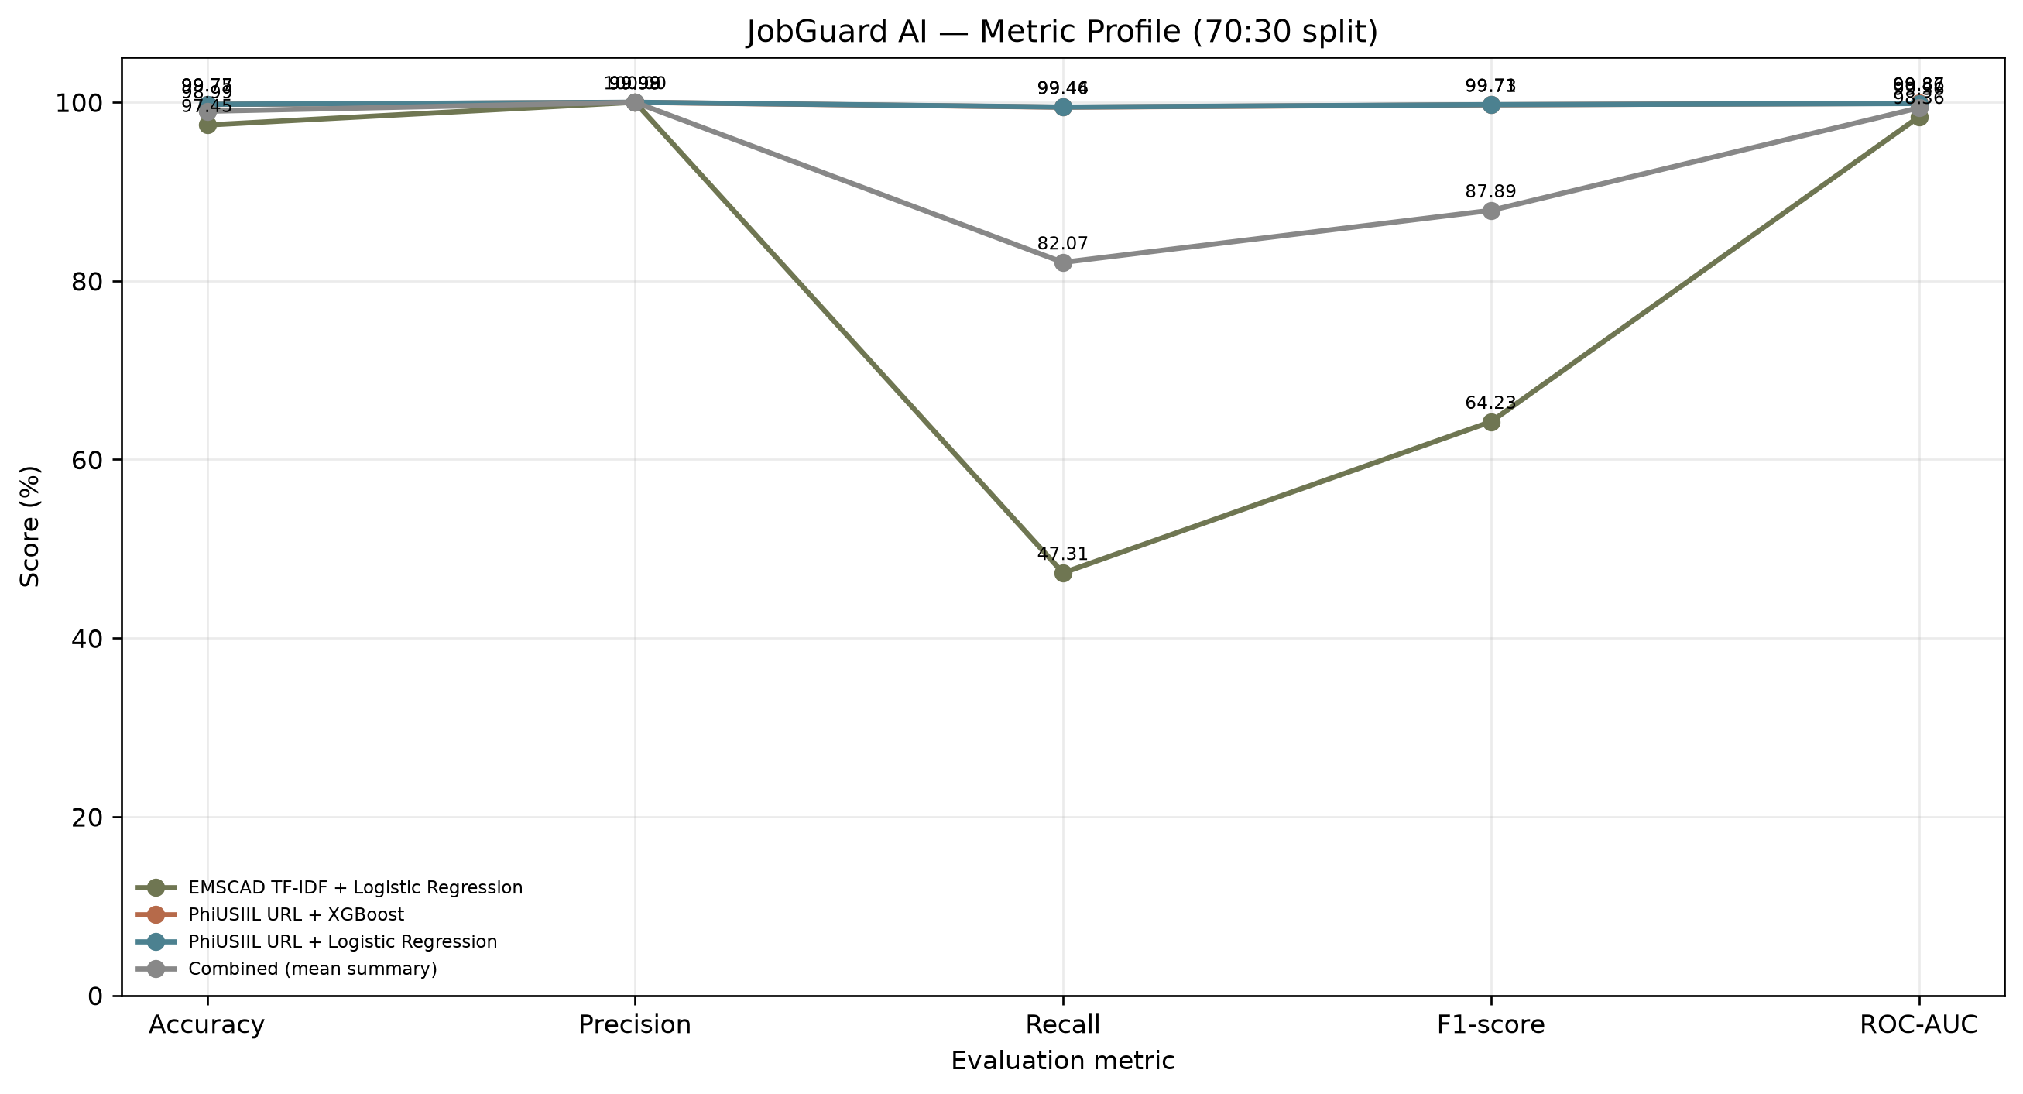
Figure 4. Large box plot of metric scores.
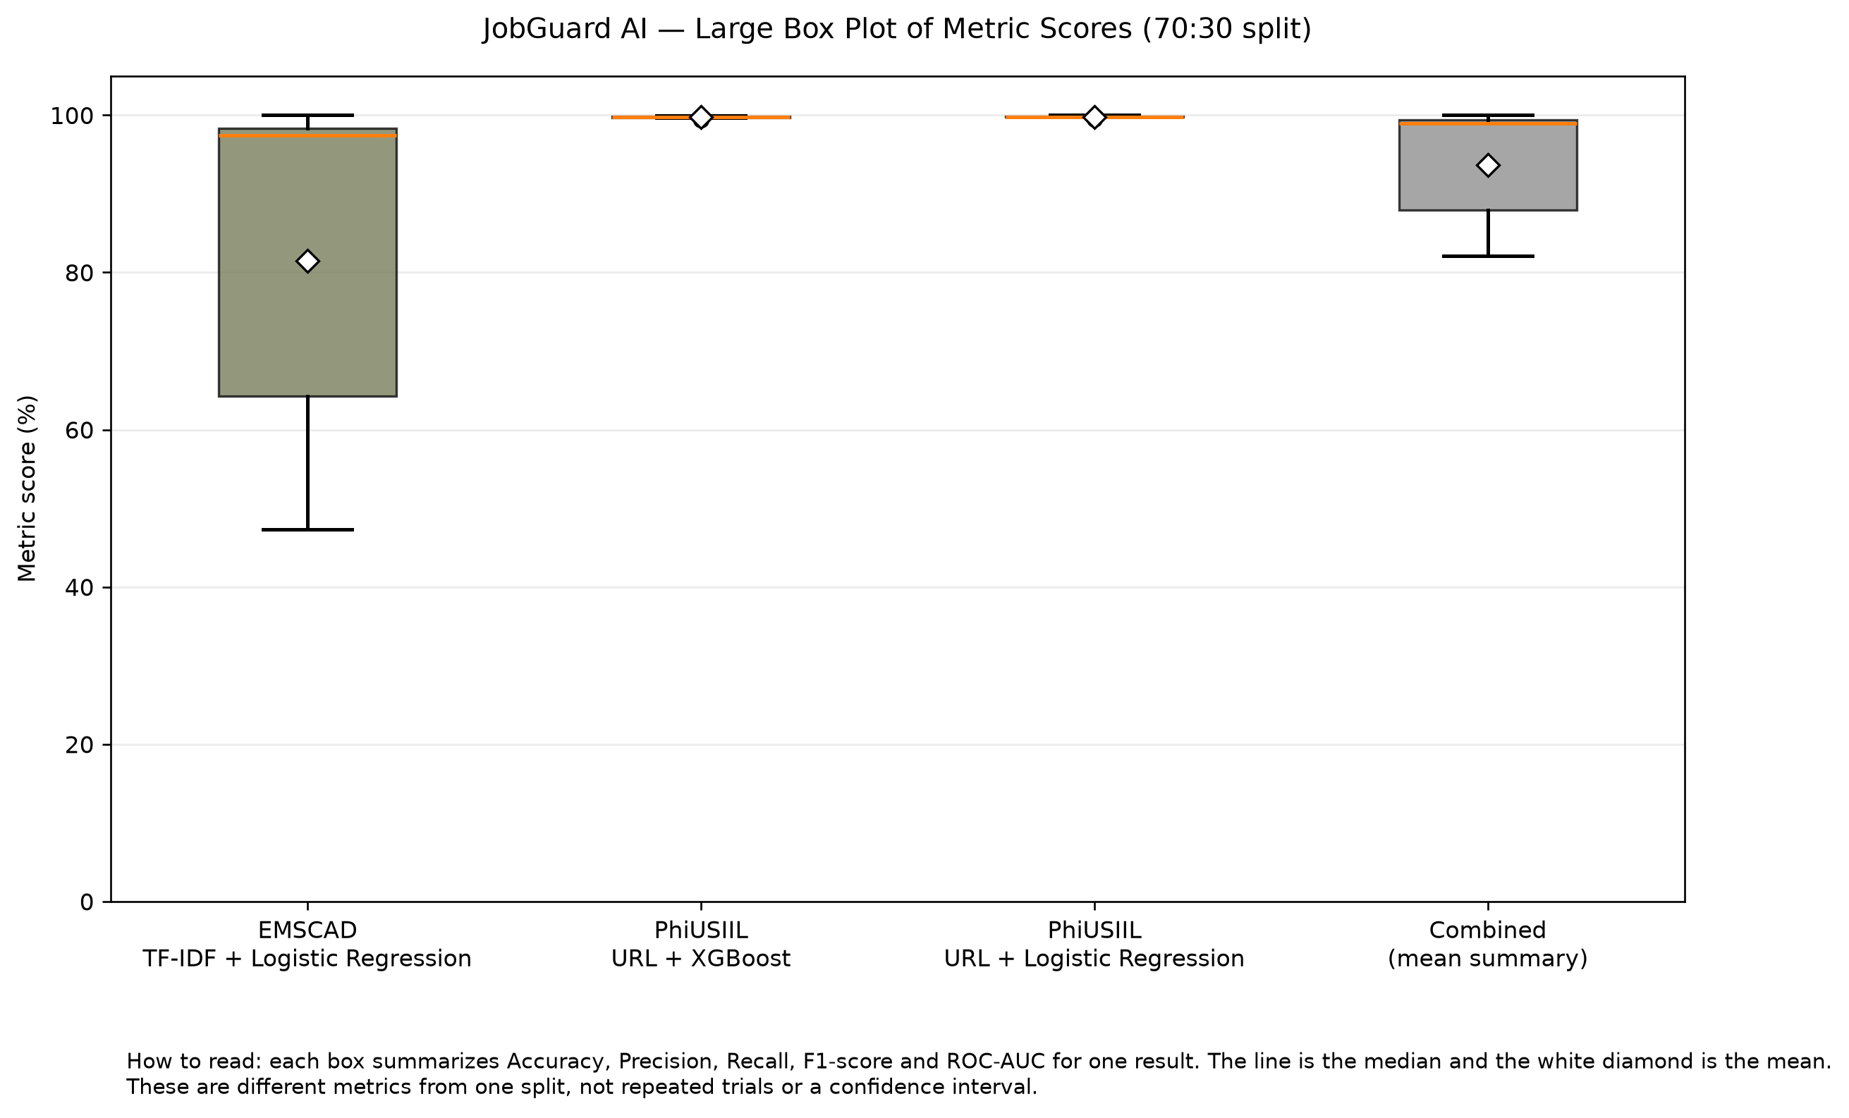

Results interpretation
The EMSCAD pipeline should be assessed particularly by recall because missed fraudulent job postings are a concern. The two PhiUSIIL URL pipelines are compared using the same 18 URL features. The combined row is only a summary of scores across different tasks and should not be interpreted as a third model.

Improvement focus
For EMSCAD, evaluate the decision threshold using validation data, compare class-weighted training, tune TF-IDF settings, and inspect missed fraudulent postings. For PhiUSIIL, verify label mapping and feature definitions and test on newer independent URLs. Re-run evaluation before reporting any improved scores.

