TV Show & Movie Genre Prediction
Machine Learning Model Development Report
Submitted By: Charan Teja
Project Objective:
The objective of this project is to build machine learning models capable of predicting the genre of TV shows and movies using metadata and textual features.
This project demonstrates a complete machine learning workflow including data exploration, preprocessing, feature engineering, model development, evaluation, and explainability.
Problem Statement
The goal of this project is to predict the genre (listed_in column) of TV shows and movies using available metadata such as description, director, cast, country, and release year.
Since the dataset contains multiple genre categories, this problem is defined as a multi-class classification problem.
Two machine learning models were developed and evaluated to determine the most suitable model for this task.
Dataset Overview
The dataset consists of metadata related to TV shows and movies available across platforms.
Key columns included:
- Title
- Director
- Cast
- Country
- Release Year
- Rating
- Description
- Platform
- Listed_in (Genre)
Target Variable:
The target variable used in this project is:
listed_in → Genre of the TV show or movie.
Dataset Characteristics:
- Contains multiple genre categories
- Includes both categorical and textual features
- Requires text processing for feature extraction

Exploratory Data Analysis (EDA)

EDA was conducted to understand the structure and distribution of the dataset.
Key analysis steps:
- Checked dataset shape and column information
- Identified missing values
- Analyzed genre distribution
- Visualized movie vs TV show distribution
- Analyzed release year trends
- Examined class imbalance in target variable
Key Observations:
- Some columns contained missing values which required handling.
- Genre distribution showed class imbalance.
- Majority of content belonged to recent years.
- Certain genres appeared more frequently than others.
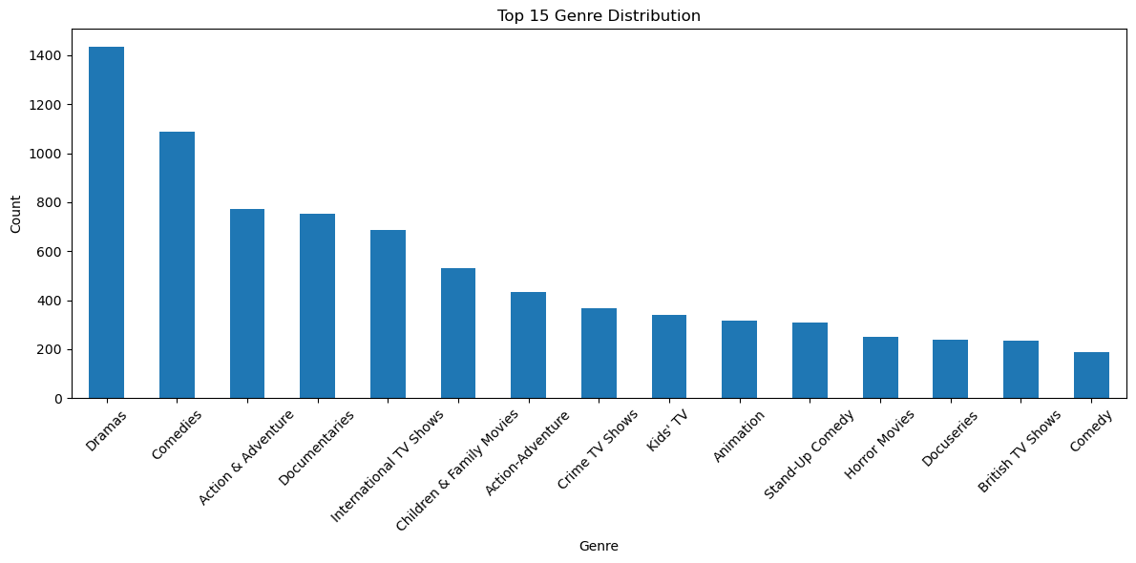
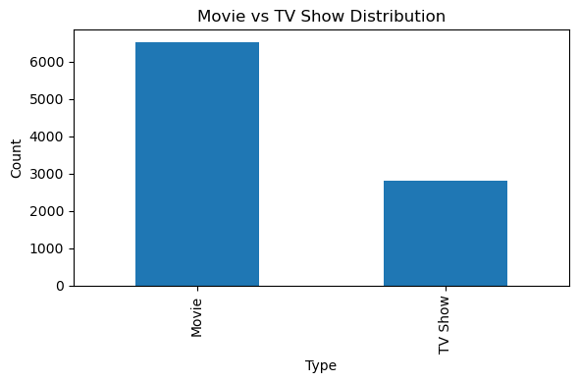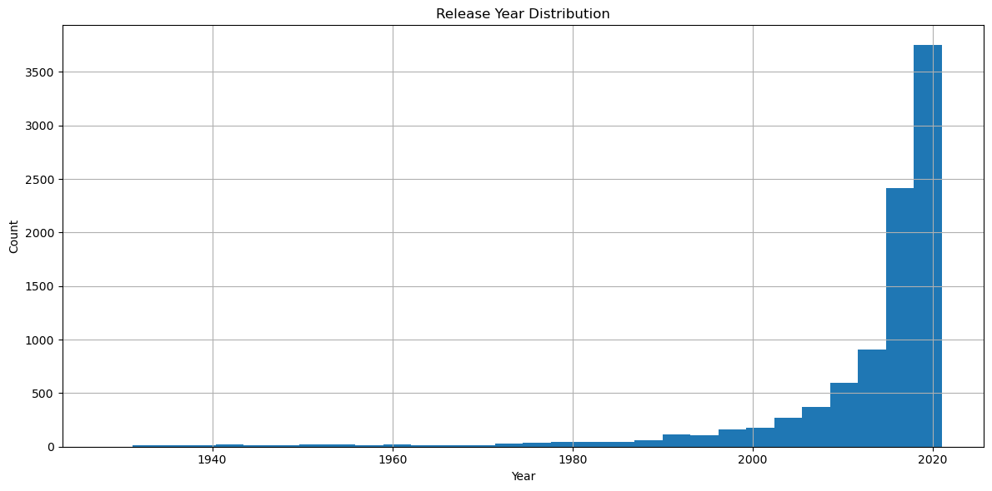
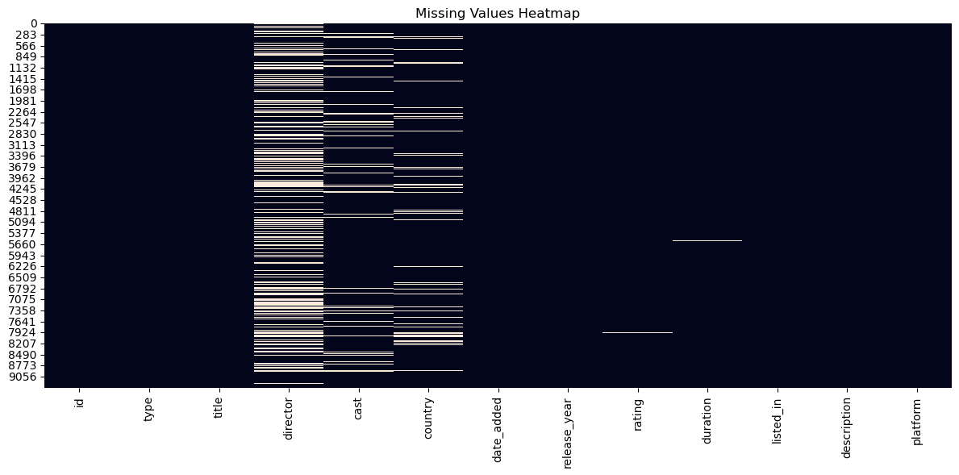

Data Preprocessing
Several preprocessing steps were applied to prepare the dataset for modeling.
Steps performed:
- Handling missing values using mean for numerical columns and mode for categorical columns
- Dropping irrelevant columns
- Combining multiple text columns into a single feature
- Cleaning textual data
- Converting text data into numerical features using TF-IDF vectorization
- Splitting dataset into training and testing sets
TF-IDF Configuration:
- max_features = 8000
- ngram_range = (1,2)
- stop_words = english
These preprocessing steps improved the quality of input data and enhanced model performance.
Feature Engineering
Feature engineering involved transforming raw data into useful input features for machine learning models.
Key feature engineering techniques used:
- Text combination from multiple columns
- TF-IDF vectorization to convert text into numerical format
- Removal of rare words
- Use of bi-grams to capture contextual relationships
These techniques helped improve the model’s ability to capture meaningful information from textual data.

