ORCA-NTN: Secure Self-Healing and Cyber Incident Coordination for
NTN-Backed Networks
Team name | Solar Sailors | Team leader | Charan Velavan
Team member | Yogender Raju | Mentor | Dr. Kaythry P
Contact | charan2520089@ssn.edu.in | GitHub | github.com/CharanVelavan/ORCA
Institution | Sri Sivasubramaniya Nadar College of Engineering (SSN), Chennai, India
- Introduction
Non-terrestrial networks (NTN) carry mobile, payment, hospital, utility and emergency traffic where fibre cannot reach. Terminals, direct-to-device links and integrated gateways are advancing. Cyber security lags: the cited 3GPP study leaves feeder-link and inter-satellite-link security unspecified [14], while India’s space cyber framework is advisory [16].
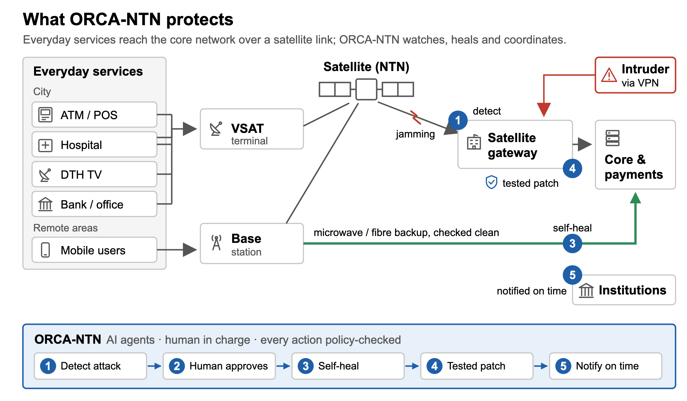
Figure 1. Everyday services over NTN and ORCA-NTN intervention points.
Faults and attacks can look alike but trigger different duties. Fixed failover may select an attacker-controlled backup. Institutions see different evidence and reporting triggers. In KA-SAT (2022), attackers reached the operator’s ground management network through a misconfigured VPN and disabled tens of thousands of terminals [1].
ORCA-NTN (Orchestrated Response and Coordination Agents) provides cyber-aware coordination and secure self-healing for NTN. Models detect causes; institution agents retrieve and explain law; deterministic rules return cited verdicts. Humans approve fixes and policy recommendations. Recovery checks backup integrity; candidate gaps retain evidence. Ten recorded scenarios reached 40 expected verdicts without unapproved execution. All links are emulated. India supplies the rules and gap register; EU, US and UAE sources provide comparisons.
- Description of the use case
Figure 2 maps ORCA-NTN onto Y.3172 [2]. Detect (1–4): per-minute link, rain, battery, login, GNSS and packet-loss observations become 36 features, including a P.838 rain-fade residual [13]. M1–M4 assess them and route scoped alerts. Assess (5–7): institution agents retrieve evidence; YAML rules return six possible cited verdicts. Recover (8–11): owners propose 17 fixed playbooks. Human approval creates a one-use, exact-plan token, valid 15 minutes. Clone and clean-path tests precede 5/25/100% rollout, re-attack checks and automatic rollback on failure. Coordinate (12): agents draft notices and evidence; humans confirm gaps and sign recommendations. A hash-chained trail records actions.
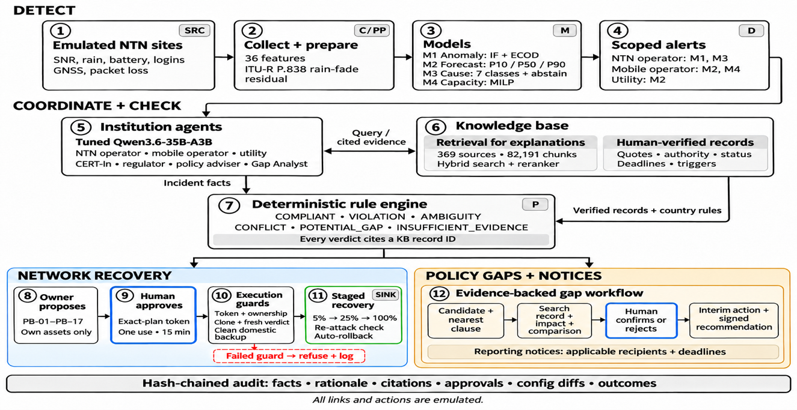
Figure 2. The ORCA-NTN pipeline.
Dashboard. Scenario briefings lead into a shared exercise console: observed sites, model alerts, cited agent explanations, reporting clocks, recovery and audit. A director rail launches emulated conditions and stops future effects. A six-checkpoint judge walkthrough tracks evidence review; recording exports retain public facts and explicit integrity limits. Replay remains read-only.
Hybrid ML and AI agents. ML reads numerical telemetry each minute; LLM agents retrieve clauses, explain model reasons and draft notices. Deterministic rules evaluate policy. M1 learns normal behaviour without attack labels. M3 classifies causes, gives SHAP reasons and abstains when unsure. M2 forecasts with uncertainty; M4 optimises auditable priorities. M1–M3 train on emulator data and face harder held-out tests (Table 1); M2 also uses a daily tier trained on ITU sandbox Turkcell data [3].
Table 1. The four models (held-out test set)
Model | Job | Method | Result
M1 | Flags unusual behaviour at a site | Isolation Forest + ECOD | ECOD AUC 0.988; 1.2% false alarms
M2 | Forecasts minutes left before the link fails | LightGBM P10/P50/P90 + conformal band | 4.3 min error; 92.5% coverage
M3 | Cause: weather, power/equipment, jamming, management plane, GNSS, SS7, or normal | Calibrated LightGBM + SHAP; abstains if unsure | 97.1% accuracy; 1.7% abstain
M4 | Shares scarce backup capacity by priority | MILP (HiGHS), greedy fallback | Emergency calls, hospital fully served
The agents. Each institution has its own view and powers (Table 2). Events wake agents to read alerts, retrieve evidence, evaluate rules and request owner-specific playbooks or notices. Code checks calls and citations. AI explains clauses, deadlines, model reasons and coverage limits. Humans interpret ambiguity, confirm gaps, judge proportionality and sign recommendations; agents cannot assume these powers.
Table 2. What each agent sees, may do and may not do
Agent | Sees | May do | May not do
NTN operator | M1, M3 alerts; logins | Run its playbooks (PB-01–05, 11–14) once approved | Act without a token
Mobile operator | M2, M4 alerts | Failover PB-06, load shedding PB-15, warning PB-10, once approved | Use a foreign gateway
Utility, CERT-In, regulator | M2 alerts; shared facts | Check power risk, reporting and licence duties; draft notices | Run any fix
Policy adviser | Questions from agents | Answer from the knowledge base, with record ids | Answer without a source
Gap Analyst | Alerts, verdicts | Test legal coverage; record gaps with search record; draft recommendations | Confirm a gap
Commander (human) | Everything | Approve or reject each plan | Hand approval to an agent

Why Qwen. Agents use Qwen3.6-35B-A3B, QLoRA-tuned on our tool-use scenarios. Its Apache-2.0 licence enables in-country self-hosting. It delivers 83 tokens/s on one 24 GB L4 and achieved 93% tool-choice accuracy across 300 held-out cases, with no unsafe execution.
Knowledge base and RAG. Three layers hold 369 official sources with authority, legal status and hash; verified quoted records and triggers for the rule engine; and a gap register. Country rules are separate YAML files. Retrieval spans 82,191 clause-level chunks using Qwen3-Embedding-8B vectors, keyword search and reranking. Each chunk retains law and clause path. Named-clause retrieval and abstention support traceability (recall@5 0.70; exact citations 5/5).
Why is it novel, innovative
NTN hardware and software advance fast; NTN cyber security is still being developed.
ORCA-NTN fills that gap:
- Fault vs. Attack: AI distinguishes failures from attacks to trigger appropriate legal responses.
- Live Policy Gap Detection: Identifies regulatory gaps with supporting evidence.
- Secure Self-Healing: Verifies backup safety and data residency before failover.
- Tested Automated Fixes: Validates patches before deployment, with rollback support.
- Law-Driven AI: Rule engine makes legal decisions; LLM only explains and drafts.
- Use case requirement
Setup. A laptop runs Python 3.12, the trained M1–M4 bundle and prebuilt React dashboard. Offline mock mode needs no LLM endpoint. Live AI needs the tuned Qwen endpoint; the recorded deployment uses a 24 GB L4. ChromaDB supports vector retrieval. To see ORCA-NTN in action: pip install -r requirements.txt, then python -m orca.live --scenario S1 --llm mock --port 8060, and open http://127.0.0.1:8060; docs/DEMO.md gives every scenario; README.md gives full setup.
- Mapping with ITU-T Y.3172 Readiness 2.0 Report, and domain-specific policies
Standards mapping e.g. ITU-T Y.3172
Nine selected Readiness 2.0 dimensions [5] map to implemented capabilities: cross-domain evidence (D3), context (D4), human interface (D6), role objectives (D7), AI collaboration (D8), human decisions (D9), policy checks (D10), emergency-service protection (D11) and digital infrastructure (D13). These are capability mappings, not official readiness scores; each recorded run needs its own evidence.
Table 3. Y.3172 nodes, components, AI Readiness 2.0 dimensions [5] and documents
Node | Use case (component and data) | Readiness 2.0 | Documents
SRC | Emulated NTN sites, per-minute KPIs; Turkcell link data | Open data factor | CERT-In Direction (iv), logs [4]
C | One collector per institution; live event injection | D7 strategy; D4 context | IT Act s.70B(4), (6) [7]; CERT-In Directions (ii), (iii) [4]
PP | 36 features, incl. rain-fade residual | D3 cross-domain | ITU-R P.838-3 [13]; DPDP Act [6]
M | M1 to M4; fine-tuned Qwen agents; RAG | D3; D13 infrastructure | 3GPP TR 33.700-29 [14]
P | YAML rules, six cited verdicts, human approval | D10 policy; D6 human interface | CERT-In Dir. (ii) [4]; TCS Rules 7(1) [8]; Telecom Act s.20 [9]; NIS2 Art. 23 [10]
D | Owner routing; hash-chained audit trail | D8 collaboration; D9 humans | ITU-T Y.3172 [2]; IT Act s.70B(4) [7]
SINK | Failover, fixes, warnings, drafted notices | D11 inclusion | CTI Rules 7(1)(j) [11]; Authorisation Rules 60(1)(b) [15]; TDRA emergency calls [12]
- Error scenarios
Scenarios for demo
Table 4. Ten reproducible scenarios; gaps refer to Table 5.
Scenario | Event and response | Question / gap
S0 Normal day | Healthy links; verify duties and domestic routing. | Negative control; covered duties, no invented incident.
S1 Terminals wiped | Detect management intrusion; sequence containment, failover and warnings. | clocks; warning; baseline.
S2 Storm / scarcity | Forecast rain and battery risk; M4 protects emergency and hospital capacity. | priority; battery.
S3 Unsafe backup | Identify jamming; reject unsafe/foreign routes; approve clean domestic path. | link standards; clean path.
N1 Battery cliff | Forecast hospital-corridor battery exhaustion; coordinate recovery and warnings. | battery; warning.
N2 Payments lost | Recover from a routing fault affecting payment terminals and ATMs. | warning.
N3 Feeder weakness | Audit an unprotected link despite healthy traffic; move to protected backup. | link standards; baseline.
N4 Dashboard lies | Cross-check false management metrics against independent traffic; contain and recover. | baseline; clean path; warning; action conflict.
N5 Several clocks | Track telecom/grid reporting triggers; use earliest applicable deadline. | clocks; baseline; warning.
CAP Double crisis | Combine rain, intrusion, battery loss and scarce capacity; coordinate recovery. | All seven confirmed gaps.
Planned dimension coverage is 5/9 for S0, 8/9 for N2 and N3, and 9/9 for the other seven scenarios. S0 excludes D6/D8/D9/D11; N2/N3 exclude D11. Names alone do not prove human impact or inclusion. Qwen reached 40/40 expected verdicts with rules versus 0/40 without; neither comparison arm executed a playbook. Approved recovery is demonstrated separately. Planned coverage is not an observed-run result.
- Policy gaps and standards gaps derived from the mapping exercise
Standards and policy gaps
Agents retrieve clauses and explain coverage limits; humans confirm gaps and sign recommendations. Candidate findings retain a search record, impact analysis, global comparison and interim action. Table 5 summarises seven confirmed findings within the Indian sources checked as of 7 Nov 2026; absence in that search is not proof that no rule exists.
Table 5. Policy and standards gap register, India
Gap | What is missing (evidence) | Interim action | Ask, and to whom
Clocks | Up to four reports to three bodies, three triggers (noticing, awareness, occurrence) [4], [8], [11] | File at the earliest deadline | DoT, CERT-In, TRAI: one trigger, one portal
Warning | No duty for an NTN operator to warn dependent services; NIS2 Art. 23 has one [10] | PB-10 warning (Authz Rule 37(5) [15]) | DoT, CERT-In: warning duty with deadline
Priority | DoT SOP names priority callers, but no ranking for scarce backup capacity | PB-06, emergency calls first | DoT, TRAI: standing priority list
Battery | “Sufficient” backup power, no minimum hours; grid nodes need 10 h (CEA) | PB-15: shed non-critical load | DoT, TRAI: minimum hours
Links | Feeder and inter-satellite links “not specified” [14]; no s.19 standard [9] | Flag links with no security standard | DoT, TEC, 3GPP, SG17: link standard
Clean path | No rule requires a clean-path check before failover | PB-06 clean-path check | DoT, TEC, SG17: make it a precondition
Baseline | NTN cyber framework is advisory [16]; no auditable baseline | Flag missing controls | DoT, CERT-In: binding core controls
Standards gaps and global comparison. A standard machine-readable policy-rule format was not found in the sources checked; ORCA uses YAML. NIS2 provides 24-hour/72-hour reports [10]; UAE TDRA prioritises emergency calls at interconnection [12]. Nineteen EU, US, California, UAE and ITU examples support the seven confirmed gap records (kb/gaps/COVERAGE.md).
REFERENCES
1. Viasat Inc. (2022), ‘KA-SAT network cyber attack overview’, 30 March.
2. ITU-T (2019), ‘Architectural framework for machine learning in future networks including IMT-2020’, Rec. Y.3172.
3. Turkcell (2021), ‘Radio-link failure prediction dataset’, ITU AI/ML in 5G Challenge.
4. CERT-In (2022), Directions under section 70B(6) of the IT Act, 2000, No. 20(3)/2022-CERT-In, 28 April.
5. ITU (2026), ‘AI ready: analysis towards a standardized readiness framework, version 2.0’, January.
6. Government of India (2025), DPDP Act, 2023 and DPDP Rules, 2025, Gazette of India, 13 November.
7. Government of India (2000), The Information Technology Act, 2000, Act No. 21 of 2000.
8. DoT (2024), Telecommunications (Telecom Cyber Security) Rules, 2024, G.S.R. 720(E), 21 November.
9. Government of India (2023), The Telecommunications Act, 2023, Act No. 44 of 2023.
10. European Parliament and Council (2022), Directive (EU) 2022/2555 (NIS2), OJ L 333, 27 December.
11. DoT (2024), Telecommunications (Critical Telecommunication Infrastructure) Rules, 2024, 22 November.
12. TDRA (2006), ‘Interconnection instructions’, Version 1.2, Abu Dhabi, UAE.
13. ITU-R (2005), ‘Specific attenuation model for rain for use in prediction methods’, Rec. P.838-3.
14. 3GPP (2025), TR 33.700-29 V19.1.0, ‘Study on security aspects of 5G satellite access; Phase 3’, Release 19, July.
15. DoT (2026), Telecommunications (Authorisation for Provision of Principal Telecommunication Services) Rules, 2026.
16. CERT-In and SIA-India (2026), Cyber Security Framework and Guidelines for Space; PIB release 2233122, 26 Feb.

