Software Requirements Specification

for

PAYS – Professionals at your service

Version 1.0

Prepared by

Group #: 8 Group Name: *Techfanatics*

|  |  |  |
| --- | --- | --- |
| Name | Roll number | Email |
|  |  |  |
| Chitte Charan Kumar Reddy  Jaya Siva Shankar  Akshay Narayan O  O Deeven Kumar  Manjusree Nayak  N.Hema Sai  Mourya Reddy N.  Chetan  P.Lokesh Nayak  Sai Sreeja  Aryan Thada | 210293  210707  210097  210681  210587  210650  210662  210281  210710  210168  210205 | ccreddy21@iitk.ac.in  jssp21@iitk.ac.in  akshayn21@iitk.ac.in  deevenk21@iitk.ac.in  manjusree21@iitk.ac.in  nhemasai21@iitk.ac.in  mourya21@iitk.ac.in  chetan21@iitk.ac.in  lokeshn21@iitk.ac.in  saisreeja21@iitk.ac.in  aryant21@iitk.ac.in |

|  |  |
| --- | --- |
| Course: | CS253 – Software Development and Operations |
| Mentor TA: | Archi |
| Date: | 27/01/23 |

Content

Contents ii

Revisions ii

1 Introduction 1

1.1 Product Scope 1

1.2 Intended Audience and Document Overview 1

1.3 Definitions, Acronyms and Abbreviations 1

1.4 Document Conventions 1

1.5 References and Acknowledgments 2

2 Overall Description 2

2.1 Product Overview 2

2.2 Product Functionality 3

2.3 Design and Implementation Constraints.............................................................................3

2.4 Assumptions and Dependencies 3

3 Specific Requirements 4

3.1 External Interface Requirements 4

3.2 Functional Requirements 4

3.3 Use Case Model 5

4 Other Non-functional Requirements 6

4.1 Performance Requirements 6

4.2 Safety and Security Requirements 6

4.3 Software Quality Attributes................................................................................................6

5 Other Requirements 7

Appendix A – Data Dictionary..........................................................................................................8

Appendix B - Group Log 9

Revisions

| Version | Primary Author(s) | Description of Version | Date Completed |
| --- | --- | --- | --- |
| 1.0 | Chitte Charan Kumar Reddy  Jaya Siva Shankar  Akshay Narayan O  O.Deeven Kumar  Manjusree Nayak  N.Hema Sai  Mourya Reddy.N  Chetan  P.Lokesh Nayak  Sai Sreeja  Aryan Thada | First draft | 27/01/23 |

# 

# Introduction

## 1.1. Product Scope

“PAYS - professionals at your service” is the one-stop destination for hiring professionals across various domains like programming and tech, graphic and design, CAD modelling, photoshop, translation, music and audio editing at IITK. The idea for “PAYS” was born when we saw many students and sometimes even clubs and societies facing problems while editing their website, designing their logo or while making posters, CAD models or in designing Arduino circuits, etc. For this very reason this platform will bridge the gap between people who have talent to the people who are need it. This application is beneficial for both the clients and the professionals providing two different profiles. The clients get a high-quality and cost-effective solution for their needs from professionals, whereas it helps students as professionals to earn and improve their skills. Overall, creating freelancing projects for students can be a valuable learning experience that can help them to develop a wide range of skills, both technical and soft skills, that will be useful in their future careers

**The main goals of the project are as follows:**

* To connect professionals with clients who need their services.
* To provide the professionals a platform to hone their skills and display them for various feedback.
* To provide students the opportunity to build a professional portfolio of work that they can showcase to potential employers.
* For students, this project should provide an opportunity to earn income along with their studies.
* To provide a platform for professionals and clients to communicate effectively and share project-related information.
* To provide a secure payment system to ensure that professionals get paid for their work and clients can pay for services easily.
* To provide a reputation system in place that allows clients to rate and review professionals based on their performance.

## 1.2. Intended Audience and Document Overview

Intended Audience

The document is intended for project stakeholders (users, project managers, and system end-users) to understand the functionality and features of the software and how it will meet their needs. This is also intended for software developers, as they will get an overview of the project and get to know all the functional and non-functional requirements. At the time of testing of the software, the testers will also read this and understand how the software works and under what constraints.

Sections and Organisation

The SRS starts by giving an overview of the project and it’s benefits to users. It then covers the overall description of the software (design and how the software will function) and then moves on to describe the specific requirements of the software which includes its interface and functional requirements and then some use cases are provided so that the user can understand. It ends up by stating some of the non-functional requirements of the software.

Sequence for Readers

* Project Stakeholders can just focus on the product scope (1.1), document overview (1.2) in Introduction Section, product overview (2.1) and product functionality (2.2) in Overall Description Section and then can focus on Specific Requirements Section.
* A Software Developer can just briefly glance the overview and then can directly focus on Functional and Non-Functional Requirements Section.

## 1.3. Definitions, Acronyms and Abbreviations

**PAYS:** Professionals at your service. It is the name of the project.

**Users:** The students who are using the website (both clients and professionals).

**Professionals:** The students of IITK who are qualified in specific skills.

**Clients:** The students of IITK who seek for professionals for their work to be done.

**Post:** A section where clients can post their work description and can tag a particular professional and the professional can accept the works of clients if they want to do the work.

**Agreement:** Proof of acceptance between Client and Professionals.

**Tags:** To mention the recipient of the post.

## 1.4. Document Conventions

**Formatting Conventions:**

* This document is written with Arial font of size 11 in black colour.
* Headings were written with Arial Bold font of size 18 in white colour with a grey background.
* Sections were written with Arial Bold font of size 14 in black colour.
* Subsections were written with Arial Bold of size 12 in black colour.
* Sub subsection headings were written with Arial Bold of size 11 in black colour.
* Bullet point ordering was used as a listing typesetting tool.

**Naming Conventions:**

● Use Case Models named as U#.

● Functional Requirements named as F#.

## 1.5. References and Acknowledgments

For the UML diagrams we took help from Creately:

<https://creately.com/?gclid=Cj0KCQiAic6eBhCoARIsANlox865dmtXonjjKwQ7Rf1469YW2qtFXNESuu5xkZbIybONJuNJflqUlBkaAr0HEALw_wcB>

For the other diagram we used Canva:

<https://www.canva.com/>

We'd also want to thank our TA, Ms. Archi, for her invaluable assistance in the development of this document. We'd also want to thank Prof. Indranil Saha for providing the SRS template and teaching us about software development.

# Overall Description

## 2.1. Product Overview

“Pays” is a web application that provides students of the campus to find other skilled students to get a high-quality and cost-effective work done. This application is implemented by Model-view control model.

The system environment looks like this:

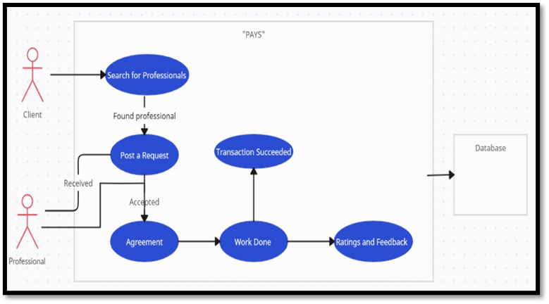

## 2.2. Product Functionality

* This product shall allow every student to sign up via IITK email id as a professional or a client and create a username and password.
* An agreement section where both client and professional agree to work together with some conditions and the previous work agreements of both clients and professionals are displayed in their respective accounts.

**The product shall have the following functionality for the client:**

* A profile where client shall update basic personal information.
* A search bar to search a specific skilled professional for the project which the client opts for.
* A post section where clients can send their project description and request a professional.
* A 5-star rating system, where client can rate the work of professional after the work is done.

**The product shall have the following functionality for the professional:**

* The professional shall create an account and shall fill the details (like skills, experience, education) in his profile.
* He shall give his IITK email id, so that client would be able to contact him.
* A post section where notifications pop up showing collab requests from the clients.
* He shall specify the price and time required for him to do the project of a particular skill in the agreement.
* He should upload the project images (only if the client agrees) to his profile.
* A 5-star rating system helps the professional to be recognised by other users.

## 2.3. Design and Implementation Constraints

* We need a computer/mobile and internet connection for this application to build and execute.
* We need an internet browser like Google, Brave, Mozilla Firefox etc. and an operating system that runs on 64-bit architecture for this application and dependencies to run smoothly.
* The software shall use English language only.

## 2.4. Assumptions and Dependencies

* We assume that the IITK authorities will provide with the student database.
* We are designing this application keeping in mind that everyone will be using the latest version of web browsers. It’s possible that the user interface is ineffective if they are using some older version of web browser.
* We rely on IITK email services for a user to sign up, so they need to be working at times.
* The backend services will be hosted on AWS and the frontend services will be hosted on AWS. Hence, they should be working for smooth conduct of the application.
* The same is also true for database.

# Specific Requirements

## 3.1. External Interface Requirements

### 3.1.1. User Interfaces

**LOGIN PAGE**

The users shall create an account by filling their IITK email ID and set a username and password in appropriate text fields and specify whether the user shall be client or professional. They shall login into the website using these credentials.

**HOME PAGE**

The Homepage contains a search bar and a dashboard. It displays some of the popular skills that the website work on. Skills are broadly categorised as follows:

* Programming and Technology
  + Web development
  + Coding languages
  + Game development etc.
* Graphic and Design
  + Poster making
  + Custom merchandise
  + Logo design etc.
* CAD Modelling
* Arduino
* Photoshop
* Career Guidance
* Writing and Translation
* Music and Audio
* Room Makeover

When user select one of these categories, professionals are displayed in the descending order of their ratings.

**SEARCH BAR**

Search bar helps users to search a particular professional by their username or by a particular skill. There will also be a filter option to search professionals according to their ratings, time taken to do the project etc.

**DASHBOARD**

In the homepage you will find a dashboard menu at the top left corner showing profile, post, agreement, logout options which mainly describe and assist the users.

**PROFILE**

After creating the account, user shall update his profile. If he chooses to be a professional, he shall select the skills which he knows. He should update his past experiences in that field. He shall add his IITK email ID for the communication with the client.

The professional profile shall include his rating, client count and project history which has been completed on the website.

**POST**

The posts section contains two sub sections “sent” and “inbox”. In the sent section, the client can post the brief description of the project and send it to a particular professional by tagging them. If the professional is willing to take-up the project, he shall accept else he could reject. This message pops up in the inbox. The further communication between client and professional is done via IITK email.

**AGREEMENT**

In agreement section, there will be two sub sections form and history. When both client and professional agree to work on the project, they shall fill the form in which specify the basic details of the project, time required for the professional and cost. This form will be seen in this section till the work is done. Both professional and client tick the “work is done” checkbox to confirm that the work is done and then the agreement will be transferred to history section. History section contains all the past agreements of the user.

**LOGOUT**

Logout allows user to logout from the account at any time.

Website homepage:

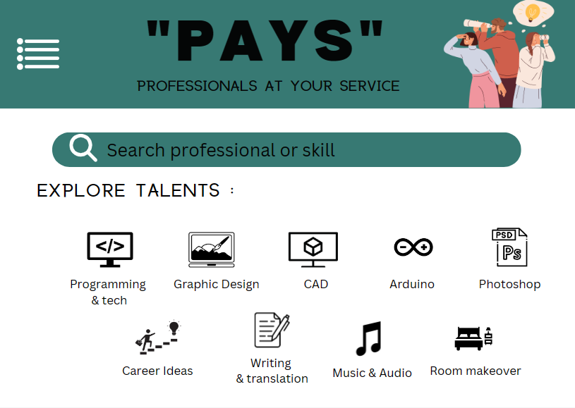

Profile of the professional:

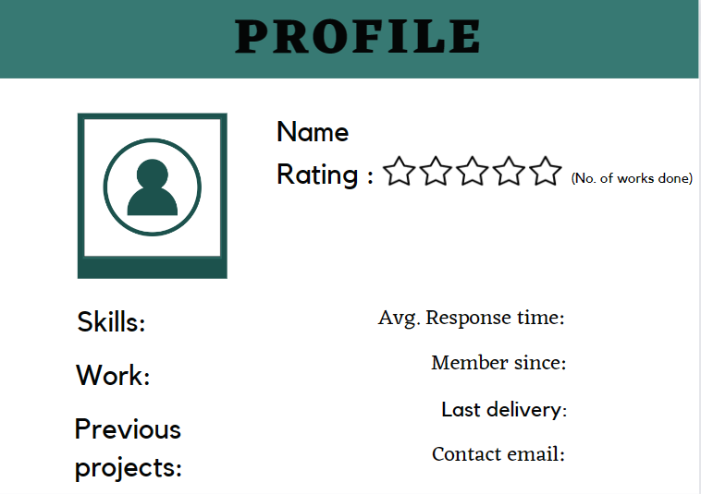

Login page:

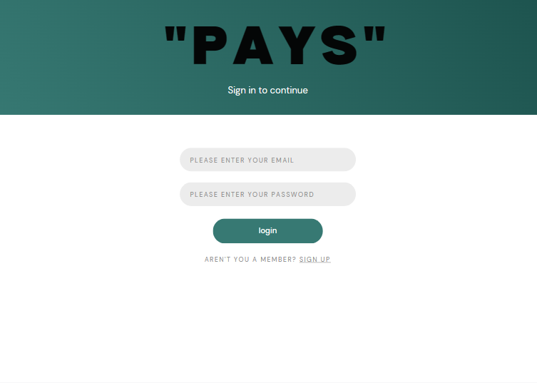

### 3.1.2. Hardware Interfaces

Since the application must run over the internet, all the hardware required to connect to the internet will be the hardware interfaces for the system. As for e.g. Modem, WAN – LAN, Ethernet Cross-Cable.

We have chosen the IIT Kanpur servers to host our WebApp Service.

### 3.1.3. Software Interfaces

**Database Service:**

To save the information of users, we have planned to use mySQL.

## 3.2. Functional Requirements

**F1: Configuring User**

**Login:**  
 The user shall enter a valid IITK email ID/username and password to login. The system will be able to recognize an invalid IITK email ID/username and pop an error message if the password is incorrect. The user will be able to access the “forgot password” option.

**Register:**

The user shall be able to register with IITK email ID and create a username and password.

**F2: Notification**

* After registration OTP will be sent to their IITK email ID.
* If the user uses the “forgot password” option, then OTP shall be sent to their IITK email ID.

**F3: Profiles and Experience**

* The user shall be able to keep a username for their profile. The user shall be able to mention their skills in their profile.
* The user shall be able to mention their previous projects in their profile.
* The system will update their ratings and the count which include the number of projects they did.

**F4: Finding professionals**

* The user shall be able to search for professionals by either choosing the work field they need from home page or search it in the search bar and filter it.
* The user shall be able to find a desired professional by seeing the time slot and other relevant information in their profile page.

**F5: Requests and Feedbacks**

* The user shall be able to send a work request to their desired professional.
* The user shall be able to explain the brief description of work project, deadlines in their Posts and other relevant information in their emails.
* The user shall be able to give the rating and feedback about the project. Other users shall be able to like/support these feedbacks.

**F6: Agreement**

* After having conversation in their IITK emails, they will do official agreement about the deadlines and payment.
* After completion of work, they shall tick the “work is done” checkbox. Further that agreement will be stored in history.

## 3.3. Use Case Model

## 3.3.1. U1: User Configuration

**Author**- Manjusree Nayak

**Purpose**- To show how the professional/client will sign up & log in

**Requirements Traceability-** F1

**Priority-** High

**Preconditions-**The user puts their IITK email Id, username, password and choose from professional or client.

**Post Conditions-**The settings to profile page or the home page of the “PAYS” will appear.

**Actors-** Any user, Database

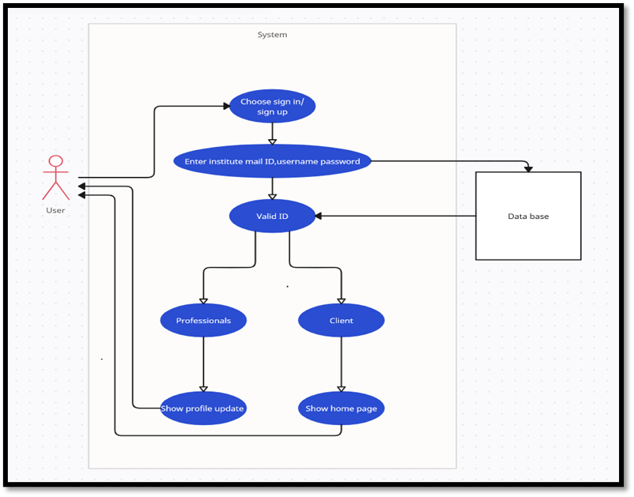

**3.3.2. U2: Updating Profile**

**Author**- Manjusree Nayak

**Purpose-** To show the previous work projects of the professional along with their ratings.

**Requirements Traceability**- F3

**Priority**- High

**Preconditions**-The user needs to of the professional profile.

**Postconditions**- The website and database get updated with the professional information

**Actors-** Professional, Database

Notes/Issues-

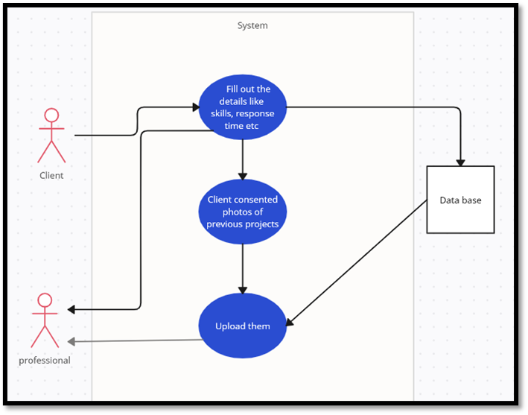

**3.3.3. U3: Finding the Professional for a Project**

**Author-** Manjusree Nayak

**Purpose**- Demonstrate how the clients will find their required professional.

**Requirements Traceability-** F4

**Priority-** High

**Preconditions-**The user needs to of the client profile and will either choose the work field they need from the home page or search it in the search bar.

**Postconditions**-A bunch of professional's profiles of the desired field with their ratings will be shown.

**Actors-** Client, Database

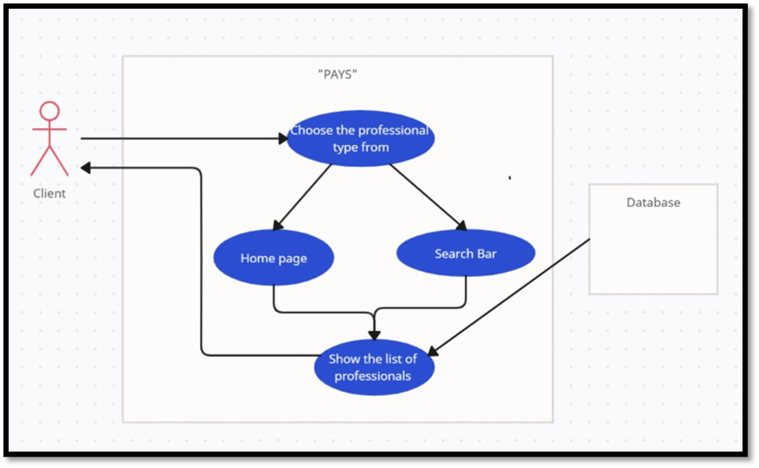

**3.3.4. U4: Making a send request in Post**

**Author**- Manjusree Nayak

**Purpose**- Enables the client to send a work request to their desired professional.

**Requirements Traceability-** F5

**Priority**- High

**Preconditions**- The client will have to give a brief description of the work project, any deadlines and any other relevant information.

**Postconditions**- The request will be sent to the professional.

**Actors**- Clients, Professionals

**Notes/Issues-**

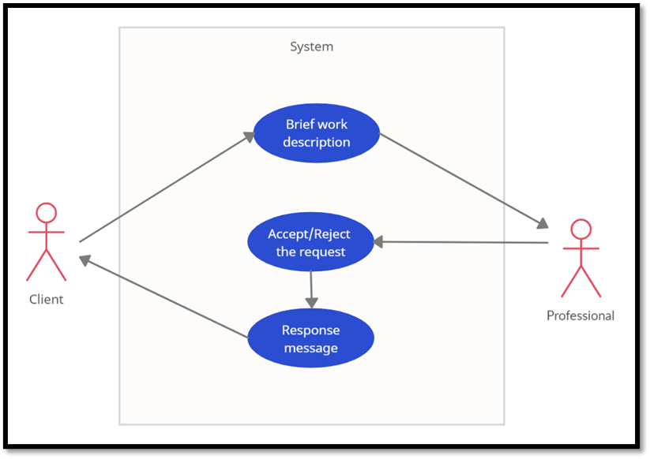

**3.3.5. U5: Agreement form**

**Author-** Manjusree Nayak

**Purpose**- Demonstrate how the clients can sign an agreement for their work with the professional.

**Requirements Traceability-** F6

**Priority-** Medium

**Preconditions-**The user needs to of the client profile and will need to fill in the agreement form with all the necessary details, tag the professional and send it.

**Postconditions**- The professional and client accept the agreement and do the work then the transaction details will be shown.

**Actors-** Client, Database

Notes/Issues-

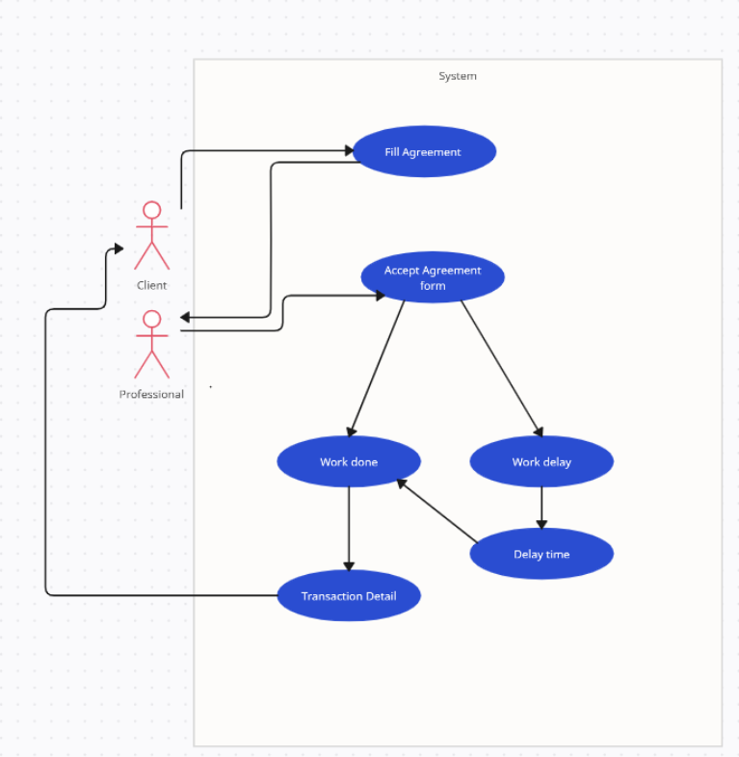

**3.3.6. U6: Filter Search**

**Author-** Manjusree Nayak

**Purpose**- To demonstrate how clients can filter their search.

**Requirements Traceability-** F4

**Priority-** Medium

**Preconditions-**The client needs to search the work field they want to choose a professional from and choose the filter option.

**Postconditions**- The client will be able to filter their search using with options like no. of stars, experience years etc.

**Actors-** Client, Database

Notes/Issues-

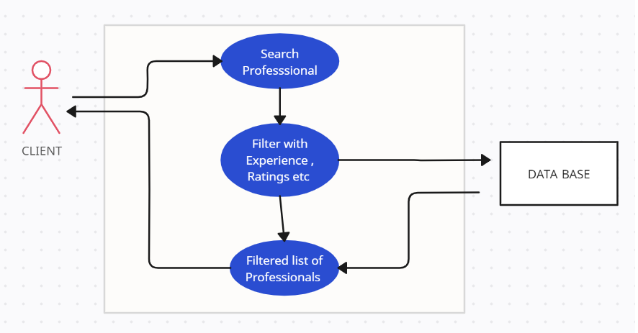

**3.3.7. U7. Feedback**

**Author-** Manjusree Nayak

**Purpose**- To show the feedback system of the platform.

**Requirements Traceability-** F5

**Priority-** Low

**Preconditions-**Along with the 5-star rating system the client can now write a review of the

product they received.

**Postconditions**- The reviews will be public, and it will be added to database.

**Actors-** Client, Database, Professional

Notes/Issues-

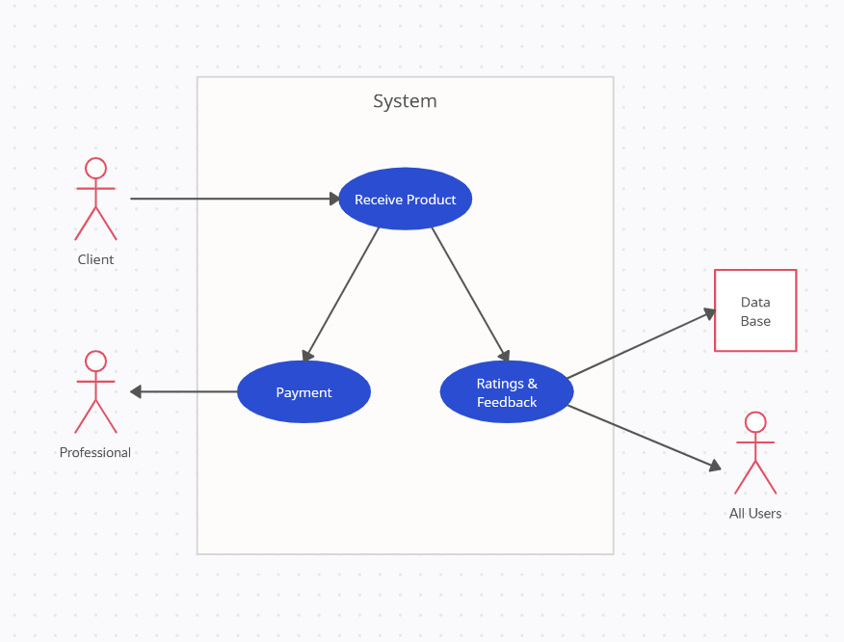

# Other Non-functional Requirements

## Performance Requirements

* Response time: How quickly a website loads a page or do a required professional search. To provide good user experience the response time should be between 200ms to 1 second.
* Load testing and Throughput: Website should be able to handle large number of simultaneous requests without experiencing slowdown or downtime. Also, Uptime should be close to 100 percent.
* Errors: Error rate should be close to null, there should not be any mismatched links, names images or information.

## Safety and Security Requirements

* To guarantee the reliability of users an authentication should be done, so users must register a login account with safe password.
* The IITK Email ID used for login purposes should not be shared in any form without the consent of user. It also applies for personal user data such as phone number, location, payment details etc.
* Privacy is one of the most important factors. The project given by client to professional should be kept confidential. As well as all the chats and payment history that took place through the application.
* The chats and payment history should not be altered or manipulated in any way. Also, the information related to users shouldn’t be affected.

## 4.3. Software Quality Attributes

* Consumable: A user friendly interface so that software user should find it easy to learn and use even if they are utilising for the first time.
* Availability: The services of software can be used by anyone with proper login id and password.
* Maintainability and Testability: The software should be thoroughly tested on a regular basis to guarantee that major bugs are removed as soon as possible.
* Scalability: The software should be able to accommodate more users like new startups which want to hire interns, also like including students from other colleges also. It should be in such a way that it can be scalable both the ways.

# Other Requirements

* We need database of IITK students.
* A chatbot will be added later if time permits.
* A payment gateway will be added later if time permits.

Appendix A – Data Dictionary

* **User Class**

|  |  |
| --- | --- |
| **Element name** | **User** |
| **Description** | The user of the software. Each user registers using an email and a password which is later used to login into their account. |
| **Attributes** | * username * Email id * Password |
| **Operations** | * Registration of a user using the software for the first time. * Used to called while user wants to login |
| **Role** | Each user has an account corresponding to given email id. One can be professional or a client. |

* **Client Class**

|  |  |
| --- | --- |
| **Element name** | **User** |
| **Description** | The students of IITK who seek for professionals for their work to be done. |
| **Attributes** | * Profile |
| **Operations** | * Proposing the project * Searching the professional * Giving the feedback |
| **Role** | These will propose the projects and seek for professional for working for their projects. |

* **Professional class**

|  |  |
| --- | --- |
| **Element name** | **User** |
| **Description** | The students of IITK who are qualified in specific skills. |
| **Attributes** | * Profile |
| **Operations** | * Search for the project * Searching for the professionals * Updating profile |
| **Role** | These will do the projects assigned by the Clients. |

* **Profile class**

|  |  |
| --- | --- |
| **Element name** | **User** |
| **Description** | This is the user’s account information |
| **Attributes** | Username  Skills and Experience  Previous Projects  Ratings  Number of projects completed |
| **Operations** | Updating the profile |
| **Relationships** | Each user will have one profile  uniquely identified by email-ID and  contains all the information about the  user |

* **Proposal Class**

|  |  |
| --- | --- |
| **Element name** | **Proposal** |
| **Description** | This is the formal communication between the professional and the client |
| **Attributes** | * Title * Description * Budget * Delivery Date * Attachments |
| **Operations** | Submit the proposal, view the proposal and accept the proposal |

* **Payment Class**

|  |  |
| --- | --- |
| **Element Name** | **Payment** |
| **Description** | This will contain details of the payment to the client |
| **Attributes** | * Name * Amount * Payment Method * Account details * Payment Id |
| **Operations** | Making and accepting the payment |

* **Review Class**

|  |  |
| --- | --- |
| **Element Name** | **Review** |
| **Description** | This will contain the feedback a client gives to his professional |
| **Attributes** | * Title * Description * Rating |
| **Operations** | Write the reviews and view reviews |

Appendix B - Group Log

<Please include here all the minutes from your group meetings, your group activities, and any other relevant information that will assist in determining the effort put forth to produce this document>

|  |  |  |
| --- | --- | --- |
| **S no.** | **DATE** | **WORK** |
| 1 | 06-01-23 | Discussed many project ideas and shortlisted a few. |
| 2 | 11-01-23 | Had an offline meeting with teammates and finalized our project. |
| 3 | 17-01-23 | Had an offline meet with TA and had discussion on project requirements. |
| 4 | 18-01-23 | Group meeting to divide work and discuss about the project. |
| 5 | 21-01-23 | Finished some parts of sections 1, 2 in SRS document. |
| 6 | 22-01-23 | Meet was conducted in online and finished sections 1, 2 and 3.1 in SRS document. |
| 7 | 23-01-23 | Finished section 4. |
| 8 | 24-01-23 | Updated few user cases in section 3.3. |
| 9 | 26-01-23 | Had a meet with TA and discussed about errors in the document. |
| 10 | 27-01-23 | Made changes suggested by TA. Final Software Requirement Specifications Document made. |