Assignment

TICT3113(P)

2019/ICTS/148

Charani Kaushalya

**Find String Length**

*AREA length, CODE, READONLY*

*LDR R1, =data ;load data's location address to R1*

*MOV R0,#0 ;R0 is used to count length*

*loop*

*LDRB R2,[R1],#1 ;Load Register Byte used for R1 value add to R2 after increment*

*CMP R2,#0 ;compare R2 value with 0*

*BEQ here ;if R2 ==0 then loop will stoped*

*ADD R0,R0,#1*

*B loop*

*endloop*

*here B here*

*data DCB "Charani",0*

*END*

**Answer Register *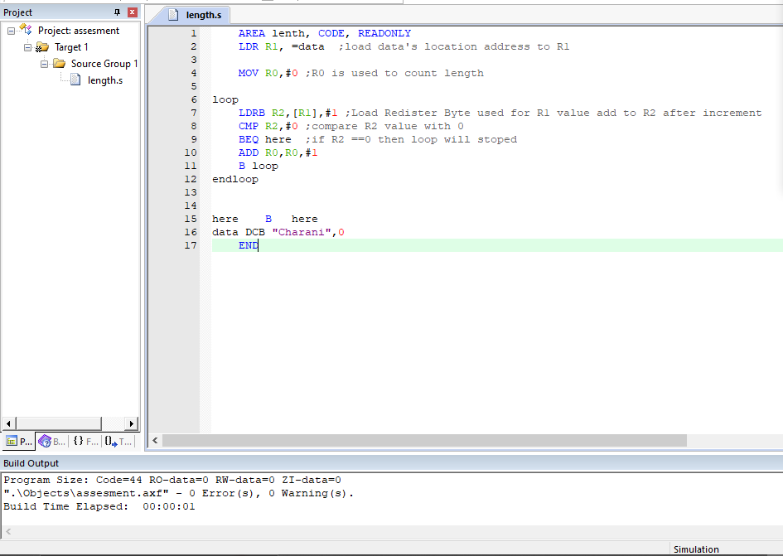***

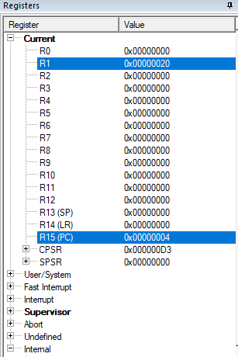

**Find Count Odd Numbers**