

MODERNISING SUPPLY CHAIN ANALYTICS WITH DEMAND FORECASTING ENGINE

Abstract- In todays’ changing market landscape precise demand prediction plays a role, in optimizing supply chain operations reducing inventory expenses and improving customer satisfaction. While traditional forecasting methods have their merits they often struggle to cope with the complexities and changing dynamics of consumer behaviour and market trends. The article is a case study of one of the leading automotive spare parts manufacturers with thousands of products. The main aim of the study is to forecast the demand of the factory on bi-weekly basis and monthly basis, compare the performance metrics with different forecast approaches and suggest suitable model.
Keywords- Demand forecasting, supply chain operations, inventory expenses, traditional forecasting methods, market trends, machine learning techniques.
Chapter 1: Introduction
Supply chain management talks about a network of organizations or a network of facilities, which begins with the procurement of raw material and then transforming this raw material into products and then distributing these products till it reaches the end customer. So, supply chain management talks about the supplier, the manufacturing, the distribution with respect to warehouse, dealers or distributors and retailers. So, supply chain management also is a large complex system and the success of supply chain management systems are around the ability to use information technology and communication to the advantage of the organization. Oliver and Webber (1982) defined “Supply chain management (SCM) is the process of planning, implementing, and controlling the operations of the supply chain with the purpose to satisfy customer requirements as efficiently as possible.
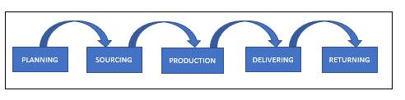
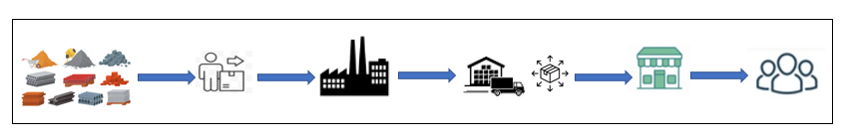
Fig.1. Pillars of Supply Chain Management

a) Raw materials b) Suppliers c) Production d) Distribution e) Retail f) End - user
Fig.2. Stages involved in Supply Chain Management
Production planning is a process of preparing and planning for manufacturing. A production plan outlines all the steps and methods to ensure the produced goods are manufactured efficiently, on time, and within budget. Production planning creates an efficient process for production according to customer and organizational needs. Production planning is closely associated to customer behaviour, going back to early days of modern society, people had a limited space to choose an item and that time they were satisfied with the available options for the variety of reasons. Over the time economic standards of the people improved, that leads to search towards more options in the market and the globalisation opens the door for more players enter in to markets so Customer are not only looking for verity of products also towards affordability, quality and on time delivery.
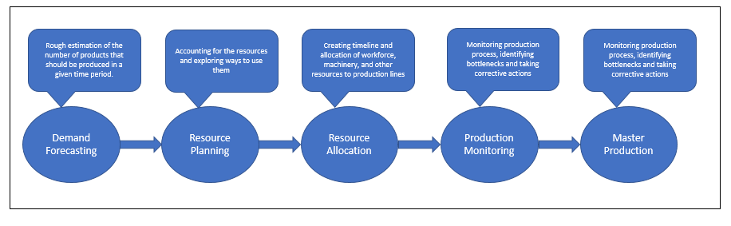
Fig.3. Production Planning Mechanism
Manufacturing deals with making a product and the first thing that we need to know is the demand for the product. The demand for the product is estimated through good forecasting models. We also need to know the capacity. The organization should have the capacity to meet the demand of these products and these capacities are usually in the form of regular time capacity, overtime capacity and outsourcing. The organization decides what type of these capacities that they are going to have. This combination of demand and capacity results in what is called the production plan, where the organization decides what the products to be produced are and how much of this capacity is going to be utilized in each period.
Forecasting essentially deals with estimation of future demand for a product and making predictions about future events based on historical data and analysis. The product could be anything. The product could be an automobile, a product could be phones, and a product could be machinery and so on.
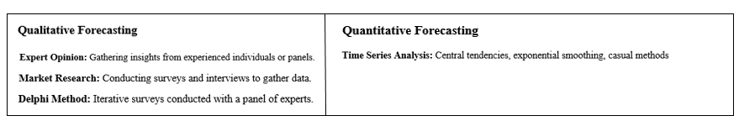
Time series analysis is a statistical technique that involves studying datasets that are recorded over time to identify patterns, trends, and other meaningful information. It aims to understand the underlying structure and function of the data points, which are typically collected at consistent intervals. By analysing these time-dependent data points, time series analysis can help forecast future values, detect seasonal variations, and uncover any cyclical patterns or long-term trends. This method is widely used in various fields such as economics, finance, environmental science, and engineering for applications like stock market prediction, weather forecasting, and demand planning.
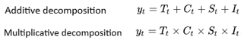
The decomposition of time series is a statistical task that split a time series into several components such as trend, seasonality, and residual, analysts can gain valuable insights into the patterns and behaviour of the series. Decomposition provides a useful abstract model for thinking about time series generally and for better understanding problems during time series analysis and forecasting
(1)
(2)

Additive model, the behaviour is linear, changes over time are in a linear trend. Additive composition is applicable when Seasonality is relatively constant and doesnot change over time.
Multiplicative model, the behaviour is non linear, can be exponential or quadratic and represented by a curve line. Multiplicative composition is useful when data having high seasonal variations over a time.
Trend Component, - A trend will be over the period of time increasing or decreasing direction in the data,
Generally, trends observed in to two forms one is Linear & another is Non-Linear
(Curvilinear).
Cyclical Component, - Short term repeated non periodic fluctuations occurs for a period of more than one
Year. Business Cycle is one of the examples for cyclicality.
Seasonal Component, - A seasonal pattern exists in a regular and a periodic manner with in period of less than
One year. Seasonality occurs over a fixed and known period (e.g., the quarter of the
Year, The month, or day of the week).
Irregular Component, - Which describes random, irregular influences called noise. This type of fluctuations
Occurs in random way or irregular ways which are unforeseen, unpredictable and due
To some irregular circumstances

Machine learning is a subset of artificial intelligence, which has to do with the development and study of algorithms that can learn from data. This field covers so many types of method like supervised learning, unsupervised learning and things in between (semi-supervised or reinforcement). For this type of setting, models will learn from labelled data in order to predict/classify new instances and it is the most common form (At least for now). Algorithms such as linear regression, logistic regression, decision tree etc. have been in existence for a long time but deep learning algorithms are neural networks which is considered to be the new space using existing techniques and tools. This is where you may want to use unsupervised learning, as in discovering patterns or structures inn unlabelled data such clustering similar mages together or reducing the dimensionality of your dataset. Unsupervised Learning involves techniques from k-means clustering, hierarchical clustering and Principal Component Analysis (PCA).
Regression techniques are commonly used across a huge number of fields for various applications, including in finance (stock price forecasting), biology (growth models), economics (market trend analysis) and countless other domains like engineering to evaluate system performance. Regression helps us in taking well informed decisions with the help of relations and even to predict accurately.
Neural networks are inspired by the structure and function of the human brain. These are made of connected nodes (often referred to as neurons) organised in layers: an input layer, one or more hidden layers and an output layer Every neuron in a layer gets the data, performs weighted summation and an activation function to produce that value which is then passed on to the next layer.
Chapter 2. Methodology
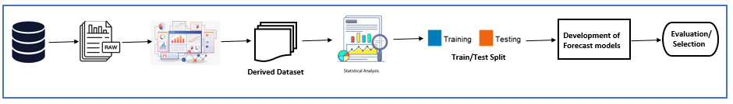
Demand Forecasting is a process in which we predict the quality of the goods and services which will be demanded by the customer or the users in nearby future. It helps the companies, industries and other organisations to plan their production, inventory and other supply chain activities. Machine learning and artificial intelligence are enhancing the accuracy and responsiveness of forecasts by analysing large datasets and identifying complex patterns.

a) Database b) Raw dataset c) Data analysis d) Data pre-processing e) Statistical analysis f) Data Training
g) Model development h) Evaluation metrics / Algorithm selection
Fig. 4. Methodology involved in Demand Forecasting
A) Moving Averages: Moving averages widely used between 1920 until 1950. Moving average method is suitable to identify trend patterns by removing the effects of noise. MAs are simple to implement and cost effective which are applicable for short term forecasts (next few weeks, few months)
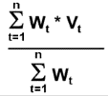
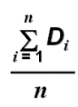
Simple Moving Average= Weighted Moving Average=
n=Window size (3) v=Values for period I (4)
D= values for period i w=Weights
n= Window size

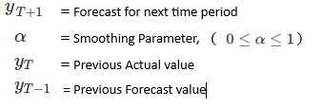
B) Simple Exponential Smoothing: first model of exponential smoothing’s is developed during 1950’s. Exponential smoothing methods are weighted averages of past observations, where the weights decrease exponentially, the smallest weights are associated with the oldest observations. In other words, the more recent the observation the higher the associated weight. This method is suitable with no trend or seasonal pattern and suitable for short term forecasts.

(5)

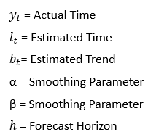
C) Holt model: Holt in the year of 1957 extended simple exponential smoothing to add trend components in the forecasting, also called double exponential smoothing. This method involves a forecast equation and two smoothing equations, one for the level and one for the trend.
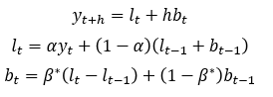
(6)
(7)
(8)

Holt’s linear method display a constant trend which is increasing or decreasing. In the year of 1985 Gardner & McKenzie introduced a parameter that “dampens” the trend to a flat line sometime in the future.
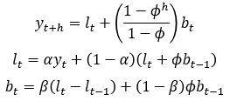
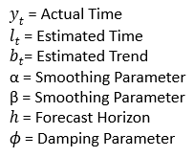
(9)
(10)

(11)
D) Holt Winter model: Winters in 1960 extended Holt’s method to capture seasonality. The Holt-Winters seasonal method comprises the forecast equation and three smoothing equations - one for the level, one for the trend, and one for the seasonal component, with corresponding smoothing parameters.
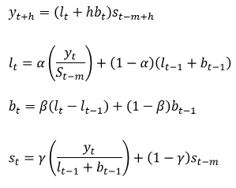
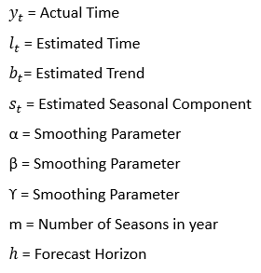
Additive Decomposition Multiplicative Decomposition
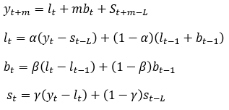
(12) (16)
(13) (17)
(14) (18)
(7) (15) (19)
E) ARIMA models: ARIMA models are combination of Auto Regression & Moving average models. In an auto regression model, we forecast the variable of interest using a linear combination of past values of the variable. In moving averages Rather than using past values of the forecast variable in a regression, uses past forecast errors in a regression-like model. ARIMA models aim to describe the autocorrelations in the data.
ARIMA models includes both the conditions of seasonality and non-seasonality.
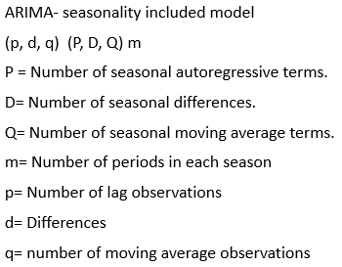
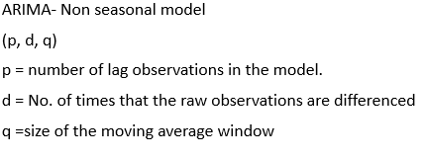
(20) (21)

(

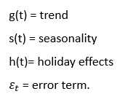
E) Prophet: In the year of 2018 Facebook introduced forecasting model on daily data with weekly and yearly seasonality, plus holiday effects. It was later extended to cover more types of seasonal data. It works best with time series that have strong seasonality and several seasons of historical data. Prophet can be considered a nonlinear regression model. Prophet uses additive decomposition for trend and seasonality, it automatically handles change points i.e new releases.
(22)

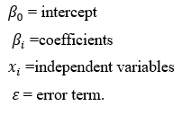
F) Linear Regression: the regression model allows for a linear relationship between forecast value and multiple independent variables at given time. When we use a linear regression model, we are implicitly making some assumptions about the variables in Equation, Mean should be zero, no autocorrelation and make sure that independent variables are in controlled manner rather random.
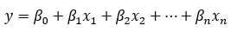
(23)

G) Deep Learning Approaches: Deep learning is a subset of machine learning that uses the neural networks in order to learn, understand and analyse the trends and patterns in the data. These neural networks can automatically learn and extract complex features from raw data. Deep learning has revolutionized demand forecasting by capturing complex patterns in data. LSTMs are great for seasonal demand forecasting, while GRUs are computationally efficient for smaller datasets. Convolutional Neural Networks (CNNs), through 1D convolutions, excel at identifying local patterns in high-frequency data.
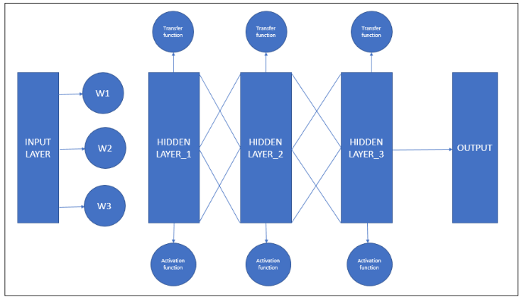

Fig. 5. Deep learning Architecture
N-BEATS (Neural Basis Expansion Analysis Time Series) is a deep learning model designed for univariate and multivariate time series forecasting. It employs a feedforward neural network architecture with a stack of fully connected layers organized into blocks, each block handling trend and seasonality components separately. N-BEATS is model-agnostic, meaning it does not require domain-specific feature engineering and has demonstrated state-of-the-art performance on various forecasting benchmarks. The architecture is flexible and interpretable, making it suitable for a wide range of time series applications.
N-HiTS (Neural Hierarchical Interpolation for Time Series) is a deep learning model for time series forecasting that leverages hierarchical interpolation within its architecture. It uses multi-resolution hierarchical blocks to capture different levels of temporal granularity and dependencies. N-HiTS combines interpolation with residual connections to effectively model and forecast time series data. This approach enhances both the accuracy and scalability of forecasting models, making it suitable for handling complex, high-dimensional time series data.
TiDE (Time-series Dense Encoder) model is a deep learning architecture designed for time series forecasting. It uses a dense encoder-decoder framework to capture complex temporal dependencies in data. The model incorporates attention mechanisms to focus on relevant parts of the time series and enhances interpretability. TiDE is effective in handling both short-term and long-term dependencies, making it suitable for a wide range of forecasting tasks. Its design allows for capturing intricate patterns without extensive feature engineering.
Chapter 3. MODELLlING
Problem statement: ABC is one of a leading spare parts manufacturer in the Europe and America regions which is constantly facing significant challenges in accurately forecasting demand for its extensive range of products. There will not be any efficient forecasting model to efficiently manage inventory, optimize production schedules, and meet customer demands. Current forecasting methods struggle with several issues like Volatility, Seasonality, Supply chain constraints and no clear trend patterns.
Data Collection: Data Collection is a process of collecting the historic data from various platforms. For the forecasting model collected raw data for past 3 years in CSV format. Raw data contains Missing Values, Wrong entry records, different data types include integers, strings, date times. This data forms the basis for identifying demand patterns, seasonal variations, and sales trends over time.
This dataset has been pre-processed by removing duplicate values, handling missing values, and outliers. The processed dataset is used to test the seasonality, trends, stationary and by applying algorithms like Simple Exponential Smoothing, Prophet, SARIMA, Holt and etc. The data has been analysed monthly, weekly, and also at the quarter intervals.
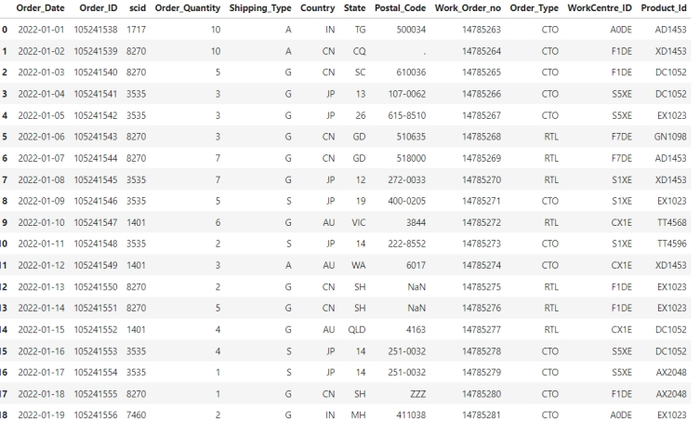

Fig. 6. The Raw dataset

Data Analysis: Data Analysis involves transforming raw data into meaningful insights, identifying patterns, and preparing the data for model building. Effective data analysis ensures the accuracy and reliability of the forecasting model. In the Exploratory Data Analysis, we have used UNIVARIATE model in order to visualize the data. Here, the EDA was performed categorically such as Monthly Sales, Weekly Sales, Quarterly sales and Yearly Sales. Proper data analysis ensures that the forecasting model is robust, reliable, and capable of making accurate predictions, ultimately aiding in better decision-making and strategic planning.
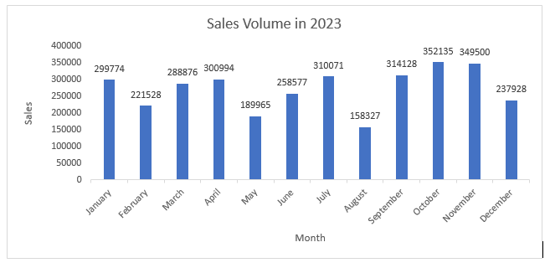
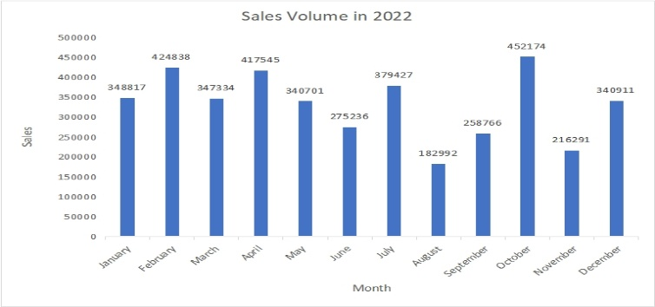

Fig. 7. Sales Volume per Month in 2022 Fig. 8. Sales Volume Per Month in 2023

(Fig.7) represents the total number of sales per month in the year 2022. This data is extracted from the dataset in order to find the trends, patterns and etc. Therefore, the average number of sales in the year 2022 is 75096 approximately. By analysing the graph, it can be concluded that in the month of October there is maximum number of sales with 452174 and August being the least with 182992. Based on the analysis, we can find the trends, patterns and seasonality and develop a forecasting model that could predict the number of sales in the future.
(Fig.8) represents the total number of sales per month in the year 2023. The month of October has the highest number of sales in 2023, indicating a significant increase in consumer activity or effective promotional strategies during this month. August has the lowest number of sales for the year 2023, suggesting a possible seasonal dip or other factors that led to reduced consumer purchasing during this period. The graph likely shows a pattern or trend in sales across the months, which can help in identifying seasonal variations
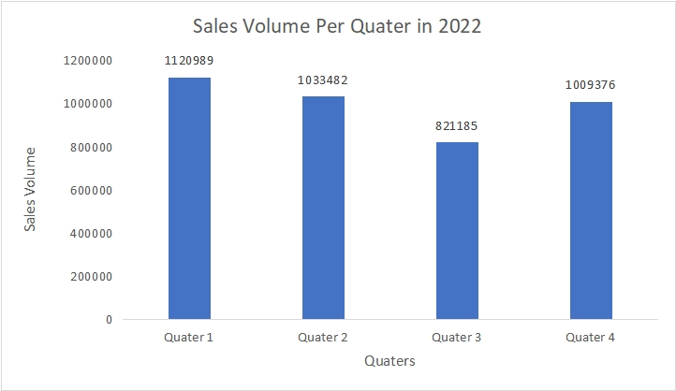
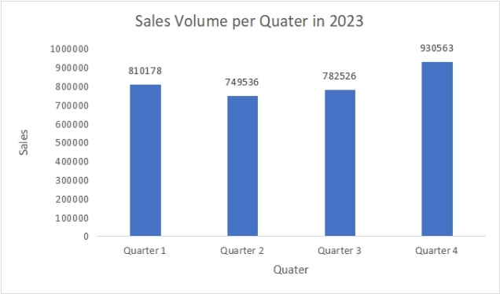

Fig.9. Sales Volume per Quarter in 2022 Fig.10. Sales Volume per Quarter in 2023

(Fig.9) represents the total number of sales per quarter in the year 2023. The fourth quarter (October to December) has the highest number of sales in 2023. There is also a decrease of 7.5% from first quarter to second quarter and also a 16% of increase from third quarter to fourth quarter. The second quarter (April to June) has the lowest number of sales for the year, suggesting a potential period of lower consumer activity, which could be influenced by various factors such as fewer holidays, seasonal trends, or economic conditions. These observations provide a comprehensive understanding of the sales performance over the quarters.
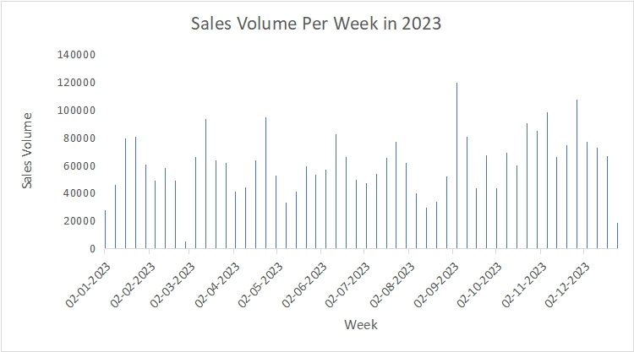
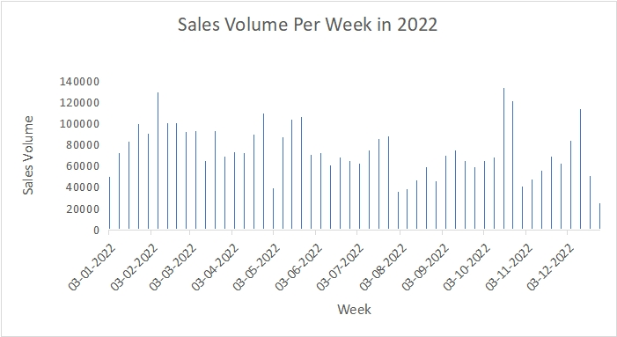
(Fig.10) represents the total number of sales per quarter in the year 2022. The first quarter (Jan to March) has the highest sales in 2022. Also, there is a decrease of 7.8% decrease from first quarter to second quarter and also an increase of 18.7% from third quarter to fourth quarter. The third quarter (July to September) has the lowest sales for the year, suggesting a potential summer slump or other factors leading to reduced consumer purchasing during these months. There are noticeable fluctuations in sales across the quarters, which could be due to a combination of seasonal trends, promotional activities, and external economic factors.
Fig.11.Sales Volume per Week in 2022 Fig.12.Sales Volume per Week in 2023
(Fig.11) represents the number of sales per week in the year 2022 starting from 03-01-2022 to 26-12-2022. Therefore, the average number of sales per week is 75096 approximately. By analysing the graph, it is clear that the most number of sales were done from 24-10-2022 to 31-10-2022 with 133851 being the highest and lowest with 25342 at the end of December.
(Fig.12) represents the number of sales per week in the year 2023 starting from 02-01-2023 to 25-12-2023. Therefore, the average number of sales per week is 61200 approximately. By analysing the graph, it is clear that the most number of sales were done from 04-09-2023 to 11-09-2023 with 119730 being the highest and lowest with 5319 at the end of February.
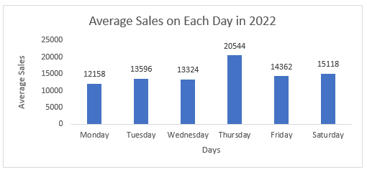

Fig.13. Average Sales Volume on Each Day of the Week in 2022

This graph represents the Average number of sales per day in the year 2022. This graph is taken by calculating average of all the number of sales per each day in year. By analysing this graph, it is clear that the number of sales has happened on Thursday being highest with 20544 approximately and Monday being the lowest with 12158. There are noticeable fluctuations in sales across the quarters, which could be due to a combination of seasonal trends, promotional activities, and external economic factors.

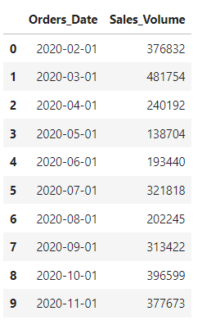
Data processing: Data Processing involves preparing and transforming raw data into a suitable format for modelling, ensuring the data's quality and relevance. It cleans the data, handles the missing values, null values and also the outliers in the data. There are numerical as well as categorical variables which have been handled and derived into timeseries dataset. We can also identify and address the anomalies in the data, which could be indicative of data quality issues or rare events that need special consideration in the modelling process. It also normalizes and the transforms the raw dataset and gives the desired derived dataset. It also aggregates and disintegrates the data based on the user requirement.

Fig.11. Derived Dataset from the Raw Dataset
Statistical analysis: Statistical analysis plays a crucial role in demand forecasting by providing insights into historical data patterns, identifying trends, seasonality, and relationships among variables. It calculates mean, median, and mode to understand the average demand. Use histograms and density plots to visualize the distribution of demand data.
Augmented Dickey-Fuller (ADF) Test: Test for the presence of unit roots to assess stationarity.
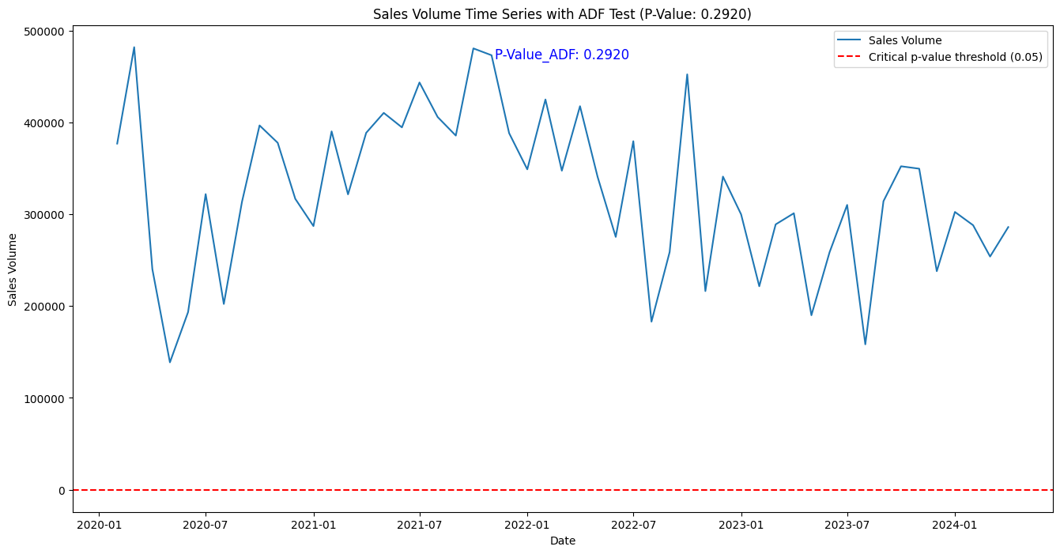
Fig.14. ADF Test on the Sales Volume (P-value: 0.2920)

Augmented Dickey-Fuller (ADF) test performed on the 'Sales Volume' series of your Data Frame. The P-value from the ADF test is 0.2920, which is greater than the commonly used significance level thresholds. Since the P-value is greater than 0.05, we fail to reject the null hypothesis of the ADF test. This implies that the 'Sales Volume' series is likely non-stationary. The non-stationarity of the series suggests that there might be trends, seasonality, or other structural components present in the data that need to be addressed before building a forecasting model.

Autocorrelation Function (ACF): Measure the correlation between observations at different lags.
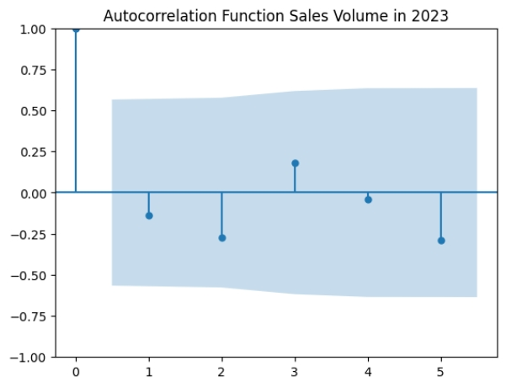
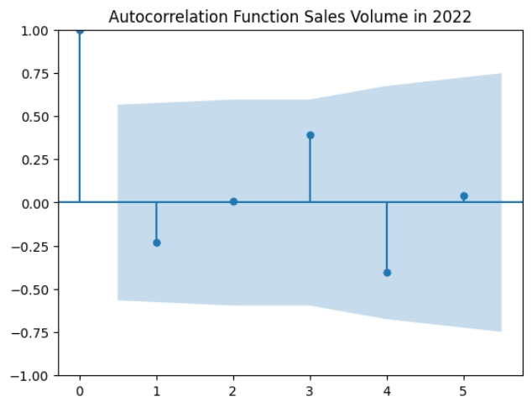

Fig.15. Autocorrelation Function on Sales in 2022 Fig.16. Autocorrelation Function on Sales in 2023
The Autocorrelation in both the figures indicates that there is a positive correlation between the current Observation and the observation at lag 0 and lag1. And also, there is a negative correlation observed at lags 1, 4 in both the graphs. There is some decay in the fig. 16 at lag 2 and lag 5.
Partial Autocorrelation Function (PACF): Isolate the correlation of current values with past values, controlling for the values of intervening lags.
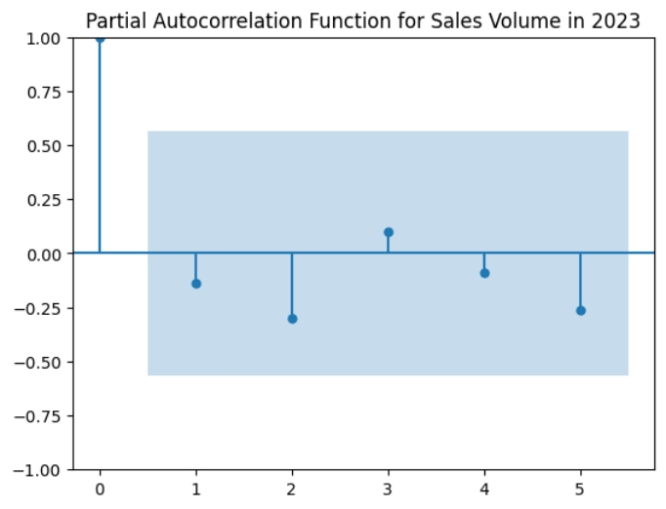
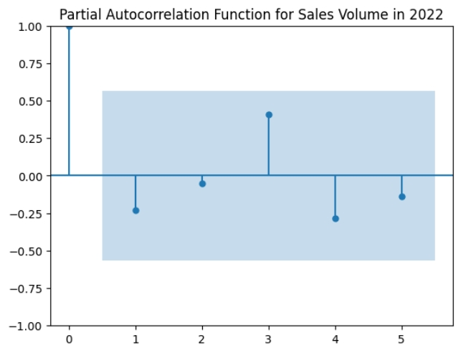

Fig.17. Partial Autocorrelation Function on Sales in 2022 Fig.18. Partial Autocorrelation Function on Sales in 2023
Partial Autocorrelation removes the intermediate lags and thus provide the direct relationship with the past observations. By analysing the Fig. 17 and Fig.18 it is clear that, the lags at 0 and 3 show a positive trend whereas all the remaining lags show negative correlation trend in Partial Autocorrelation.
Decomposition: Trend components of sales volumes are in downward trend in year of 2022 and upward trend in year of 2023.The additive method is suitable for trend and seasonality which does not change over time, while the multiplicative method works best with data that has a trend and seasonality that grows over time. Residual component shows zero, i.e. Data don’t have any kind of noise.
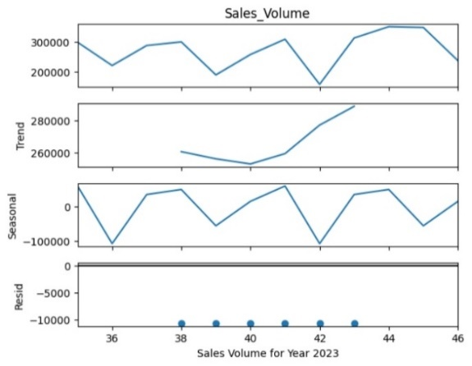
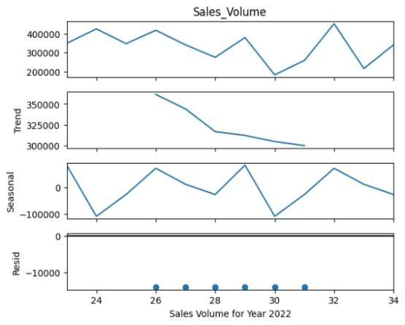

Chapter 4. Results & Discussion
ABC, a prominent spare parts manufacturer in Europe and America, faces ongoing challenges in accurately predicting the demand for its vast product range. Without a reliable forecasting model, the company struggles to efficiently manage inventory, optimize production schedules, and meet customer needs. The raw dataset has been pre-processed into a structured timeseries dataset which have been analysed monthly, weekly and quarterly using some algorithms like Simple Exponential smoothing, Holt Model, Holt-Winter Model, SARIMA, Prophet, NBEATS , NHITS and etc. out of which Prophet yielded the model with high accuracy which was followed by Simple Exponential Smoothing. The data is given as follows.
Table 1: Performance metrics of different models (testing period of 6 months).
S:NO: | Models | MAE | MAPE | MSE | RMSE | SMAPE
1 | Simple Exponential Smoothing | 31528.29 | 11.34% | 1655179414.12 | 40683.89625 | 10.95%
2 | HOLT | 36172.42928 | 12.75% | 2050438874.40 | 45281.77199 | 12.48%
3 | HOLT Winter | 38979.43563 | 12.62% | 2632001484.85 | 51303.03582 | 14.07%
4 | SARIMA | 44131.08992 | 16.06% | 2973684072.44 | 54531.49615 | 16.12%
5 | Prophet | 31195.99077 | 11.30% | 1695035931.02 | 41170.81407 | 10.86%
6 | Linear Regression | 75851.69813 | 26.67% | 8376548483.02 | 91523.48596 | 25.37%
7 | NBEATS | 46986.61523 | 15.09% | 531273816.4 | 73152.4013 | 17.86%
8 | NHITS | 43589.37767 | 13.92% | 5103826023 | 71441.06678 | 16.46%
9 | TiDE | 58813.73323 | 18.85% | 6413427414 | 80083.87737 | 21.17%

In the Simple Exponential Smoothing, using an estimated initial level and also optimizes the Smoothing level (‘alpha (‘α’)) and then the data will be forecasted that generates the value. In the Holt Model uses the damped and exponential trends. Here, the initialization method is said to be “estimated”. The smoothing level is manually set to 0.2, and the smoothing trend is set to 0.3. The `Holt – winter’ model contains an additive trend and a multiplicative seasonal component with seasonal period 4. Here, initialization method is set to "estimated". The trend is damped to avoid extreme values in the forecast and variance is stabilized by Box-Cox transformation.
In the `SARIMAX` model with order ARIMA (1, 0, 0) and seasonal order (0, 0, 0, 4). `auto_arima` function shall be used to determine the best ARIMA parameters. The ‘prophet’ model learns data from `Train` and creates a data frame for future forecasting, then running the prediction phase. The arithmetic mean of each prediction is summarized, which serves as the final result. In the `NBEATS Model`, `NHiTS Model`, `TiDE Model’ used from Darts library, The model undergoes training on the `Train` data where input and output chunk lengths are equal to six, and it runs for 100 epochs. the actual process of forecasting step is then performed. The first of the forecasts is taken as the predicted solution.
Proposed model
Given the observed strengths and limitations of the individual models, a hybrid approach was developed, combining the “Prophet model” with “Simple Exponential Smoothing.” The hybrid model leverages the Prophet model's robust handling of seasonality and trend components. The performance of the hybrid model was evaluated against the same accuracy metrics. The data is given as follows: -
Table 2: Performance metrics of Hybrid model
S:NO: | Models | MAE | MAPE | MSE | RMSE | SMAPE
1 | Prophet- Exponential hybrid | 29838.57727 | 9.60% | 1555294104.28 | 39437.21725 | 9.38%
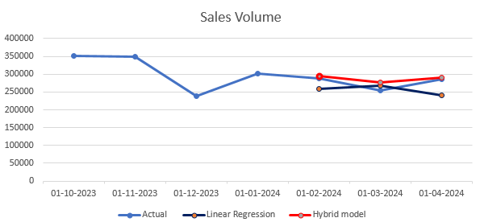
The Simple Exponential Smoothing model excels with the lowest MAE (31,528.29), MAPE (11.34%), and SMAPE (10.95%), indicating the highest accuracy and reliability. HOLT and HOLT Winter models have higher MAE and MAPE, with HOLT Winter showing the highest RMSE, suggesting less precise forecasting. SARIMA performs well but is slightly less accurate than Simple Exponential Smoothing. Linear Regression performs poorly overall, with the highest MAE, MAPE, and RMSE, indicating significant forecasting issues. NBEATS and NHITS offer moderate performance, with NBEATS having a better MAE but higher RMSE, while NHITS has higher MAPE and SMAPE. TiDE is the least effective, showing the highest MAE, MAPE, and RMSE, and is less reliable for forecasting.

Fig.22. Sales Volume Predicted vs Actual
The development of a hybrid model incorporating Simple Exponential Smoothing with prophet further enhanced the forecast reliability. The hybrid model provided a balanced approach, ensuring that the forecasts were neither too reactive to short-term fluctuations nor too rigid, thereby offering a practical solution for demand prediction in the automotive spare parts industry.

Chapter 5. Metrics & Evaluation
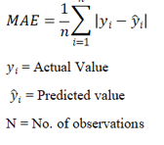
Mean Absolute Error: MAE measures the average magnitude of errors between predicted values and actual values. MAE indicates the average absolute deviation of predictions from actual values. It is easy to interpret (24) and gives equal weight to all errors.

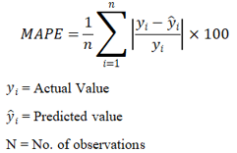
Mean Absolute Percentage Error: MAPE calculates the average percentage difference between predicted values and actual values. MAPE expresses prediction errors as a percentage of actual values, making it useful for comparing forecast accuracy across different datasets.
(25)

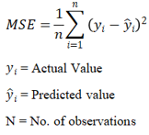
Mean Squared Error: MSE calculates the average of the squared differences between predicted values and actual values. MSE penalizes larger errors more heavily due to squaring each error term, making it sensitive to outliers in the data.
(26)

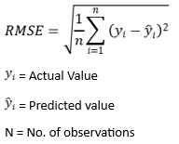
Root Mean Square Error: RMSE is the square root of the MSE and
(27)
provides an estimate of the standard deviation of prediction errors. RMSE
is in the same units as the predicted values, making it easy to interpret
in the context of the forecasted variable.

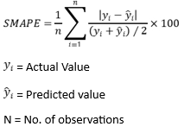
Symmetric Mean Absolute Percentage error: SMAPE calculates the average of the absolute percentage errors as a proportion of the sum of actual and predicted values. SMAPE provides a balanced view of forecast accuracy by handling both zero values and proportional errors, making it suitable for datasets with varying scales and values.
(28)

Chapter: 5. Conclusion
While concluding, cultivating an operative production arranging and scheduling scheme is fundamental for synchronizing fabricated techniques to sector require and functional abilities. To start with inclusive marketplace examination and demand projection, companies can base their product conception and evolution on correct client styles and choices. Proficient ability planning makes certain prime benefit of sources such as machinery, work, and materials, whereas state-of-the-art scheduling algorithms and programming instruments facilitate thorough fabrication timelines and job sequencing. Integrating stock administration strategies, such as just-in-time (JIT) fabrication, diminishes excess stock and linked costs. Continuous tracking and real-time alterations enhance the system's dexterity, allowing businesses to react hastily to market variations and operational dynamics. Meanwhile, an agile supply chain supports rapid adjustments as needs change. Long- and short-term goals must be balanced for optimal results.
Chapter: 6. Future Enhancements
Future advancements in production planning and scheduling will be driven by technology and data analytics. Predictive analytics, powered by AI and machine learning, will enhance accuracy in demand forecasting, optimize inventory levels, and predict machine maintenance needs. Prescriptive analytics will recommend optimal production schedules considering multiple constraints and objectives, such as cost reduction and resource utilization. IoT will enable real-time monitoring of manufacturing processes, improving efficiency and responsiveness. Digital twins will facilitate simulation-based testing of production strategies, accelerating innovation and decision-making. These advancements promise more efficient, agile, and competitive manufacturing operations in the future.

References
- Brown, R. G. (1959). Statistical forecasting for inventory control. McGraw/Hill.
- Holt, C. C. (1957). Forecasting seasonals and trends by exponentially weighted averages (O.N.R. Memorandum No. 52). Carnegie Institute of Technology, Pittsburgh USA.
- Winters, P. R. (1960). Forecasting sales by exponentially weighted moving averages. Management Science, 6(3), 324–342.
- Heizer, J., Render, B., & Munson, C. (2017). Operations Management: Sustainability and Supply Chain Management. Pearson Education.
- Sipper, D., & Bulfin, R. L. (2007). Production: Planning, Control, and Integration. McGraw-Hill Education.
- Pinedo, M. L. (2016). Planning and Scheduling in Manufacturing and Services. Springer Science & Business Media.
- Slack, N., Brandon-Jones, A., & Johnston, R. (2017). Operations Management. Pearson Education.
- Corbett, C. J., & Klassen, R. D. (2006). Extending the horizons: Advances in management of supply chains. Journal of Operations Management, 24(5), 933-937.
- Silver, E. A., Pyke, D. F., & Peterson, R. (1998). Inventory Management and Production Planning and Scheduling. John Wiley & Sons.
- Simchi-Levi, D., Kaminsky, P., & Simchi-Levi, E. (2007). Designing and Managing the Supply Chain: Concepts, Strategies, and Case Studies. McGraw-Hill/Irwin.
- Chopra, S., & Meindl, P. (2016). Supply Chain Management: Strategy, Planning, and Operation. Pearson Education.
- Nahmias, S., & Olsen, T. L. (2015). Production and Operations Analysis. Waveland Press.
- Stevenson, W. J. (2020). Operations Management. McGraw-Hill Education.

