THECAM

EMBEDDED

Table of Contents

1. Introduction 3

2. Hardware Part 4

2.1. Connectivity of different section of the product 4

2.2. Hardware Images and Descriptions 4

3. Software Part 8

3.1. FLOW OF PROJECT- Starting 8

3.2. Installing Software and Dependencies 9

3.3. 9

4. MQTT with EG25G 10

5. Tips and Key Notes 11

# Introduction

Controllers used are 1) PIC 16f1938, 2) DSP Chip NT96655

Camera works in 2 modes, 1) Setup, 2) Auto

Here, PIC uC works as the master of the board while in auto mode “ON”. PIC uC is connected to different power controlling circuits responsible for controlling different segments of device like, GSM, PIR, LEDs, Camera, DSP chip power, etc. In auto-mode, the PIC uC stays active with PIR sensor and IR LEDs (if required), If PIR sensor detects any motion, It triggers the power circuit for DSP chip, GSM and other circuitry.

The DSP Chip – NT96655, communicates with PIC uC over I2C protocol. NT96655’s pipelines are programmed to capture image/video and take further actions like to sending these image/video packet over SMTP, FTP, MMS protocols to the end-user’s credentials configured in the camera. To configure any credentials or to make any changes in settings of the device, it should be set in Setup-mode. In setup-mode you can do multiple setting by clicking the ‘OK’ and 4 ‘arrow’ buttons available on device like Capture mode, date-time, Zone, Quality of capturing, credentials for internet service provider APN, port, email-ids, phone numbers with country code, many more, Auto/Manual setting for pushing data packets over SMTP, FTP, MMS protocols, a lot more. These configurations can even be automated by using a .txt file in SD-Card. You can find this in documentation.

# Hardware Part

## Connectivity of different section of the product

** I/O = Input Output Pins

1. DSP Chip 🡪 I2C 🡪 PIC uC
2. DSP Chip 🡪 UART 🡪 GSM communication
3. DSP Chip 🡪 I/O 🡪 GSM controlling
4. DSP Chip 🡪 I/O 🡪 Camera
5. DSP Chip 🡪 I/O 🡪 Buttons

(Variable resistance technique, to save number of I/Os and traces)

1. PIC uC 🡪 I/O 🡪 Power control button

(ON/OFF/SETUP)

1. PIC uC 🡪 I/O 🡪 GSM module
2. PIC uC 🡪 I/O 🡪 PIR sensor
3. PIC uC 🡪 I/O 🡪 IR blaster array
4. PIC uC 🡪 I/O 🡪 Indicator LEDs

## Hardware Images and Descriptions

Red wire is +ve terminal. (to power up the CAMERA via external source)

Blue wire is -ve terminal. (to power up the CAMERA via external source)

Operating power recommended 6V and 2Amps.

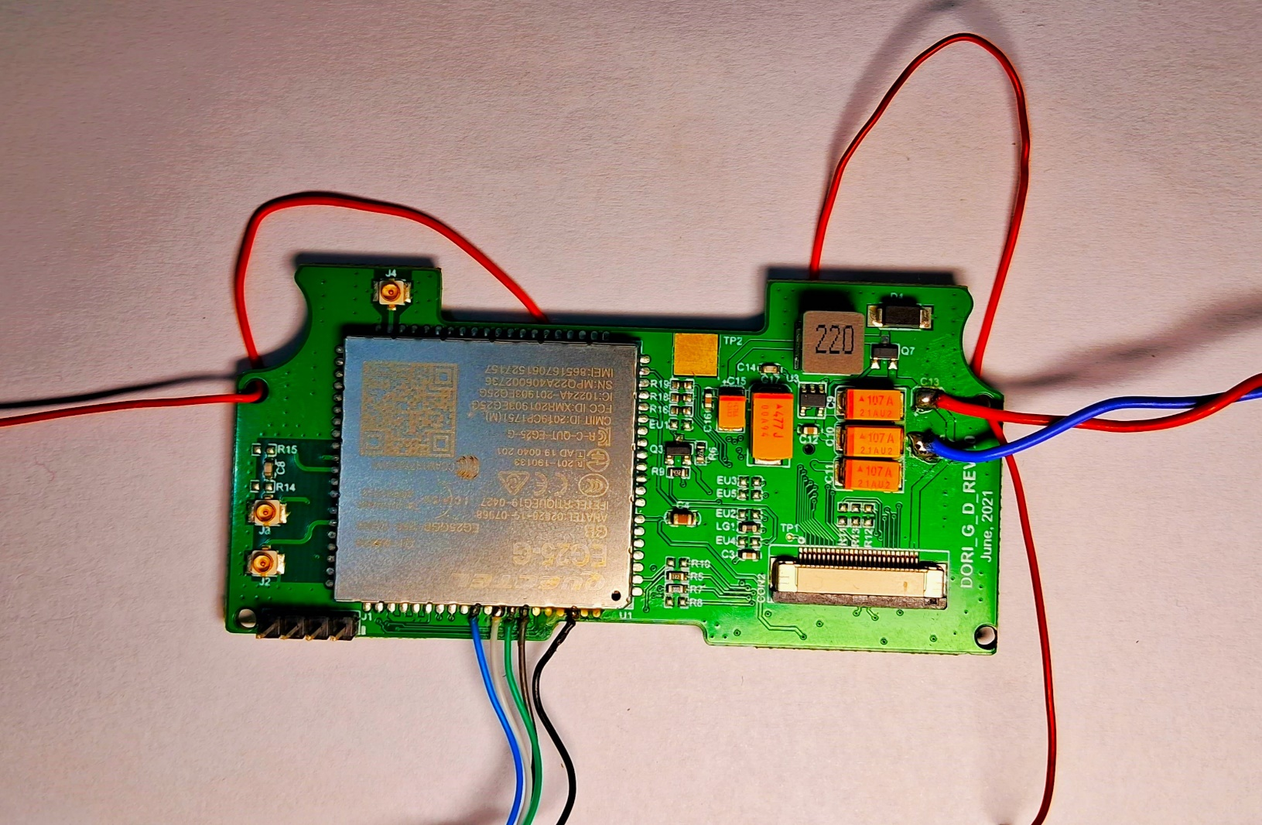

This is the GSM module for New Model. They have different chips, Quectel EC20, EG25 etc.

Quectel these series have similar pinouts, so, they are using same PCB boards and common method to control these chips. To control the module, send data, communicate with Pic uc or DSP chip, you need to control some specific to HIGH signal or set to HIGH for few seconds and again pull LOW, to keep it ON.

Operating Voltage – 4V 1Amp recommended.

#### Wires CONNECTED!

Blue, White, Green, Brown are connected to CTS, DTR, Tx, Rx

&

Black is connected to GND of PCB.

Red wire is +ve terminal. (to power up the GSM module externally)

Blue wire is -ve terminal. (to power up the GSM module externally)

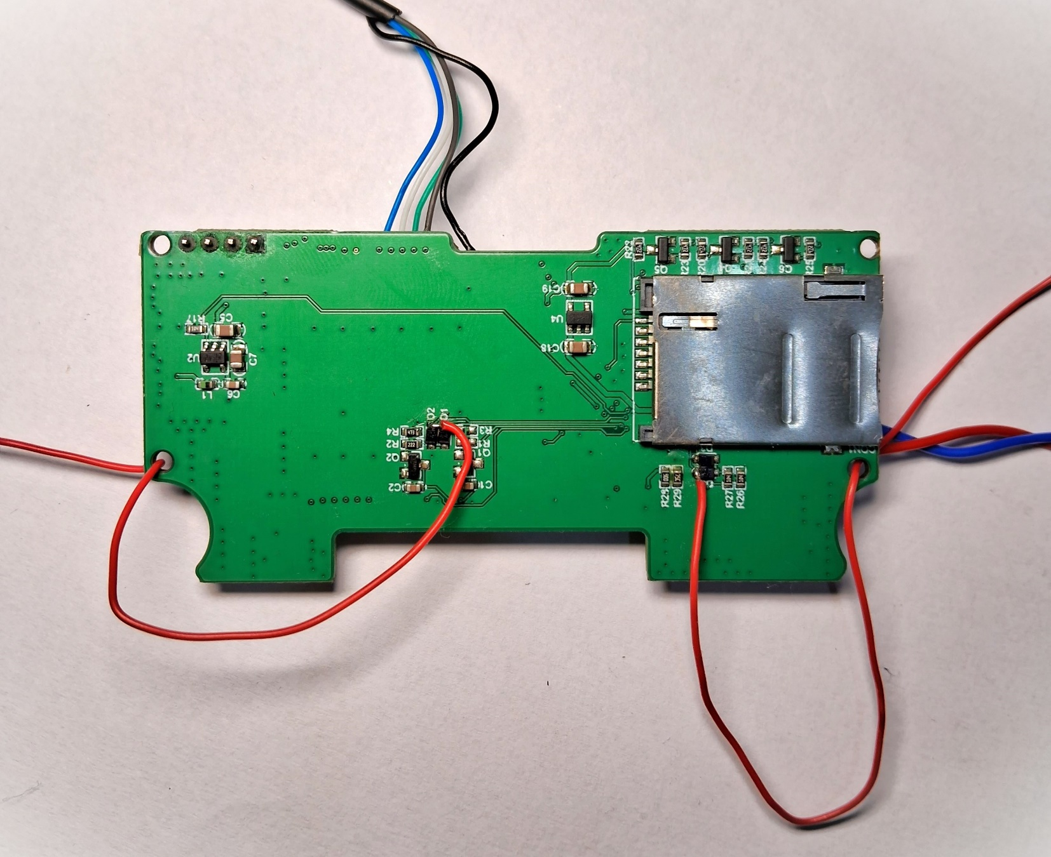



{In case of testing or trying to use the GSM module without master board you have to power up the GSM module PCB and enable few pins in case to use it and to keep it active}

3.3 V signal recommended for transistors D1, D2 connected to red hard wires. These wires are connected to diode and transistor circuits those are responsible turning ON the Quectel chip and start communication with respective controller {uC, uP}.

{While using Master PCB along with the GSM module} These all pins are connected to the 30 pin connector used to connect MASTER PCB, and the 2 red wires connected to diodes and transistor circuit will be controlled by the GPIO pins coming from DSP chip and PIC uC .

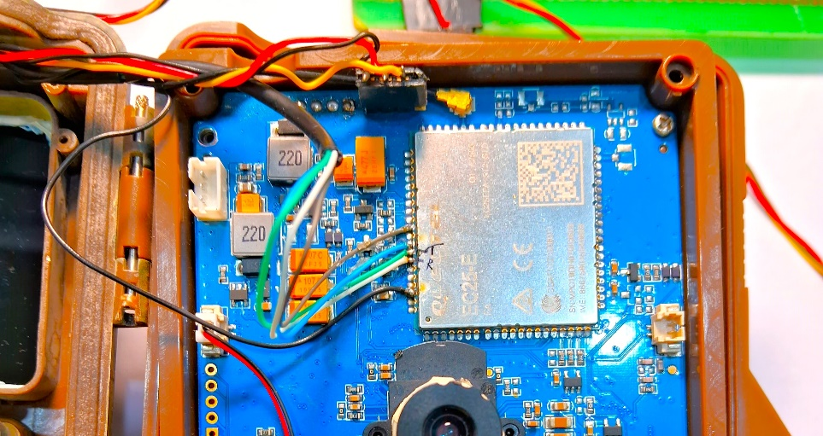

# Software Part

## FLOW OF PROJECT- Starting

Here UI plays the master role to initiating the ‘main’ function of the project! While the camera is in SETUP mode or the main function {“ int NvtMain(int argc, char *argv[]) ”}, present on PATH - *“..\DSP\NT96655_BG8304_IQ_V1.0.70\Project\BskCamera\SrcCode\System\”* and the file name is “main.c”.

To understand the flow of project, you will be needing SDK manual provided by the vendor itself. If you want to start with understanding the project source code for DSP chip, just follow function “int NvtMain(int argc, char *argv[]” on the path just mentioned above. By following it you can figure out the flow of backend source code for DSP chip. To know more about image capturing pipelines or data handing, or image handling pipelines and other pipelines like for SD card and all, you will be required to go through the operation manual/or programming manual provided by the vender of DSP chip.

For changes in UI and functionality of UI, You have different files shared in same folder “/1DSP_source_code/UI/…”. Need to go through to it and understand the flow, what happens on clicking in respective area of screen / icons on screen.

Now talking about PIC controller. The MCU source code is modified and compiled and flashed using Microchip's own development tools. The flow of PIC micro controller is just basic and standard one. The main() func and other functions being called with pointers and times for controlling the things.

Here PIC uC works as master, as mentioned in Introduction as well, the mode set on camera depends on position of button on camers. The modes are ON, OFF, SETUP. The state of button is read by the PIC uC, and it controls the power of the master PCB of the product. It is only responsible for powering up the DSP chip, IR blaster, GSM, which device will communicate over GSM data lines {via a transistor based circuits, it controls the control lines for DSP and PIC ICs}, PIC, voltage level, and what all Functions of camera will work !!.

PIC uC is only responsible for controlling DSP chip in ON-mode {to capture single image or set of images, video of specific time length as per camera is configured using the configuration file }

## Installing Software and Dependencies

Refer to the Chapter “Tips and Key Notes”

## 

# MQTT with EG25G

Refer to the USER MANUAL for EG25 for 4G modules provided by the vender.

And in case you are using EC20, it is a 3G supported module! So, select the SIM card or the service provider accordingly, the one who supports 3G signals as well. Like in INDIA, JIO4G does NOT support 2G, 3G at all, so JIO SIM card will never work in EC20. So for trial JIO SIM card we used EG25 only !!.

# Tips and Key Notes

🡪" I am able to set up the SDK and load the current firm into a commercial BG8304 I have here? Is that possible, or is it just compatible with other hardware?  "

STEPS to write new firmware to CAMERA are !

Step 1: Get an SD card and format it;

Step 2: Put the FW96655A.bin file into the SD card;

Step 3: Lock the card and insert the SD card into the camera; - Keep CAMERA power == OFF

Step 4: Turn the camera switch to power ON the camera;

Step 5: Wait for about 30s, the camera will display a blue interface, and the upgrade is complete;

Step 6: Pull out the SD card and unlock it, insert the camera and restart it, enter the menu to confirm the version.

** The developer can use any Text editor to write code for DSP chip, what so ever editor you are comfortable!

After making changes to the source code, Compilation can be done as mentioned in Step 2. Just take care you have install NMAKE and other required dependences, and softwares for getting project compiled without errors.

Basic steps to compile DSP code and make .bin files to be written to the camera are:-

1. To read the code, you can install the SourceInsight tool (shared with backup) to read and modify the code;

2. Compile and directly run build.bat or build-all.bat in the root directory;

STEPS to INSTALL all dependences and required software's...

1. Install ADS1.2 first, and there is a cracking method after decompressing the file;

2. Install MIPS, NT96655 platform is a processor using MIPS instruction set;

3. Install the C language compilation tool NMake.

YOU WILL FIND BUILD OUTPUT BIN FILE AND OTHER ‘.o’ , ‘.a’ files in 'release' folder

...\DSP\NT96655_BG8304_IQ_V1.0.70\NT96655_BG8304_IQ_V1.0.70\Project\BskCamera\BskCamera_Data\Release\...

Two burning methods:

1. Self-made burning fixture, using BG830 motherboard, welding burning seat, directly using SD card lock card upgrade method of burning;

2. Use ordinary burner to burn, and burn directly;

# Configuration File format