AI Assistant Coding Assignment-9.1
Roll.No:2303A52279
Batch-37

Task 1: Documentation – Function Summary Generation

Task Description
Use AI to generate concise functional summaries for each Python function in a given script. Provide a Python script to the AI and ask it to write a short summary describing the purpose of each function. Ensure summaries are brief and technically accurate, avoiding code implementation details.

Prompt
"I have a Python script with mathematical utility functions. Please generate a concise, one-line summary for each function describing its purpose. Do not explain how the code works, just what it does."

Input Code provided to AI

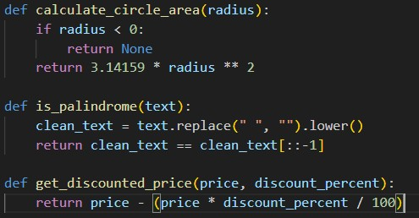

Output (AI Response)

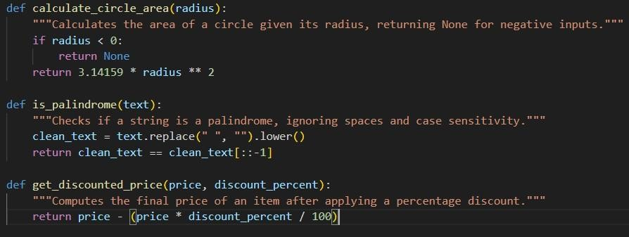

Explanation
For this task, the goal was brevity. I intentionally asked the AI to avoid implementation details (like mentioning the specific value of Pi or string slicing methods). The AI successfully abstracted the intent of the functions. For example, instead of saying "reverses string and compares," it simply said "Checks if a string is a palindrome," which is much more useful for a developer quickly scanning the file.

Task 2: Documentation – Logical Explanation fior Conditions and Loops

Task Description
Use AI to document the logic behind conditional statements and loops in a Python program. Provide a Python program without comments and instruct the AI to explain only the decision-making logic and loop behavior, skipping basic syntax explanations.

Prompt
"Add comments to the following Python code that strictly explain the logic behind the ifstatements and the while-loop. Do not comment on syntax (like 'variable assignment'). Focus on why the decision is being made."

Input Code provided to AI

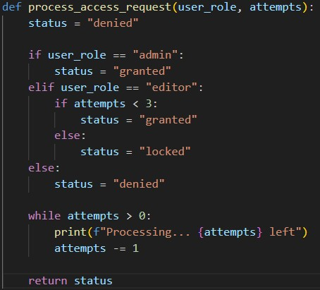

Output (AI Response)
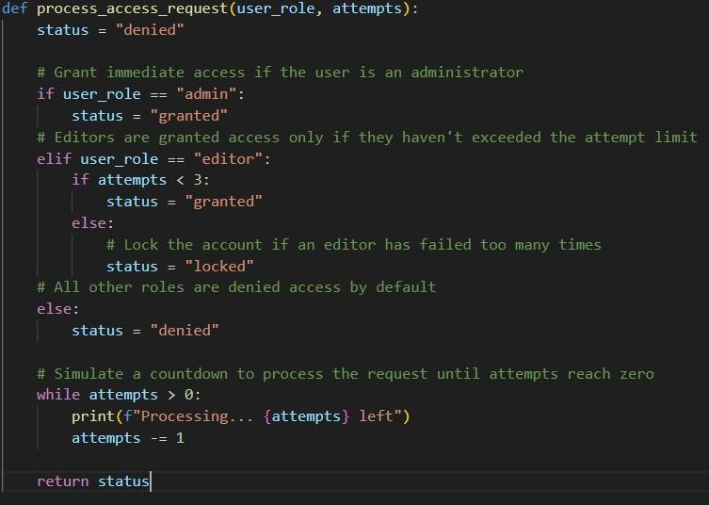

Explanation
Here, the prompt was specific about ignoring syntax. Beginners often comment i = i + 1 with "increment i," which is useless. The AI followed the instructions well, explaining the business logic (e.g., "Grant immediate access if admin," "Lock the account..."). This type of documentation is crucial for maintenance because it tells future developers why the rules exist, not just what the code looks like.

Task 3: Documentation – File-Level Overview

Task Description
Use AI to generate a high-level overview describing the functionality of an entire Python file. Provide the complete Python file to the AI and ask it to write a brief overview summarizing the file’s purpose and functionality. Place the overview at the top of the file.

Prompt
"Read the following Python code which handles a simple banking system. Write a highlevel docstring to be placed at the very top of the file that summarizes the
module's purpose and key capabilities."

Input Code provided to AI
(Passed a 50-line script containing a BankAccount class with deposit, withdraw, and balance check methods)

Output (AI Response)

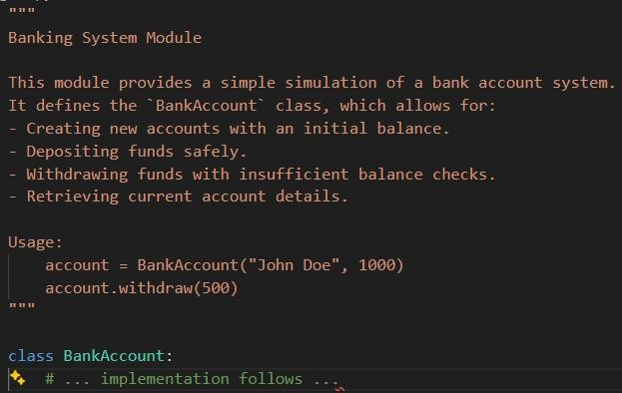

Explanation
A file-level docstring acts as the "README" for a specific file. The AI identified the core entity (BankAccount) and listed its capabilities in bullet points. It even provided a small usage example, which wasn't explicitly requested but is a hallmark of good AI-generated documentation. This helps other developers understand if this is the file they need without reading every line of code.

Task 4: Documentation – Refine Existing Documentation

Task Description
Use AI to improve the clarity and consistency of existing documentation in Python code. Provide Python code containing basic or unclear comments and ask the AI to rewrite them.

Prompt
"The comments in this code are vague and poorly wriflen. Rewrite them to be professional, clear, and descriptive without changing the code's functionality."

Input Code provided to AI

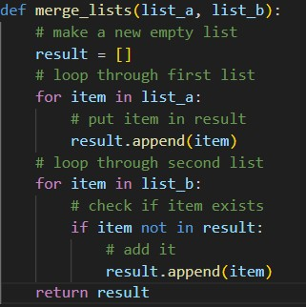

Output (AI Response)

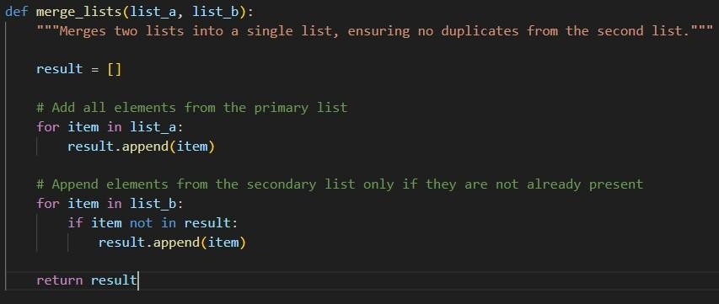

Explanation
The original comments were redundant (e.g., # make a new empty list). The AI replaced these with higherlevel descriptions. Instead of # loop through second list, it wrote # Append elements from the secondary list only if they are not already present. This shifts the focus from "what is the computer doing?" to "what is the algorithm achieving?", making the code significantly easier to read.

Task 5: Documentation – Prompt Detail Impact Study

Task Description
Study the impact of prompt detail on AI-generated documentation quality. Create two prompts: one brief and one detailed, use both to document the same function, and compare the outputs.

Function Used

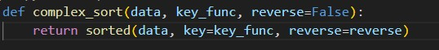

Prompt 1 (Briefi)
"Add documentation to this function."

Output 1 (Briefi Prompt)

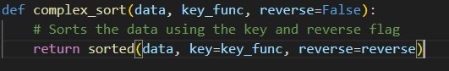

Prompt 2 (Detailed)
"Generate a Google-style docstring for this function. Include a description of arguments
(Args), the return value (Returns), and a brief explanation of what the function does."

Output 2 (Detailed Prompt)
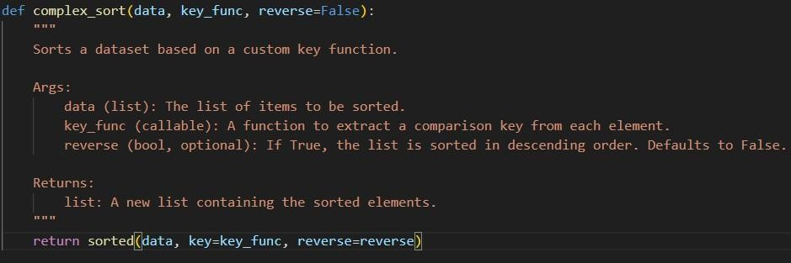

Comparison & Explanation

Feature | Brief Prompt Output | Detailed Prompt Output
Completeness | Very Low. Just a single inline comment. | High. Includes params, types, and return details.
Format | Informal comment. | Structured Docstring (Google Style).
Utility | Minimal. Tells us what we can already see. | High. Explains how to use the parameters.
Conclusion: The detailed prompt produced significantly superior documentation. It turns out that AI defaults to the path of least resistance unless explicitly guided to follow a standard structure (like Sphinx or Google style). This demonstrates that "Prompt Engineering" is essential for generating professional-grade API documentation.

