EXPERIMENT NO.1

**Aim**: Student Registration Form

**Objective**: Design and implement a basic student registration form that collects user information and validates inputs using HTML5 features.

**Task Description**: Create a student registration form using HTML. The form should include fields for:

* Name
* Email
* Age

Add appropriate HTML5 validation to ensure each field is correctly filled before form submission.

**Expected Output**

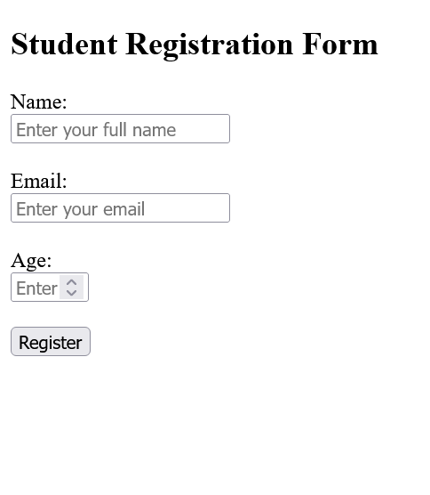

**CODE**-

<!DOCTYPE html>

<html>

  <head>

    <title>

      STUDENT REGISTRATION FORM

    </title><style>

</style>

  </head>

  <body>

    <h2>STUDENT REGISTRATION FORM</h2>

    <br>

    <br>

   <label for="Name">Name :</label>

   <br>

    <input type="text" placeholder="Enter your full name" required>

    <br>

    <br>

   <label for="Email">Email :</label>

   <br>

    <input type="text" placeholder="Enter your email" required>

    <br>

    <br>

    <label for="Age">Age :</label><br>

<input type="number" placeholder="Age" required>

<br>

<br>

<button>register</button>

</center>

</body>

</html>

**OUTPUT:**

