**EXPERIMENT-4**

**AIM:** Live Character Counter for Text area.

**Objective**: Create a simple feature that displays a live character count as the user types in a text area. This helps you practice real-time event handling and dynamic content updates to improve user interaction.

**Task Description**: Build a web page that includes a textarea where the user can type text. Below or beside the text area, display a character counter that updates immediately as the user types or deletes content. The counter should show the current number of characters entered, providing clear and instant feedback.

**Expected Output**

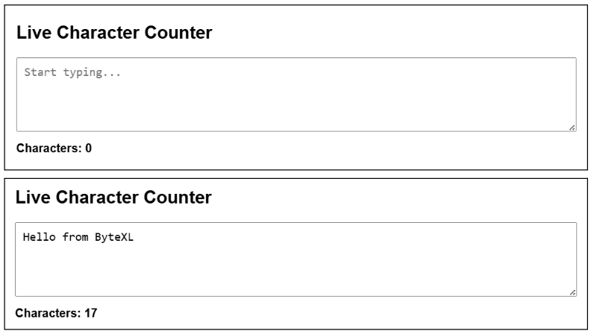

**CODE** :

<!DOCTYPE html>

<html lang="en">

<head>

  <meta charset="UTF-8" />

  <meta name="viewport" content="width=device-width, initial-scale=1.0"/>

  <title>Live Character Count</title>

  <style>

    body {

      font-family: Arial, sans-serif;

      padding: 20px;

    }

    textarea {

      width: 100%;

      height: 100px;

      font-size: 16px;

    }

    .count {

      margin-top: 10px;

      font-size: 18px;

    }

  </style>

</head>

<body>

  <h2>Type something:</h2>

  <textarea id="textInput" placeholder="Start typing..."></textarea>

  <div class="count">Characters: <span id="charCount">0</span></div>

  <script>

    const textarea = document.getElementById('textInput');

    const countDisplay = document.getElementById('charCount');

    textarea.addEventListener('input', () => {

      countDisplay.textContent = textarea.value.length;

    });

  </script>

</body>

</html>

**OUTPUT:**

