Traffic Sign 0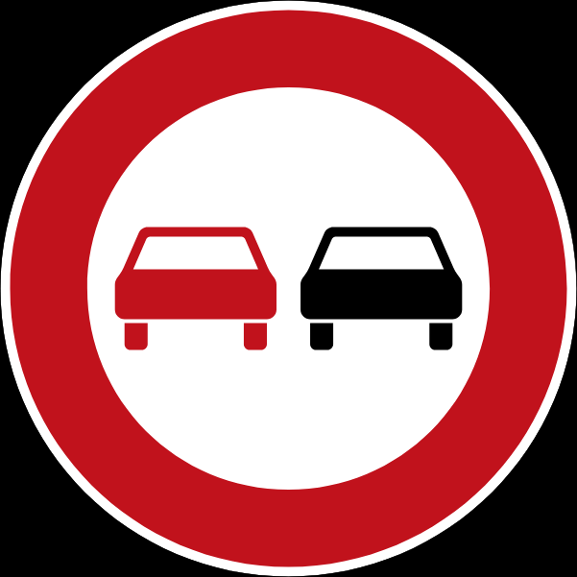

No Overtaking/ No Passing

Traffic Sign 1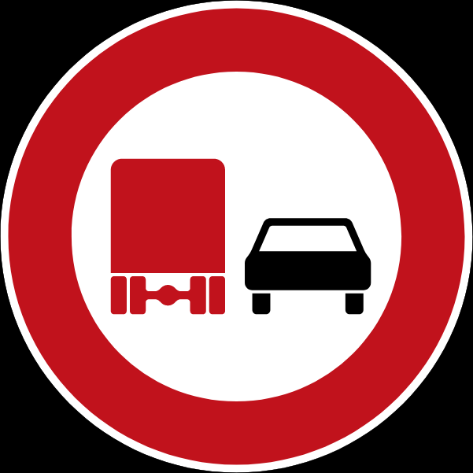

No Overtaking Trucks/ No Passing For Vehicles Over 3.5 Tonnes

Traffic Sign 2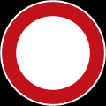

Forbids Action

Traffic Sign 3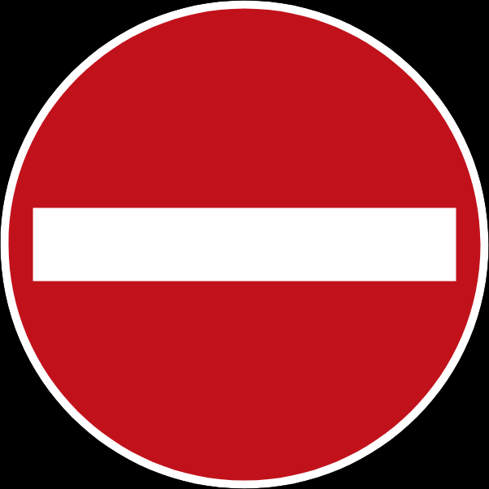

No Entry

Traffic Sign 4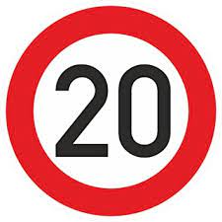

Maximum Speed Limit 20 km/h

Traffic Sign 5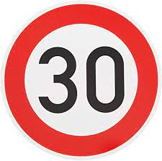

Maximum Speed Limit 30 km/h

Traffic Sign 6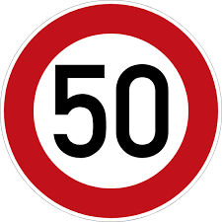

Maximum Speed Limit 50 km/h

Traffic Sign 7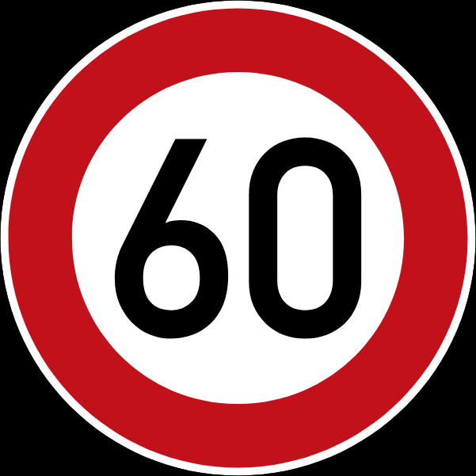

Maximum Speed Limit 60 km/h

Traffic Sign 8

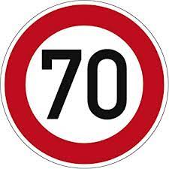

Maximum Speed Limit 70 km/h

Traffic Sign 9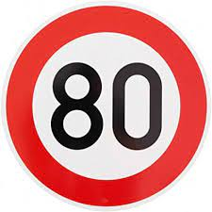

Maximum Speed Limit 80 km/h

Traffic Sign 10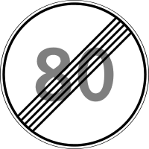

End of Speed Limit

The Statutory Speed Limit Now Applies

Traffic Sign 11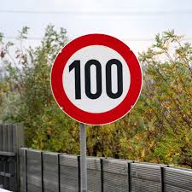

Maximum Speed Limit 100 km/h

Traffic Sign 12

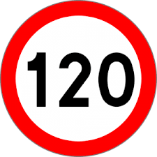

Maximum Speed Limit 120 km/h

Traffic Sign 13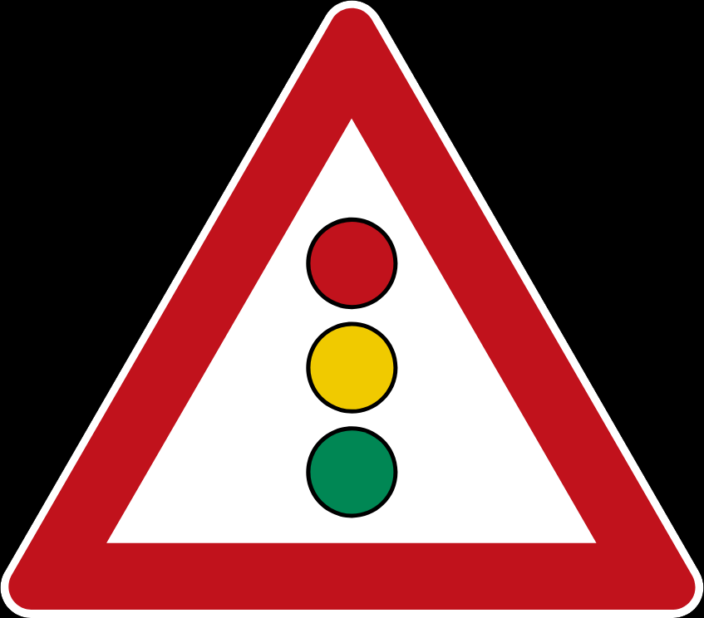

Traffic Signals Ahead

Traffic Sign 14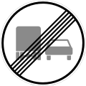

End of No Passing Zone For Trucks

Traffic Sign 15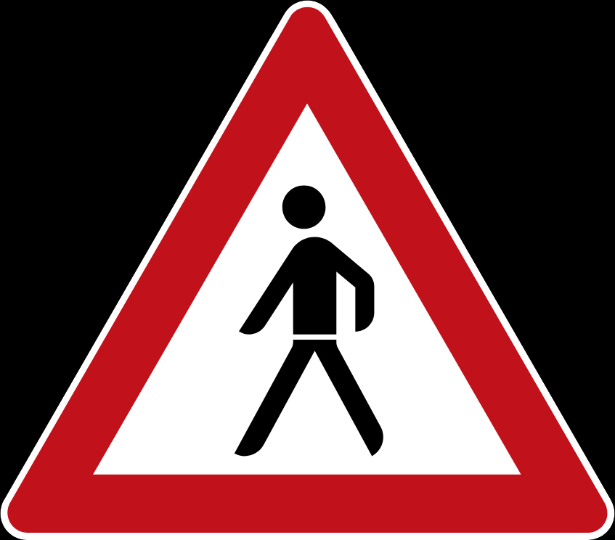

Pedestrian Crossing

Traffic Sign 16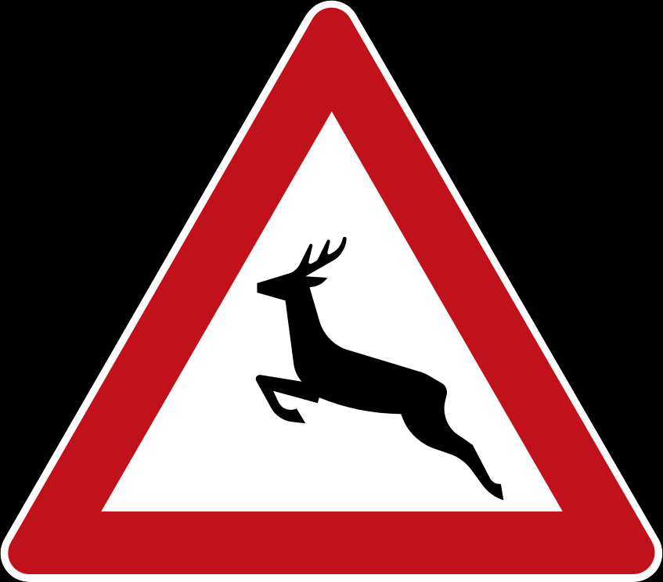

Wild Animal Crossing (Use Dipped Headlights, be prepared to brake suddenly)

Traffic Sign 17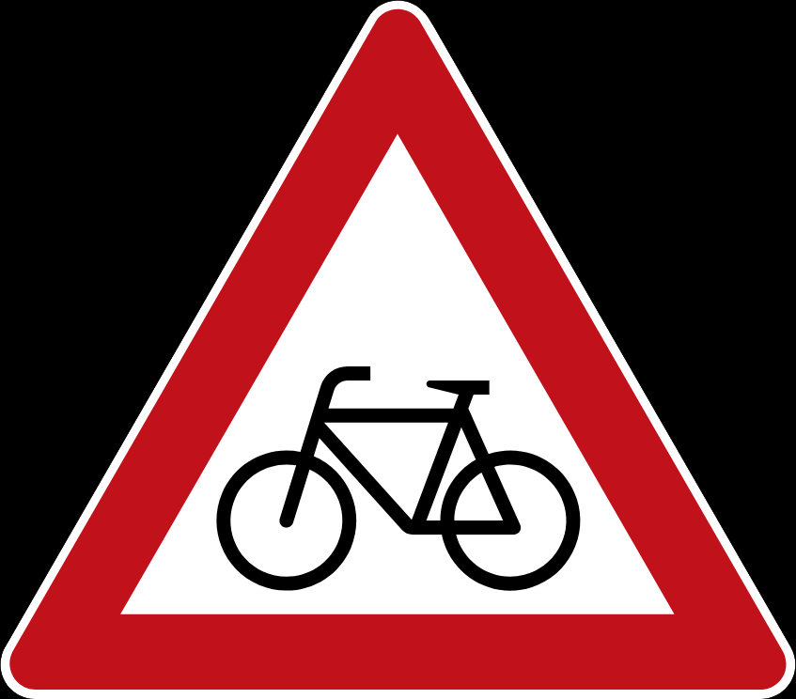

Bicycles Probhibited

Traffic Sign 18

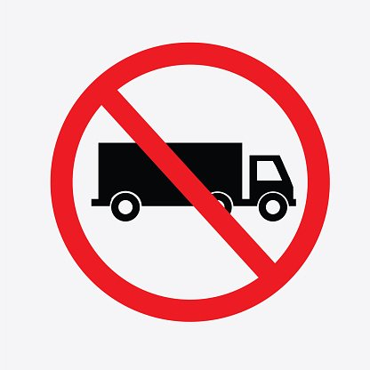

No Lorries

Traffic Sign 19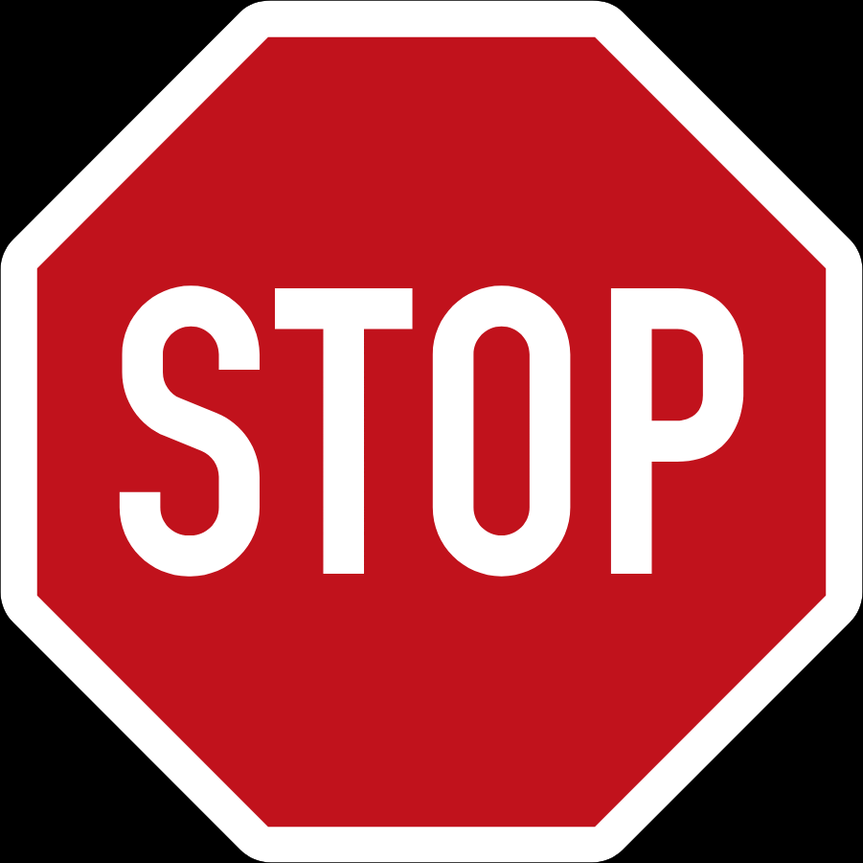

Stop

Traffic Sign 20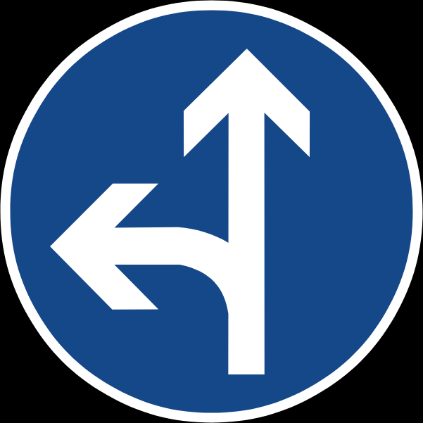

Ahead Or Turn Only

Traffic Sign 21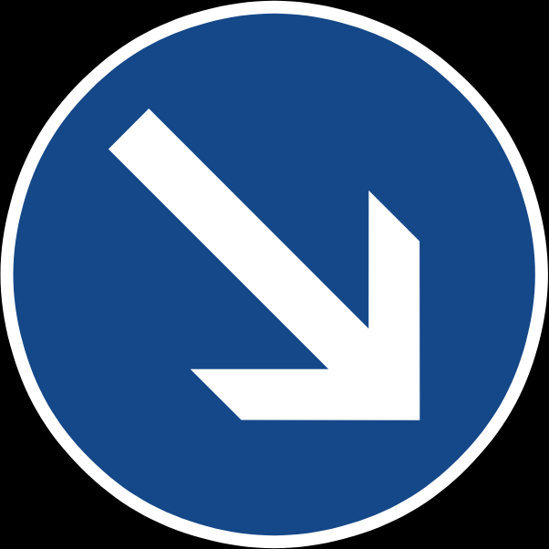

Pass By On Right

Traffic Sign 22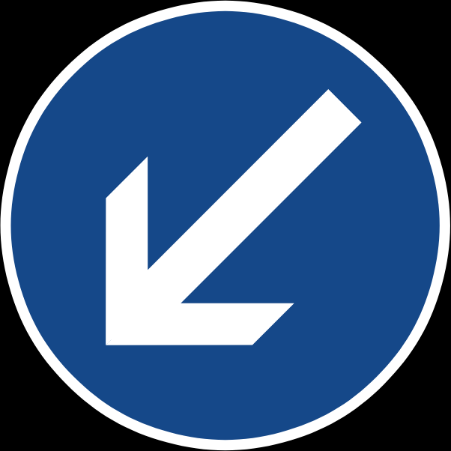

Pass By On Left

Traffic Sign 23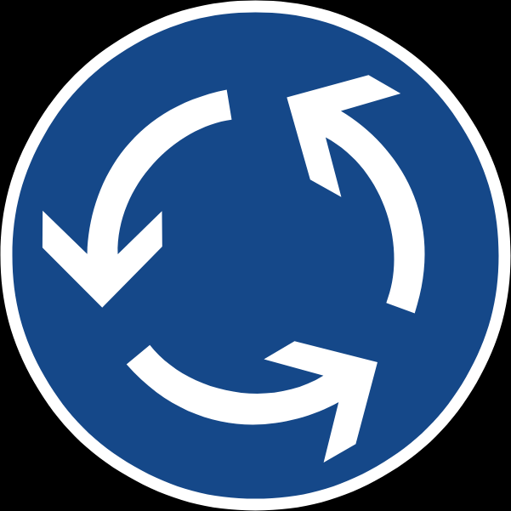

Roundabout

Traffic Sign 24A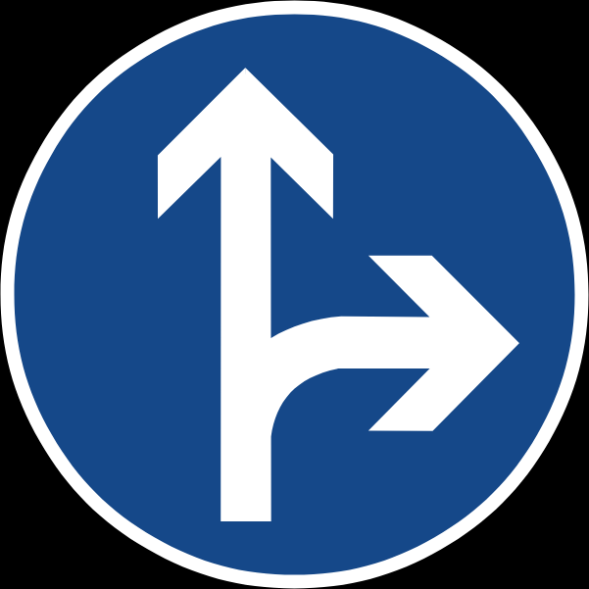

Ahead Or Turn Only

Traffic Sign 25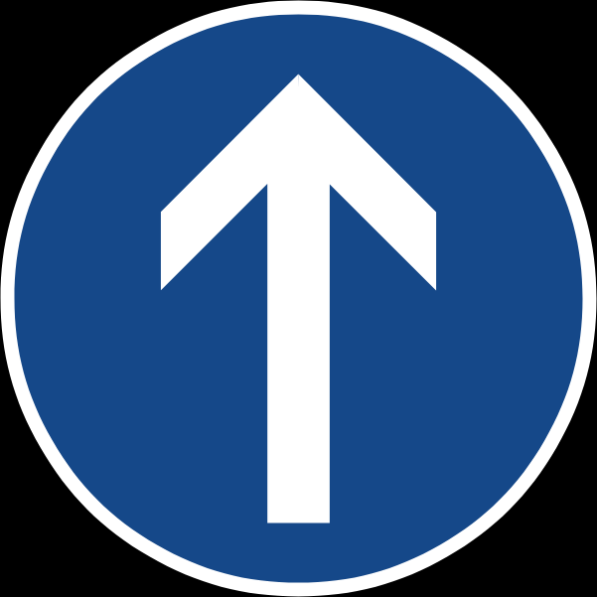

Ahead Only

Traffic Sign 26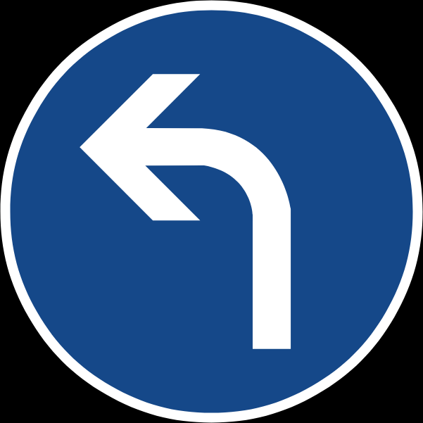

Turn Left Ahead

Traffic Sign 27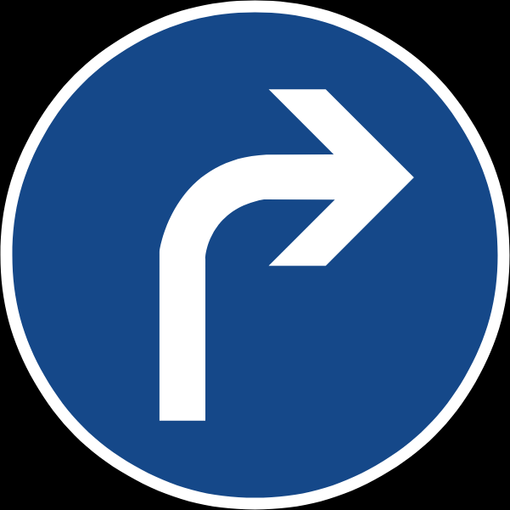

Turn Right Ahead

Traffic Sign 28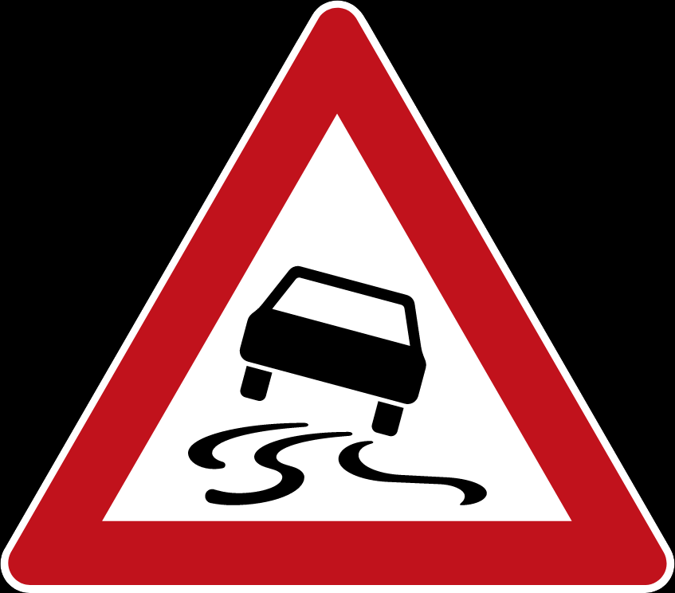

Slippery When Wet Or Dirty

Traffic Sign 29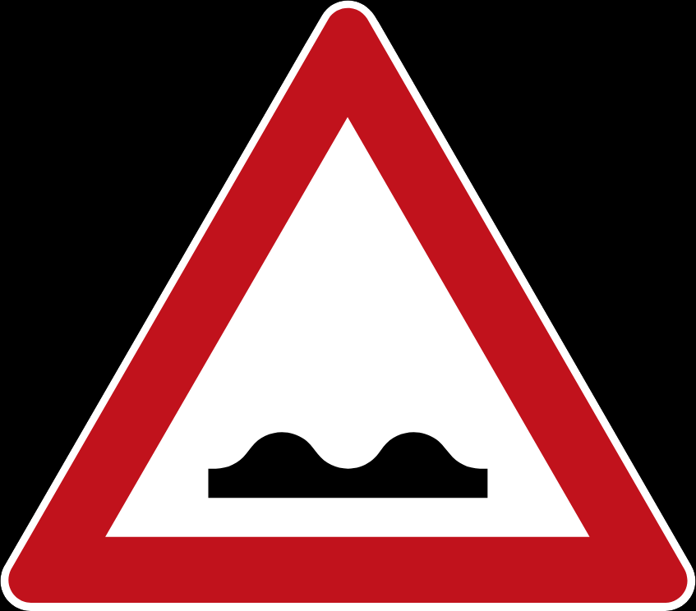

Uneven Road Surface (Reduce Speed)

Traffic Sign 30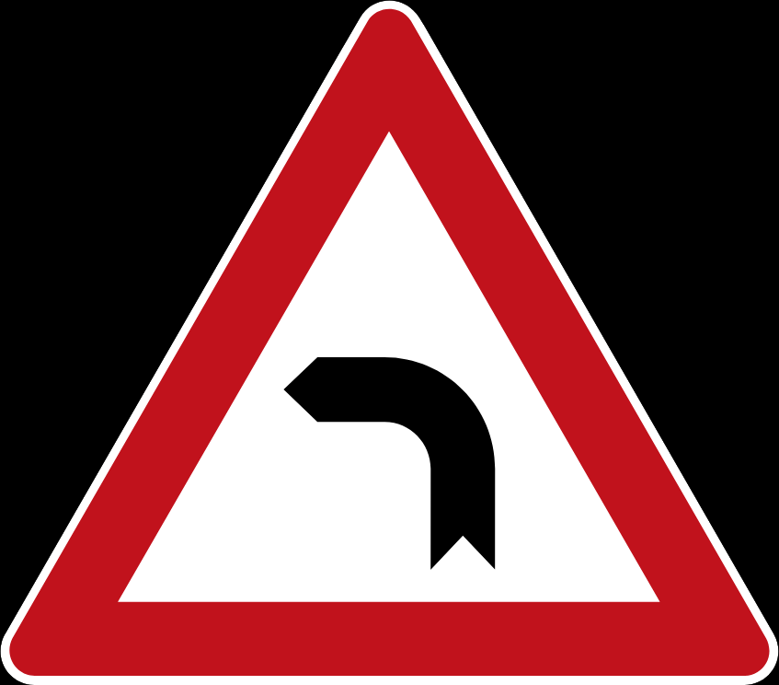

Curve Left

Traffic Sign 31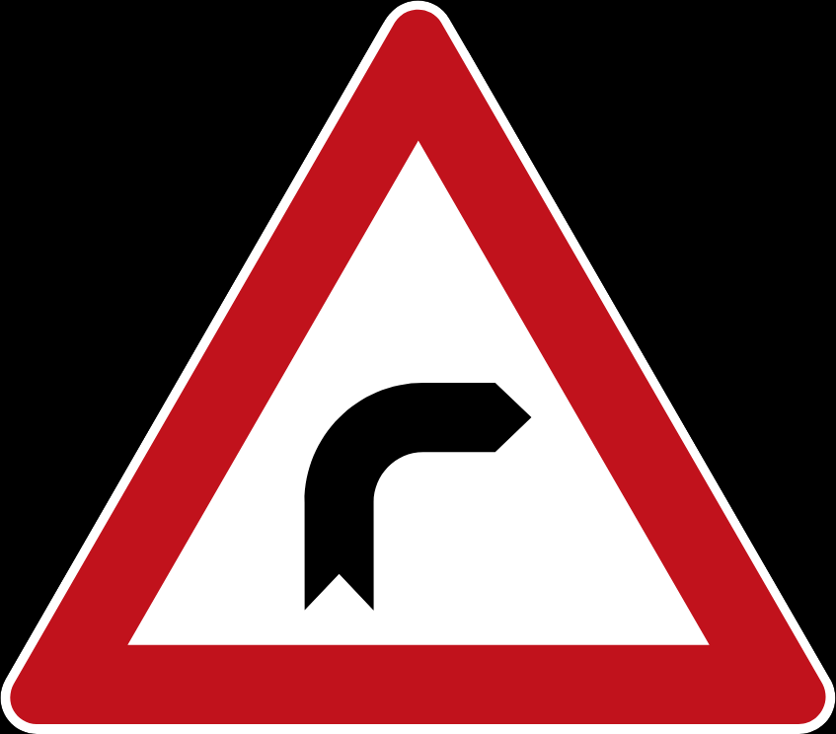

Curve Right

Traffic Sign 32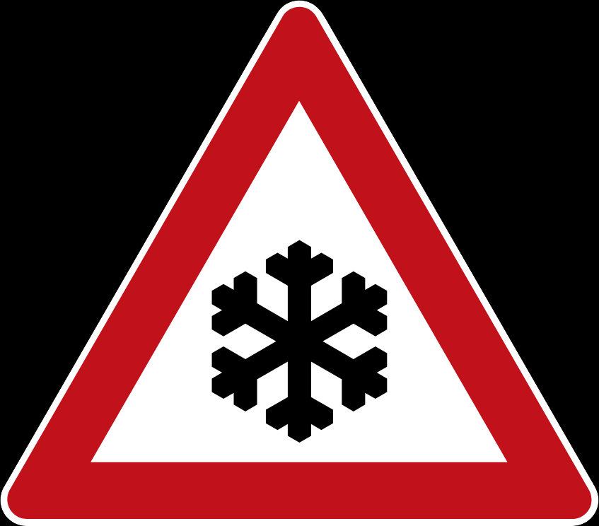

Ice/ Snow

(The bridge or road ahead may be icy)

Traffic Sign 33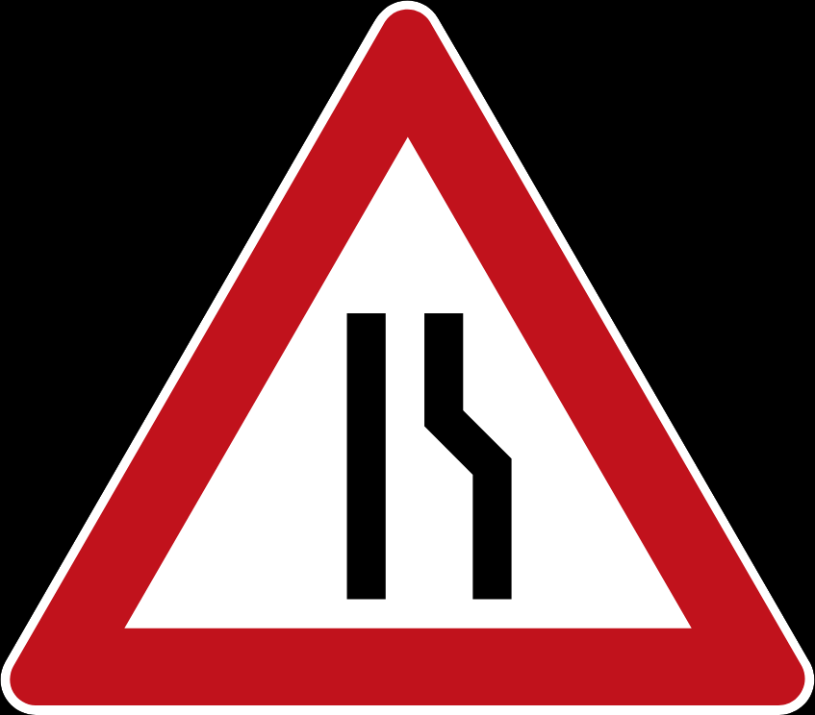

Road Narrows

Traffic Sign 34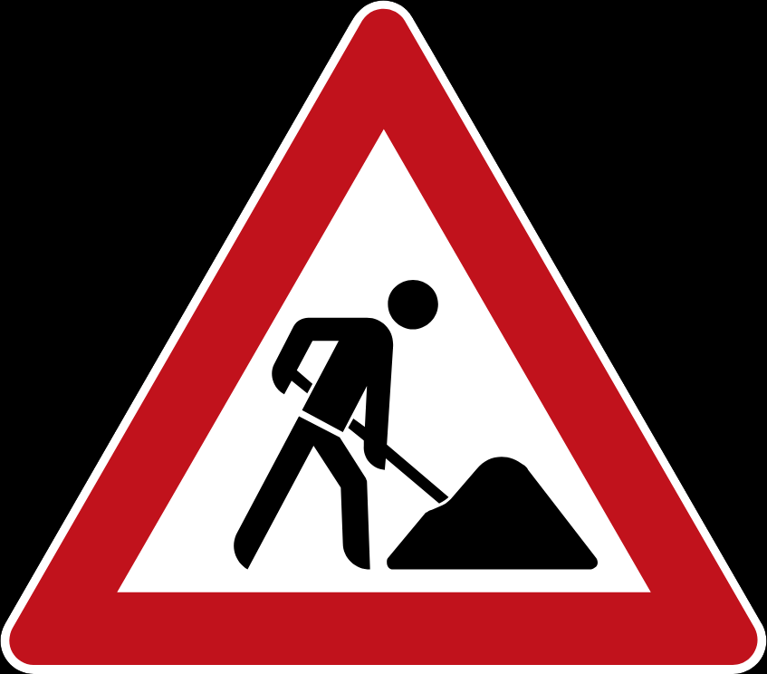

Roadworks

Traffic Sign 35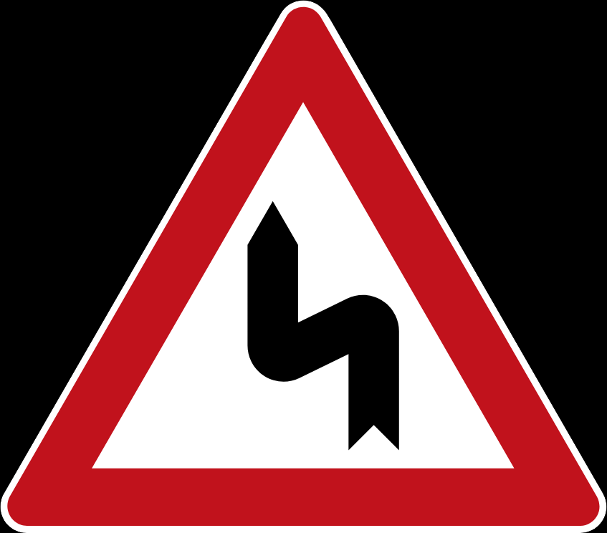

Double Curve

Traffic Sign 36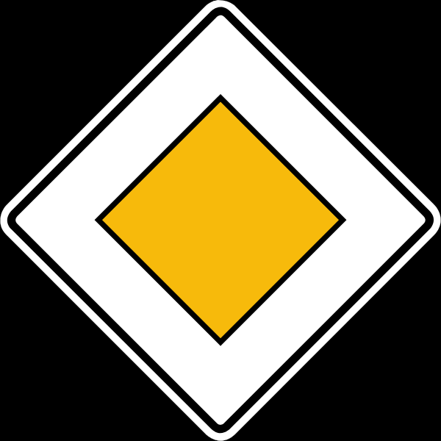

Priority Road

Traffic Sign 37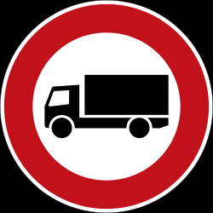

Vehicles Over 3.5 Tonnes Prohibited

(Lorries – Trucks Forbidden)

Traffic Sign 38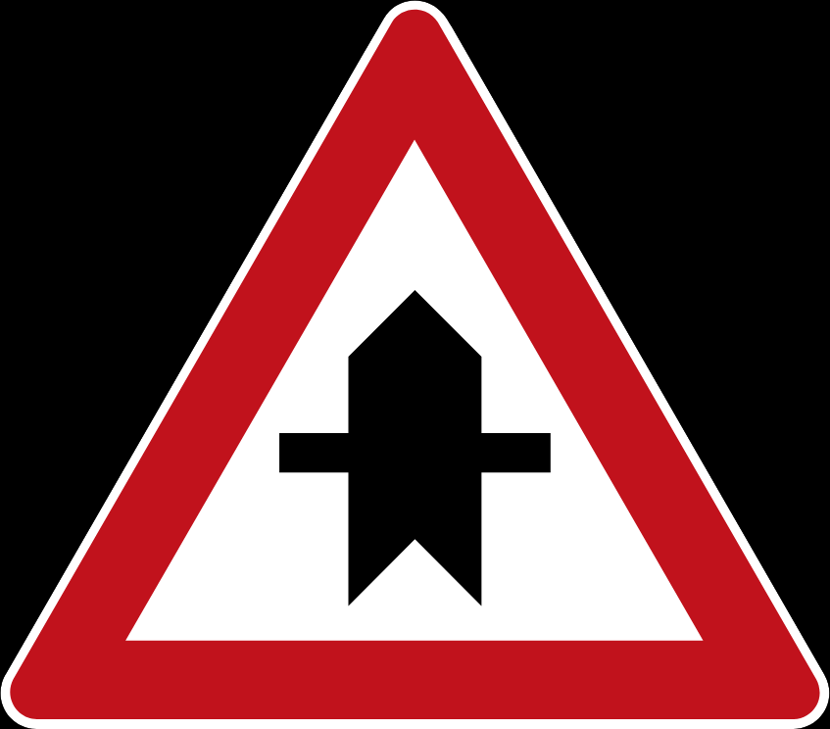

Right of way/ Priority

Crossroad ahead, side roads to left and right

Traffic Sign 39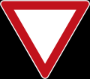

Yield

Traffic Sign 40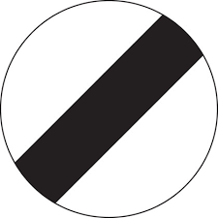

National Speed Limit Applies

Traffic Sign 41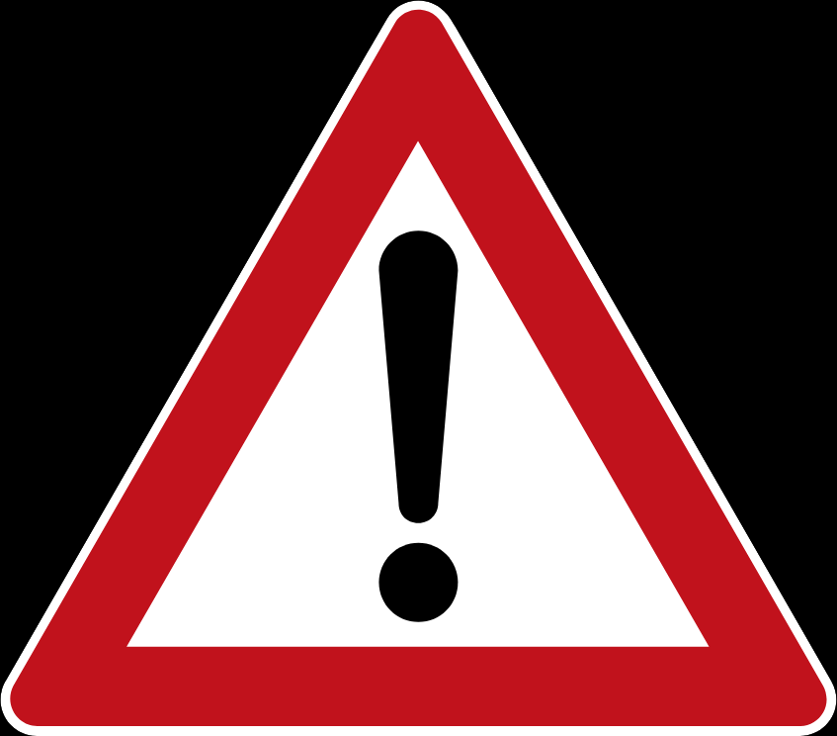

Danger

(Frequently used with a supplimentary sign to specify the danger)

Traffic Sign 42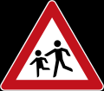

Watch For Children

(Schools and playgrounds in the area)