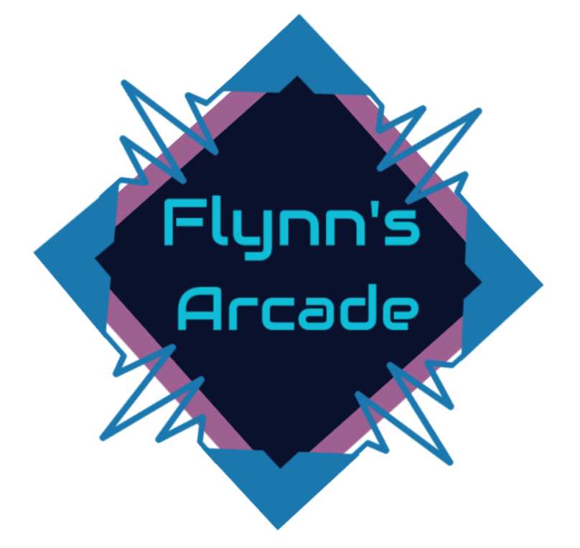

Portfolio

Flynn’s Website

Charbel Daher | IST | 30/08/2019

Contents

DESIGN BRIEF 2

# DESIGN BRIEF

Flynn’s Arcade has been slowly losing money as the trend for accessing video games has moved away from social ‘video game arcades’ to at home ‘video game consoles’ such as the Atari & Commadore 64. Flynn wants to reposition his business as a venue for selling new games and trading used games. Flynn wants you to design and create ‘alpha phase’ website that communicates his new business model.

AREA OF INVESTIGATION

# COMPARISON OF WEBSITE CREATION TOOLS

The website creation tool we used to create our website was notepad++. Notepad++ is a text editor and source code editor for use with Microsoft windows; it supports tabbed editing, which allows working with multiple files open in a single window.

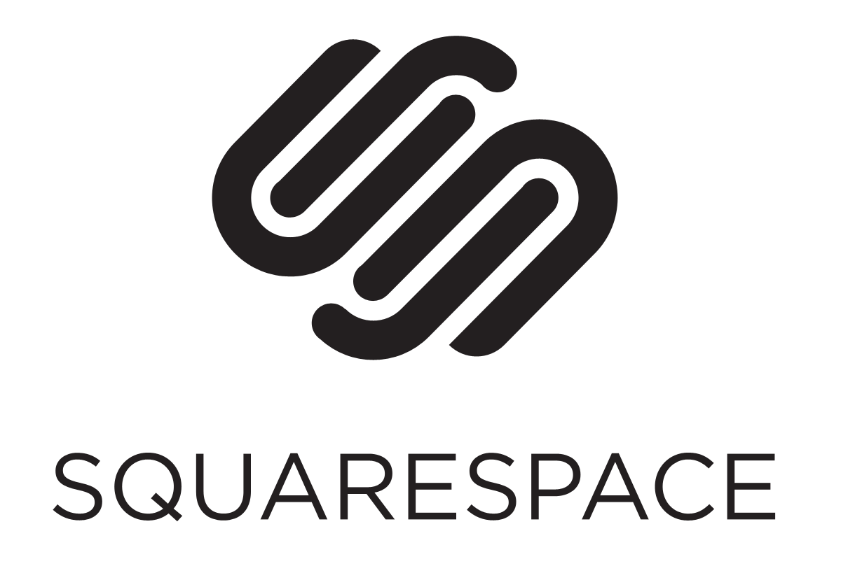Other website creation tools such as Wix, Weebly and Squarespace which are web creation tools that use drag and drop tools to create websites without code but require repetitive payment (monthly).

Wix and Weebly are very similar in many ways and are both reliable web creation tools that have many acquisitions to improve and vary its use to spread to a wider audience such as, although squarespace has the same features; although the other two are more simple and have more acquisitions for multiple audiences.

## Kevin Flynn & his design aesthetic

Kevin Flynn was a talented developer working for a company named ENCOM; He developed successful games for ENCOM such as Space Paranoids, Vice Squad, Matrix Blaster and Light Cycles. Kevin Flynn than ended up creating a game known as TRON and disappeared right (an arcade game based on his experience inside the computer world) after he was fired from ENCON due to a fellow ENCOM programmer stealing his code.

The web creation tools we used were:

* HTML

Hypertext Markup Language, A standardized system for tagging files to achieve font, colour, graphic and hyperlink effects on World Wide Web Pages.

* CSS

Cascading Style Sheet, A language which allows developers to adapt the presentation to different types of devices and enables the developer to decorate/edit text or images size, colour, position etc.

* Bootstrap

Bootstrap is a free collection of tools for creating a website or web applications. It contains HTML and CSS-based design templates for typography, forms, buttons, navigation and other interface components.

We used these three tools to create the website’s design, function.